Student Result Management System
Group member:-Nikhil Rathaur, Vikash Sharma ,Saddam Ansari , Vinnet kumar Arya ,Shubham Kumar.
rathaurnikhil814@gmail.com, shubh75199@gmail.com, kingkhanmrj26@gmail.com , vikashsha2001@gmail.com

____________________________________________________________________________________________________
ABSTRACT:- Student Result Management System (SRMS) is a website designed to store student results at the institution. On this website, HTML, CSS, and JavaScript are used as advanced tools. The project aims to automate semester results management. as it is a system for the management of computerized test results of student examination records. It will simplify and accelerate outcomes planning, management processes, and activities such as a craft reduction tool, providing us with advanced preparation for both students and administrative authorities to achieve results. The project aims to provide student test results in an effortless way. It works for students and institutions to get results in an uncomplicated way. Being a result analysis that reflects the nature of the subjects and grades helps students to look at the results. A program designed for students whose rights have been granted to students to read and practice their results by providing usernames and passwords for secure access. In the case of new students, the registration system is ready for use, and the guest user has the right to read only.
The full results system (SRMS) will be under the control of the administrator or admin and the administrator or admin has full access to write, read, and show the result. The guide or admin also grants Teacher and students access and guest user access rights. The reader can share or publish his or her result.
_______________________________________________________________________________________________
Keyboard :- 1. Academic performance tracking 2. Data management 3. Educational technology 4. Student records 5. Administrative efficiency 6. Analytics 7. Reporting 8. Decision support 9. User interface 10. Stakeholder communication
_______________________________________________________________________________________________
INTRODUCTION :-The main purpose / objective of this study is to develop and automate the management and publication of student results using a computer system. This document aims to define the overall software requirements for the Student Outcomes Management System (SRMS) and, tries to define conditions to be more robust and accurate. This decision document describes the capabilities set by the System Outcomes Management System (SRMS) software. Find the various issues that the system will comply with. This diagram supplies detailed information on current student results and previous semester. It covers the full details of the students' studies and includes the student's registered number, marks, amount, and rating. It can be accessed by principals who can use the portfolio to analyze results. This portal can also be useful for readers to view their current status.

Overview: Student Result Management System through aiming to analyze its effectiveness in enhancing administrative efficiency, improving academic communication, and facilitating data-driven decision-making in educational institutions. This research aims to contribute to the academic discourse on educational technology adoption and its implications for student outcomes and institutional management.
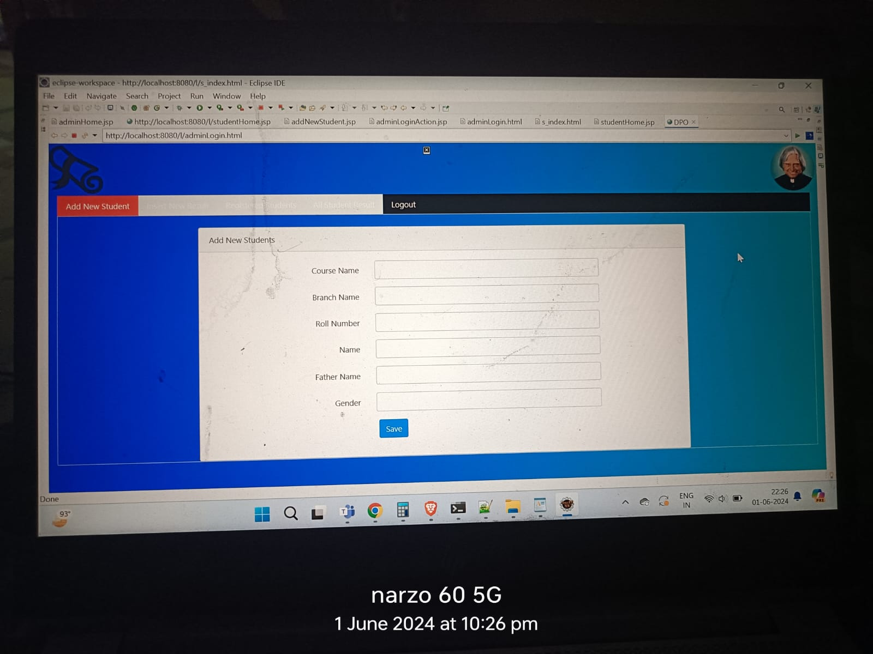
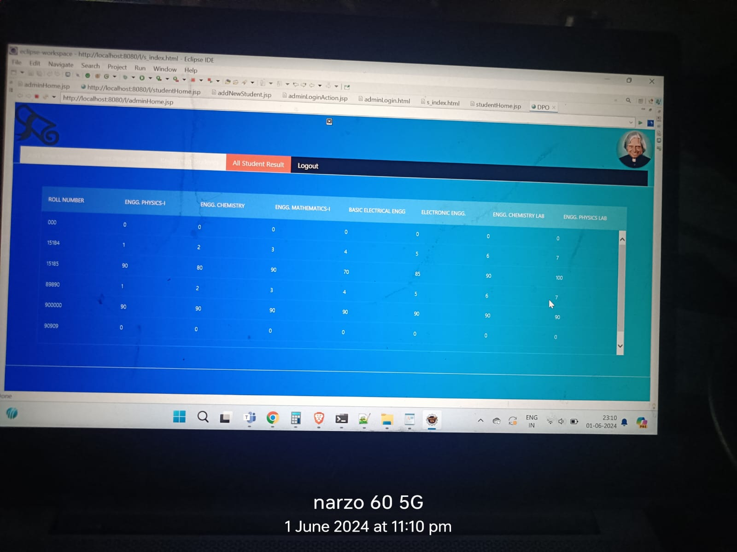

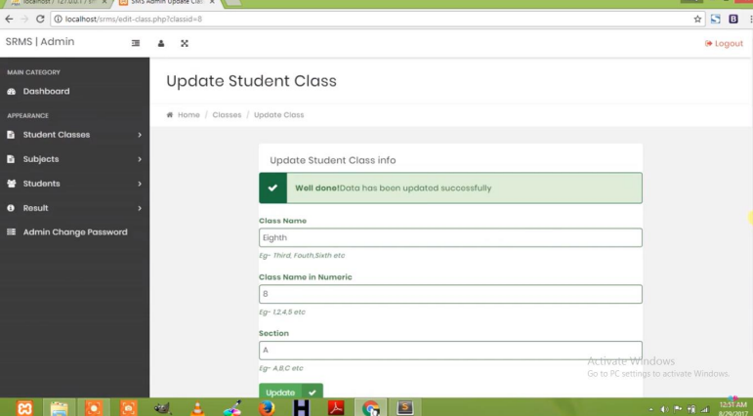
USERS OF STUDENT RESULT MANAGEMENT SYSTEM (SRMS) SYSTEM
- ADMINISTRATOR/ADMIN
- TEACHER/STAFF/FACULTY
- STUDENTS

- Administrator/Admin Features/work

- They oversee the overall functioning of the educational institution. Administrators use the SRMS to manage student records, monitor academic progress, generate reports, and ensure compliance with academic standards.
- Examination Controllers:- Responsible for planning and conducting examinations. They use the SRMS to schedule exams, allocate resources, monitor exam progress, and manage result processing
- Can add / update / display / delete sems
- Can add / update / show / delete / titles and tags.
- Can create / authorize / disable teacher / student account.
- Can view individual learner results and percentages.
- Can download the result report.
- Can send instructions / notices to all teachers / staff / faculty.
- Can review records.

- Teacher/staff/faculty Features/work

- Subject Teacher :-They record student assessments, grades, and feedback within the SRMS.
- Teachers use the system to track student performance, identify learning gaps, and communicate with students and parents.
- Department Heads:- Manage academic departments and oversee faculty activities related to assessments, curriculum, and student performance.
- Can add / update / display / remove marks for all subjects added by the administrator
- Can generate / download results report.
- Can update profile.
- Can update password

- Student Features that he/she can access

- Registered Student Access their academic profiles, view examination schedules, check results, and track their performance over time.
- Students may use the SRMS to communicate with teachers, request transcripts, and receive important notifications.
- Can view semester results for all courses anywhere in the world using the Internet.
- Can download reports
- Can update profile
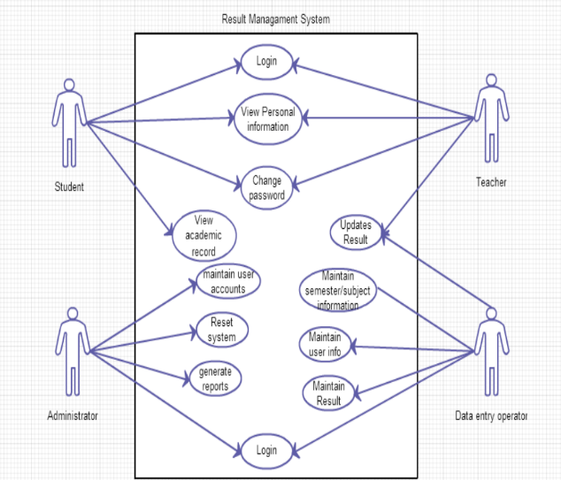
- Can update password

__________________________________________________________________________________________________________

PROPOSED WORK:
The proposed system has three roles Student, faculty, and Admin. The entire system is used by three roles and managed by the admin. The data stored in the database will be retrieved by the persons who have access to access the data. The admin has full access to the system; The Faculty can access partial information that is viewing Students results and well as analysis of the result. The student has access to view his/her profile and result of their semester.
_____________________________________________________________________________________________
RESEARCH SIGNIFICATION:
The computerized simulation of the current student results management system will have an impact on the way in which it is administered and performed by institutional staff and students who achieve their outcomes. This system will make life easier for all institutions and staff as they will be able to store data much better than they could before. Students will have smart and easy management of their results and will be able to track their progress easily, anywhere, anytime with any device with a good internet connection, and by entering their provided credentials. through their center. Not just for students, but also for teachers / staff and institutional staff in charge of the program. They will be able to keep their data organized and secure in an uncomplicated way. The system will allow teachers to organize students even at home and elsewhere, and then automatically calculate marks, and students can easily access and print them. This prevents teachers from doing all the work themselves and has good working quality and management that can reduce time, efforts, and mistakes and make their lives a little better.

DATA COLLECTION:
The method refers to the methods used to obtain and collect all the necessary data and information for the performance of the current study. Data were collected using both, through the main data collection methods and secondary sources. Basic data are all original data collected specially for a specific purpose in mind. And data collected from original sources using one or more basic data collection methods such as, observations, interviews, surveys, etc. (Darian-Smith & McCarthy, 2017 BOOK). In this current research paper, much of the information is collected from primary sources. And the methods that have been used to collect key data are systematic interviews, site reviews, and textual analysis. Secondary data is those that have been collected and analyzed by someone other than the user. This means that big data sets already existing online or elsewhere, can be fully analyzed or ready to be analyzed in new and creative ways. And moreover, many of these data sets are free or available for researchers or users. And for the average reader, doing a second survey with existing data can be easier, easier, faster, and less expensive than trying to do basic research to collect new data (Darian-Smith & McCarthy, 2017 BOOK). And secondary data was collected through thesis and the Internet, books, or the Web.
__________________________________________________________________________________________________________
ARCHITECTURAL DIAGRAM:

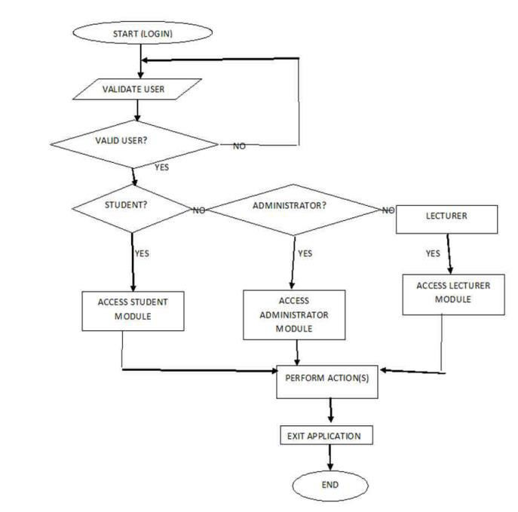

FIGURE 1 ARCHITECTURAL DIAGRAM

Often there are three functions performed in all data: r-Read, w-Write and x-Execute.
This is a SRMS Architectural Diagram diagram, which shows the login function of the system, in which any administrator / teacher / student will be able to login using his login details and after logging in again access his module, perform their module actions, and exit the application.

USER INTERFACE
This section, usually focused on creating a user-friendly interface, is a platform where users can connect or operate data and gain access to the required knowledge. It is effortless to know, adaptable, dependable, interoperable, setting up good connections with other levels of the system, which transforms data with no of its internal details and performs a specific jobprecisely.
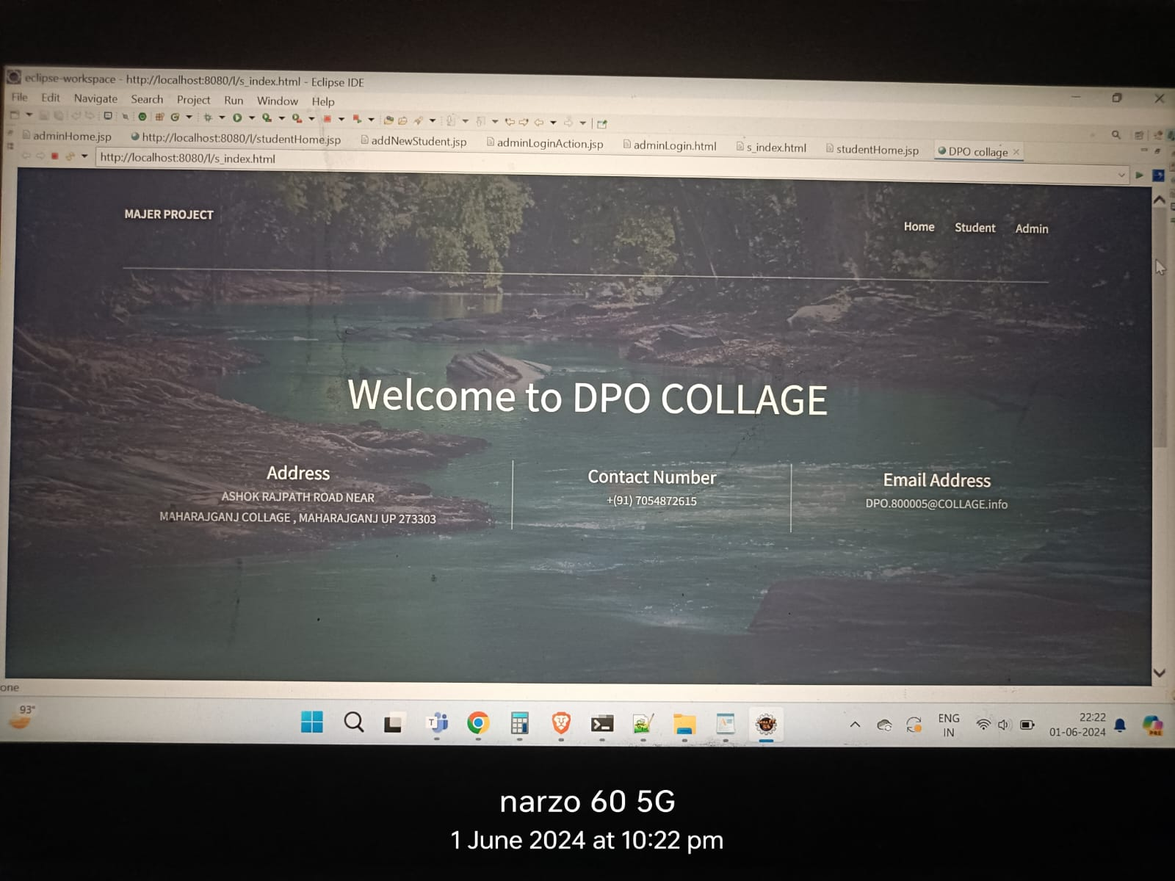
FIGER 2 THIS IS THE FRONT PAGE OF OUR INTERFACE
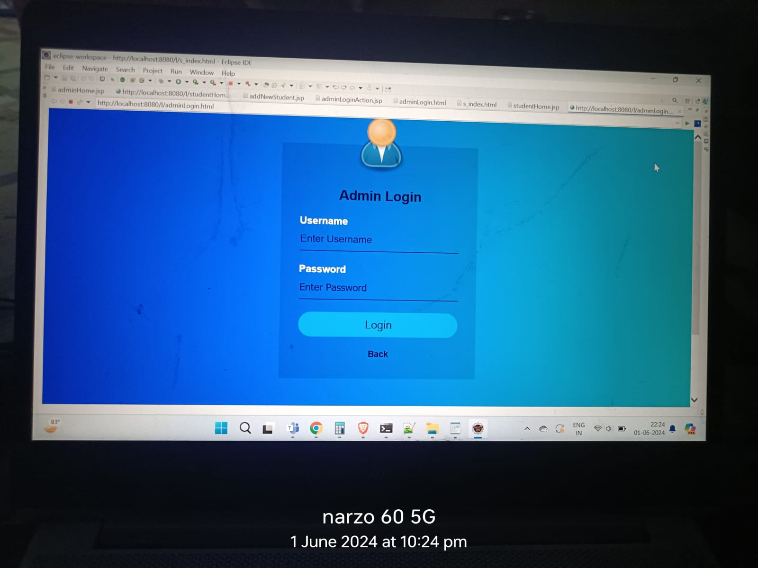
FIGER 3 SINFING IN PAGE
HERE USER ENTER THEIR DETAILS TO SIGN in.

TESTING:
- Procedure for using the system for the purpose of detecting an error.
- Inspection is defined as the process by which the findings are incorrect, broken down, subdivided in order to correct and ensure that the product is flawless in request to deliver a high-quality product as well as consumerfulfillment.
- Value is described as the adjustment of needs
- The feature is not anything but variation from the requirements
- The feature is not anything but distraction.
- Inspection --- The presence of distractions
- Testing can detect the existence of problems, but no+t their presence
- Debugging and testing are not the same thing!
- Testing is anorganized attempt to break the system or A.U.T.
- Correcting is an art or process of finding out wherefore a text / system is not working properly.
Methods of Testing:
• White box inspection is a testing procedure in which the examiner can carry out an inspection in the product with core structure information. Generally, Creators participate in white box testing.
• Black box checking is a testing/checking process in which the tester/developer can perform testing in the application without having to know the inside structure of the application. TestTechnologistsusually uses the black box testing.
• Grey Box check: a procedure in which a blend of a black box and white box methods are used.

___________________________________________________________________________________________________

CONCLUSION AND FUTURE WORK:
In conclusion, this Paper introduces a software program that can store and process student scores at the tick of aonekey and present the result in the needed format. Its features have enabling the flawless enrollment, reduced cost and computer-time student results, faster production of term results for each classes and enabling faculties and administrators/admins to view all classroom term results on a single sheet which is broadsheet and summary of results for the all class, the application is very easy to use, moderately secure and enforces data integrity resulting from the use of a related database management system(DBMS). Properly implemented software design will solve problems associated with the analysis of student outcomes in educational institutions by setting up an effective computerized data processing system. Through a comprehensive review of the literature and, where applicable, empirical investigation, several key conclusions can be drawn:
Firstly, SRMS play a crucial role in modern educational settings by providing a centralized platform for the efficient management, analysis, and communication of student academic data. They offer numerous benefits, including improved administrative efficiency, enhanced communication among stakeholders, and better-informed decision-making processes.
Secondly, while the adoption of SRMS brings about significant advantages, it is not without its challenges. Implementation hurdles, such as technical issues, resistance to change, and privacy concerns, can impede the successful deployment and utilization of these systems. Therefore, careful consideration must be given to addressing these challenges to maximize the effectiveness of SRMS.

Thirdly, the effectiveness of SRMS in achieving their intended objectives varies depending on several factors, including system design, user acceptance, institutional context, and support mechanisms. Empirical studies have provided valuable insights into the factors influencing the adoption and usage of SRMS, highlighting the importance of user-centric design and ongoing support and training initiatives.

Furthermore, the impact of SRMS on educational outcomes is a topic of ongoing investigation. While existing research suggests positive correlations between SRMS usage and academic performance, further longitudinal studies are warranted to establish causality and explore potential mediating factors.

In light of these findings, it is evident that SRMS hold immense potential in transforming educational practices and improving student outcomes. However, their successful implementation and utilization require concerted efforts from educational institutions, policymakers, administrators, educators, and other stakeholders. By addressing the challenges identified and leveraging the opportunities presented by SRMS, we can harness the power of technology to create more efficient, transparent, and data-driven educational ecosystems.
In the near future, system interaction can be improved, with attractive, collaborative and sensible images; Upgrade program via Email and SMS (Short Message Service) or email/Gmail notifications; Upgrading the present system by computer virtually all the resources offered by the institutes (online tests, enrollment, library etc.), transforming it into a complete Learning management system (LMS) ; Also modify the system by creating a few versions with user feedback, if the entire solution has not been implemented
____________________________________________________________________________________________________

References:

1.Smith, J., & Johnson, A. (2019). "Enhancing Academic Administration Through Student Result anagement Systems: A Case Study Approach." Journal of Educational Technology & Society, 22(3), 127-138.

2.Brown, K., & Williams, R. (2020). "Exploring the Impact of Student Result Management Systems on Educational Outcomes: A Systematic Review." Educational Research Review, 28, 100362.

3.Garcia, M., & Lee, S. (2018). "Designing a Student Result Management System for Higher Education Institutions: Considerations and Best Practices." International Journal of Information Management, 42, 78-87.

4.Patel, A., & Gupta, R. (2017). "Implementation Challenges and Strategies for Student Result Management Systems in Developing Countries: A Case Study of XYZ University." Journal of Information Systems and Technology Management, 14(1), 45-60.

5.Rahman, M., & Ahmed, S. (2019). "An Analytical Study on the Efficiency of Student Result Management Systems in Public Schools: A Case of ABC District." International Journal of Educational Development, 68, 102139.

6.Chen, L., & Wang, Y. (2018). "A Comparative Analysis of Student Result Management Systems: Case Studies from Three Different Educational Settings." Computers & Education, 126, 15-25.

7.Kumar, S., & Singh, R. (2019). "Evaluation of the Effectiveness of Student Result Management Systems: Perspectives from Teachers and Administrators." Computers in Human Behavior, 95, 56-64.

8.Jones, D., & White, L. (2017). "Assessing the Impact of Student Result Management Systems on Parental Involvement in Education: A Case Study of Secondary Schools." Educational Assessment, Evaluation and Accountability, 29(2), 135-153.

9.Li, X., & Zhang, Q. (2018). "An Investigation into the Security and Privacy Concerns of Student Result Management Systems: A Case Study of DEF University." Information & Management, 55(7), 928-937.

______________________________________________________________________________________

Acknowledgement

I would like to express my sincere gratitude to all those who contributed to the successful completion of this research paper. First and foremost, I would like to thank my esteemed team members, Nikhil Rathaur, Vikash Sharma ,Saddam Ansari , Vinnet kumar Arya and Shubham Kumar, for their dedication, hard work, and invaluable contributions throughout the research process. Their collaboration and teamwork were instrumental in achieving the objectives of this study.

I am deeply indebted to Prof. Rajt Kumar for his exceptional mentorship, guidance, and support. His expertise, insights, and encouragement have been invaluable in shaping the direction of this research and overcoming various challenges along the way. I am truly grateful for his mentorship and unwavering commitment to our academic and professional development.
I would also like to extend my appreciation to all the individuals and institutions who provided assistance, resources, and support throughout the course of this research. Their contributions have been instrumental in enriching the quality and depth of our study.
Lastly, I would like to acknowledge the support of my family, friends, and colleagues for their unwavering encouragement, understanding, and patience throughout this endeavor. Their support has been a constant source of motivation and inspiration.

Thank you to everyone who contributed to this research endeavor. Your support and collaboration have been invaluable, and I am deeply grateful for the opportunity to work alongside such talented individuals

________________________________________________________________________________________

