Cataract Detection and Classification using Machine learning

C.V Rane¹, Shreya Mamdapure², Chinmay Nawale³, Harshal Yadav⁴
Dept of Electronics & Telecommunication
JSPM’s RSCOE Tathawade Pune, MS-India
Savitribai Phule Pune University, Pune
cvrane_entc@jspmrscoe.edu shreya.mamdapure@gmail.com nawalechinmay1@gmail.com harshyadav4900@gmail.com

Abstract— This study introduces an innovative machine-learning methodology for automating the detection and classification of multiple ophthalmic diseases, including cataracts, glaucoma, and retinal disorders, using fundus images. Traditional diagnostic methods often suffer from subjectivity and limitations in accuracy. To overcome these challenges, a robust convolutional neural network (CNN) model was developed, and trained on a diverse dataset encompassing various disease manifestations across severity levels. Leveraging advanced image preprocessing techniques and feature engineering, the model achieves remarkable accuracy rates of 95.93% for cataract detection, 93.7% for glaucoma detection, and 92.43% for classifying retinal diseases. This system demonstrates exceptional versatility as a comprehensive screening solution, potentially revolutionizing ophthalmic diagnostics and improving eye health outcomes on a global scale.
Keywords- Cataract; Normal Eye Image; Cataract Eye Image; Glaucoma Image, Retina Image, Image Preprocessing; Gray Scale Conversion; Gray Level Cooccurrence Matrix(GLCM); Size Invariant Feature Transform(SIFT); Binary Image; Feature Extraction; CNN (convolutional neural networks);
- INTRODUCTION
Cataracts represent a significant global healthcare concern, with the World Health Organization estimating that cataracts are responsible for nearly 51% of world blindness. Their influence on a person's standard of living is profound, impacting their capacity to carry out everyday duties, preserve their independence, and actively participate in society. Therefore, there is an urgent need for accurate and timely cataract detection to facilitate early intervention and improve patient outcomes.
Traditional cataract diagnosis involves subjective assessment by ophthalmologists, often reliant on visual inspection of the crystalline lens and other clinical examinations. While these methods are effective, they can be time-consuming, subject to interobserver variability, and often require specialized expertise. Machine learning, with its ability to process large volumes of medical images, has emerged as a transformative technology for enhancing cataract detection.
The paper presents an extensive investigation of machine learning methods for cataract identification. Realizing the full potential of deep learning and machine vision. To develop a system capable of automating the cataract diagnosis process, potentially reducing the burden on healthcare professionals and increasing the accessibility of early diagnosis. Our approach leverages a diverse dataset of ocular images, including various cataract types and severity levels, to train and validate our ML model.
With automated cataract detection, we can offer quicker and more consistent assessments, thereby facilitating timely treatment and ultimately preserving patients' visual acuity.
In addition, we are also determining the glaucoma eye and retinal eye images. Additionally, this technology can be deployed in underserved regions where access to skilled ophthalmologists may be limited, extending the reach of eye care services.
- LITERATURE SURVEY
M. S. Junayed et al. [1] introduce 'Cataract Net,' an automated cataract detection system. It begins by preparing and enhancing a dataset of fundus images for training. Cataract Net is designed as a lightweight deep learning model, focusing on optimizing various aspects of its architecture, including layers, activation functions, loss functions, and optimization algorithms, to minimize computational costs without compromising model accuracy. The paper compares Cataract Net's performance with five pre-trained CNN models: Mobile Net, VGG-16, VGG-19, InceptionV3, and ResNet-50 and demonstrates that Cataract Net achieves competitive performance in cataract detection, making it a valuable contribution to the field of automated cataract diagnosis. Furthermore, it was not intended to be used for grading or pinpointing the precise location of cataracts, which would have been useful for ophthalmologists.
Leonardo Michael Marcello et al. [2] developed a cataract detection system utilizing image processing and the support vector machine (SVM) methods The technique performed well in differentiating between eyes without cataracts and those with cataracts. However, limitations in data availability impacted its performance. The authors plan to improve the system and develop it as a standalone embedded system with a camera for real-world applications.
S. Hu et al. [3] highlight the importance of automated cataract diagnosis, emphasizing its potential to enhance access to cataract examinations, particularly in underserved regions with limited medical resources, thus helping prevent blindness caused by cataracts. Using slit-lamp pictures taken with a smartphone, the study offers a unifying paradigm for automated nuclear cataract severity grading. This system, which draws inspiration from the grafting concept, combines classic feature extraction techniques with deep learning. This strategy provides real-time detection with greater mean average precision (MAP) than the widely used Faster-RCNN deep learning target detection method. Notably, in order to guarantee image quality, it adds an image blur assessment stage prior to grading.
Touma, S. et al. [4] underscores the significance of automated cataract diagnosis, particularly in underserved areas with limited medical resources. It introduces a novel framework for smartphone-based slit-lamp photo analysis, merging traditional feature extraction with deep learning techniques inspired by Grafting. In contrast to Faster-RCNN, this approach enables detection in real time and achieves higher mean average precision (MAP). It also incorporates an image blur assessment step to ensure picture quality before grading. The experimental results demonstrate the framework's competitiveness among existing cataract grading methods. By simplifying the cataract screening process and harnessing AI technology, this method enhances diagnostic accuracy, reduces misdiagnoses, and improves medical accessibility, ultimately benefiting patients.
A. Imran et al. in [5] describe the Retinal diseases typically require expert examination for vessel segmentation, making it a costly and time-consuming process. Extraction and segmentation of vessels automatically are crucial for detection at early stages using AI. Researchers have categorized vessel segmentation algorithms into supervised (SVM-based, NN-based, and miscellaneous) and unsupervised methods. They compared these techniques, considering datasets, fundus photography, preprocessing, post-processing, and evaluation criteria. While these algorithms enhance retinal disease diagnosis, they don't replace experts but alleviate their workload. Advancements in technology, such as high-resolution fundus cameras, continue to improve retinal imaging, enabling more efficient and accurate detection.
Wang J. et al. [6] examine the difficulties in interpreting cortical cataract images, paying special attention to the difficulties in measuring opacity features and the subjectivity of medical professionals' judgments. The knowledge distillation network TKD-Net, designed for cortical cataract grading, is presented by the authors. as a novel solution to these problems. TKD-Net uses a feature zone decomposition approach to classify image characteristics into periocular and central regions for further analysis and weight correction. A multi-modal transformer is used to combine image features with clinical data (sub-scores) in order to further modify the weights of central and periocular features. Notably, their knowledge distillation technique allows the use of ambiguous samples without the need for hard labels and maintains excellent performance even in the absence of sub-scores.
I. Jindal et al. [7], two algorithms for automated cataract detection and classification were presented. The first algorithm is a feature-based methodology that is effective and adaptable for detecting non-circular pupils in real-time photographs. The second algorithm is an area-based technique that assesses the degree of cataract but requires good colour contrast and a perfect circular pupil in the eye, which in many situations means manual preprocessing. When both algorithms were evaluated on real photographs of healthy and cataract-affected eyes, the results were acceptable. The database is being expanded in order to provide more precise results and early-stage cataract identification.
S. Ramesh et al. [8] introduce a weak tracking method for surgical steps, focusing on taking advantage of less demand for level descriptions. The proposed method, known as the “DEP” model, was evaluated on two datasets: the Bypass40 dataset containing 40 cases of laparoscopic Roux-en-Y gastric bypass (LRYGB) surgery and CATARAKTS dataset containing 50 patients with cataract surgery. The main results of this paper include the introduction of phase-dependent loss to model weak tracking of steps and phases. The model ResNet-50 + SS-TCN was used for training end-to-end and the performance was evaluated based on the "FSA" model. For step analysis, the benchmark shows that the “DEP” model consistently outperforms the “FSA” model over a large number of step descriptions.
R. Munarto et al. in [9] describe the performance of neural networks studied via backpropagation for the classification of different cataract levels. The system achieves an overall accuracy of 82.14%. The accuracy of identifying normal retina, moderate cataracts, and severe cataracts is high, but the accuracy of identifying cataracts is low. The system is known for its effectiveness in quickly classifying cataracts, but it is recommended that its results be supported by laboratory tests for a complete diagnosis. Evaluation results show that the plan can improve doctors' diagnoses and reduce the physical and financial burden on patients and people.
Zhang et al. [10] explore new advances in machine learning (ML) for cataract classification., focusing on traditional ML and deep learning. While acknowledging the progress, he underscores the need for publicly available data, recommends investigating image annotations, and emphasizes the importance of properly designing and interpreting machine learning for cataract diagnosis. The survey also advocated to utilize techniques of machine learning diagnose cataracts in confined settings.
O. J. Afolabi et al. developed a two-stage glaucoma detection model [11] developed using an improved U-Net for segmentation and the post-glaucoma detection process. This segmentation model has been shown to perform up to 40 times less than the original U-Net, allowing for fast and cost-effective training. The results of optical disk segmentation are quite accurate across many databases, achieving IoU scores between 0.90 and 0.97. Good results were obtained using the suggested glaucoma diagnostic model with an accuracy of 0.883 and an AUC-ROC score of 0.936, on the RIM-ONE v3 and DRISHTI-GS databases. The result value is 0.893, and the degree is 0.893. The value is 0.883. In conclusion, our approach shows good illumination and performs well in glaucoma detection and segmentation processes.

- BLOCK DIAGRAM

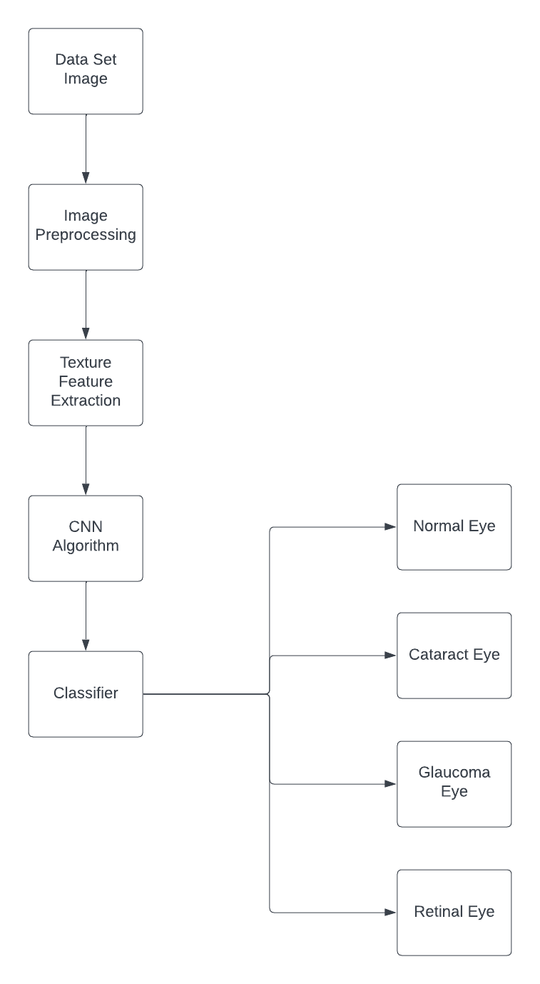

Fig.1 Block diagram

- METHODOLOGY
Preprocessing:
Phase 1:
One thousand photographs that have been carefully cropped and reduced to 64 by 64 pixels make up the original dataset. To extract texture features, the photos are transformed to grayscale.
Phase 2:
The dataset consists of 1000 images categorized into four classes: 400 normal, 200 cataract, and 200 glaucoma images, 200 retina eye images. Images are resized to 64x64 pixels. In that, for training, there are 800 images, while for testing, there are 200 images. The region of interest, which is the pupil of the eye, is extracted using HSV colour space and masking. A mask is created in HSV space color based on the pupil colour scale. The Hough circle algorithm is applied to extract the circular area of the pupil. A black colour mask is created, and a circle is drawn around the pupil. Further operations are performed to extract the rectangular contour around the pupil. The region of interest (pupil) is cropped based on the coordinates, width, and height obtained.

Feature Extraction:
The Gray Level Cooccurrence Matrix (GLCM) is one tool for extracting texture features. Using the GLCM, statistics such as contrast, correlation, energy, and homogeneity are computed. These data reveal the texture of the image. The size-invariant feature transform (SIFT) is a technique for extracting features that remain constant in terms of size and rotation. There are four steps in the SIFT algorithm:
1. Scale-space extrema detection is known as finding stable pivotal points in the scale space.
2.Localization of key points: eliminating weakly contrasted or inadequately positioned focal points.
3. Assignment of orientation Provide key points for a consistent orientation based on local characteristics.
4. Key point Descriptor: Descriptors are generated with the use of local gradient data. A new feature vector is created by combining the features obtained from these procedures.
Gray Scale Image: The process of converting fundus images from colour to grayscale is a crucial preprocessing step in ophthalmic image analysis. the weighted sum method, where each RGB channel is assigned a weight (e.g., 0.299, 0.587, 0.114) to calculate the grayscale intensity. Fundus images are typically captured in colour, often containing three channels representing the red, green, and blue (RGB) each pixel component. The conversion from colour to grayscale involves assigning a single intensity value to each pixel based on the original colour information. The most common method is to calculate the luminance or brightness of each pixel using a The RGB values weighted sum.
Y = 0.299 * R + 0.587 * G + 0.114 * B
Here, Y represents the grayscale intensity, and
R, G and B are the colour values of the pixel
The dataset is further divided into training and testing sets, with 80% allocated for training and 20% for testing, probably for purposes of machine learning or additional analysis. Classification algorithms are used for detection and classification tasks.
- Logistic Regression:
To determine the probability of an event happening, logistic regression, a binary classification technique, is employed. It applies a logistic function to transfer the result to a range of 0 to 1.
b. Random Forest: This ensemble learning technique can be applied to regression as well as classification. It builds several decision trees and uses a majority vote to combine their forecasts.
c. Convolutional Neural Networks (CNN): In neural networks, CNN is used for image recognition and classification. Object identification, face recognition, scene labelling, and other applications are among the fields in which convolutional neural networks find extensive application. It was initially developed for binary classification problems and focuses on correcting the mistakes of weak classifiers.

V. Results

The images are converted into grayscale and binary. The model achieves remarkable accuracy rates of 95.93% for cataract detection, 93.7% for glaucoma detection, and 92.43% for classifying retinal diseases.

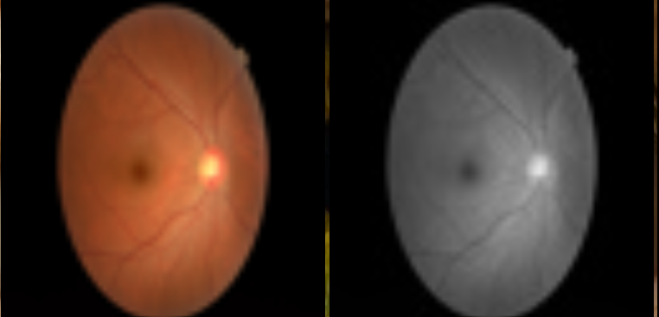

Fig. 2 Gray Scale Image

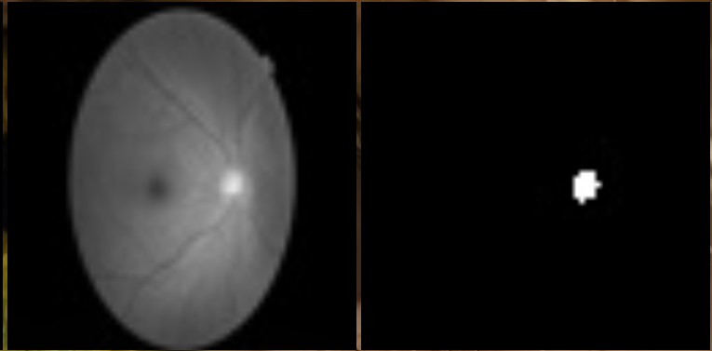

Fig.3 Binary Image

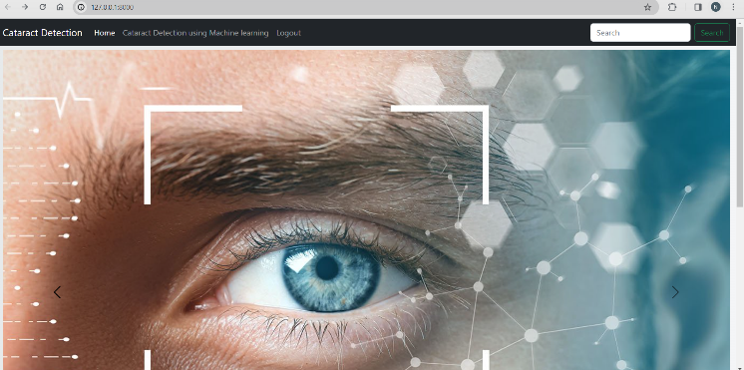
Fig.4 Home Page

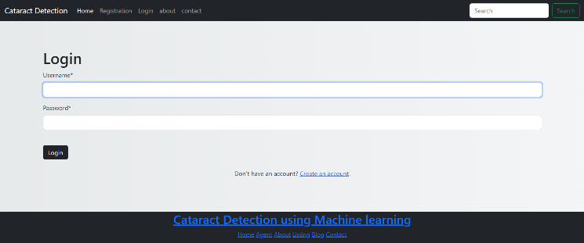
Fig. 5 Login Page
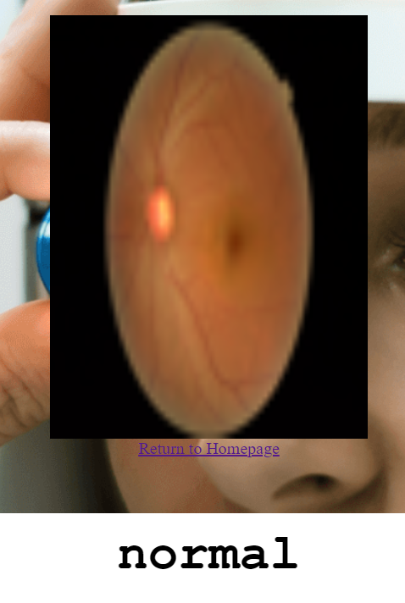
Fig.6 Normal Eye Image

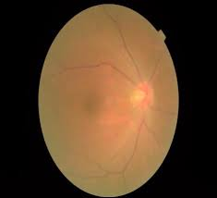

Fig. 7 Cataract Image

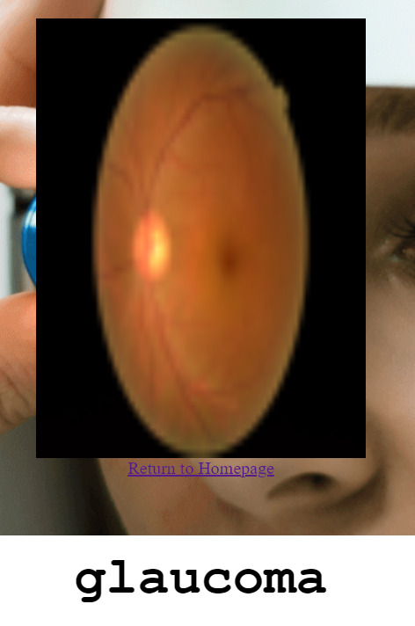
Fig. 7 Glaucoma Eye

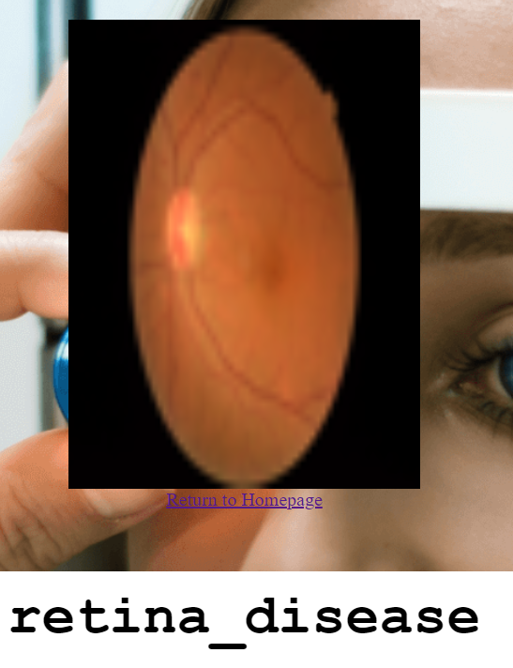
Fig.8 Retinal Eye

VI. CONCLUSION

In conclusion, the Cataract Detection System using Machine Learning represents a significant advancement in ophthalmic diagnostics, offering early and accurate identification of cataracts. The system’s efficiency, non-invasiveness, and accessibility make it a valuable tool for healthcare professionals, particularly in streamlining screening programs and optimizing resources. While the system holds promise for improving global health outcomes related to cataract-related visual impairment, challenges such as interpretability and ethical considerations must be addressed. Continued research, refinement of algorithms, and collaboration between the medical and technological communities are essential for maximizing the system’s impact and ensuring its responsible integration into clinical practice. For the detection of cataracts, we got accuracy during training as 92.93% and the accuracy on the test set was 91.54%. The Cataract Detection System with Machine Learning is a shining example of innovation, demonstrating how artificial intelligence may improve patient care in the ophthalmology sector.

V. REFERENCES

[1] M. S. Junayed M. B. Islam, A. Sadeghzadeh and S. Rahman, "Cataract Net”: An Automated Cataract Detection System Using Deep Learning for Fundus Images," in IEEE Access, vol. 9, pp. 128799-128808, 2021.

[2] Leonardo Michael Marcello, Endra Oey, Zener Sukra Lie, Winda Astuti,” Automatic Cataract Detection System based on Support Vector Machine (SVM),”in IEEE Access,2021.

[3] S. Hu et al., "Unified Diagnosis Framework for Automated Nuclear Cataract Grading Based on Smartphone Slit-Lamp Images," in IEEE Access, vol. 8, pp. 174169-174178, 2020.

[4] Touma, S., Antaki, F. & Duval, R. Development of a code-free machine learning model for the classification of cataract surgery phases. Sci Rep 12, 2398 (2022).

[5] A. Imran, J. Li, Y. Pei, J. -J. Yang and Q. Wang, "Comparative Analysis of Vessel Segmentation Techniques in Retinal Images," in IEEE Access, vol. 7, pp. 114862-114887, 2019.

[6] Wang J, Xu Z, Zheng W, Ying H, Chen T, Liu Z, Chen DZ, Yao K, Wu J. A Transformer-based Knowledge Distillation Network for Cortical Cataract Grading. IEEE Trans Med Imaging. 2023 Oct 24;PP.

[7] I. Jindal, P. Gupta and A. Goyal, "Cataract Detection using Digital Image Processing," 2019 Global Conference for Advancement in Technology (GCAT), Bangalore, India, 2019, pp. 1-4.

[8] S. Ramesh et al., "Weakly Supervised Temporal Convolutional Networks for Fine-Grained Surgical Activity Recognition," in IEEE Transactions on Medical Imaging, vol. 42, no. 9, pp. 2592-2602, Sept. 2023.

[9] R. Munarto, M. Ali Setyo Yudono and E. Permata, "Automatic Cataract Classification System Using Neural Network Algorithm Backpropagation," 2020 2nd International Conference on Industrial Electrical and Electronics (ICIEE), Lombok, Indonesia, 2020, pp. 101-106.

[10] Zhang, XQ., Hu, Y., Xiao, ZJ. et al. Machine Learning for Cataract Classification/Grading on Ophthalmic Imaging Modalities: A Survey. Mach. Intell. Res. 19, 184–208 (2022).

[11] O. J. Afolabi, G. P. Mabuza-Hocquet, F. V. Nelwamondo and B. S. Paul, "The Use of U-Net Lite and Extreme Gradient Boost (XGB) for Glaucoma Detection," in IEEE Access, vol. 9, pp. 47411-47424, 2021.

