Low Cost Ventilator using NodeMCU with Blood-Oxygen sensing
Kruthik Chand D C | Akash J
Department of Electronics and Communication Engineering | Department of Electronics and Communication Engineering
Global Academy of Technology, Bengaluru | Global Academy of Technology, Bengaluru
Karnataka, India | Karnataka, India
dcchandu8@gmail.com | akashjayaram2811@gmail.com

Aswin Jayadasan | Chandan P
Department of Electronics and Communication Engineering | Department of Electronics and Communication Engineering
Global Academy of Technology, Bengaluru | Global Academy of Technology, Bengaluru
Karnataka, India | Karnataka, India
haemoglobin14@gmail.com | chandan041.p@gmail.com

Abstract- This paper portrays outline of different examination done. The human lungs are utilized for breaths. They use push system in every breath motivation and exhalation process happens. The DIY ventilator here we configuration is to help individuals during Covid pandemic. It is exceptionally modest and reasonable. At the point when patients experience the ill effects of lung or breathing issue this can be utilized in a patient basic condition. Stepper Motor component is utilized to push the ambu sack. While breathing heartbeat level identified are low this component can be performed. The LED screen is utilized to show the breathing heartbeat levels. Likewise, in a patient basic condition or breathing issue ringer is fitted in the framework to sound a ready when any irregularities are identified. Aside from this the ventilator should have the option to screen the patient's blood oxygen level and breathed out lung strain to keep away from over/under air tension at the same time. The ventilator we here plan and foster utilizing NodeMCU envelops this large number of necessities to create a dependable yet cheap DIY ventilator to help in the midst of pandemic.

Keywords: NodeMCU, ventilator, bag valve mask , pneumatic, COVID-19

I. Introduction
Human lungs utilize the opposite pressure produced by the compression movement of the stomach to suck in air for relaxing. An incongruous movement is utilized by a ventilator to swell the lungs by siphoning type movement. A ventilator component should have the option to convey inside the scope of 10 30 breaths each moment, with the adaptability to manage rising augmentations in sets of two. along with this, the ventilator should have the ability to manage the air volume drove into the lungs with every breath. Last however presently least is that the setting to control the time length for inward breath to exhalation proportion. Aside from this the ventilator should have the option to screen the patient's blood oxygen level and breathed out lung strain to keep away from over/under gas tension at the same time. The ventilator we here plan and foster utilizing NodeMCU envelops of these prerequisites to create a solid yet reasonable DIY ventilator to aid seasons of pandemic. We here utilize a silicon ventilator pack coupled driven by DC engines with 2 side push system to push the ventilator sack. We utilize an electric switch for exchanging and a variable pot to direct the breath length and thusly the BPM an incentive for the patient. Our framework utilizes a blood oxygen sensor along with a delicate tension sensor to watch the compulsory vitals of the patient and show them on a little screen. Likewise, a crisis ringer alert is fitted inside the framework to sound a ready when an abnormality is identified. The whole framework is driven by an NodeMCU regulator to acknowledge wanted results and to help patients inside the COVID pandemic and other crisis circumstances. In the midst of the world emergency brought about by the Covid pandemic, medical clinics and medical services offices are revealing deficiencies of significant gear. As creators, it's our obligation to battle the deficiency by building improvised open-source substitute gadgets. Our nation likely could be in an extremely lockdown yet our creativity is not! One significant gadget that request has inclined up is ventilators for patients who need help with their breathing thanks to the respiratory impacts of COVID-
19. Fundamentally, a ventilator could be a machine that gives breathable air into and out of the lungs, to convey breaths to a truly incapable patient to inhale, or breathing deficiently. A DIY ventilator probably won't be proficient as that of a clinical grade ventilator yet it can go about as a fair substitute on the off chance that it's command over the ensuing key boundaries.

II. METHODOLOGY

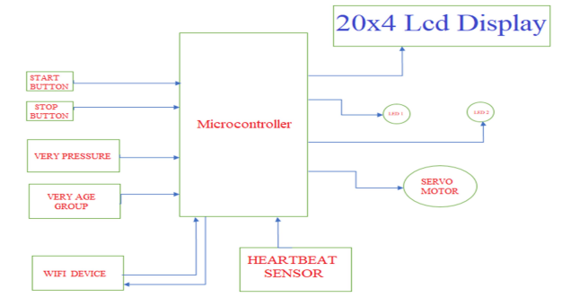
FIG 2 1.1
Descriptions:

- Power supply: Provides regulated voltage, usually 5V, to power the relay driver (if required), and Arduino.
The microcontroller that runs the complete system is called NodeMCU..

- Digital I/O Pins: To exchange data and control relays, connect the Arduino’s digital pins to the RFID reader and relay driver.

- Relay Driver (Optional): A relay driver is used to enhance the Arduino's signal if the relay requires more power to handle the connected device (such as a door lock).

- Relay: An Arduino-based switch that uses the device's output to operate the linked device (such as an alarm or door)

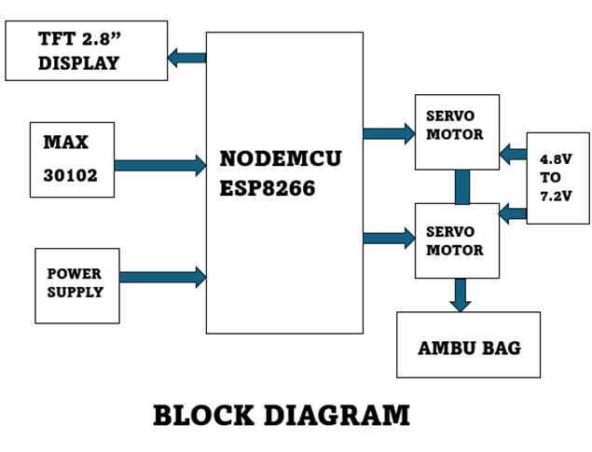

Fig 2.1.2

SYSTEM OVERVIEW
The projected system consists of observe the breathing of the tolerant. The ceremony setup consists of a ventilator, bpm, switches, and toggles. This project was to develop a low-cost ventilator oppression one or two possible and easily obtain part in an extremely very prompt technique. The hardware strategies enclosed the developed trial of a model ventilator.
Tidal volume: it is the volume of air delivered to the lungs with each breath by the ventilator - typically 500ml at rest.

BPM (Breaths per minute): this is often the set rate for delivering breaths. Range is 10 – 30.

Inspiratory: Expiratory ratio (IE Ratio): refers to the ratio of inspiratory time: and expiratory time.

Flow rate: is that the most flow at which a set tidal volume of breath is deliver by the ventilator

Peep (Positive end-expiratory pressure): it's the pressure within the lungs above gas pressure that exists at the top of expiration.

2.3 DESIGN AND IMPLEMENTATION
The diagram of a ventilator using NodeMCU with blood oxygen sensing is shown within the above Fig. Rapid prototyping technologies were accustomed create a medical ventilator. The unnatural physical respire element is joined to the wall oxygen source employing a flow meter as an air reservoir.

3.3.1 Components Required:

NodeMCU: Acts as microcontroller for the whole setup. Here we use Esp:8266.

MAX30102 Sensor: Heart rate and blood oxygen sensors to give the required readings of body stats.

TFT 2.8” display: To display the output of the sensors to the user.

Servo Motors: To pump the ambu bag to supply oxygen.

Wiring and Connectors: To connect the components.

Power Supply: Ensure you have a stable power supply for your microcontroller and MAX sensors

TESTING:

Verify that the MAX30102 sensor:

Recognizes pulses correctly and that the microcontroller generates the right signals by testing the heartrate system.
Examine the Module for Relays:
Check that the microcontroller's reading of the Max30102 sensor causes the relay to activate and deactivate.
Test with breathing:

Assess the values of the sensor and speed of pump with different subjects and breathing pattern so as to verify the ambiguity.

HARDWARE SETUP:
- Servo Motor: Used to pump the ambu bag.
- Ambu Bag: A respiratory device used to aid breathing.
- Oxygen Supply: External oxygen supply to enchance the effect of aid.
- TFT Display: To monitor the body stats from sensors.
- Power Supply: External adapter or battery(12V)

To connect an embedded system to a microcontroller, use serial communication or GPIO pins. Microcontroller to Relay Module: Join a digital output pin on the microcontroller with the relay control pin. Attach the relay module to the bike's electrical system by plugging it into the circuit that regulates the starter solenoid.

SOFTWARE SETUP:
- Install Arduino IDE
- Load the setup code
- Run the microcontroller

On running the Arduino takes a glance at the code, the motor executes cycles of dextrorotatory or anticlockwise rotations so you'll make sure that the mechanism is running swimmingly.

TESTING AND DEPLOYMENT:
Bench Testing: Confirm that the readings from the heartrate sensor is accurate in terms of medical reference and apply the same to the speed of the servo motor while pumping the bag with air..
Integrity testing: Join the relay to the adapter’s electrical system.
Verify that the servo motor runs properly with supply.
Final Modifications: Provide components with vibration-resistant and waterproof housings.
To avoid damage from vibration or movement, secure the wiring.

III. RESULT
The Project was initiated in response to the ventilator shortage during the COVID-19 pandemic. The project aimed to design and distribute low-cost, open-source ventilators to hospitals in low-income regions severely affected by the crisis. The ventilator featured a modular design, allowing for easy assembly and repair. Key components included a repurposed manual resuscitator bag (Ambu bag), stepper motors, pressure sensors, and a microcontroller.
Improved Observance of Safety:
- Addressing Shortages: During pandemics or in regions with limited healthcare resources, DIY ventilators can fill the gap when there are not enough commercial ventilators available.
- Emergency Situations: In disaster scenarios where medical supplies are scarce, DIY ventilators can provide immediate respiratory support.
- Affordable Care: DIY ventilators are generally less expensive to build and maintain compared to commercial models, making them accessible for low-income regions and reducing the financial burden on healthcare systems.
- Reduced Equipment Costs: This cost reduction can free up resources for other critical medical supplies and treatments.

.

IV. FUTURE RECOMMENDATION
We can involve this venture in season of crisis as a first help device. For instance: If an individual gets a respiratory issue. He really wants to taken to clinic quickly while going in rescue vehicle or in the mishap area he wanted of ventilator to breath so around then our venture is little, helpful and to work which can save a daily existence. Since the cost of our project is reasonable it is simple purchase by a destitute group to rich individuals. In later we can foster the venture by adding GSM module to remain associated
with specialists during going in emergency vehicle, we can add BP sensor rather than pressure sensor for more exactness, we can add camera to live correspondence with specialists for better fid help treatment while voyaging. These ventilators can be adapted for various environments, including makeshift hospitals or home care settings, ensuring continuous patient support. Local production of DIY ventilators empowers communities to take control of their healthcare needs, fostering self-reliance.

V. CONCLUSION
This work is a reasonable strategy potential for crisis and Covid pandemic. It is an open source ventilator configuration created utilizing disseminated fabricating. This paper is an itemized clarification of delivering minimal expense, open source mechanical ventilators for patients. This is at the beginning phases of plan required further turns. Sure this work will acquire more noteworthy consideration. There is a great deal of future work to be moved up to make it clinical grade equipment. It is a major hotspot for both the ongoing pandemic circumstance and crisis purposes and in any event, for regular use in low asset settings. Thus this project was aimed towards focusing on the regions where people cannot afford quality ventilators in time of their needs. By ensuring the market readiness of this project, it is highly possible to target rural areas and help people who are in need of immediate medical attention.

VI. REFERENCES

- Alamurugan, C. R., Kasthuri, A., Malathi, E., Dharanidharan, S., Hariharan, D., Kishore, B. V., & Venkadesh, T. (2021). Design of Ventilator Using NodeMCU for Covid Pandemic. Annals of the Romanian Society for Cell Biology, 14530-14533.
- Acho, L., Vargas, A. N., & Pujol-Vázquez, G. (2020, September). Low-Cost, Open-Source Mechanical Ventilator with Pulmonary Monitoring for COVID-19 Patients. In Actuators (Vol. 9, No. 3, p. 84). Multidisciplinary Digital Publishing Institute.
- Petsiuk, A., Tanikella, N. G., Dertinger, S., Pringle, A., Oberloier, S., & Pearce, J. M. (2020). Partially RepRapable automated open source bag valve mask- based ventilator. HardwareX, 8, e00131.
- Couchman, B. A., et al. (2006). Nurses role in prevention and management of mechanical ventilation related complications.
- World Health Organization: Critical preparedness, readiness and response actions for COVID-19: interim guidance, 7 March 2020.(No. WHO/COVID- 19/Community_Actions/2020.1).

