DETECTION OF COTTON PLANT DISEASE USING DEEP LEARNING
Dr Shilpa mangshetty¹, Sapna pawar², Shazia fatima³ , Sneha gobbur⁴
^{,#1}Department of Computer Science, Vishveshwarayya Technological University PDA Kalaburagi, Karnataka, India Email:sapnapawar118@gmail.com
^{*2}Department of Computer Science, Vishveshwarayya Technological UniversityPDA Kalaburagi, Karnataka, India Email:shaziaf891@gmail.com
^{#3}Department of Computer Science, Vishveshwarayya Technological University PDA Kalaburagi, Karnataka, India Email:sneha02gobbur@gmail.com

Abstract—Cotton is one the majorly grown crop in India it is also called as cash crop because of the economic benefits it provides to farmers and even contribute in country's GDP. But it constantly faces threat from various pest, insects, bacteria etc which causes various diseases in plant leading production loss for farmers. Few of the commonly occurring diseases which the model detects here is Aphids, Armyworm, Bacteria blight, Powdery Mildew etc. Since it's difficult to identify diseases with naked for farmers and even constant monitoring of diseases by bare eye is tedious job. Thus, the project aims to identify the diseases using deep learning CNN, a web-based application is designed to classify the diseases based on effected area and using deep cnn it passes through various layers to successfully detect the diseases even provide remedies accordingly in different languages. Model is being trained using various algorithms, dataset is obtained from kaggle website alongwith imageNet and few data from regular monitoring of cotton plant. Additionally, providing the accuracy of around 92.3%.

Keywords— Aphids, Armyworm Bacteria blight Powdery mildew, deep learning, web-based applications, remedies.
- INTRODUCTION
Cotton is one of the most important fiber and cash crop of India and plays a dominant role in the industrial and agricultural economy of the country. It provides the basic raw material (cotton fibre) to the cotton textile industry. Cotton in India provides direct livelihood to 6 million farmers and about 40- 50 million people (about twice the population of Texas) are employed in cotton trade and its processing. These plants often face disease threat leading to quality and quantity losses eventually production will be greatly affected provides less economic benefits.

Using Deep CNN model, a web-based application is designed which identifies the most commonly occurring diseases in cotton plants like Aphids, Armyworm, Bacteria blight, Powdery mildew and
Healthy leaf. Though it's quite a tedious job to monitor a large field. To tackle the challenge a robust deep cnn model is designed which detects the diseases early and provides timely Solutions with images of products in various regional languages.
What is Deep Learning?
Deep learning is the branch of machine learning which is based on artificial neural network architecture. An artificial neural network or ANN uses layers of interconnected nodes called neurons that work together to process and learn from the input data.
In a fully connected Deep neural network, there is an input layer and one or more hidden layers connected one after the other. Each neuron receives input from the previous layer neurons or the input layer. The output of one neuron becomes the input to other neurons in the next layer of the network, and this process continues until the final layer produces the output of the network.
In this work, deep learning algorithms were used to construct Cotton leaf disease detection technique. There is a wide area of farm suitable for cotton plantation, but only limited research attention is given to cotton crop production. Traditionally, experts detect and identify such plant diseases and pests on bared eyes. Bared eye determination is considered as a loss of low-level accuracy to detect any diseases.
- RELATED WORK

Al-bayati and Üstündağ (2020) proposed an evolutionary feature optimization technique for detecting plant leaf diseases using deep neural networks.[1]As their approach aimed to enhance the performance of disease detection models by optimizing the features extracted from leaf images, improving the overall accuracy of disease classification systems. Shah and Jain (2019) focused on detecting diseases in cotton leaves using an Artificial Neural Network (ANN)[2].It showed the study of utilized ANN models to analyze and classify images of cotton leaves based on disease symptoms, enabling accurate and efficient disease identification in cotton plants. Jenifa et al. (2019) employed a Multi-support Vector Machine (SVM) for classifying cotton leaf diseases.[3] Their mainly focused on enhancing disease classification accuracy by utilizing SVM, a machine learning algorithm known for its effectiveness in handling complex classification tasks. Ma et al. (2018) developed a method for recognizing cucumber diseases using deep convolutional neural networks (CNNs) based on leaf symptom images.[4] The main purpose of their study was to demonstrated the potential of CNNs in accurately identifying and classifying diseases in cucumber plants, showcasing the effectiveness of deep learning techniques in agricultural disease detection. The (2017 )International Conference on Innovations in Information, Embedded and Communication Systems featured a study on detecting leaf diseases and classifying them using digital image processing. [5]This research likely explored various image processing techniques for preprocessing leaf images and extracting relevant features for disease classification. Mehra, Kumar, and Gupta (2016) worked on detecting maturity and diseases in tomatoes using computer vision. [6] The main objective of this is likely involved developing computer vision algorithms to analyze tomato images and distinguish between healthy and diseased tomatoes, contributing to the field of automated agricultural disease detection. Tejonidhi et al. (2016) presented a plant disease analysis technique using histogram matching based on Bhattacharya's distance calculation.[7] This method likely focused on comparing the color histograms of diseased and healthy plant images to quantify the similarity and detect the presence of diseases, offering a novel approach to plant disease analysis.

III .PROPOSED SYSTEM

In the proposed system, we use kaggle and a real- time dataset containing images of various cotton diseases. These images are used for training and testing. The are passed through various cnn deep layer to accurately detect using image processing technique. The model works on this further two classified caterogies.
1.Image Processing 2.Training model 1.Image Processing:
- Image Pre-Processing: Here, we require images with better resolution and with better quality so for that median filter a non-linear digital filtering technique, is used to remove the noise from image to get improved result for further preprocessing. All the images are resized in a specific manner and resolution.Non-local means(nlm) algorithm it is a patch based method for denoising.
- Segmentation: In segmentation image is divided into foreground and background using threshold a built-in function. Later morphology is used to take the image into different areas like brightness and contrast. Thus removes the complex image data into various required segments.
- Feature extraction: In the feature extraction process, we find some important features of the defected leaf. It extracts structured data from unstructured data .Canny edge algorithm is used to get the smooth thin edges of a image. These features are used to train our neural network. Which will train model on vgg16 by entering into 16 different later improving accuracy and loss.
4. Image Classification: Classification helps to analyze the measurements to identify the classes to which that image belongs. To classify diseases vgg16 is used.

2. The training model takes the leaf image as input and that image goes under four stages:

- Convolution layer:

- RELU Layer:

- Pooling Layer:

- Fully Connected Layer:

LOAD IMAGE

IMAGE PREPROCESSING

SEGMENTATION

FEATURE EXTRACTION

CLASSIFICATION

DETECTION

Figure 1:workflow of the proposed system

- METHODOLOGY

To predict the disease, the user has to upload a cotton leaf image. After the user has uploaded an image, Image Processing begins with a digitized colour image of the plant leaf. The Image Data Generator will read pictures and the images are resized with a target size of 150 × 150, which are chosen to be small and close to a fraction of the average image size. Finally, plant disease can be anticipated by using CNN. On different scales and resolutions of images, the system can anticipate diseases. The output result is unaffected by size, direction, or light intensity. On the other hand, in high-resolution image detection accuracy of the image detection will be high. A total of 520 images make up the training dataset, while 217 images make up the testing dataset. The system’s overall accuracy is found to be 89%.The detection involves an image of the leaf along with the disease name in different languages.
Diseases chosen for detection Diseases that are chosen for detection in this project are listed as follows:
  - Aphids
  - Armyworm
  - Bacterialblight
  - PowderyMildew
Step 1: Data Collection and Samples:
Few of the images were collected from day-to-day survey and data has been used from kaggle.Data is Divided into Train-Validation-Test, Model training
perform on Training set and check the performance on validation set, will check model performance on test set once we finalize the model based on validation performance.
Step 2: Preprocessing:
In preprocessing Original image is converted to gray scale as shown in the figure.
-for better visualization
-for better performance
-reduces complexity

Random bright pixels and random dark pixels are added to an image to add salt and pepper noise. Because it statistically reduces the original data values. The Median filter is the one type of nonlinear filters. It is very effective at removing impulse noise, the “salt and pepper” noise, in the image.
Non-local means filtering takes a mean of all pixels in the image, weighted by how similar these pixels are to the target pixel. This results in much greater post-filtering clarity, and less loss of detail in the image compared with local mean algorithms. It compares the patch or pixel size of neighbouring matrix.
Luminance size h is set to 10
NL(v)(i)=Σ w(i,j)v(j)
j€i
Groups the similar pixels and smoothens the image by removing noise.
Step 3: Segmentation:
Here the image is partitioned into multiple segments or regions to simplify its representation and make it easier to analyze. The goal is to group pixels into meaningful areas that share similar characteristics, such as color, intensity, texture, motion and edges.
Segmentation algorithm used here is thresholding, where pixels in the image are classified as belonging to either the foreground or background based on their intensity values compared to a threshold. The method works well for images with distinct foreground and background regions.
Threshold selection:
A threshold value is selected first. Value(t)=0.95 Pixel classification: Each pixel in image is compared with the threshold value leading to separation of foreground and background.

Binary image creation: Where foreground pixels are representated by black color and background pixels are representated by white color. This binary image effectively segments the objects of interest from the background based on their intensity levels.
Step 4: Feature extraction:
Features are distinctive characteristics of an image that help in identifying objects or patterns. These features are typically derived from groups of pixels and can include edges, corners, textures, and other visual elements. Feature recognition is the process of identifying and extracting these relevant features from an input image so that they can be analyzed by a convolutional neural network (CNN).

The Canny edge detection algorithm is a popular technique used to detect a wide range of edges in images.
The parameters of the Canny edge detection algorithm include the Gaussian kernel size (determines the extent of blurring), the high and low threshold values (determine the edge strength), and the size of the Sobel operator kernel (determines the scale of the gradient calculation). Adjusting these parameters can affect the performance and sensitivity of the edge detection process.

- Grayscale conversion
The first step in the Canny edge detection algorithm is to convert the input image into grayscale
- Noise reduction The first step in the Canny edge detection algorithm is to apply a Gaussian filter to the input image. The Gaussian filter is a smoothing operation that helps to reduce noise in the image. Mathematically, the Gaussian kernel is defined as:

G(x,y)=1/2πσ2 *exp(− x2 +y2 /2σ2)

Where:
x and y are the spatial coordinates of the kernel.
π is the mathematical constant Pi (approximately 3.14159).
σ is the standard deviation, controlling the width of the Gaussian distribution
- Gradient calculation
After reducing noise, the Canny algorithm proceeds to compute the gradient of the smoothed image. The gradient measures how fast the intensity changes at each pixel’s location.
The Sobel operator is a technique used to find the gradient, or the rate of change, in both the horizontal (from left to right) and vertical (from top to bottom) directions of an image. It’s commonly used for edge detection in image processing. The formulas for the Sobel operators are as follows:

- Non-maximum suppression
Now that we have computed the gradient magnitude and orientation at each pixel, we move on to the critical step of Non-Maximum Suppression. This step effectively thins out the edges and produces a cleaner representation of the actual edges in the image.
- Double thresholding
The next step involves double thresholding to categorize edges into three categories: strong edges, weak edges, and non-edges.
- Edge tracking by hysteresis
The last step of the Canny edge detection algorithm is edge tracking by hysteresis. Hysteresis means 'remembering the past' to make our edges more accurate and reliable. This step aims to link weak edges that are likely part of real edges to the strong edges.

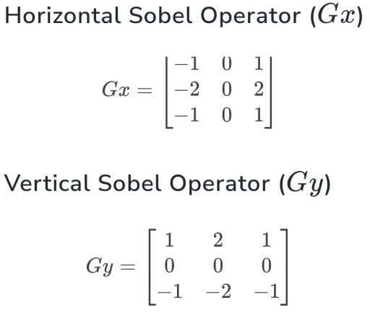
|G|=sqrt(Gx2+Gy2 Theta=arctanh|Gx/Gy|

Step 5: Classification:
In Classification goal is to categorize input data into predefined classes or categories. It's a type of supervised learning, meaning the algorithm learns from labeled training data, where each input is associated with a correct output label. The algorithm then generalizes this knowledge to make predictions on new, unseen data.
Split the Data: Split the dataset into training and testing sets to evaluate the model's performance.
VGG16 is a deep convolutional neural network (CNN) architecture that is widely used for image classification tasks. It was proposed by the Visual Geometry Group (VGG) at the University of Oxford. The "16" in VGG16 refers to the 16 weight layers in the network, which include 13 convolutional layers and 3 fully connected layers.

Here's a brief explanation of how the VGG16 model works for image classification:
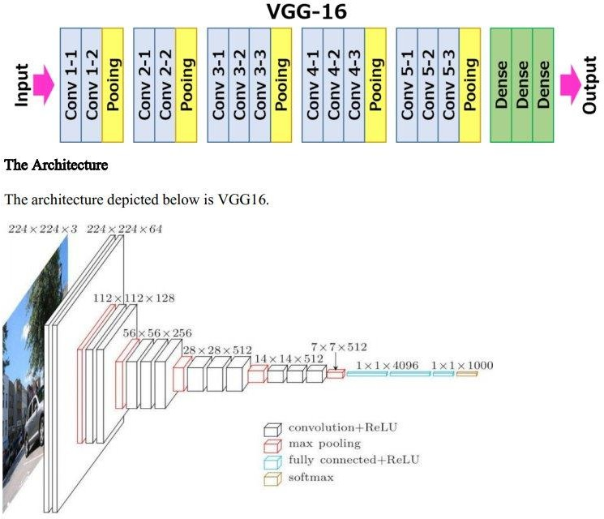

Input: The network takes an input image of size 224x224 pixels with three color channels (RGB). [Type a quote from the document or the summary of an interesting point. You can position the text box anywhere in the document. Use the Text Box Tools tab to change the formatting of the pull quote text box.]

- Convolutional Layers:The convolutional layers in VGG16 perform feature extraction. These layers consist of 3x3 convolutional filters that slide over the input image to extract various features, such as edges, shapes, and textures. There are a total of 13 convolutional layers, each followed by a ReLU activation function and a 2x2 max pooling layer. And resizes the image.
- Fully Connected Layers: After the convolutional layers, the extracted features are flattened into a vector and passed through three fully connected layers(1x1x4096). These layers act as a classifier, combining the extracted features to make a final prediction.
- Output: The output of the last fully connected layer is a vector of size N, where N is the number of classes in the classification task. Each element in the vector represents the probability of the input image belonging to a particular class. The class with the highest probability is considered the predicted class outputs a probability distribution over the different classes using a softmax activation function(1x1x1000).

In test case
The model was trained for 3 epochs. The training accuracy for the 1st epoch was 48.15%, and the validation accuracy for the 1st epoch was 76.24%. However, after 3 epochs, the training accuracy improved to 89.15%, and the validation accuracy reached 89.24%, indicating that the model performed moderately and achieved an accuracy of 82-90%. After increasing the epochs to 10 accuracy also improved giving and accurate result of aroung 92%.

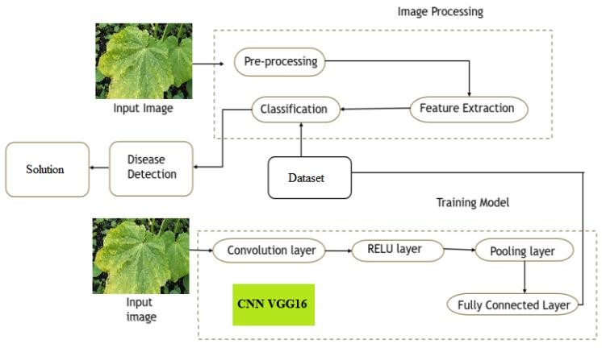
Figure 2: System Architecture

First a image is taken from dataset uploaded into the website. The selected image is preprocessed to remove any irregularity or noise present in it possible required features are extracted using canny edge algorithm. Now during classification it enters

the various layers of cnn . More precisely vgg16 passing through 13 convolutional layers and 3 fully connected layer finally going through softmax layer to provide the probabilities of occurances of a disease and successfully the disease is detected.
- RESULTS AND DISCUSSIONS

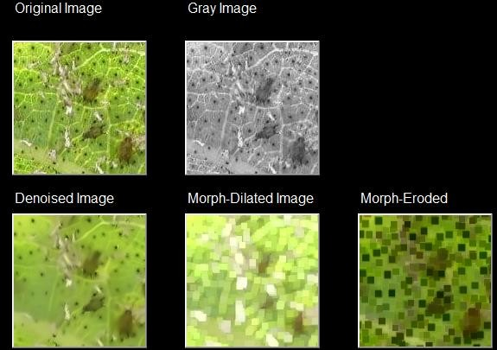
Figure 3: Image Pre-Processing
In this phase, we require images with better resolution and with better quality. All the images are resized in a specific manner and resolution. Image pre-processing removes noise content and the images using data augmentation. Morphology is a broad set of image processing operations that process images based on shapes. Morphological operations apply a structuring element to an inpuimage, creating an output image of the same size
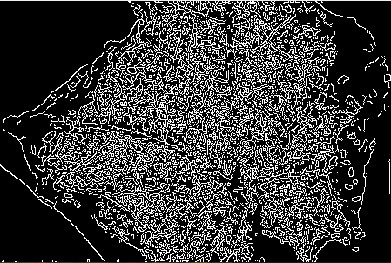
Figure 4: Feature extraction
In the feature extraction process, we find some important features of the defected leaf. It extracts structured data from unstructured data. These features are used to train our neural network.

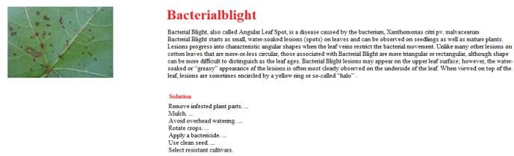
Figure 5: Image Classification: Classification helps to analyze the measurements to identify the classes to which that image belongs.and gives the solution
VI. CONCLUSION
A system has been successfully implemented for crop disease detection for cotton leaves using a Convolutional Neural Network. The Convolutional neural network has been developed with three hidden layers to classify the cotton leaf disease images. The System successfully processes input from the user and provides output in the form of disease detected. Provided sufficient data is available for training, deep learning techniques are capable of recognizing plant leaf diseases with high accuracy. The importance of acquiring large datasets with high variability, data augmentation, transfer learning, and visualization of CNN activation maps in improving classification accuracy.
Future scope
This system can be extended to any other crop having the availability of enough large datasets for that crop. A number of other diseases can be included for detection. The System also can implement hardware using IoT for Image capturing in fields. The Web interface can also involve a forum for formers to have discussions regarding the current trends they are facing in different diseases.

References
- Al-bayati, J. S. H., & Üstündağ, B. B. (2020) “Evolutionary Feature Optimization for Plant Leaf Disease Detection by Deep Neural Networks”, International Journal of Computational Intelligence Systems. Computational Intelligence Systems.
- Nikhil Shah, Sarika Jain, “Detection of disease in Cotton leaf using Artificial Neural Network”, 2019 IEEE
- A. Jenifa, R. Ramalakshmi, V. Ramachandran, “Classification of cotton leaf Disease using Multi-support Vector Machine”, 2019 IEEE.
- J. Ma, K. Du, F. Zheng, L. Zhang, Z. Gong, and Z. Sun, ‘‘A recognition method for cucumber diseases using leaf symptom images based on deep convolution neural network,”

Computer Electron. Agriculture. Vol 154, pp. 18-24, Nov.2018.
- Detection of leaf diseases and classification using digital image processing2017 International Conference on Innovations in Information, Embedded and Communication Systems.
- Tanvi Mehra, Vinay Kumar, Pragya Gupta "Maturity and disease detection in tomato using computer vision" 2016 Fourth international conference on parallel, distributed and grid computing (PDGC).
- Tejonidhi M.R, Nanjesh B.R, Jagadeesh Gujanuru Math, Ashwin GeetD'sa "Plant Disease Analysis Using Histogram Matching Based on Bhattacharya's Distance Calculation" International Conference on Electrical, Electronics and Optimization Techniques (ICEEOT)-20164 Vector Machine”, 2019 IEEE

