H.K.E SOCIETY’S
POOJYA DODDAPPA APPA COLLEGE OF ENGINEERING

KALABURAGI- 585102
(An Autonomous Institution, Affiliated To VTU Belgaum, and Approved By AICTE)


PROJECT REPORT
ON
“SKIN CANCER DETECTION USING DEEP LEARNING” Submitted To The
POOJYA DODDAPPA APPA COLLEGE OF ENGINEERING, KALABURAGI.
(An Autonomous Institution, affiliated to VTU Belgaum and Approved by AICTE.) In the partial fulfilment of the requirements for the award of the degree of

BACHELOR OF ENGINEERING

IN

COMPUTER SCIENCE & ENGINEERING
SUBMITTED BY
ASHWINI 3PD21CS401
SARASWATI 3PD21CS407
VIDYASHREE 3PD21CS411

UNDER THE GUIDANCE OF

Dr. Pooja A
Associate Professor
DEPARTMENT OF COMPUTER SCIENCE AND ENGINEERING

P.D.A COLLEGE OF ENGINEERING
(AUTONOMOUS INSTITUTION)
2022-2023

H.K.E SOCIETY’S
Poojya Doddappa Appa College of Engineering,
Aiwan-E-Shahi Area, Kalaburagi, Karnataka 585102
(An Autonomous Institution, affiliated to VTU Belgaum, and Approved ByICTE)
Department of Computer Science and Engineering



This is to certify that the seminar entitled “SKIN CANCER DETECTION USING DEEP LEARNING” has been carried out by , Ashwini (3PD21CS401),Saraswati(3PD21CS407), Vidyashree(3PD21CS411)under the guidance in partial fulfillment of the degree of Bachelor of Engineering in Computer Science and Engineering in Visvesvaraya technological university,belagavi,Karnataka during the academic year 2023-24. To the best of my knowledge and belief this work has not been submitted elsewhere for the award of any other degree.

Dr. Pooja A | Dr.Prakash Pattan | Dr.Shreedevi Soma
(Project Guide) | (Project Co-Ordinator) | (HOD Dept. of CSE)

EXAMINERS:
1.
2.
Acknowledgement
The satisfaction that accomplished the successful completion of any work would be incomplete without the mention of people who made it possible and whose constant guidance and encouragement crown all the effort with success. This acknowledgement transcends the reality of formality when I would like to express deep gratitude and respect to all the people who have inspired and helped me for the completion of my project.
My special gratitude to my guide Dr.Pooja A for her inspiration, guidance, constant supervision, direction and discussions in successful completion of the Project Report.
I would like to show case my gratitude to the project coordinator Dr. Prakash Pattan for his valuable guidance, keen increase and encouragement at various stages of my project.
It’s my great pleasure to express my heartiest thank fullness and gratitude to my H.O.D Dr. shreedevi soma who has been the inspiration right from the starting till its completion of the project work successfully.
Also, I would like to express my sincere thanks to DR. S.R.Mise, principal PDACEK, for his valuable support during the development of this project work.
Last but not least I express my deep sense of gratitude to the teaching and non-teaching staff members of the department who have cooperated and supported me in or the way during the completion of the project work.

Abstract
This project focuses on intelligent skin cancer diagnosis based on a balanced dataset of melanoma and non-melanoma skin moles images. Skin cancer is a typical kind of cancer that grows abnormally on skin cells, and studies found that the early detection of skin cancer increases survival by a large margin. The main aim of this research work is to detect skin cancer. If people could detect cancer in the early stage, it can be diagnosed comparatively easy. Skin cancer is most often occurs on skin that is commonly exposed to the sun, But it is also a common form of cancer that can also occur on areas of your skin not ordinarily exposed to sunlight. This project presents a detailed review of skin cancer detection using a convolutional neural network. The results are shown with different images for better understanding.

- Introduction
Deep learning
Deep learning is a branch of machine learning which is based on artificial neural networks. It is capable of learning complex patterns and relationships within data. In deep learning, we don’t need to explicitly program everything. It has become increasingly popular in recent years due to the advances in processing power and the availability of large datasets. Because it is based on artificial neural networks (ANNs) also known as deep neural networks (DNNs). These neural networks are inspired by the structure and function of the human brain’s biological neurons, and they are designed to learn from large amounts of data.
- Deep Learning is a subfield of Machine Learning that involves the use of neural networks to model and solve complex problems. Neural networks are modeled after the structure and function of the human brain and consist of layers of interconnected nodes that process and transform data.
- The key characteristic of Deep Learning is the use of deep neural networks, which have multiple layers of interconnected nodes. These networks can learn complex representations of data by discovering hierarchical patterns and features in the data. Deep Learning algorithms can automatically learn and improve from data without the need for manual feature engineering.
- Deep Learning has achieved significant success in various fields, including image recognition, natural language processing, speech recognition, and recommendation systems. Some of the popular Deep Learning architectures include Convolutional Neural Networks (CNNs), Recurrent Neural Networks (RNNs), and Deep Belief Networks (DBNs).
- Training deep neural networks typically requires a large amount of data and computational resources. However, the availability of cloud computing and the development of specialized hardware, such as Graphics Processing Units (GPUs), has made it easier to train deep neural networks.

What is Deep Learning?
Deep learning is the branch of machine learning which is based on artificial neural network architecture. An artificial neural network or ANN uses layers of interconnected nodes called neurons that work together to process and learn from the input data.In a fully connected Deep neural network, there is an input layer and one or more hidden layers connected one after the other. Each neuron receives input from the previous layer neurons or the input layer. The output of one neuron becomes the input to other neurons in the next layer of the network, and this process continues until the final layer produces the output of the network. The layers of the neural network transform the input data through a series of nonlinear transformations, allowing the network to learn complex representations of the input data. Deep Learning is a subfield of Machine Learning that involves the use of deep neural networks to model and solve complex problems. Deep Learning has achieved significant success in various fields, and its use is expected to continue to grow as more data becomes available, and more powerful computing resources become available.

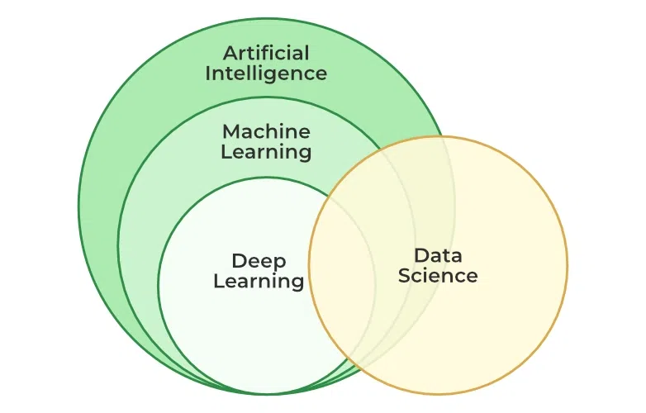

Figure: The techniques of Artificial Intelligence

1.1 Introduction
Early detection of skin cancer is crucial as it is a dangerous form of cancer spreading vigorously among human beings. Skin cancer is one of the most prevalent types of cancer worldwide, with millions of new cases diagnosed each year. It primarily arises due to the uncontrolled growth of abnormal skin cells, often induced by excessive exposure to ultraviolet (UV) radiation from the sun. Each year in the USA alone, approximately 5.4 million new cases of skin cancer are recorded. The mortality rate of this condition is expected to increase in the next decade. The survival rate is less than 14% if diagnosed in later stages. However, if skin cancer is detected at early stages, the survival rate is nearly 97% . This demands the early detection of skin cancer. This research addresses the issue of early diagnosis with improved accuracy. To diagnose skin cancer speedily at the earliest stage and solve some of the problems, there have been extensive research solutions by developing computer image analysis algorithms. The dataset used for this research is taken from the International Skin Image Collaboration (ISIC) archive. It consists of a total thousand pictures. These images include 500 images of non-melanoma moles and 500 images of melanoma moles. The high definition images are modified to low-resolution images to improve the performance, and images have all been resized to low resolution (224x224x3) RGB. The model will be tested with accuracy. In this project, we address developing deep learning-based image classification models to identify skin cancer . To classify the cell images into two types of Cancer. The two types of skin cancers focused here are: 1. melanoma 2. Non-melanoma.

1.Melanoma is a type of skin cancer that originates in the pigment-producing cells called melanocytes. It's crucial to monitor moles for changes in size, shape, or color, and consult a healthcare professional if you notice anything concerning. Regular skin checks and sun protection can help reduce the risk of melanoma.

2.Non-melanoma skin cancers include basal cell carcinoma and squamous cell carcinoma. They are more common than melanoma and typically develop on sun-exposed areas. While less aggressive than melanoma, early detection and treatment are important. Regular skin examinations and sun protection remain essential for prevention. If you have concerns, consult a dermatologist for evaluation.

2.Literature Survey
1.skin diseases detection using image processing method(2022)
Author:- Jagdis etal J.A.D.L. Cruz-Vargas, M.E.R Camacho.
Jagdis etal., J.A.D.L. Cruz-Vargas, M.E.R. Camacho, (2022) author presents skin diseases detection using image processing methods, Nat. Volatiles Essent. OilsJ. In this research advanced study of skin disease detection using image processing methods isconsidered. As we know skin diseases vary accordingly from symptom and severity. They can representpermanent or temporary or painful or painless based on affected disease. Some diseases have a geneticcause or some situational. Some diseases can be found life threatens or some minor based condition. Butas per the survey report, many skin diseases become serious issues. So it is very important to continuouslymonitor and detect skin disease to provide proper treatment and faster recovery protocols. In thisinvestigation, advance study of skin disease detection using fuzzy clustering with machine learningmethods KNN and SVM classification algorithm with wavelet analysis is tested with 50 sample images. Theresults represent the K-Nearest Neighbor classification algorithm works well compared to the Supportvector machine (SVM) classification technique with an accuracy of 80. The algorithm also identifiesthe type of skin disease using classification methods.
2.skin cancer using deep extreme machine.(2022)
Author:- Z.Naeem, G. Zia, Z.Bukhari.
author presents healthcare model to predict skin cancer using deep extreme machine. In the modern world, skin diseases are the leading cause of death in humans. Malignant skin growths most commonly develop on areas of the body that are exposed to sunlight, but they can appear anywhere on the body. In the early stages, most skin tumors are treatable. Early and rapid detection of skin diseases can save a patient's life. Innovation makes it possible to detect skin diseases at an early stage. A biopsy is a formal technique for detecting malignant growths on the skin . After the skin cells are removed, the example is sent to different research centers for testing. The interaction is difficult and time-consuming, and we have developed a framework for spotting skin malignant growths with SVM for the early detection of skin cancers. Patients benefit more from this.Diagnoses are made using image processing strategies and support vector machines (SVMs). Various pre-handling procedures for clamor evacuation and picture improvement are performed on the coloscopy picture of skin disease.A thresholding procedure is then used to divide the picture. The GLCM method should be used to separate a fewhighlights in the image. The classifier uses these elements as inputs. The data is then classified using SVM. Aharmful or harmless image is classified.

3.Machine learning and deep learning integration for skin diseases prediction.(2022)
Author:-S.K Bandyopadhyay, P.Bose, A.Bhaumika, s.poddhar.
In this paper author presents a Machine learning and deep learning integration for skin diseases prediction, Int. J. Eng. Trends Technol. Living creature skin disease is a fairly prevalent ailment. In the medical world, monitoring dermatological disorders and classifying them is a complex process. Due to the sheer intricacy of individual skin tone and the visible proximity effect of infections, recognizing the precise type can be challenging at times. As a result, it is critical to diagnose and recognize skin disease as soon as possible. Artificial intelligence (AI) is quickly expanding in therapeutic areas in a modern context. For diagnostic purposes, much deep learning (DL) and machine learning (ML) methods are applied. These strategies drastically enhance the diagnosing process while also speeding it up. In this study, to improve disease detection, a model combining deep learning (DL) and machine learning (ML) has been developed. For classification, three sets of machine learning models were utilized, and for feature selection, four sets of pre-trained deep learning models were being used. For classification models, deep neural networks Alexnet, Googlenet, Resnet50, and VGG16 were used, while Support Vector Machine, Decision tree, and Ensemble boosting Adaboost classifier were applied for classification. To identify the best prediction model, a comparative study was carried out. The hybrid method Resnet50 with SVM produced the best results, with 99.11% accuracy.
4.Detection and classification of skin diseases within sembles of deep learning networks in medical imageing.(2022)
Author:- A. Kalaivani, S. Karpagavalli
In this paper author presents Detection and classification of skin diseases withensembles of deep learning networks in medical imaging, Int. J. Health Sci. 6(S1).Skin disorders are a serious worldwide public health issue that affects a large number of individuals. In recent years, with the fast advancement of technology and the use of different data mining approaches, treatment of skin predictive classification has really become highly predictive as well as accurate. As a result, the type of machine learning approaches capable of efficiently differentiating skin condition categorization is essential. So far, no one machine learning approach has outperformed the others in terms of skin disease prediction. In this research, we introduce a new method that combines two separate data mining approaches into a single unit, as well as an ensemble approach that combines both data mining techniques into a single group. We explore different data mining strategies to categorize the skin condition using an informative Dermatology publicly accessible dataset ISIC2019 images, and then apply an ensemble deep learning method. Furthermore, the presented ensemble technique, which is based on machine and deep learning, was tested on Dermatology datasets and was able to categorize skin disorders into seven categories.
5. A model for classification and diagnosis of skin disease using machine learning and image processing techniques(2022)
author presents A model for classification and diagnosis of skin disease using machine learning and image processing techniques, Int. J. Adv. Comput. Sci..Skin diseases are a global health problem that is difficult to diagnose sometimes due to the disease’s complexity, and the time-consuming effort. In addition to the fact that skin diseases affect human health, it also affects the psycho-social life if not diagnosed and controlled early. The enhancement of images processing techniques and machine learning leads to an effective and fast diagnosis that help detect the skin disease early. This paper presents a model that takes an image of the skin affected by a disease and diagnose acne, cherry angioma, melanoma, and psoriasis. The proposed model is composed of five steps, i.e., image acquisition, preprocessing, segmentation, feature extraction, and classification. In addition to using the machine learning algorithms for evaluating the model, i.e., Support Vector Machine (SVM), Random Forest (RF), and K-Nearest Neighbor (K-NN) classifiers, and achieved 90.7%, 84.2%, and 67.1%, respectively. Also, the SVM classifier result of the proposed model was compared with other papers, and mostly the proposed model’s result is better. In contrast, one paper achieved an accuracy of 100% .
6. Deep learning approaches for prognosis of automated skin disease(2022)
Author:-P.R. Kshirsagar, H. Manoharan, S. Shitharth, A.M. Alshareef, N. Albishry, P.K. Balachandran
author presents Deep learning approaches for prognosis of automated skin disease. Skin problems are among the most common ailments on Earth. Despite its popularity, assessing it is not easy because of the complexities in skin tones, hair colors, and hairstyles. Skin disorders provide a significant public health risk across the globe. They become dangerous when they enter the invasive phase. Dermatological illnesses are a significant concern for the medical community. Because of increased pollution and poor diet, the number of individuals with skin disorders is on the rise at an alarming rate. People often overlook the early signs of skin illness. The current approach for diagnosing and treating skin conditions relies on a biopsy process examined and administered by physicians. Human assessment can be avoided with a hybrid technique, thus providing hopeful findings on time. Approaches to a thorough investigation indicate that deep learning methods might be used to construct frameworks capable of identifying diverse skin conditions. Skin and non-skin tissue must be distinguished to detect skin diseases. This research developed a skin disease classification system using MobileNetV2 and LSTM. For this system, accuracy in skin disease forecasting is the primary aim while ensuring excellent efficiency in storing complete state information for exact forecasts.
7.Skin lesion classification system using a Knearest neighbor al- gorithm, in: Visual Computing for Industry, Biomedicin(2022)
Autjor:-M.Q. Hatem
In this paper author presents Skin lesion classification system using a Knearest neighbor al- gorithm, in: Visual Computing for Industry, Biomedicine.One of the most critical steps in medical health is the proper diagnosis of the disease. Dermatology is one of the most volatile and challenging fields in terms of diagnosis. Dermatologists often require further testing, review of the patient’s history, and other data to ensure a proper diagnosis. Therefore, finding a method that can guarantee a proper trusted diagnosis quickly is essential. Several approaches have been developed over the years to facilitate the diagnosis based on machine learning. However, the developed systems lack certain properties, such as high accuracy. This study proposes a system developed in MATLAB that can identify skin lesions and classify them as normal or benign. The classification process is effectuated by implementing the K-nearest neighbor (KNN) approach to differentiate between normal skin and malignant skin lesions that imply pathology. KNN is used because it is time efficient and promises highly accurate results. The accuracy of the system reached 98% in classifying skin lesions.

8. Mobile Enabled System for Early Melanoma Skin Cancer Detection Using Support Vector Machine(2021)
Author:-M. Taufiq, N. Hameed, A. Anjum, F. Hameed, mSkin Doctor

author presents Mobile Enabled System for Early Melanoma Skin Cancer Detection Using Support Vector Machine, in: eHealth 360◦. International Summit on eHealth. Early detection of skin cancer is very important as it is one of thedangerous form of cancer spreading vigorously among humans. With theadvancement of mobile technology; mobile enabled skin cancer detection systems are really demanding but currently very few real time skin cancer detectionsystems are available for general public and mostly available are the paid. In thispaper authors proposed a real time mobile enabled health care system for thedetection of skin melanoma for general users. Proposed system is developedusing computer vision and image processing techniques. Noise is removed byapplying the Gaussian filter. For segmentation Grab Cut algorithm is used.Support Vector Machine (SVM) is applied as a classification technique on thetexture features like area, perimeter, eccentricity etc. The sensitivity andspecificity rate achieved by the m-Skin Doctor is 80% and 75% respectively.The average time consumed by the application for classifying one image is14938 ms.

9. The skin is the body's largest organ.(2021)

Author:- Feng Guo, Jie Yang, Yilei Chen, Bao Yao. et al

In this paper author has proposed Facts about the skin.The skin is the body's largest organ. It covers the entire body. It serves as a protective shield against heat, light, injury, and infection. The skin also:Regulates body temperatureStores water and fat Is a sensory organPrevents water loss Prevents entry of bacteriaActs as a barrier between the organism and its environment Helps to make vitamin D when exposed to the sunYour skin takes on different thickness, color, and texture all over your body. For example, your head contains more hair follicles than anywhere else. But the soles of your feet have none. In addition, the soles of your feet and the palms of your hands are much thicker than skin on other areas of your body.

10. survey on a skin disease detection system,(2021)

Author:-Md. Al Mamun, Mohammad Shorif Uddin

In this paper author has proposed survey on a skin disease detection system, Int. J. Healthc. Inform. Syst. This article focuses on the review of the tools and techniques used in the diagnosis of 28 common skin diseases. Furthermore, it has discussed the available image databases and the evaluation metrics for the performance analysis of various diagnosis systems. This is vital for figuring out the implementation framework as well as the efficacy of the diagnosis methods for the neophyte. Based on the performance accuracy, the state-of-the-art method for the diagnosis of a particular disease is figured out. It also highlights challenges and shows future research directions.

11.using deep learning for dermoscopy image analysis(2020)

Author:-C.N. Vasconcelos, B.N. Vasconcelos,

In this paper the author has aimed Experiments using deep learning for dermoscopy image analysis, Pattern Recognit. Lett. Skin cancer is a major public health problem, as is the most common type of cancer and represents more than half of cancer diagnosed worldwide. Early detection influences the outcome of the disease and motivates the research presented in this paper. Recent results show that deep learning based approaches learn from data, and can outperform human specialists in a set of tasks when large databases are available for training. This research investigates the scenario where the amount of data available for training is small. It obtains relevant results for the ISBI 2016 melanoma classification challenge (named Skin Lesion Analysis for Melanoma Detection) facing the peculiarities of dealing with such a small and unbalanced biological database. To do this, it explores committees of Deep Convolutional Neural Networks (DCNN), the augmentation of the training data set by image processing classical transforms and by deformations guided by expert knowledge about the lesion axis, and it introduces a third class aiming to improve the classifiers' distinction of the region of interest of the lesion. The experiments show that the proposed approach improves the final classifier invariance for common melanoma variations, common skin patterns and markers, and dermatoscope capturing conditions.

11. presents image processing as an image registration approach that outperforms top image registration techniques(2019)

Author:-Fulgencio Navarro, Marcos Escudero -Vinolo and Jesus Bescos. et al.

In this paper author has proposed a image processing as an image registration approach that outperforms top image registration techniques. Combined with the proposed lesion segmentation algorithm, this allows for the accurate extraction of features to assess the evolution of the lesion in a skin cancer scenario. Thus, it presents a case study with the lesion-size feature, paving the way for the development of automatic systems to easily evaluate skin lesion evolution. The main drawback of this paper is that this paper gives more dependance on feature extraction, Segmentation and not on prediction using machine learning.

12. SIFT algorithm is invariant on rotations, translations and scaling and SIFT features have strong matching robustness for radiation transformation((2018)

Author:-M.W Greaves. (2018)

In this paper author has proposed a shows that SIFT algorithm is invariant on rotations, translations and scaling and SIFT features have strong matching robustness for radiation transformation, perspective changes, illumination changes and noises. This paper does a comparative analysis of different results obtained by different ratio threshold and finally set 0.6 as the best value considering the balance number of matched points and matching accuracy of a given image. It is important to image recognition application. The main drawback of this paper is that this paper gives more dependance on feature extraction, Segmentation and not on prediction using machine learning(2018)

14. identifies the possible regions in the image by collecting image classifier samples
Author:-Tu Yawen and Guo Jinxu. et al.

In this paper author has proposed identifies the possible regions in the image by collecting image classifier samples, using SIFT algorithm to extract the eigen values, using support vector machine (svm) classifier to classify, and using Gaussian pyramid in combination with sliding window. Then, to extract the results by the non-maximal suppression algorithm to improve the recognition rate of vehicle recognition system using SIFT. Based on this, to perform the experimental verification. The experimental process and the results analysis show that the vehicle identification accuracy rate of the above method reaches 93.4% using the above technique and combining the image processing and machine learning together.
.

15. The skin cancer classification using deep convolutional neural network(2018)

Author:- U.-O. Dorj, K.K. Lee, J.Y. Choi and. M. Lee

In this paper author has proposed The skin cancer classification using deep convolutional neural network, Multimedia Tools Appl.This paper addresses the demand for an intelligent and rapid classification system of skin cancer using contemporary highly-efficient deep convolutional neural network. In this paper, we mainly focus on the task of classifying the skin cancer using ECOC SVM, and deep convolutional neural network. RGB images of the skin cancers are collected from the Internet. Some collected images have noises such as other organs, and tools. These images are cropped to reduce the noise for better results. In this paper, an existing, and pre-trained AlexNet convolutional neural network model is used in extracting features. A ECOC SVM clasifier is utilized in classification the skin cancer. The results are obtained by executing a proposed algorithm with a total of 3753 images, which include four kinds of skin cancers images. The implementation result shows that maximum values of the average accuracy, sensitivity, and specificity are 95.1 (squamous cell carcinoma), 98.9 (actinic keratosis), 94.17 (squamous cell carcinoma), respectively. Minimum values of the average in these measures are 91.8 (basal cell carcinoma), 96.9 (Squamous cell carcinoma), and 90.74 (melanoma), respectively.

- Existing System
Artificial Neural Network(ANN). An artificial neural network (ANN) is a statistical nonlinear predictive modelling method which is used to learn the complex relationships between input and output. The structure of ANN is inspired by the biological pattern of our brain neuron. An ANN has three types of computation node. ANNs learn computation at each node through back-propagation. There are two sorts of data set trained and untrained data set which produces the accuracy by employing a supervised and unsupervised learning approach with different sort of neural network architectures like feed forward, back propagation method which uses the info set at a special manner. Using Artificial Neural Network, accuracy obtained in various researches is 80% which isn’t optimum .

- Proposed System
The data set consists of 1000 images for training data and testing data. The training data consisted of 500 melanoma images and 500 non-melanoma images. Test data consisted of 5 images of melanoma and 5 images of non-melanoma. The data to be used is primary data, so preprocessing is necessary to get a good image. After preprocessing, the next step is to extract the features from the preprocessing results to get the statistical features of the image. In the next stage, the statistical features will be used as input for the classification process. The system built will have several stages. The first stage will start from assessing the dermoscopy image which will be used as training data and testing system data to be created. The next stage is preprocessing using the image adjustment method to increase the light intensity of the image, then using the thresholding method to create a black and white image then the classification stage using the Convolutional Neural Network method. Determination of filter, pool size, stride and padding The filter used is 3 x 3, while the pool size used is 2 x 2. The Stride and Padding settings are set to default, namely 1 and 0.
- Determination of the activation function :The calculation results between input, weight and bias will be calculated again with the equation of the activation function to get the output of each layer. In this project we used the ReLu on activation function convolutional layer and softmax activation function on the output layer for get a result which is categorical data. Systematically, function ReLu activation can be seen in equation below.
Where a is the calculation result in the layer. The softmax function can be seen from equation below
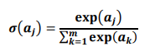
- Determination of the optimizer: Optimizer is an algorithm for determining the optimal weight .
- Determination of the batch size: The batch size is used to determine the number of 16 observations made before making changes in weight, which is determined relative based on computer specifications.
- In the training process, the input image measuring 224 x 244 x 3 will first be processed by Convolutional Layer First with a 32 kernel sized filter 112 x 122 x 32 with the results of the size 56 x 61 x 64. In the first pooling layer, size Dimensions were reduced from 224 to 56. At each pooling layer, parameters do not change. Then, the result from the First Convolutional Layer measuring 112 x 122 x 32 will be at process by Convolutional Layer Second with 128 kernels filter 28 x 31 x 128 in size with the results of the size 28 x 31 x 128. In the second pooling layer, the dimensions are reduced from 56 to 28. The results from the Second Convolutional Layer with size 28 x 31 x 128 will be processed by Convolutional Layer Third with a filter 256 kernels of 512 batch normalization size with the results of the size 14-x192. In the third pooling layer, measure dimensions reduced from 28 to 14. The results from the Second Convolutional Layer with batch size 128 will be processed by Convolutional Layer Third with a filter 192 kernels of 14 x 16 x 192 size with the results of the size 7 x 8 x 256. In the third pooling layer, measure dimensions reduced from 14 to 7. After the Convolutional Layer process, 2 fully connected layers are generated which has 256 neurons in the first layer and 3 neurons in the second layer. The Training Process for Each Layer uses Deep Convolutional Neural Network can be seen.
- Determination of epoch: Epoch is literally the amount used to repeat the process learning. The larger the number of epochs the higher the yield rate learning. There are several epoch values used in this research. The number of epochs used in this study is 80 and saving the as comma separated value “.csv” extension. testing model the configuration of the training process that displays a graph of the results with maximum accuracy of 94.85%, 22.96% loss and confusion matrix of the training process.
5.Problem Definition and objectives

Problem Definition
Early detection and treatment has a higher probability of recovery. If we failed to detect early it may spread and once melanoma spread.Dermoscopy is also known as Dermatoscopy. By using non-invading diagnosis technique like light microscopy can be used to detect pigmented skin lesion. It is a new type of imaging technique which can use to examine skin lesion attached with a piece of equipment called dermatoscopy. Although analysis of dermoscopy images plays an important role to detect malignant melanoma in the early stage, this traditional method is subjective and time-consuming. Due to these limitations, computer aided diagnosis system is an urgent need for the dermatologists for the clinical evaluation to detect early the risk factor of melanoma.

Objectives.
- To improve productivity and decision making of a Medical Practitioner.
- Maintaining an accurate database of various stages of cancer images.
- To create an accurate skin cancer detection features dataset with three classes benign, malignant and normal.
- To apply and analyze the various cancer stages defined by the above three classes using CNN algorithm.

6.Proposed Methodologies
The disease detection methodology starts with the first phase of data pre-proceeding and labeling. Secondly, pre-processed data is classified using a Convolution neural network. In below Figure2: The CNN is tuned on hyperparameters which are based on the training of proposed network and numbers of hidden layer. Here , the hyperparameter are chosen based on the network which used to classify the images.
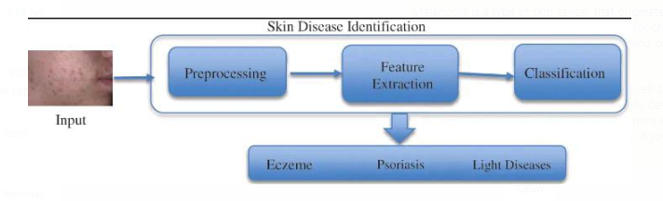
Figure 6.1: Proposed methodology
Image Pre-Processing
This is an initial phase, where the raw image dataset is pre-processed to remove noise before inputting it to the Convolution neural network classifier. It must for a model to analyze the structure of the network and dataset to generate better outcomes. Therefore, the dataset is preprocessed initially to collect appropriate features of images which can be used by the model to accurately diagnose or predict the actual outcomes. Here in pre-processing, firstly, the size of each image is normalized as per requirement which is 256*256 pixels. The image size is defined during network design and act as input node. The same is used to train the model to achieve consistent results. The python libraries are utilized to perform the same task with maximum accuracy. Secondly, all images are converted into grey images.
The pre-processing stage is considered as a phase that extracts image features to train the model. These training features are the reason for accurate prediction. After pre-processing, the data labeled with the correct acronym. After this data is segregated into different classes which can be used for testing.
C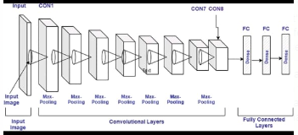
Figure 6.1.2: CNN model architecture

Mathematical Representation of Classification
Here, the Convolution neural network (CNN) is utilized for classification, one of the most prominent technologies used at present. Here, the model is accomplished with the feature extracted in the previous phase. In the CNN, the image dataset is processed in different layers and each layer has the following sub-layers:
a) Convolutional Layer
The main operation in the convolutional layer is convolution in which the input image is mapped with a filter of m*m and generates outcome feature maps. The outcome of the convolutional layer is expressed by Eq. (1)
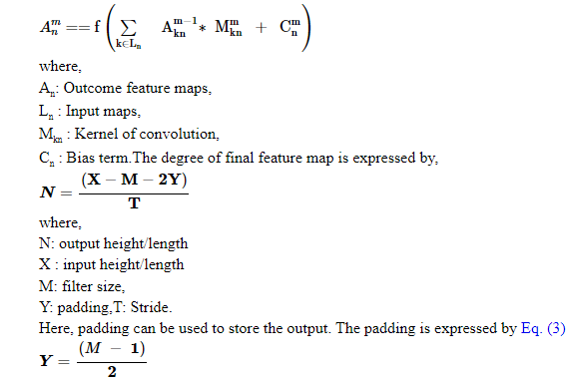

where, M: filter size.
• ReLU Layer: This also plays an important in CNN and is also known as the Activation layer. This layer is next to the convolution layer and the output of the same will be input to the ReLU. This layer creates linearity in the convolutional process. So, each convolutional layer is associated with a ReLU layer. The important task of this layer is to update all negative activation to zero and thresholding which is given by f(p) = max(0, p). This layer helps the system to learn quickly and remove gradient problems. ReLU activation function is well designed for multiclass classification.
• Max-Pooling Layer: This layer generates the reduce sized output after maximizing the elements of each block. This layer also controls the overfitting problem without the learning process.
• Dropout Layer: This layer is used to drop out the input elements having a probability less than a certain value and this process is a part of the training phase.
• Batch Normalization Layer: This layer plays an important role in between the convolutional and ReLU layer. This layer is used to enhance the training speed and reduce sensitivity. This layer performs different operations (subtractor, division, shifting, and scaling). The activation layer to normalize its value. Firstly, the activation is subtracted with mean, and divided by the standard deviation which is followed by fluctuating by α and then scaled by Θ. The batch normalized outcome, B_{k} is expressed by the Eqs. (4)–(7),

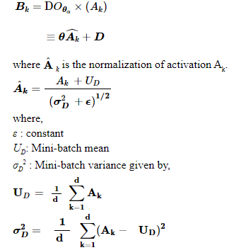
b) Fully Connected Layer
Here, the neurons of the next layer are linked with neurons of the previous layer and produced a vector, and the vector dimensions represent the number of classes.
c) Output Layer
This layer is a combination of softmax and classification. In this layer, firstly, the softmax is used to distribute the probability and the classification is carried out by the network. The softmax is defined by Eq. (8)
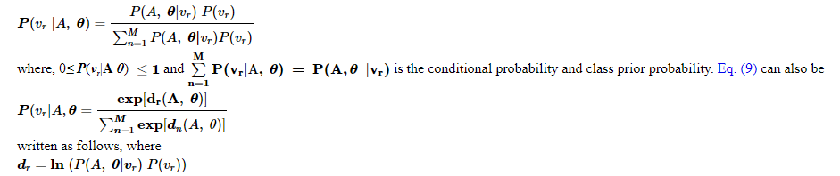

- System Design
Block diagram of the project
INPUT IMAGE
PRE PROCESSING

SEGMENTATION
FEATURE EXTRACTION

CONVOLUTIONAL LAYER
MAXPOOLING LAYER

FULLY CONNECTED LAYER

NON MELANOMA
MELANOMA

Fig 7.1.1: Block diagram

- Input image: user can select the image.
- Pre processing : It converts image to gray color and remove noise using median filter
- Segmentation : using segmentation threshold and morphology divides the image into number of parts.
- Feature extraction : Finds the edges of an image using canny edge algorithm.
- A convolution layer: A convolution layer is a fundamental building block in convolutional neural networks (CNNs), Convolution layers capture local patterns and spatial hierarchies in the data. These layers are crucial for tasks such as image recognition, object detection, and segmentation in computer vision.
A convolution layer: A convolution layer is a fundamental building block in convolutional neural networks (CNNs), a type of deep learning architecture commonly used for image and spatial data analysis. In this layer, a set of learnable filters (kernels) slide or convolve across input data, performing element-wise multiplications and aggregating the results to produce feature maps. Convolution layers capture local patterns and spatial hierarchies in the data, enabling the network to learn hierarchical representations. These layers are crucial for tasks such as image recognition, object detection, and segmentation in computer vision.
Max pooling: Max pooling is a down sampling operation often used in conjunction with convolutional layers in neural networks, particularly in convolutional neural networks (CNNs). It involves dividing the input into non-overlapping regions and retaining only the maximum value from each region. Max pooling has several benefits, including reducing computational complexity, providing some degree of translational invariance, and aiding in capturing the most prominent features in the data. The most common form is 2x2 max pooling, where a 2x2 grid is used to select the maximum value from each region. max pooling is a technique used to downsample the spatial dimensions of the input data, helping in the extraction of essential features and reducing the overall computational load.
A fully connected layer: A fully connected layer, also known as a dense layer, is a type of layer in neural networks where each neuron or node is connected to every neuron in the previous layer. In this layer, all inputs from the previous layer are connected to each neuron.

- SYSTEM REQUIREMENT
HARDWARE REQUIREMENTS:
Processor : Intel Core I5 and above
Processor Speed : 1.0GHZ or above
 RAM : 4 GB RAM or above
Hard Disk : 500 GB hard disk or above
SOFTWARE REQUIREMENTS:
Operating System : Windows 7/10 or above
Front End : PYTHON
Back End : SQLITE3

- System Implementation
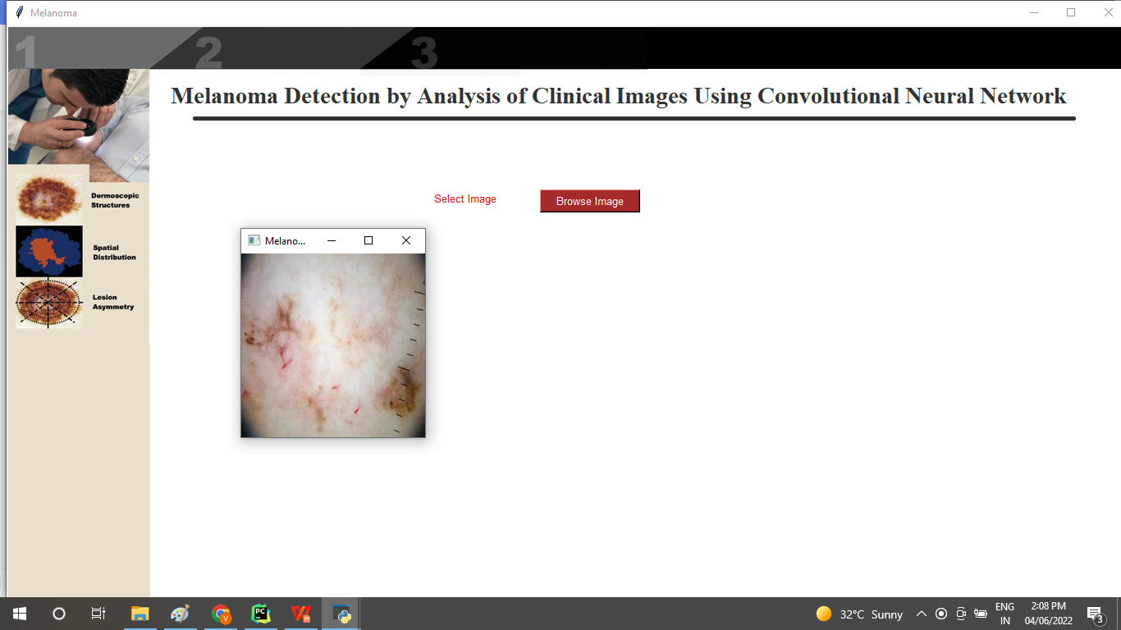
Figure 9.1 : input image
In this module selecting the skin image using the following code :
filename = askopenfilename(filetypes=[("images",".")])
img = cv2.imread(filename)
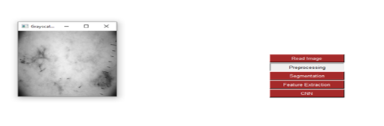
Figure 9.2 :Gray colored Image
In this module, converts the selected image into grayscale and denoises the image using Guassian filter algorithm called preprocessing.

Figure 9.3 :Segmentation
Converts the image into various parts called segmentation. Image segmentation involves converting an image into a collection of regions of pixels that are represented by a mask or a labeled image. By dividing an image into segments, you can process only the important segments of the image instead of processing the entire image.
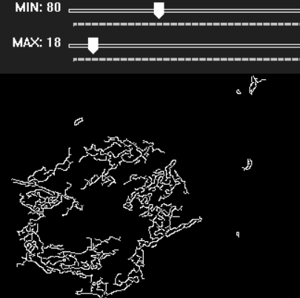
Figure 9.4 :feature extraction

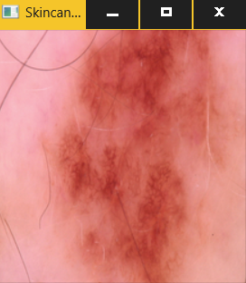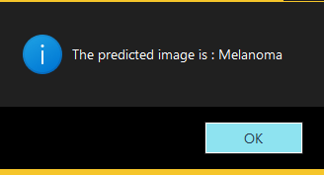
Figure 9.5 :predicted image melanoma

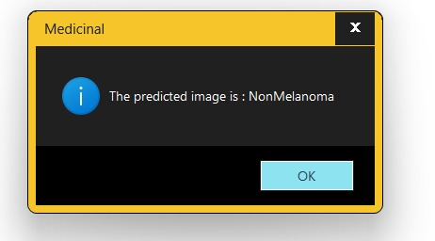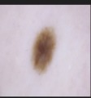

Figure 9.5 :predicted image is non melanoma

10.Conclusion and future scope

This project introduces a method to detect skin cancer using the deep learning method. In our proposed system, the CNN can combine local features and learn characteristics of the image by combining convolutional and pooling layers. The proposed method includes images from International Skin Imaging Collaboration preprocessing to extract the region of interest in the image and then augment some pictures to produce a more extensive dataset containing images. The resulting dataset has been applied to the CNN model to train the model, which comprises different layers, including pooling, convolutional, classification layer, etc. Testing the model produced promising results with an accuracy of 70%. To improve the accuracy, we used another variation of the convolutional neural network, which is support vector machine. The results are promising. The results were enhanced from 70 to 92%. Unlike other methods, the proposed method based on neural networks shows the best results, and different machine learning techniques can improve the results.

Future scope
This project presents serveral sections on state of art techniques, analysis and comparisons on benchmark datasets for the brain tumor, breast cancer, lung cancer, skin cancer detection respectively of measure, senstivity, specificity, accuracy, precision point of view it is feasible to Implmented. Different types of cancer detection and classification using machine assistance have opened up a new research area for early detection of cancer, which has shown the ability to reduce manual system impairments.

References

[1] Fulgencio Navarro, Marcos Escudero-Vinolo and Jesus Bescos., et al. "Accurate segmentation and registration of skin lesion images to evaluate lesion change” 2168-2194 (c) 2018 IEEE. Personal. Anatomy of the skin, Stanford children’s health, 2021, [Online]. Available: https://www.stanfordchildrens.org/en/topic/default?i d=anatomy-of-the-skin-85-P01336 (Accessed 11 June 2021).
[2] M.W. Greaves, Skin disease, Britannica, 29, 2020, [Online]. Available: https://www.britannica.com/science/human-skindisease. (Accessed 11 June 2021).
[3] Bangladesh: Skin disease, 2018, [Online]. Available: https://www. worldlifeexpectancy.com/bangladesh-skin-disease. (Accessed 9 July 2021).
[4] Feng Guo, Jie Yang, Yilei Chen, Bao Yao. et al Cancer, world health organization, 21, 2021, [Online]. Available: https://www.who.int/newsroom/fact-sheets/detail/cancer. (Accessed 20 March 2020).
[5] Md. Al Mamun, Mohammad Shorif Uddin, 2 IJCRT2307676 International Journal of Creative Research Thoughts (IJCRT) www.ijcrt.org f777 survey on a skin disease detection system, Int. J. Healthc. Inform. Syst. Inform. 16 (4) (2021) 1–7
[6] C.N. Vasconcelos, B.N. Vasconcelos, Experiments using deep learning for dermoscopy image analysis, Pattern Recognit. Lett. 139 (2020) 95–103.
[7] U.-O. Dorj, K.K. Lee, J.Y. Choi and. M. Lee, The skin cancer classification using deep convolutional neural network, Multimedia Tools Appl. 77 (2018) 9909–9924.
[8] M. Taufiq, N. Hameed, A. Anjum, F. Hameed, mSkin Doctor: A Mobile Enabled System for Early Melanoma Skin Cancer Detection Using Support Vector Machine, in: eHealth 360◦. International Summit on eHealth, 2017, pp. 468–475.
[9] Jagdis etal., J.A.D.L. Cruz-Vargas, M.E.R. Camacho, Advance study of skin diseases detection using image processing methods, Nat. Volatiles Essent. OilsJ. 9 (1) (2022) 997–1007.
[10] Z. Naeem, G. Zia, Z. Bukhari, A healthcare model to predict skin cancer using deep extreme machine, J. NCBAE 1 (2) (2022) 23–30.
[11] S.K. Bandyopadhyay, P. Bose, A. Bhaumik, S. Poddar, Machine learning and deep learning integration for skin diseases prediction, Int. J. Eng. Trends Technol. 70 (2) (2022) 11–18.
[12] A. Kalaivani, S. Karpagavalli, Detection and classification of skin diseases withensembles of deep learning networks in medical imaging, Int. J. Health Sci. 6(S1) (2022) 13624–13637.
[13] S.A. AlDera, M.T.B. Othman, A model for classification and diagnosis of skin disease using machine learning and image processing techniques, Int. J. Adv. Comput. Sci. Appl. 13 (5) (2022).
[14] P.R. Kshirsagar, H. Manoharan, S. Shitharth, A.M. Alshareef, N. Albishry, P.K. Balachandran, Deep learning approaches for prognosis of automated skin disease, Life 2022 12 (426) (2022).
[15] .M.Q. Hatem, Skin lesion classification system using a Knearest neighbor al- gorithm, in: Visual Computing for Industry, Biomedicine, and Art. Vol. 5, (7) 2022.

