SMART WATER PURIFIER AND QUALITY MONITORING USING IOT

Dr.Geenu Paul
HOD Bachelor of Technology

Department of Electronics and Communication

Engineering St.Thomas Institute for Science

and Technology,Trivandrum

Dr.Tony Alwin Hima A S, Joel Saju, Meera Rajesh, Siddarth H Lal

Lecturer-Bachelor of Technology Department of Electronics and Communication Engineering St.Thomas Institute for Science and Technology,Trivandrum
Student-Bachelor of Technology Department of Electronics and Communication Engineering

St.Thomas Institute for Science and Technology,Trivandrum

Abstract -

Water is vital resource for life. Drinking safe water is important aspect for a healthy life. In modern world water pollution is one of the major cause for various types of water-borne diseases, 40% of the deaths worldwide are caused by water pollution. The clean and safe drinking water is getting depleted every second hence water
.
\

[A]

LITERATURE SURVEY Rural Areas

purification is todays need. World bank estimates that 21% of communicable diseases in India are related to unsafe water, contamination has been a long standing problem in our country. The older methods are unable to monitor the water quality in real time and notify the user about the contamination. So, it is necessary to develop a real time water quality monitoring and notification system. Smart solutions for water quality monitoring are gaining importance with advancement in communication technology. Water quality depends on pH, turbidity, temperature along with some other factors are significant, and will be monitored by the system using sensors, through wifi system the sensor output data is sent to concern authority for further steps to improve water quality. The proposed system is portable, automatic water quality monitoring and notification system saves time and human resources. The notification will be sent to authorized person when sensors will detect bad water quality. It is low cost system for real time water quality monitoring.

Keywords : IOT, pH sensor, Turbidity sensor, Temperature sensor, UV sensor

INTRODUCTION
Drinking pure water is an important aspect for a healthy life. It is necessary to develop a real time water quality monitoring and notification system. Smart solutions for water quality monitoring are gaining importance with advancement in communication technology. Factors determining water quality are monitored by the system using sensors and the output data is sent to user to improve water quality. The proposed system is an automatic water quality monitoring and notification system which saves time and human resources.
1st International Conference on Next Generation Computing
Technologies (NGCT-2015) Dehradun, India. This paper highlights theentire water quality monitoring methods, sensors, embedded design, and information dissipation procedure, role of government, network operator and villagers in ensuring proper information dissipation. It also explores the Sensor Cloud domain. While automatically improving the water quality is not feasible at this point, efficient use of technology and economic practices can help improve water quality and awareness among people.

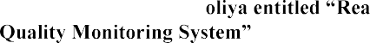[B]
Jayti Bhatt,Jignesh Pat

This paper describes to ensure the safe supply of drinking water the quality should be monitored in real time for that purpose new approach IOT (Internet of Things) based water quality monitoring has been proposed. In this paper, we present the design of IOT based water quality monitoring system that monitor the quality of water in real time. This system consists some sensors which measure the water quality parameter such as pH, turbidity, conductivity, dissolved oxygen, temperature. The measured values from the sensors are processed by microcontroller and this processed values are transmitted remotely to the core controller that is raspberry pi using Zigbee protocol. Finally, sensors data can view on internet browser application using cloud computing.

[C] Zhanwei Sun,Chi Harold Li,Chatschik Bisdikian,Joel
-Aware Energy Management in Internet-of-Things Sensory Environments
In this paper an efficient energy management frame work to provide satisfactory QOI experience in IOT sensory environments is studied. Contrary to past efforts, it is transparent and compatible to lower protocols in use, and preserving energy-efficiency in the long run without sacrificing any attained QOI levels. Specifically, the new concept of QOI-
-to-ta
sensing capabilities offered by an sensor to the IOT sensory environments, and QOI requirements required by a task. A

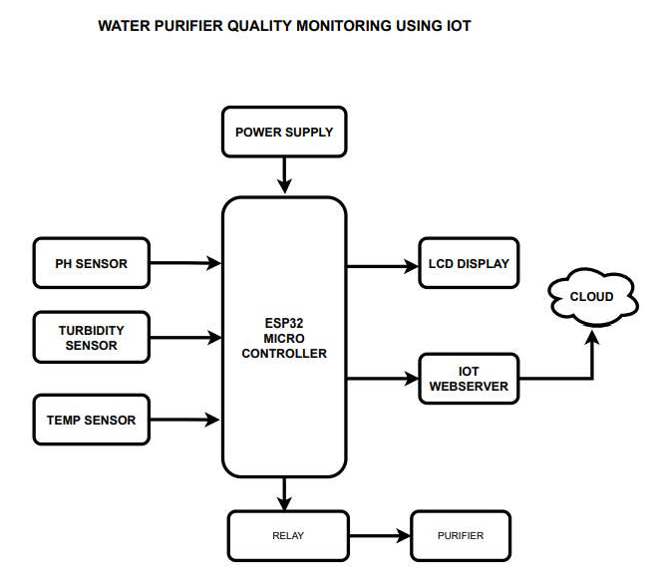
selecting the sensors to service a task over time. Energy management.

PROPOSED SYSTEM

- CIRCUIT DIAGRAM

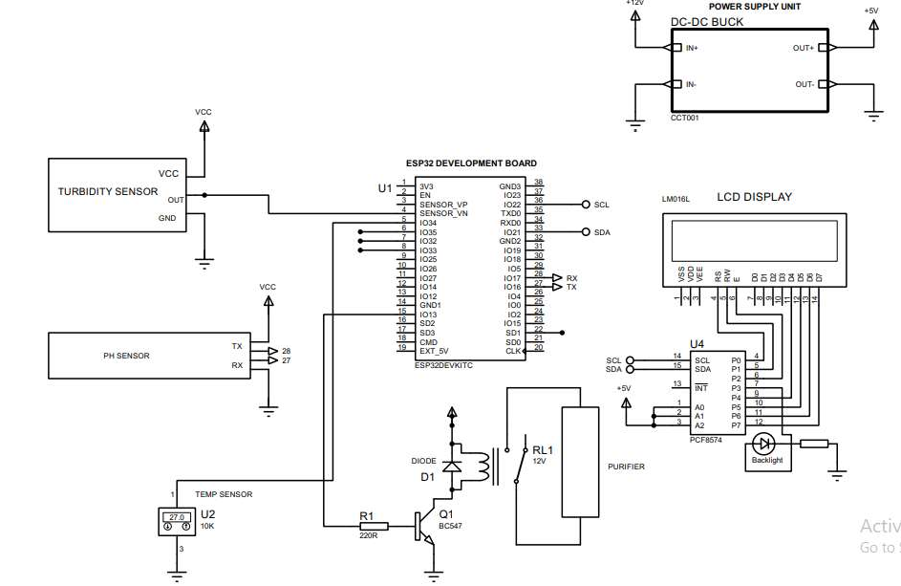

Water quality monitoring using IoT employs a multifaceted approach. It begins with the deployment of various sensors that continuously measure parameters such as pH, temperature, turbidity, dissolved oxygen, and contaminants in water bodies. These sensors feed real-time data to a microcontroller or processor, which acts as the hub for data processing and analysis. Through connectivity modules like Wi-Fi, Bluetooth, or GSM, the microcontroller transmits the collected data to a central server or cloud platform. Here, the data is stored, processed, and analyzed using algorithms to detect anomalies, trends, and potential water quality issues. Stakeholders can then access the analyzed data through visualization tools like dashboards or applications, enabling them to monitor water quality in real-time and receive alerts for any deviations from predefined thresholds. Automated feedback mechanisms ensure that relevant authorities are promptly notified of any critical issues, allowing for timely intervention and remediation efforts. This interconnected system provides continuous monitoring of water quality, facilitating effective management and protection of water resources

WORKING
A smart water purifier with IoT functionality typically works by continuously monitoring water quality parameters like pH levels, turbidity, and contaminants. IoT sensors collect data in real-time, which is then analyzed by the system to ensure water quality meets safety standards. Additionally, the system can provide alerts and notifications to users or even automatically adjust purification settings as needed. Overall, it offers real-time monitoring and control, enhancing the efficiency and effectiveness of water purification processes.
- IoT Sensors: Smart water purifiers utilize various sensors such as pH sensors, turbidity sensors, conductivity sensors, and temperature sensors to continuously monitor water quality parameters.

- Data Transmission: The data collected by these sensors is transmitted wirelessly to a central control unit or a cloud-based platform using Wi-Fi, Bluetooth, or other communication protocols.
- Data Analysis: Upon receiving the data, the system analyzes it in real-time to assess water quality. This analysis may involve comparing the measured parameters against predefined thresholds or standards.
- Alerts and Notifications: If any parameter deviates from the acceptable range, the system generates alerts or notifications. These alerts can be sent to users via mobile apps, email, or SMS, prompting them to take necessary actions.
- Automatic Control: In some advanced systems, IoT-enabled water purifiers can automatically adjust purification settings based on the real-time data. For example, if the turbidity level increases, the system may increase the filtration rate to maintain water quality.
- Remote Monitoring: Users can remotely monitor the water quality and purification process through a smartphone app or web interface. This feature provides convenience and peace of mind, especially when away from home.
- Maintenance Alerts: The system can also generate alerts for maintenance tasks such as filter replacement or system calibration based on usage and sensor data, ensuring optimal performance of the purifier.
- Data Logging and Analytics: All data collected by the IoT- enabled water purifier is logged and stored for further analysis. This data can be used to identify long-term trends, optimize purification processes, and ensure compliance with regulatory standards.

RESULT
This paper focus on analysing the water quality with high performance, real time and accuracy. In our proposed system we have measured Temperature, Turbidity and pH values of water with the help of various Sensors. The output of the sensors is shown on lcd and in case of failure of system notification is sent to the authorised person. In future, the parameters like conductivity, hardness, chloride, ammonia, iron fluoride etc. also can be monitored by using corresponding sensors and changing appropriate python programs. The system can monitor water quality automatically, and it updates the parameter details automatically to the authorised person through a webserver. The proposed water quality testing has to be more cost effective, suitable and rapid. The system has good flexibility. The operation is simple. The system can be prolonged to examine hydrologic, air pollution, industrial and agricultural fabrication and so on. So, this application will be the best challenger in real time monitoring & control system and use to solve all the water related problems. An efficient, real time water quality monitoring system based on IoT is presented. Proposed system monitors the working of water purifier. The range of pH value for drinking water is observed to be 6-8.

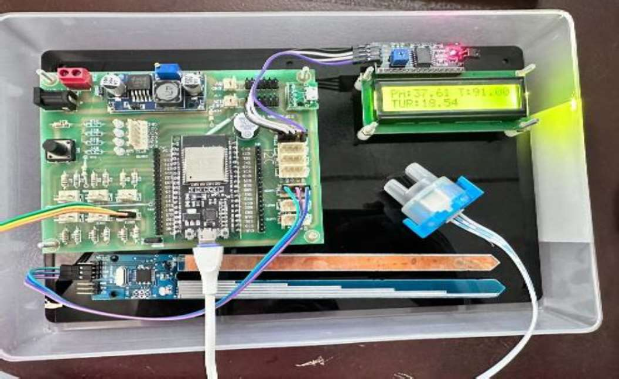

FUTURE SCOPE
The future scope for smart water purifiers and quality monitoring using IoT is quite promising and includes several advancements:
Enhanced Sensor Technology: Continued advancements in sensor technology will lead to more sensitive, accurate, and cost-effective sensors for monitoring a wider range of water quality parameters. AI and Machine Learning Integration: Integration of AI and machine learning algorithms will enable predictive analysis of water quality trends, anomaly detection, and adaptive purification processes based on historical data and environmental factors.
Blockchain for Data Security: Implementing blockchain technology can ensure the security and integrity of water quality data by creating an immutable record of sensor readings, purification processes, and maintenance activities.
Integration with Smart Home Ecosystems: Smart water purifiers will increasingly integrate with other smart home devices and ecosystems, allowing for seamless automation and control through voice assistants, home automation platforms, and interconnected IoT devices. Mobile Health Monitoring: With the rise of wearable health monitoring devices, future smart water purifiers could integrate health tracking features to monitor hydration levels and provide personalized recommendations for optimal water intake based on individual needs.
Environmental Monitoring: Beyond just ensuring drinking water quality, IoT-enabled water purifiers could expand to monitor and manage water resources at a larger scale, including environmental factors such as river pollution, groundwater levels, and water usage patterns.
Community-Level Solutions: Collaborative efforts involving IoT-enabled water purification systems could lead to community-level solutions for ensuring safe and sustainable water access in remote or

underserved areas, leveraging shared data and resources for collective benefit.

Regulatory Compliance and Standards: With increasing emphasis on water quality regulations and standards worldwide, smart water purifiers will play a crucial role in ensuring compliance through real-time monitoring, reporting, and adherence to quality benchmarks.

Overall, the future of smart water purifiers and quality monitoring using IoT holds tremendous potential for improving water safety, efficiency, and accessibility on both individual and community levels, while also contributing to environmental sustainability and public health.

CONCLUSION
In this project we made a IoT enabled smart water purifier, and achieved real time quality monitoring and notification system with the help of temperature sensor, turbidity sensor, pH sensor and UV sensor. Proposed system will monitor the working of water purifier. Monitoring of working of water purifier is necessary and it is not present in the current systems. Hence the project is low cost compared to the available systems for water purification. The components used are easily available and inexpensive. The proposed system saves time as well as human resources and ensures proper working of the water purifier.
ACKNOWLEDGMENT
We would like to take this opportunity to express our profound gratitude towards many individuals, as without their kind support, it would not be possible for us to complete this project. We would like to extend our sincere thanks to our respected principal Dr A G Mathew for his immense support. We addressed many difficulties in coordinating the activities of the project, but we are highly indebted to Dr. Tony Alwin, our project guide for her continuous guidance and constant supervision as well for providing necessary information regarding this project and also for her support in completing the project. We would like to express my gratitude towards our project coordinator Dr Anju S for her kind support and guidance. Also we express our sincere thanks to our HOD, Dr Geenu Paul for helping as and for encouraging as. We also thank all our faculties for their valuable support throughout this project .We end up by thanking our dear parents, friends and all who helped us in finalizing the project with in the limited time frame. Last but not the least we thank Almighty, for letting us
iding
Telecommunication Engineering, NBN Sinhgad School of Engineering
July 2020 | IJIRT | Volume 7 Issue 2 | ISSN: 2349-6002
- Vaishnavi V. Daigavane and Dr. M.A Gaikwad,Water Quality Monitoring System Based on IOT.
- Prof. S.G. Kambalimath, Mr. Manjunath V.Patil, Ms. Anupama I. Patil, Ms. Kavya Handral, Ms. Riso Kaka, Project Refeference
no.: 40S_BE_2050, IoT ENABLED WATER PURIFIER.
- Ibraheem M. Khalil, Hazem Noori Abdulrazzak(2019), Monitoring of Water Purification Process Based on IoT.

us with everything
.

REFERENCES

  - Water Purifier Quality Monitoring Using IOT Trupti Deshmukh,H.N Lokhande, Mayuri Raj, Electronics &

