Laundry Management System for College
Mrs.T.Sathya(AP/IT)¹,Pradeepa.S², Preethi Roja.G³, Ragavi.R⁴

^{1,2,3,4}Information Technology, Sri Shakthi Institute of Engineering and Technology

---------------------------------------------------------------------***---------------------------------------------------------------------
ABSTRACT - College Laundry presents a transformative approach to student laundry management, departing from conventional delivery services by introducing a centralized hub pickup system. Gone are the days of waiting for door-to-door service; instead, students have the flexibility to drop off and collect their laundry orders at designated hubs conveniently located throughout the campus. Our cutting-edge web platform redefines the ordering process, offering a seamless interface for students to submit their laundry requests with ease. Behind the scenes, administrators efficiently handle these requests, providing transparent updates on order statuses in real-time, ensuring a smooth and accountable process for all users. To promote equitable access and optimize resource allocation, each student is granted one weekly order slot, scheduled for a specific day, minimizing excess usage and promoting sustainability. Proactive reminder notifications are a cornerstone of our service, gently prompting students via our webpage to ensure timely drop-offs, thereby maintaining a consistent laundry routine amidst the demands of student life. By amalgamating convenience, transparency, and sustainability, College Laundry empowers students to reclaim their time and focus on their academic endeavors, one load at a time.

Key Words: college laundry system ,feedback option,efficient

1.INTRODUCTION
Laundry management in college campuses poses significant logistical hurdles, given the high demand and diverse schedules of students. To mitigate these challenges, the Laundry Management System for College offers a comprehensive solution. This web-based platform enables students to effortlessly schedule pick-up and drop-off times at designated laundry hubs, streamlining the entire process. With features like real-time order status updates, weekly order limits, and feedback mechanisms, the system enhances efficiency and convenience for students while optimizing laundry operations for administrators. By leveraging technology, our system revolutionizes the traditional approach to laundry services, promising a seamless and satisfying experience for all involved parties
.

2. LITERATURE SURVEY
2.1 HISTORICAL DEVELOPMENT
The evolution of laundry services has moved from manual labor-intensive processes to more automated and efficient systems. Early automation attempts involved simple machinery for washing and drying clothes, whereas modern systems integrate advanced technologies like RFID and cloud computing to enhance efficiency. Historically, laundry services were local businesses with limited reach. The introduction of industrial laundry services and later, the digitization of services, transformed the industry significantly.
2.2 CURRENT TECHNOLOGIES
Modern LMS utilize technologies such as RFID for tracking individual garments, IoT for machine connectivity and monitoring, and cloud computing for centralized data management. These technologies facilitate real-time monitoring, predictive maintenance, and efficient resource utilization. Software platforms like CleanCloud and LaundryPro offer comprehensive management tools including mobile apps, customer relationship management (CRM), and advanced reporting capabilities.
2.3 PREVIOUS STUDIES
Research indicates significant improvements in operational efficiency and customer satisfaction with the implementation of LMS. Studies highlight the effectiveness of various technologies in reducing turnaround times and operational costs. For example, a study on the use of RFID technology in laundries showed a 30% increase in efficiency and a significant reduction in garment loss. Another study on cloud-based LMS demonstrated enhanced scalability and flexibility, allowing businesses to easily adapt to changing demands.
2.4 GAPS IN THE LITERATURE
Existing research often overlooks the specific needs of niche markets like college campuses. There's limited exploration of LMS tailored for environments where students have unique schedules and constraints. This project aims to address these gaps by focusing on the specific requirements of college laundry services, such as accommodating limited availability and providing specific drop-off and pick-up schedules. Furthermore, there is a need for studies on the long-term impact of LMS on customer loyalty and business growth.
3.RESEARCH METHODOLOGIES
3.1.EXISTING METHOD
The current method employed in laundry management relies heavily on manual processes. Customer records, including details and laundry orders, are recorded by hand in logbooks or spreadsheets. Clothes are sorted, tagged, and processed manually without any digital tracking system. Invoicing and payments are done through handwritten invoices or basic accounting software, lacking automation. Inventory management is also manual, leading to discrepancies in stock levels. Lastly, delivery and pickup scheduling are managed through phone calls or in-person interactions, lacking automated reminders.
3.2.DISADVANTAGE
Manual laundry management comes with several disadvantages. Human errors are common due to the reliance on manual data entry and processing, leading to inaccuracies in records and orders. The process is time-consuming, resulting in inefficiencies and delays in service delivery. Additionally, there's a risk of data loss or damage to physical records, impacting the reliability of the system. Lack of real-time tracking hampers visibility into order status and inventory levels, while inconsistent service quality and delayed deliveries can result in customer dissatisfaction. Moreover, inefficient communication due to the absence of automated notifications further compounds these challenges.
3.3.PROPOSED METHOD
Automated Laundry Management System
To address the limitations of manual processes, an automated laundry management system is proposed. This system digitizes various aspects of laundry operations, starting with centralized customer records stored in a digital database accessible through web or mobile applications. Automated sorting, tagging, and tracking of clothes using barcode or RFID technology streamline order processing. Digital invoicing and payment systems integrated with accounting software facilitate efficient billing and transaction recording. Real-time inventory management with automated alerts ensures optimal stock levels, while automated scheduling and tracking of pickup and delivery enhance customer service experience.

3.4.ADVANTAGES
The implementation of an automated laundry management system offers numerous advantages. Firstly, it enhances accuracy by reducing human errors in data entry and processing. Secondly, it improves efficiency with faster processing times and streamlined workflows, leading to enhanced operational efficiency. Furthermore, the system ensures data security by securely storing records in digital format, mitigating the risk of data loss. Real-time tracking capabilities provide visibility into order status and inventory levels, facilitating better management and planning. Improved service quality and timely deliveries contribute to higher customer satisfaction and loyalty. Additionally, automated communication through notifications and reminders improves interaction with customers and staff, ensuring timely updates and actions. Lastly, the system offers scalability, making it easier to expand operations as the business grows..

4.SOFTWARE TECHNOLOGIES
4. 1.HTML
4.2.CSS
4.3.JAVA SCRIPT
4.4.PHP
4.5.MYSQL

5.IMPLEMENTAION

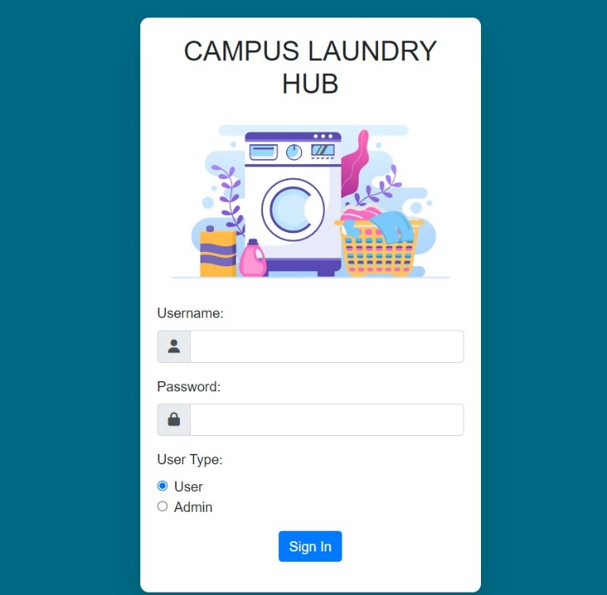

Fig -5.1 login page

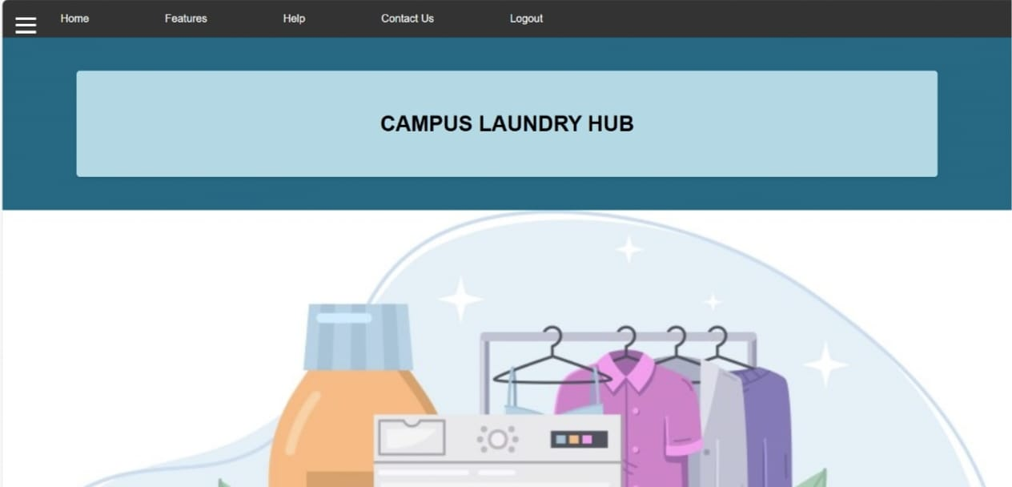

Fig-5.2 User home page

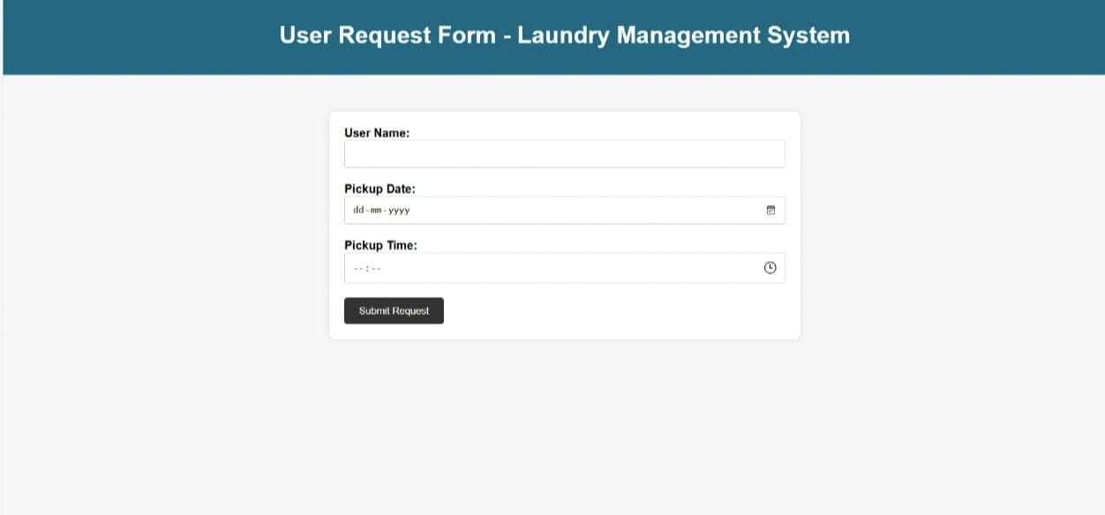

Fig-5.3 User request page

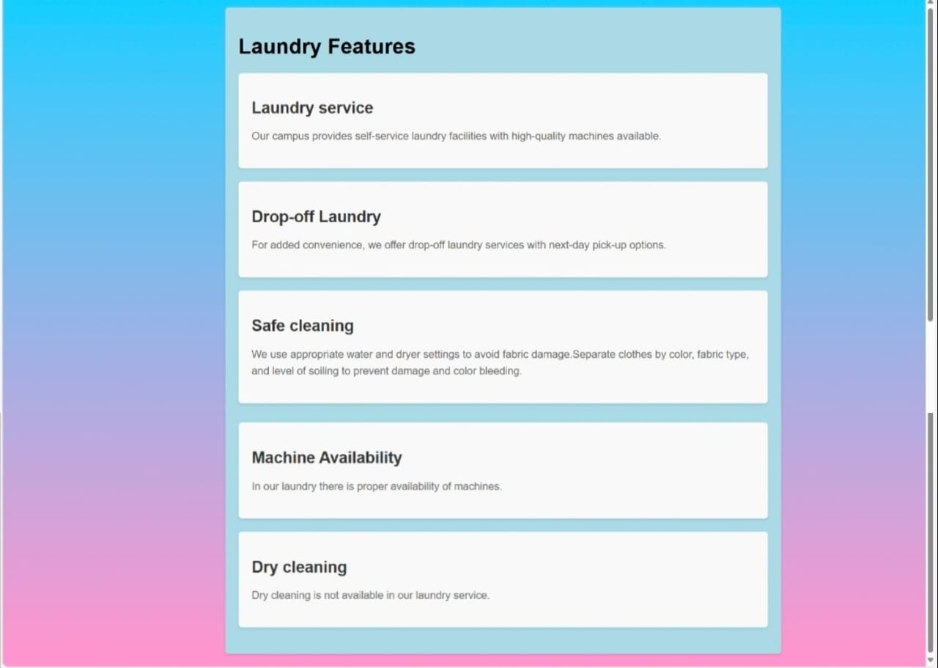

Fig-5.4 Features

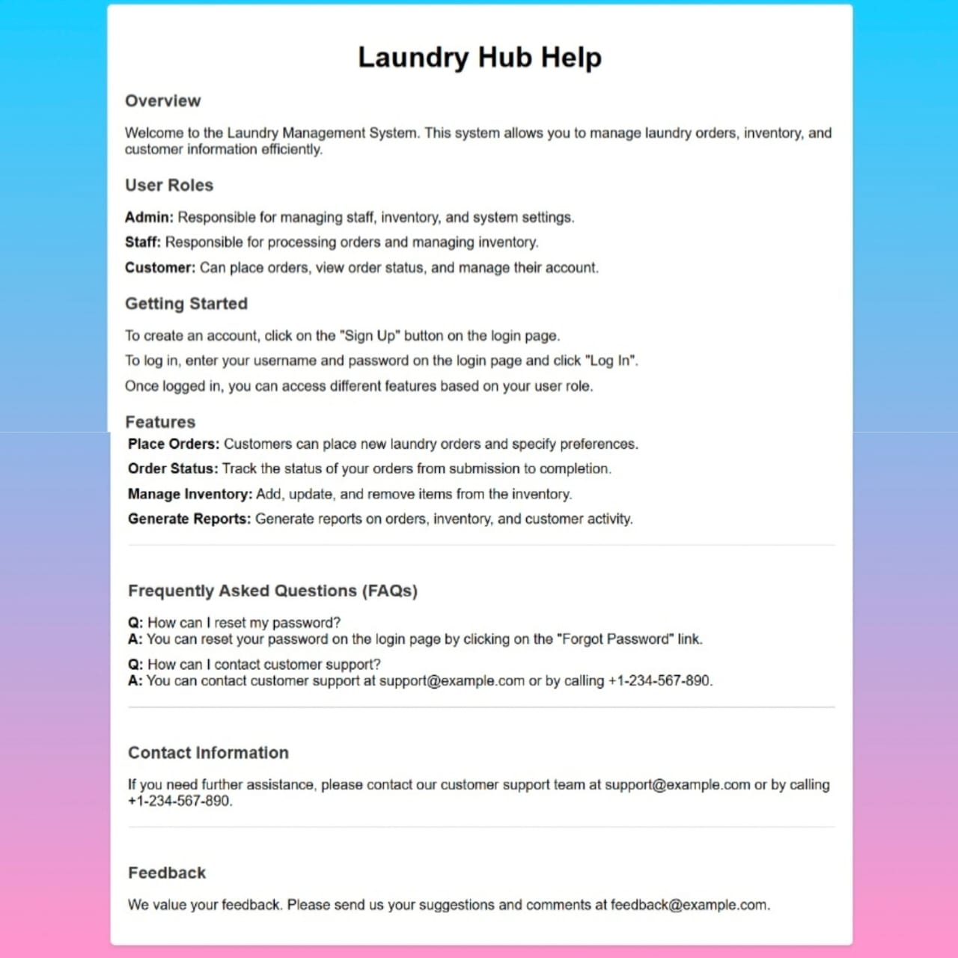

Fig-5.5 Help

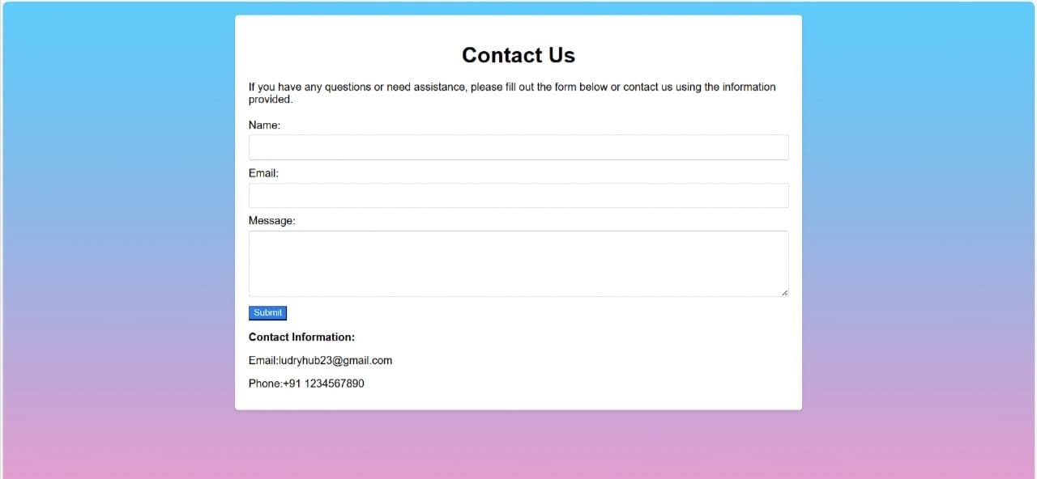

Fig-5.6 Contact

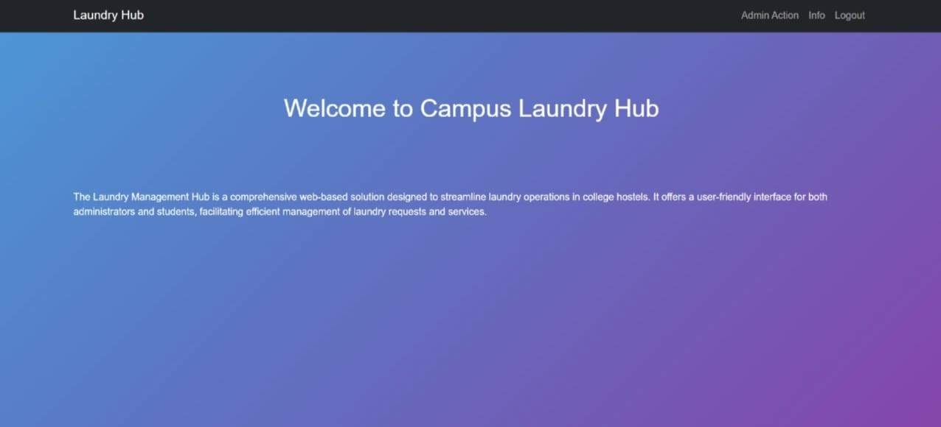

Fig-5.7 Admin Page

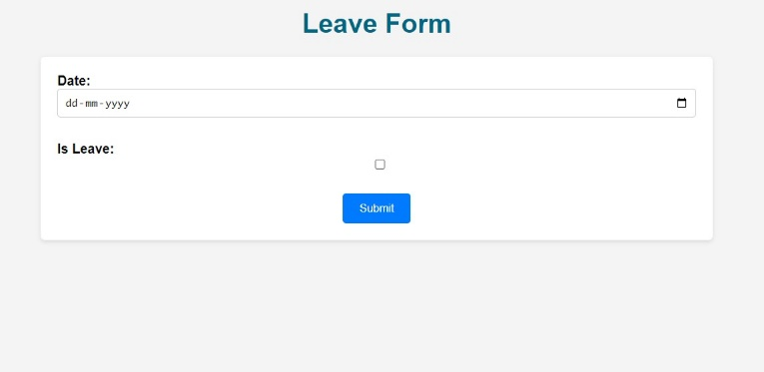
Fig-5.8 Info Page

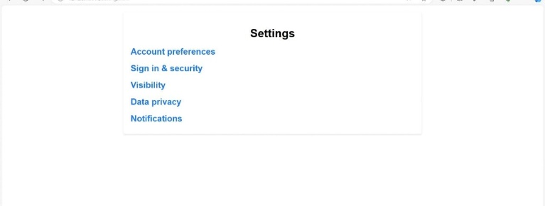

Fig-5.9 Setting

6.CONCLUSIONS

The Laundry Management System for College represents a significant advancement in streamlining and optimizing laundry services for college campuses. By transitioning from traditional, manual methods to a comprehensive, web-based platform, the system addresses common issues such as scheduling conflicts, long wait times, and inefficiencies in communication. With features like real-time order tracking, designated weekly order placements, and feedback options, the system enhances the convenience and satisfaction of students while enabling administrators to manage laundry operations more effectively.The implementation of this system promises to save time and reduce frustration for students, ensuring they can focus more on their academic and social activities. Additionally, it provides a scalable solution that can be adapted to different college environments, making it a versatile tool for improving campus life. As we move forward, continuous improvements and updates will ensure that the Laundry Management System remains responsive to the needs of its users, further solidifying its role as an essential service in the modern college setting.

ACKNOWLEDGEMENT

We are grateful to our development team for their hard work and to Sri Shakthi Institute of Engineering and Technology for their generous support, which made this project possible.

REFERENCES

1. Morba, S.: Laundry Management System Project Report (2019). [Laundry Management System Project Report (2019)](https://www.slideshare.net/SanjayMorba123/laundry-management-system-project-report)
2. PHPtpoint Team: Online Laundry Management System (2020). [Online Laundry Management System (2020)](https://www.phptpoint.com/projects/online-laundry-management-system/)
3. Anonymous: Laundry Management System Documentation (2021). [Laundry Management System Documentation (2021)](https://www.academia.edu/45678930/Laundry_Management_System_Documentation)

