STUDENT RESULT MANAGEMENT SYSTEM
Dr. M. DEEPA (ASP/IT)
LATHIKA SRI. B, MAGIZHOVIYA. S, MANISHA. K
B. Tech Information Technology & Sri Shakthi Institute of Engineering and Technology
---------------------------------------------------------------------***---------------------------------------------------------------------
Abstract - The paper outlines the creation and assessment of a Student Result Management System (SRMS) designed to improve the efficiency and accuracy of academic record-keeping. The SRMS is intended to automate the processes involved in managing student grades and performance analytics. To accomplish this, the SRMS features a user-friendly interface and a secure, scalable database capable of storing and processing student data. The system's primary functions include automated grade calculation, the generation of comprehensive academic reports, and real-time performance monitoring. After being implemented and tested within an academic institution, the SRMS demonstrated a substantial improvement in data accuracy and administrative efficiency. Moreover, the SRMS offers valuable insights into students performance trends, which can be utilized for more effective academic planning and support. The findings of this research suggest that adopting similar systems can significantly enhance the operational efficiency of educational institutions.

Key Words: Student Result Management System, academic records, grade automation, performance analytics, database security, educational technology.

1.INTRODUCTION ( Size 11, Times New roman)
Efficient administration of understudy scholarly records is basic in modern instructive settings. Conventional strategies, dependent on manual information section and paper-based frameworks, are regularly wasteful and inclined to blunders, driving to mistakes and authoritative burdens.

This paper presents the Understudy Result Administration Framework (SRMS), a advanced arrangement created to improve the precision and proficiency of overseeing understudy grades and execution information. The SRMS mechanizes review calculations, produces comprehensive reports, and offers real-time execution following, in this manner lessening authoritative workload and minimizing errors.

Designed with a user-friendly interface and secure database administration, the SRMS gives profitable experiences into understudy execution, helping teachers and directors in making educated choices. This paper points of interest the system’s plan and execution, and assesses its affect through introductory sending comes about, illustrating its potential to change scholastic record administration.

2. SRMS Functionalities
The Student Result Management System (SRMS) is a pivotal software solution designed to revolutionize result management within educational institutions. This paper presents a comprehensive overview of SRMS, detailing its functionalities, advantages, and implementation strategies.

SRMS is an integrated platform that automates the process of managing student results, offering a centralized system for data entry, storage, analysis, and reporting. By digitizing traditional manual processes, SRMS enhances administrative efficiency and accuracy while providing valuable insights into student performance.

2.1 User Authentication and Role-Based Access Control

In this segment, the implementation of user authentication and role-based access control in the Student Result Management System (SRMS). The system incorporates secure login functionality for both administrators and students, ensuring that only authorized users can access the platform.

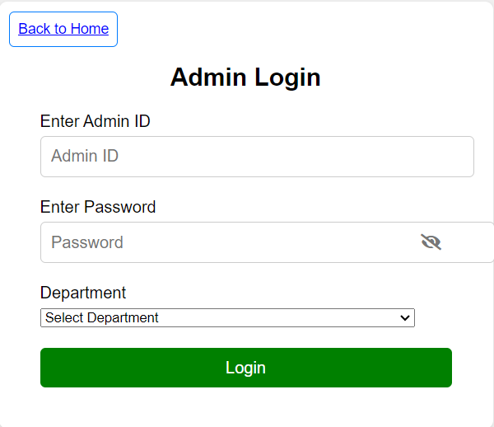

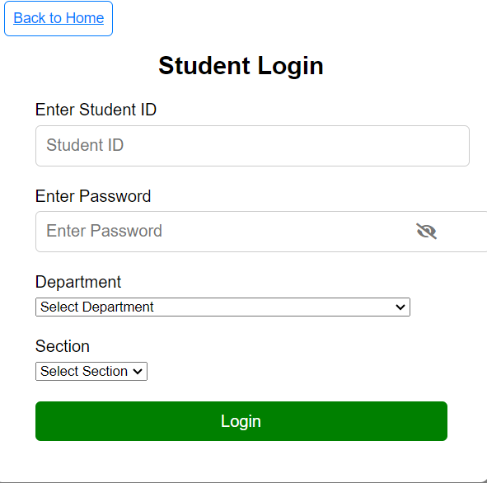
2.2 Administrator Interface and Functionality
This section focuses on the features and functionalities available to administrators within the SRMS. We provide an overview of the administrator interface, which serves as the primary dashboard for managing student results and system settings.
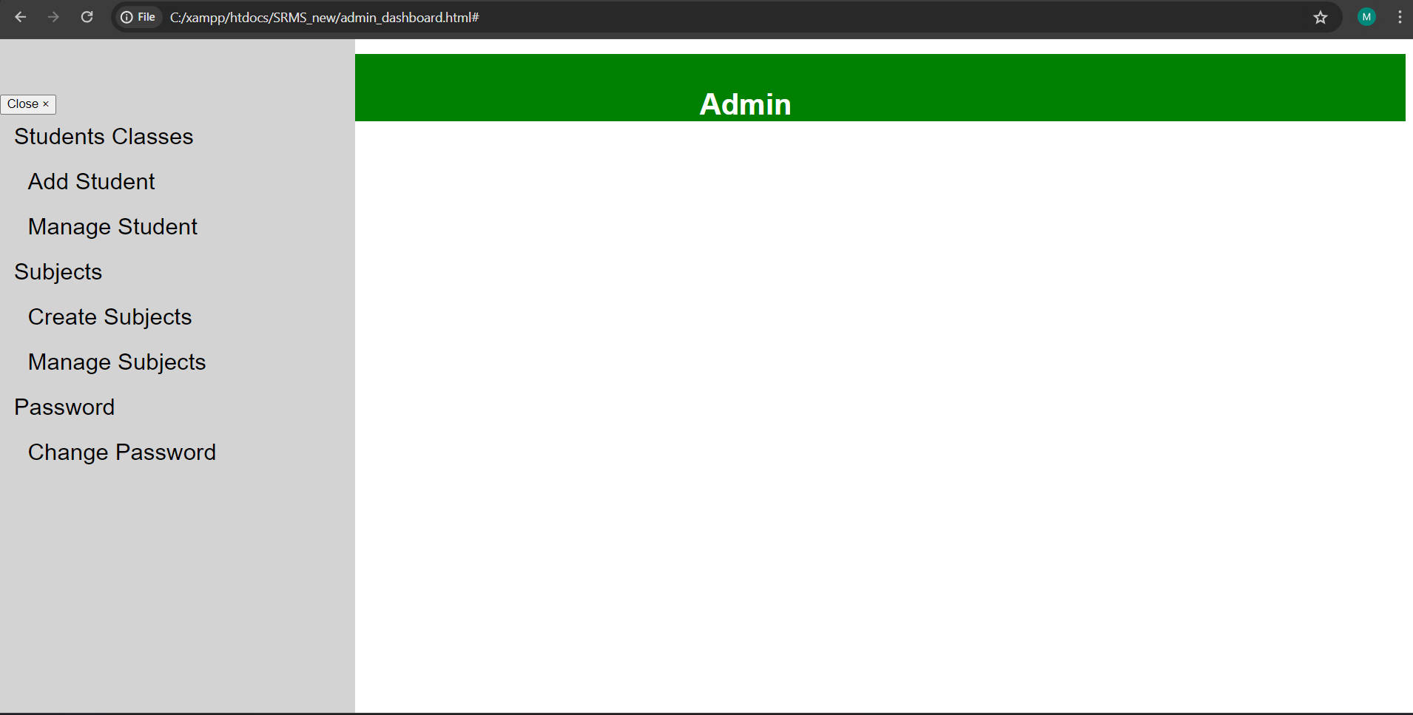
2.2.1 Add Student and Manage Student
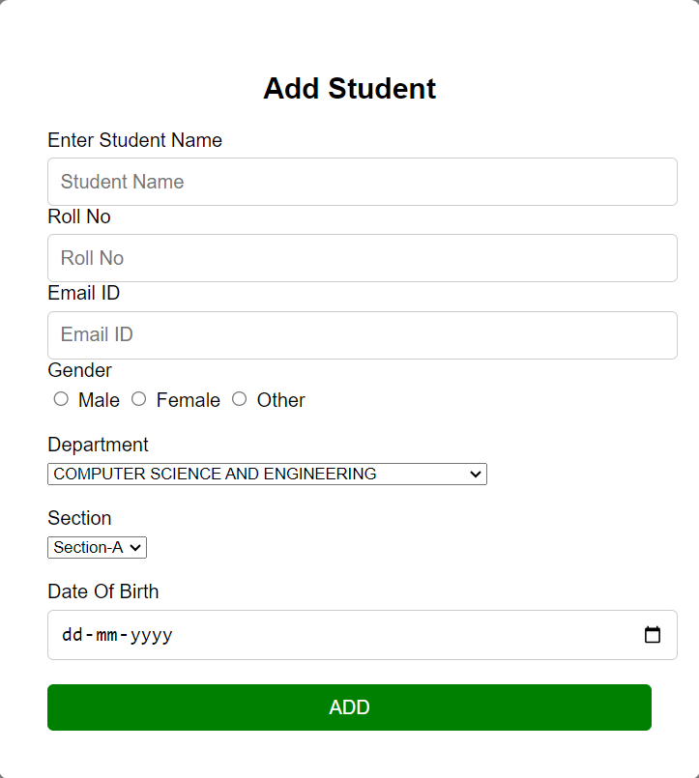
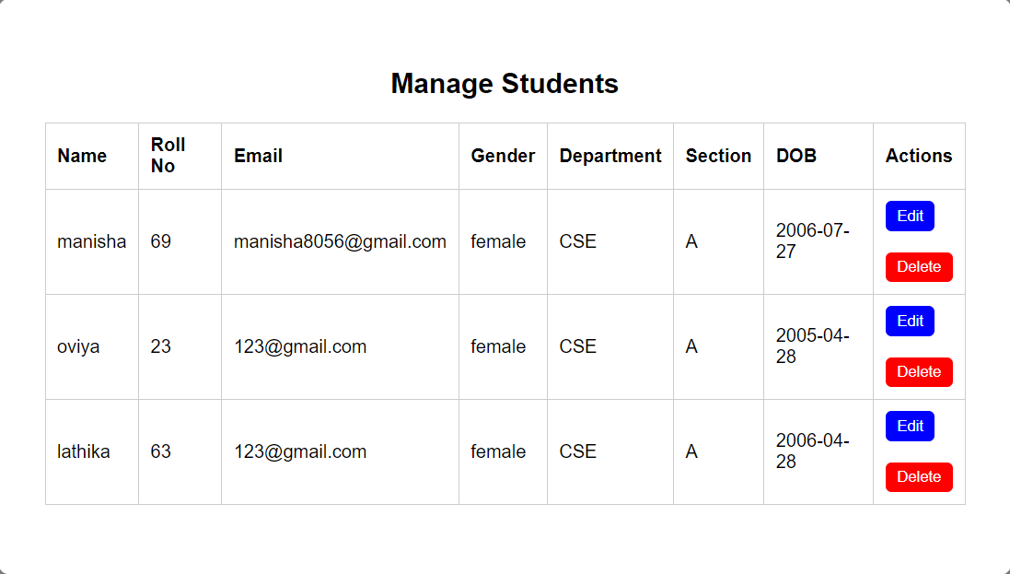

2.2.2 Create Subject and Manage Subject
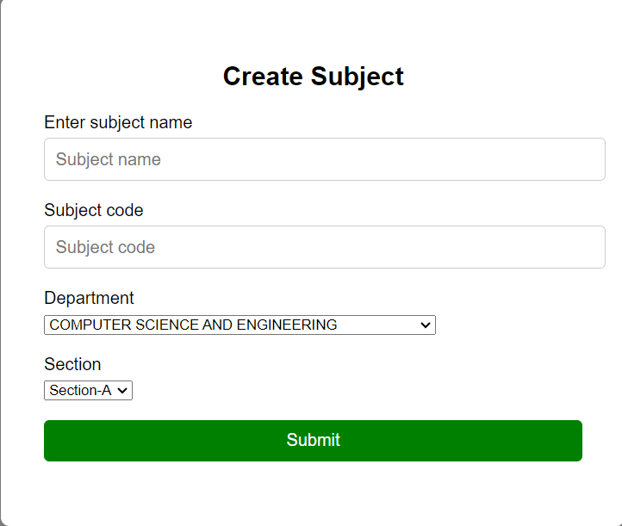
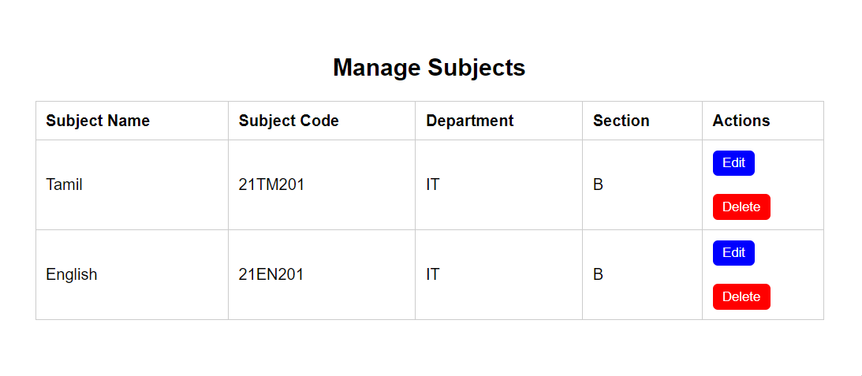2.3 Student Interface and Functionality
This section explores the features and functionalities accessible to students within the SRMS. We provide insights into the student interface, which allows students to view their results, track academic progress, and communicate with instructors.
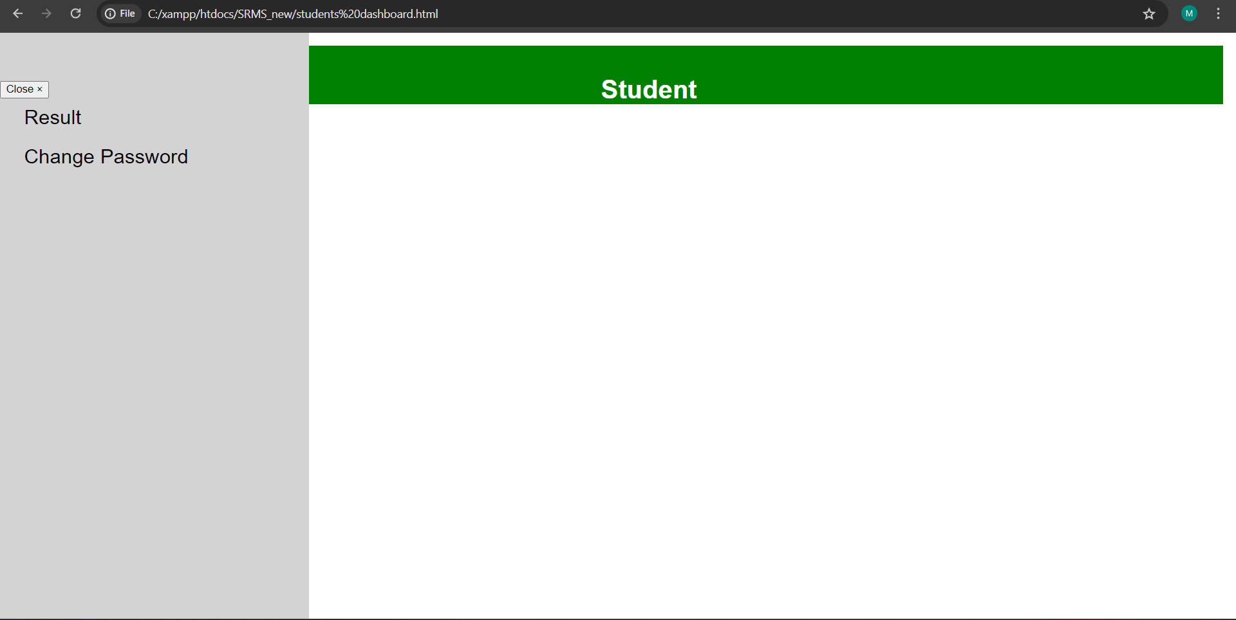
2.3.1 Result Analysis
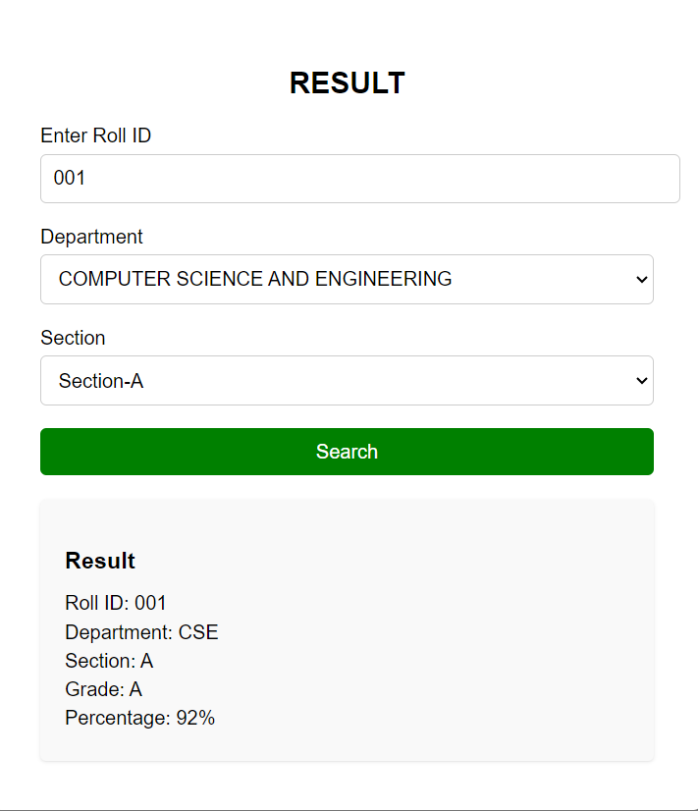

3. CONCLUSIONS

In conclusion, developing a Student Result Management System (SRMS) involves creating a comprehensive solution to efficiently manage and display student results. Through the integration of frontend technologies like HTML and CSS with backend technologies like JavaScript, you can create a dynamic and user-friendly platform for administrators, teachers, and students to access and manage academic data.
The frontend interface provides an intuitive layout for users to view student information, including roll numbers, departments, subjects, grades, and pass percentages. By incorporating responsive design principles, the system ensures accessibility across various devices and screen sizes, enhancing usability for all stakeholders.

ACKNOWLEDGEMENT

We are grateful to our development team for their hard work and to Sri Shakthi Institute of Engineering and Technology for their generous support, which made this project possible.

REFERENCES

1.Akinmosin James (2014). Automated Students Result Management System using Oracle’s Database, Forms and Reports. Journal of Information Engineering and Applications, (Vol 4, No. 11). Retrieved from www.iiste.org.
2.Akpado K., and Agajo J. (2011). Interactive Intranet Portal for Effective Management in Tertiary Institution. International Journal of Advanced Computer Science and Applications, (Vol. 2, No. 6.www.ijacsa.thesai.org.
3. Bijoy C., Sanjay K. P., Bhibak S., Nishal M. and Zarmit L. (2016). Accessing a portion of MIS: Result Management System. International Journal of Engineering Trends and Technology, (Vol. 34, No. 5.www.ijettjournal.or.
4.Duan R. and Zhang M. (2010). Design of Web-based Management Information System for Academic Degree and Graduate Education.
5.Bharaagoudar S. R., Geeta R. B. and Totad S. G. (2013). Web-based Student Information Management System. International Journal of Advanced Research in Computer and Communication Engineering, (Vol.2, Issue Retrieved from www.ijarcce.com.

