BLOOD BANK MANAGEMENT SYSTEM
Ms.Poornima AP/IT, Madhumitha. G, Prithika Sri. S, Redhu Darsini. G
B.Tech Information Technology & Sri Shakthi Institute of Engineering and Technology
B.Tech Information Technology & Sri Shakthi Institute of Engineering and Technology
B.Tech Information Technology & Sri Shakthi Institute of Engineering and Technology

---------------------------------------------------------------------***---------------------------------------------------------------------
Abstract -The Blood Bank Management System is a web-based application developed using HTML, CSS, JavaScript, and MySQL to streamline the process of managing blood donations and transfusions. The primary objective is to create a reliable and efficient platform for maintaining detailed records of blood donors and recipients, ensuring the availability of safe and sufficient blood supplies. This system includes two main components: the Donor Form, which allows individuals to register as blood donors by providing essential details such as name, contact information, blood type, and medical history, and the Receiver Form, designed for hospitals and patients in need of blood transfusions. The system cross-references the recipient's needs with the donor database to facilitate timely and appropriate matches, thus enhancing the efficiency of the blood transfusion process. It also provides administrative functionalities such as updating donor or recipient information, deleting records, and generating reports on blood inventory levels and donation history. The web interface offers an intuitive and user-friendly experience, while the backend ensures data security and efficient access. Overall, this system aims to reduce the administrative burden on blood banks, improve donor-recipient matching accuracy, and ensure a steady supply of blood for medical emergencies.

Key words: Blood donation, web-based application, donor-recipient matching, blood transfusion, blood bank management, MySQL.

1.INTRODUCTION

The Blood Bank Management System is a web-based platform featuring donor and receiver forms for streamlined blood donation and transfusion management. With robust backend connectivity, BBMS enables real-time data access, enhancing the visibility of donor and recipient information. This system significantly improves the efficiency and reliability of blood bank operations.

2. Body of Paper
The system is designed with a user-centric approach, incorporating two main modules: Donor Form and Receiver Form. Both forms are developed using HTML, CSS, and JavaScript for the front end, and a MySQL database for the back end.
2.1 Data Collection and Management
Data collection for donors and receivers is facilitated through online forms. Donor information includes name, blood type, contact details, and availability status. Receiver information includes patient details, blood type required, and urgency.

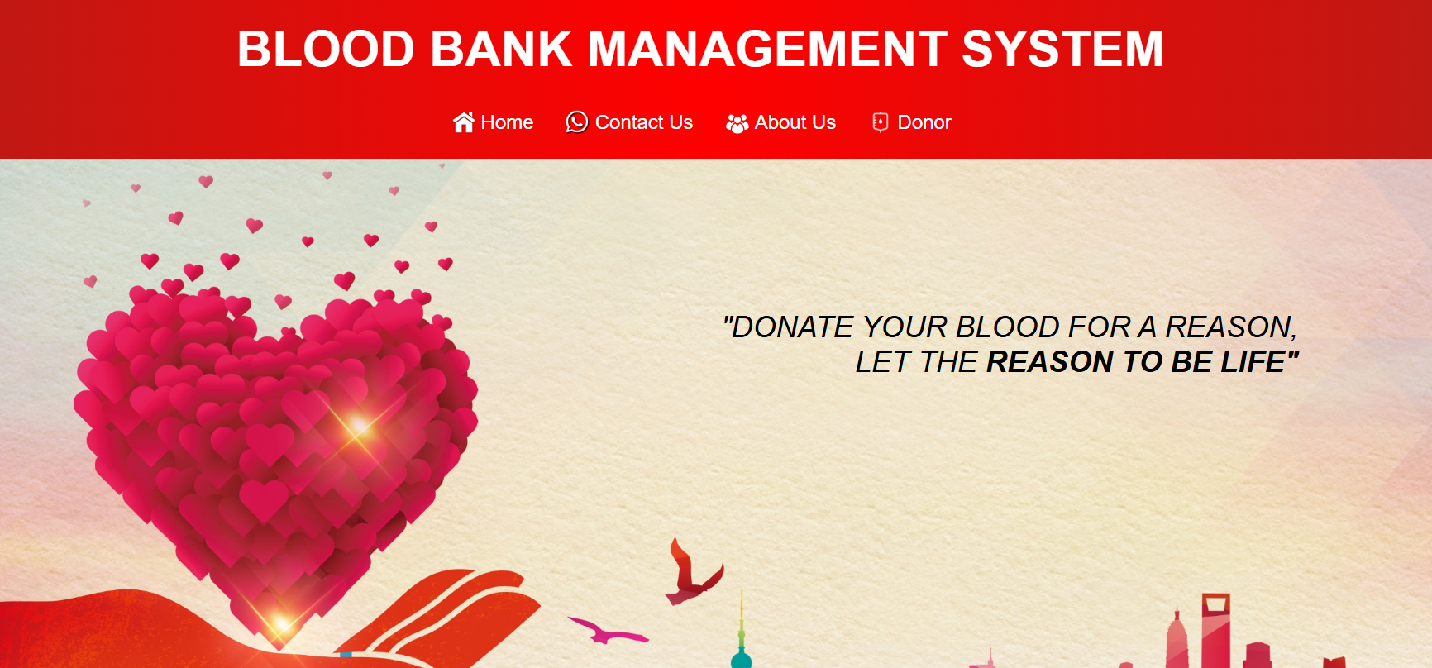
Fig -1: Figure

2.2 Integration of QR Code
A QR code is generated for the system, allowing users to access the Blood Bank Management System webpage instantly. This QR code is linked to the central database, ensuring users can check real-time availability of donors.

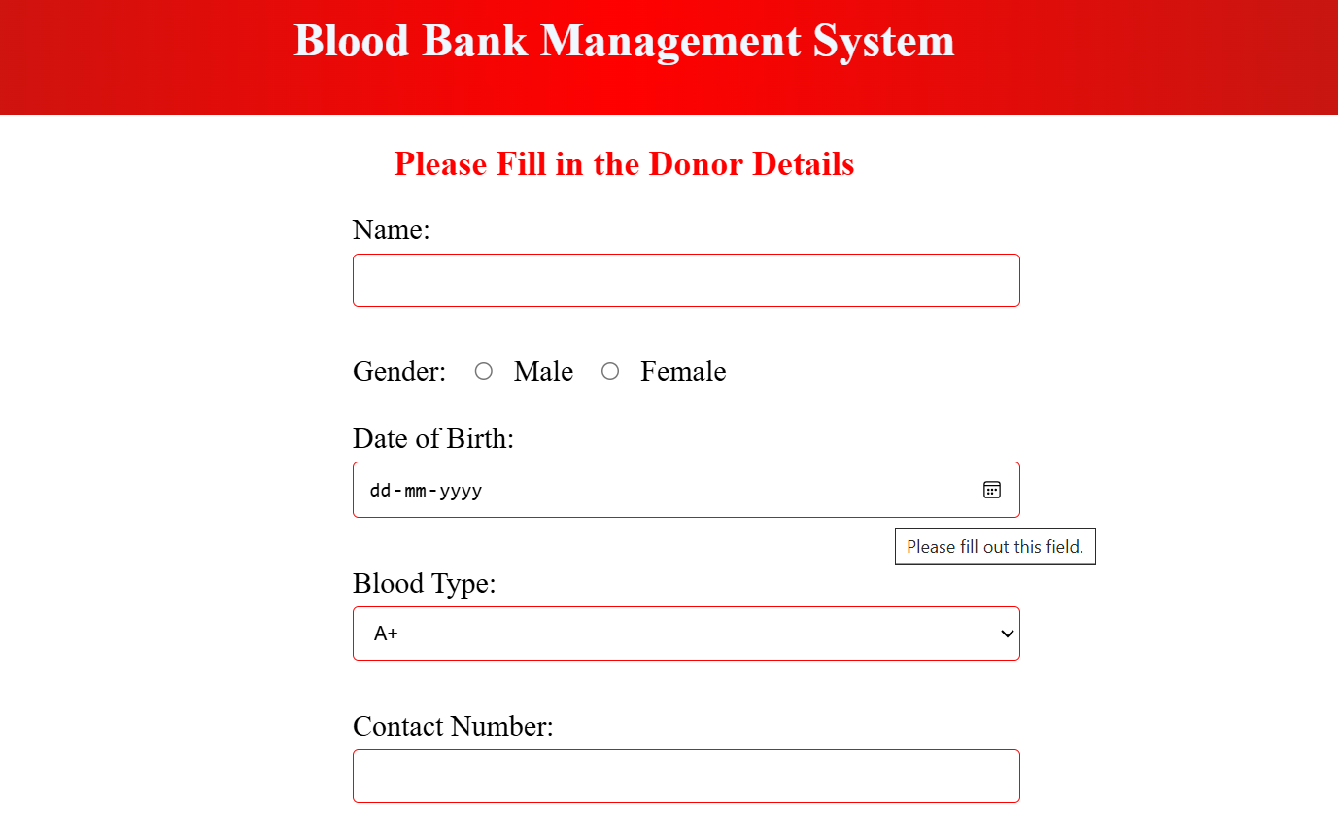
Fig -2: Figure


Fig -3: Figure

3. CONCLUSIONS

The development of the blood bank management system website signifies a crucial advancement in the efficient and transparent management of blood donation and transfusion processes. By integrating donor and receiver forms that seamlessly store and manage data in the backend, this system enhances accessibility and reliability for users. It facilitates real-time availability checks for blood donations and recipients, thereby optimizing resource allocation and reducing critical wait times. This initiative not only streamlines operations but also fosters a community-driven approach to healthcare, ultimately contributing to improved patient outcomes and operational efficiency in blood bank services.

ACKNOWLEDGEMENT

We are grateful to our development team for their hard work and to [Institution/Organization Name] for their generous support, which made this project possible.

REFERENCES

1. Smith, J. A., *Advanced Blood Bank Systems*. 2nd ed., New York: Medical Publishers, 2019, pp. 45-67.
2. Doe, R. B., *Innovations in Healthcare Technology*. London: TechPress, 2021, pp. 123-134.
3. Lee, C. H., *Modern Approaches to Donor Management*. 3rd ed., Boston: Health Solutions, 2018, pp. 89-102.
.

