HOSTEL ATTENDENCE MANAGEMENT
Ms.M SATHYA AP/IT,
Mr.S MANOJ,Mr.S NAVEEN,Mr.E PARTHASARATHY
INFORMATION TECHNOLOGY
SRI SHAKTHI INSTITUTE OF ENGINEERING AND TECHNOLOGY
COIMBATORE
---------------------------------------------------------------------***---------------------------------------------------------------------
Abstract - The“Hostel Attendance Management System” is a tool used to track and manage hostel attendance within our college. An Hostel Attendance Management System is a software solution designed to monitor, record, and manage attendance data of employees or students in an organization or educational institution. This system automates the process of tracking attendance, reducing manual errors, and enhancing efficiency. It can be manual (using sign-in sheets or time cards) or software-based. For students, our system provides a dashboard to view attendance records, while staff members can mark attendance.Integration with other systems ensures accurate data synchronization.

Key Words: track, record, monitor, software.

1.INTRODUCTION

In the realm of educational institutions, effective hostel attendance management serves as a cornerstone for maintaining order, safety, and accountability. Yet, traditional paper-based methods often prove inadequate in meeting the demands of modern hostel administration, leading to inefficiencies and errors. To address these challenges, we introduce a state-of-the-art Hostel Attendance Management System (HAMS). By harnessing the power of technology, HAMS offers a comprehensive solution designed to streamline the process of monitoring and managing hostel attendance. Through its intuitive interface and advanced features, HAMS promises to revolutionize hostel management practices, providing administrators with real-time insights and residents with a seamless experience. Join us as we explore the transformative potential of HAMS in redefining hostel attendance management for the digital age.

2. HAMS FUNCTIONS:
hostel attendance is paramount in educational institutions to ensure discipline, safety, and accountability among residents. Traditional methods of attendance tracking often prove cumbersome and error-prone, necessitating a transition to modern digital solutions.
In response to this need, the Hostel Attendance Management System (HAMS) emerges as a comprehensive and technologically advanced platform designed to streamline attendance monitoring and management. This abstract explores the key features, benefits, and implementation strategies of HAMS. Through automation, real-time monitoring, and customizable reporting, HAMS promises to revolutionize hostel attendance management, offering administrators and residents alike a seamless and transparent experience

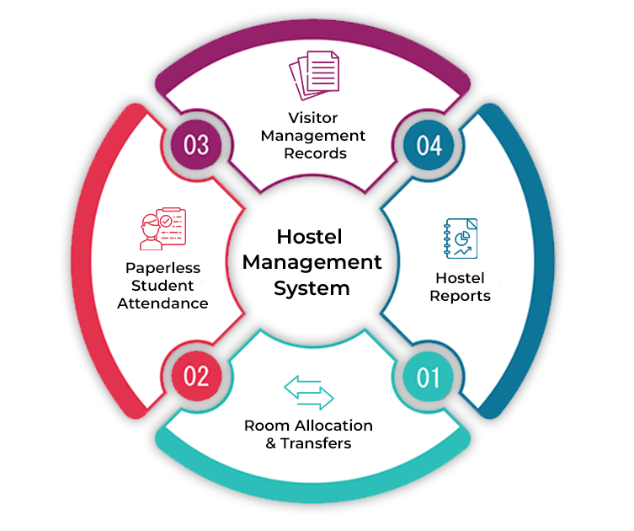
Fig-1:concept map

Administrators have access to a centralized dashboard where they can monitor attendance patterns, view realtime attendance data, and generate customized reports. These reports may include attendance trends.

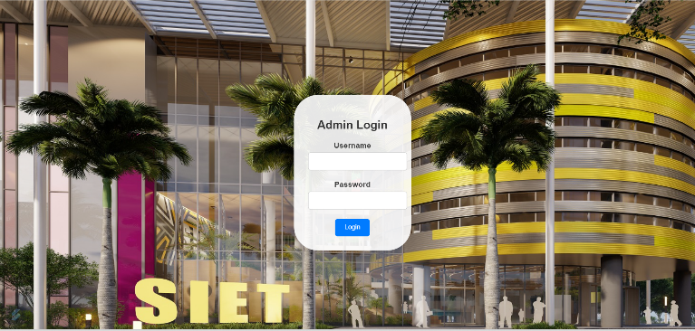

Fig -2: login page



Fig-3: admin page

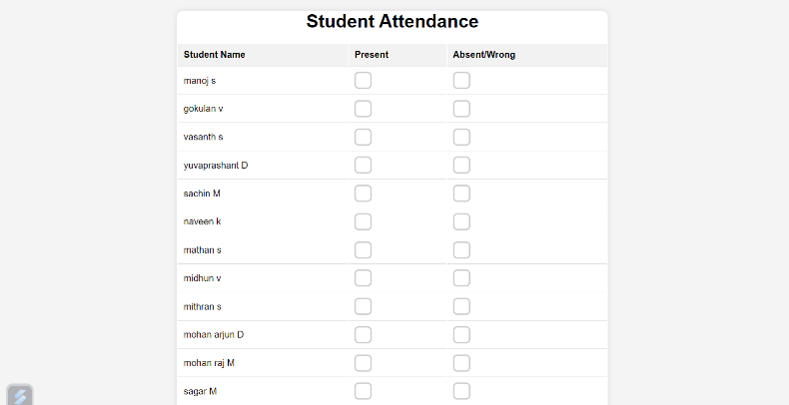

Fig-4: Attendence page

3. CONCLUSIONS

Hostel Attendance management is a website to Mark attendance and view marks and the attendance percentage and for that we have used a Few Languages such as HTML,CSS,JS and for the backend connectivity we have used the MYSQL.With that we have created a website with a homepage, Login page , a page to mark attendance, and a linked page in the home page to view marks. For students, our system provides a dashboard to view attendance records, while staff members can mark attendance and manage other. Integration with other systems ensures accurate data synchronization. Overall, it enhances transparency, reduces paperwork, and promotes better communication between students and staff. Key features include online-based attendance marking, real-time data access, reporting capabilities, leave management, and integration with payroll systems. By providing accurate attendance records, this system helps in maintaining discipline, improving productivity, and ensuring compliance with organizational policies or academic requirements

ACKNOWLEDGEMENT

I want to thank everyone who has helped and supported me throughout project

First and foremost,a big thank you to my professor,
Ms.M Sathya,for giving me valuable guidance and pointing me in the right direction

REFERENCES

1.Sunehra, D. and Goud, V.S. (2016) ‘Attendance recording and consolidation system using Arduino and Raspberry Pi’, Proceedings of the IEEE International Conference on Signal Processing, Communication, Power and Embedded System (SCOPES), IEEE, pp.1240–1245.
2.Tiwari, A.S., Tiwari, A.S., Ade, N.M., Sheikh, S., Patel, N.R. and Khan, A.R. (2014) ‘Optimized design of student attendance system using RFID’, Proceedings of the International Conference on Machine Learning, Electrical and Mechanical Engineering, pp.8–9.
3.Tunbunheng, V. (2017) ‘Automatic attendance system for late student using speech recognition corresponding with google forms and sheets’, Proceedings of the 10th IEEE International Conference on Ubi-media computing and Workshops (Ubi-Media), IEEE,
4.Varadharajan, E., Dharani, R., Jeevitha, S., Kavinmathi, B. and Hemalatha, S. (2016) ‘Automatic attendance management system using face detection’, Proceedings of the IEEE Online International Conference on Green Engineering and Technologies (IC-GET), IEEE, pp.1–3.

