CARTOONIZING THE IMAGE

ABSTRACT

Cartoonifying images is a popular technique in a variety of fields including fields including, graphic design, animation, and video editing. Cartoonifying an image is a process of transforming image into cartoon like drawing. A cartoonified image is a digital image that has been processed to resemble a cartoon drawing. This can be done using variety of methods, but one common approach is to use the OpenCV computer vision library, GAN (Generative Adversarial Network) used to create images that look like photographs of human faces, even though they don’t belong to the real person. Image Processing – In the field of the research processing of an image consisting of identifying an object in an image, identify the dimensions, no of objects, changing the images to blur effect and such effects are highly appreciated in this modern era of media and communication. There are multiple properties in the image processing. Each of the property estimates the image to be produced more with essence and sharper image.

- INTRODUCTION

Cartoons are illustrations of characters that can be imaginary or based on a personality. They are semi-realistic or non-realistic, popular nowadays to depict a situation or a happening in a funny, satirical manner. Animes are so popular that are cartoonized characters. Automation technology is booming nowadays. Human effort reduced to the minimum; with a set of programs doing our job, animation technology has taken a considerable leap. Our job is to make those programs. So, this is a project which converts regular camera clicked images into cartoonized form, created using Python language and relative libraries. In times like today, where technology is taking huge leaps with creative minds improving them day by day. Anime movies take much longer than regular movies in times of VFX effects and animations. The workforce, skillset, and resources in terms of equipped and investment are more than classic movies, so time plays an essential role in creating these movies. For saving time, automation is the best way to go; with improvement in machine learning and artificial intelligence, every production process has improved significantly and improved the quality of the product. Playing, with images is a fun activity, and recently, image processing has outburst social sites, with many people making careers in image processing and enhancement. The OpenCV library works the same thing, and here we get to know the backend procedures of image processing and understand how computer vision works. These filters and techniques improve lost details on older photos, and with a combination of some filters, one of them is converting a black and white image to a coloured one. There are numerous ways to convert a specific photo to a cartoonized one, but the best way is to do a manual with software like Adobe Photoshop, and not everyone has their hands on tools like these, so the users there are limited. Although the output obtained from the manual process is the best, it is time-consuming, and doing it for many images is not efficient. Therefore, systems like these are a go-go for every field as it provides output in seconds with upgrades, the scale will surely improve with even better results. We can do it with a limited number of lines of code in a programming language with better results using OpenCV library and machine learning algorithms in Python. To achieve the basic cartoon effect, we don't need powerful rendering software or even years of experience. All we need is essentially a bilateral filter and some edge detection. Cartoonfying images is a popular technique in a variety of fields including fields including, graphic design, animation, and video editing. Cartoonifying an image is a process of transforming image into cartoon like drawing. A cartoonified image is a digital image that has been processed to resemble a cartoon drawing. This can be done using variety of methods, but one common approach is to use the OpenCV computer vision library, GAN (Generative Adversarial Network) used to create images that look like photographs of human faces, even though they don’t belong to the real person.

- RELATED WORK

- Cartoonizing Techniques:

  - Bilateral Filter: Load the image that is to be converted.It goes through the edge operations to get the effects of a cartoon i.e., to get thicker edges around the object (person, thing, etc.) in the image. Then, reduce the colour palette using OpenCV optimized algorithms.After doing colour quantization, reduce the noise of the image using bilateral filter. It would give a bit blurry and sharpness reducing effect to the image. The last step is to combine the edge mask with the colour processed image.

  - Median Filter: It is a non-linear filtering technique used to remove noise and improve the edge detection result of an image. And preserve the edges of an image during noise removal. Median filters are suitable for handling extreme outlier, which would skew an average. A classic use of the median filter is for removing salt and pepper noise. Intensity calculation of median filter is done by replacing the central pixel of an image with the median value from a sorted window. In this, a positive odd integer is used for the kernel size.

  - OpenCV: OpenCV is an open-source library in python that is used mainly for computer vision tasks in the areas of machine learning and artificial intelligence. Nowadays, OpenCV is playing a major role in the field of technology. Using OpenCV we can process images and videos for some tasks like object detection, face detection, object tracking, and all. OpenCV has C, C++, java, and python interfaces and it supports all kinds of systems such as Windows, Linux, Android, Mac OS, IOS, and all.

  - Flask: We have two basic folders that flask app requires i.e., static and templates folder. The static folder contains basic CSS files, images for giving style while designing the user interface of the web app whereas templates folder contains all the HTML pages of the web app. Apart from that we have two other folders i.e., cartoon images where the output of image stylization will be stored whereas uploads folder contains those images which will be uploaded using uploader for applying image stylization. The home page of our web app is index.html where we will actually upload the image for stylization and also choose which stylization we want for our uploaded image. So, now we will run this web app by executing command python app.py in the terminal. After executing the command the web app will be available on localhost:8080.

  - White-box Technique: It is the fastest among four methods on all devices and all resolutions, and has the smallest model size. Especially, this model can process a 720*1280 image on GPU within only 17.23ms, which enables it for real-time High-Resolution video processing tasks. This model applied on diverse real-world scenes, including natural landscape, city views, people, animals, and plants.

1.6 Realistic Images into Cartoon Images using GAN:
Cartoonfying images is a popular technique in a variety of fields including fields including, graphic design, animation, and video editing. Cartoonifying an image is a process of transforming image into cartoon like drawing. A cartoonified image is a digital image that has been processed to resemble a cartoon drawing. This can be done using variety of methods, but one common approach is to use the OpenCV computer vision library, GAN (Generative Adversarial Network) used to create images that look like photographs of human faces, even though they don’t belong to the real person.

- Applications
Cartoonization, the process of converting images and videos into cartoon-like representations, finds diverse applications across multiple fields. In entertainment and media, it enhances animation, video games, and social media filters. Advertising and marketing utilize cartoonization for engaging brand promotion and product packaging. Educational tools and e-learning benefit from simplified, engaging visual content. Digital art, graphic design, and personal use applications include custom portraits and social media avatars. Healthcare uses cartoonized content for therapeutic and educational purposes. In retail, product visualization is enhanced, while film, photography, VR, and AR industries leverage cartoonization for stylized content creation and immersive experiences, respectively. These applications demonstrate the broad utility and appeal of cartoonization in creating visually engaging, accessible, and memorable content.

C. Experiments:
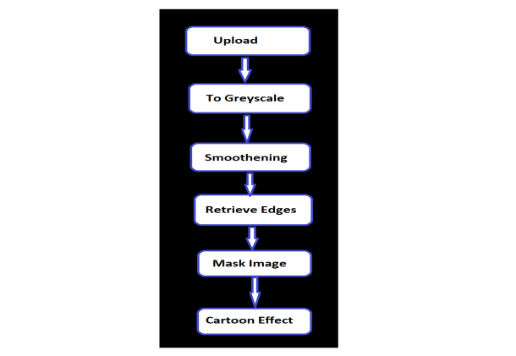

First of all using easygui, we will upload the image, and then the image is converted to a greyscale image.
The next two steps are the important steps to converting images into cartoon images. They are smoothening and then retrieving the edges. In this color of the image is smoothened to give the cartoon look and then we retrieve the edges and then highlight them in the final image.
Next, we will prepare a mask Image. In this, we use the bilateral filter with removes the noise and smoothen it to some extent. Now the final step is giving the cartoon effect. To the image which we got in the previous step,

D.OBJECTIVES:
• The outcome of the project is to cartoonize images with high quality. The characteristics of cartoon images, such as simplified shapes, bold colors, and exaggerated features. It was also able to generalize well to different types of images, including faces, objects, and scenes.
• The project has the potential to be used in a variety of applications, such as social media filters, photo editing software, animation production, medical imaging.
• The advantages of cartoonization include the ability to generate cartoonized images that are more realistic and visually appealing than traditional methods, as well as the ability to automate the process of cartoonization.
•Data Compression: Simplifying complex images into cartoon-like representations for efficient storage or transmission while retVisual Appeal: Creating a more visually appealing or artistic representation of an image by converting it into a cartoon style.
•Personalization: Making personalized avatars, profile pictures, or artisticrenditions for social media, forums, or gamingplatforms.
aining essential features.
•Anonymity or Privacy: Concealing or distorting facial features while maintaining a recognizable or entertaining representation.

- OUTCOME:

- FUTURE SCOPE:

- CONCLUSION:

- REFERENCES:

