Dr S Prakash S¹ ,Srinivasan D² , Vibin Richard D³ , Thikanthra G⁴
¹Prakash S Information technology & Sri Shakthi Institute of Engineering and Technology.
²Srinivasan D Information technology & Sri Shakthi Institute of Engineering and Technology.
³Vibin Richard Information technology & Sri Shakthi Institute of Engineering and Technology.
⁴Thikanthra Information technology & Sri Shakthi Institute of Engineering and Technology.

---------------------------------------------------------------------***---------------------------------------------------------------------

Abstract -
Managing tasks and activities within a college campus setting presents unique challenges due to the diverse range of activities, stakeholders, and deadlines involved. To address this, the SIET Task Management System (SIET) offers a robust solution tailored to the specific needs of campus environments. Key functionalities of SIET include event scheduling, resource allocation, real-time updates, communication tools, and analytics capabilities. These features facilitate seamless coordination and collaboration among campus stakeholders, fostering a culture of efficiency and accountability. By streamlining task management processes and promoting transparent communication, SIET empowers college communities to achieve their goals effectively and efficiently. Its implementation has the potential to revolutionize campus operations, enhance student engagement, and improve overall organizational effectiveness. In summary, SIET represents a transformative tool for enhancing productivity and collaboration within college campuses. By harnessing the power of technology to streamline task management, SIET enables colleges to adapt to the evolving needs of their communities and foster a culture of excellence and innovation.
INTRODUCTION- Effective SIET task management is the cornerstone of productivity and success in any organization, be it a small business, a large corporation, or an academic institution. A proper SIET Task Management System (SIET TMS) serves as the backbone of efficient operations, enabling teams to organize, prioritize, and execute tasks systematically. In today's fast-pace and interconnected world, where deadlines loom large and resources are limited, the need for a robust SIET TMS has never been greater. A proper SIET TMS goes beyond simple to-do lists and spreadsheets, offering a comprehensive platform that centralizes task-related information, facilitates collaboration, and provides insights for informed decision-making.

PROPOSED SYSTEM:
TASK MANAGEMENT SYSTEMS
Task management systems are integral tools used by individuals, teams, and organizations to organize, prioritize, and track tasks and projects efficiently. This paper provides an overview of task management systems, encompassing their functionalities, benefits, and key components.
FLOWCHART:
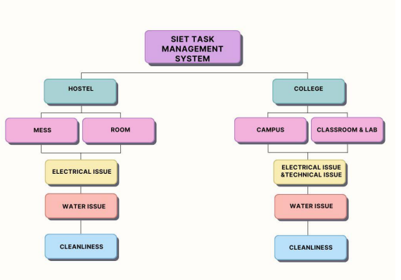

SOFTWARE REQUIREMENTS:
❖ HTML
❖ CSS
❖ JAVASCRIPT
❖ PHP
❖ MYSQL

OUTPUT:
HOME PAGE:

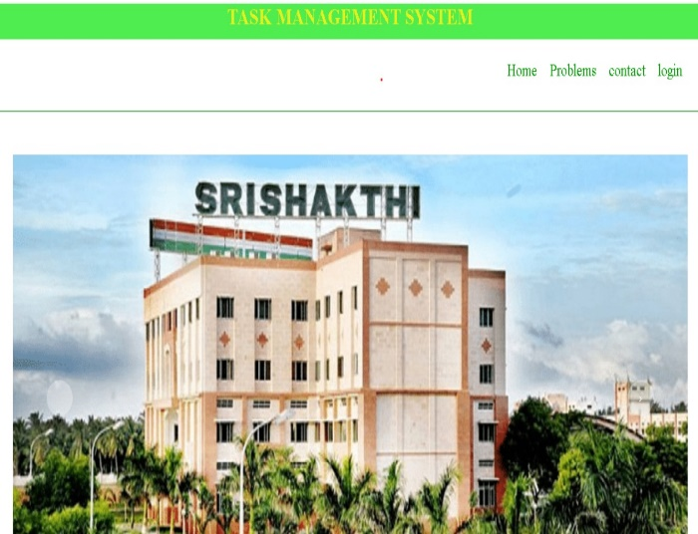
LOGIN PAGE:
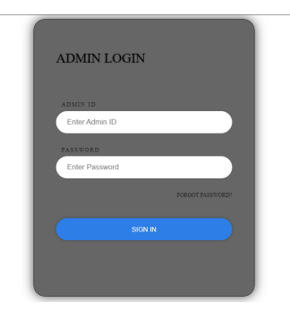
MAIN PAGE:
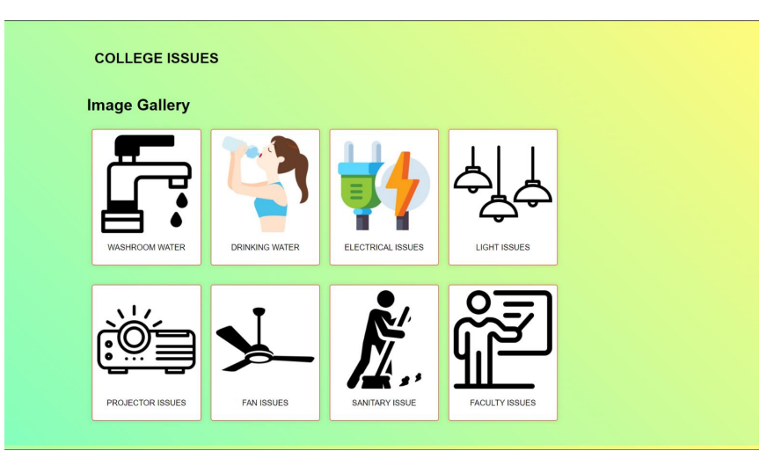

COMMENT PAGE:

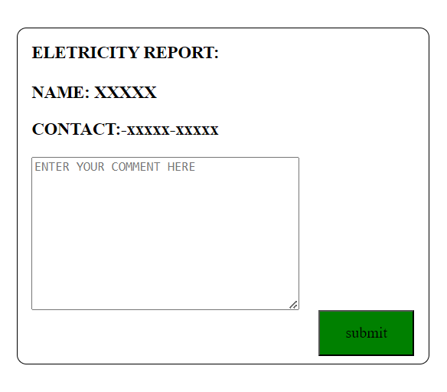
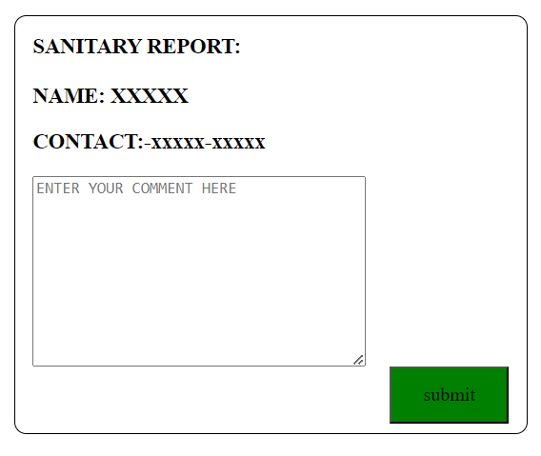
BACKEND RESPONSE PAGE:
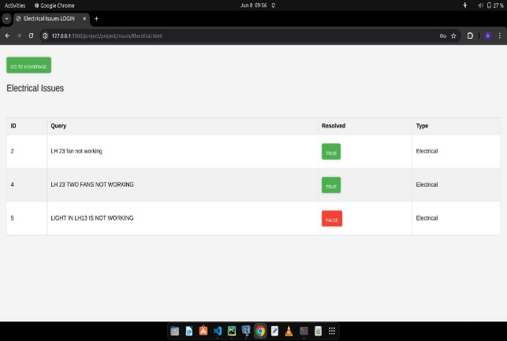

CONCLUSION:
In conclusion, the development of the CLG Task Management System represents a significant step towards enhancing organizational efficiency and productivity. Through its user-friendly interface, robust features, and seamless integration capabilities, the system streamlines task allocation, tracking, and collaboration processes. With further refinement and user feedback incorporation, the CLG Task Management System is poised to become an indispensable tool for optimizing workflow management and achieving project success.
REFERENCE:
1.Kasmawahida Ab Wahab, School of Computing & Analytics, Faculty of Science ,Engineering & Agrotechnology, University College of Yayasan Pahang, Taman Gelora Campus, 25050 Kuantan, Pahang, Malaysia
2. Online Task Management System (OTMS), GRISHMA HEDAOO1, PRIYANKA THOKE2, RAKSHA TABHANE3, SHUBHAM MESHRAM4 ,SWAPNILKUMBHALKAR5, PROF. MUKESH BARAPATRE , S. B. Jain Institute of Technology, Management and Research, Nagpur, India
3. Author={Bellotti, Victoria and Dalal, Brinda and Good, Nathaniel and Flynn, Peter and Bobrow, Daniel and Ducheneaut , Nicolas},year = {2004},month = {04},pages = {735-742},title = {What a to-do: studies of task management towards the design of a personal task list manager},volume={24–29},journal = {Proceedings of CHI, Vienna, Austria}

