Online Auction (AUCTION.in)
Ms.POORNIMA SENTHIL
R LOGU AJITH KUMAR, S NAVANEETH KUMAR, K PARTHA SARATHI
INFORMATION TECHNOLOGY
SRI SHAKTHI INSTITUTE OF ENGINEERING AND TECHNOLOGY
COIMBATORE
---------------------------------------------------------------------***---------------------------------------------------------------------
Abstract - Biddings are among the oldest economic institutions in place. They have been used since antiquity to sell a wide variety of goods, and their basic form has remained unchanged. In this dissertation, we explore the efficiency of common Biddings when values are interdependent- the value to a particular bidder may depend on information available only to others-and asymmetric. In this setting, it is well known that sealed-bid .Biddings do not achieve efficient allocations in general since they do not allow the information held by different bidders to be shared.Typically, in a Bidding, say of the kind used to sell art, the Bidding sets a relatively low initial price.

Key Words: Bidding , Goods, Price.

1.INTRODUCTION :

Online Bidding is a group which is based for auction. If you want to \something sells by Bidding then you post that on website. It just a selling of products. This project user can do a bid on products. The main objective of the e-Bidding process must be to obtain best value and the highest price. It cannot be possible to achieve best value outcomes whilst the focus remains on price. There are two categories of persons one is customers and second one is vendor. Vendor can sell his products on this website and customer will purchase it. Product will be given to thosOe customers who put a high bid price on product to purchase. One user can do a more than one bid on products. There are two categories of persons one is customers and second one is vendor. Both have their own registration form. There is a common login page for vendors and for users but when both login in, it would be easily found out that ether it is a vendor or a user. There are two home pages i.e., one page behaves different if vendor login then show the vendor’s menu or if customer will login then customer menu will show.
Customers should have an appropriate knowledge of the e- Bidding subject its market, its market price. In this website anyone wants to sell products will have to register first then a unique id is given to the registered users. After registered user have to give details of their products like (price of product, at what price he/she wants to start the bid, image of the product) if he/she wants to sell his/her product .Product will be given to that customer who put a high bid price on product to purchase.
One user can do a more than one bid on products. After completion of bidding process all the bids are check and the product will give to that customer for purchase who has a high bid price. The bidding exercise will have a specified opening and closing time. The E-Bidding will close when no new bids are received, and the closing time has expired. If, however, a new (lower) bid is received just before the Scheduled closing time, the allocated bidding time will be extended.If user have problem related and wanted to know that what is e-Bidding they can contacts the experts through contact details given on website. Online Bidding isloaded with features and functionality that allows you to create a Bidding that is powerful and useful for buyers and sellers.

2. Auction.in :

The popularity of auctions has long roots and is widespread in the culture of trade in different markets and countries. Initially, the word "auction" implied a public sale of goods, securities, works of art, and other objects, which is carried out according to predetermined auction rules.
The principle common to all auctions is the competition between potential buyers. During the process of competition between buyers for the right to purchase goods, the auction winner is revealed. The winner of the auction is the person who won the auction in accordance with its rules. In this case, the object is acquired by the auction winner

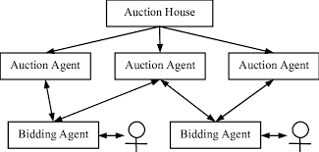

Fig-1: Concept Map

Auction.in helps you to learn about all the process of the auction and helps you to evaluate your own self with others who also use this website. This website allows you to Sell, Buy and admin the auction of website.This also helps you to manage the money transaction of your things or product .The levels are in this website makes you to access easy and move to the next one by within a second .
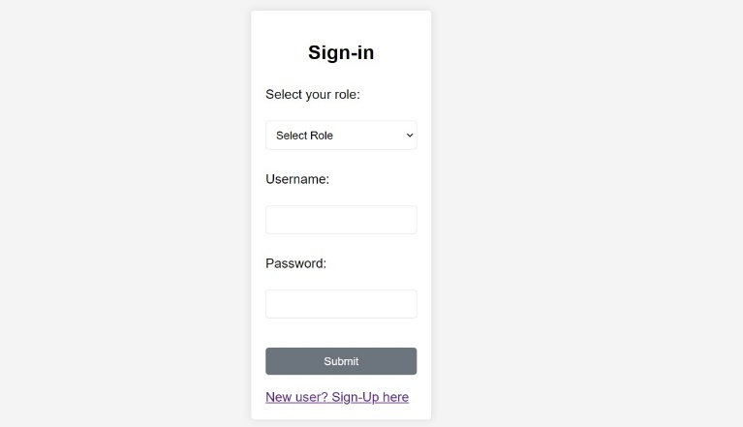
Fig-2: Home Page


Fig -3: Information



Fig-3:Seller Module

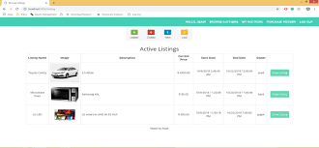

Fig-4:Buyer Module

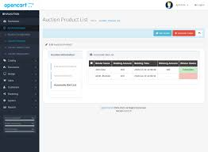

Fig-5:Admin Module

Fig-6:Contact Page

3. CONCLUSIONS

Online Auction Portal is a new experience and has greatly impacted the lives of consumers in its short time ofexistence. Online auction portal has made consumers more effective and efficientin their behavior and has driven businesses to a new level,forcing many to make the necessary adjustments and changes to reach the new market of knowledgeable consumer

ACKNOWLEDGEMENT

We extend our heartfelt gratitude to our developing team for their hard work and to Sri Shakthi Institute of Engineering and Technology for their generous support which made project possible .

REFERENCES

- Anthony, P.; Jennings, N. R.: Developing a Bidding Agent for Multiple Heterogeneous Auctions. In: ACM Transactions on Internet Technology (TOIT) 3(3). 2003. S. 185–217.
- Bapna, R.; Goes, P.; Gupta, A.: Insights and analyses of online auctions. In: Communications of the ACM 44(11). 2001. S. 42–50.

