Learnorama(LEARNORAMA.in)
Sugashini K(AP/IT )
Nandha kumar S, Nesly Jeniston M, Rithish.R,
INFORMATION TECHNOLOGY
SRI SHAKTHI INSTITUTE OF ENGINEERING AND TECHNOLOGY
COIMBATORE
---------------------------------------------------------------------***---------------------------------------------------------------------
Abstract - Learnorama is a web application designed to engage users by offering quizzes on various topics. Users can test their knowledge, learn new facts, and have fun while answering questions. The portal typically includes features like user registration, question banks, scoring, and feedback. To create a quiz portal, it is an innovative online platform designed to facilitate engaging and interactive knowledge assessment. In today's fast-paced world, continuous learning and evaluation are essential for personal and professional growth. Quiz Portal offers a user-friendly interface with a diverse range of quizzes covering various topics, from general knowledge to specialized subjects.

Key Words: innovative , interactive knowledge assessment , online platform.

1.INTRODUCTION :

Learnorama Quiz Portal is an innovative web application designed to provide users with an engaging and interactive platform for testing their knowledge and learning new facts. This project leverages HTML, CSS, and JavaScript to create a dynamic and user-friendly environment where individuals of all ages can explore a diverse range of quiz topics. By focusing on a seamless user experience, robust security measures, and comprehensive content coverage, Learnorama aims to fill the gaps left by existing quiz platforms. Our goal is to foster continuous learning, encourage self-improvement, and offer a fun and educational activity that can be enjoyed by everyone. Through regular updates and the integration of modern technologies, we are committed to maintaining the platform's relevance and effectiveness in promoting knowledge and education.

In addition to quizzes, Learnorama will feature gamification elements like badges and leaderboards to keep users motivated. Users will also benefit from personalized feedback that helps them understand their strengths and areas for improvement. The platform's modular design ensures easy scalability and the addition of new features over time. Our commitment to accessibility will ensure that Learnorama is usable by people with varying abilities. Ultimately, Learnorama aims to build a community of curious learners who are eager to expand their horizons.

2. Body of Paper :

Learnorama is an innovative quiz portal designed to help users improve their skills in MS Word and Excel. The platform offers a comprehensive range of interactive quizzes and games that cater to different levels of proficiency, from beginner to advanced. With Learnorama, users can assess their knowledge and understanding of various MS Word and Excel features, including document formatting, spreadsheet management, and data analysis. The quiz portal features a vast collection of quizzes covering various aspects of MS Word and Excel, such as text editing, table management, chart creation, and formula application. These quizzes test users' skills and knowledge in a realistic and practical way, providing instant feedback and results.

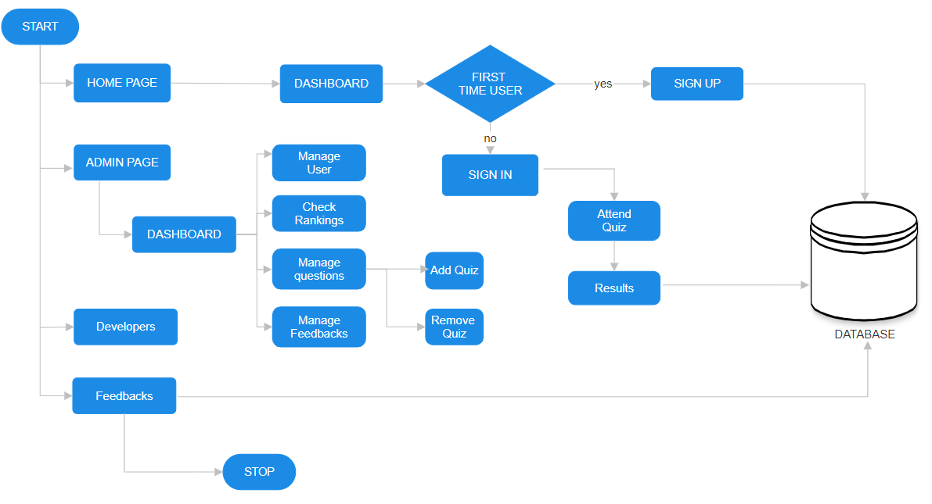
Fig-1: Concept Map

Additionally, Learnorama offers personalized learning recommendations based on users' performance, helping them identify areas of improvement and focus their learning efforts. Whether you're a student seeking to reinforce your knowledge, a professional aiming to enhance your skills, or simply an enthusiast hungry for new insights, Learnorama provides the tools and resources to support your educational endeavors. 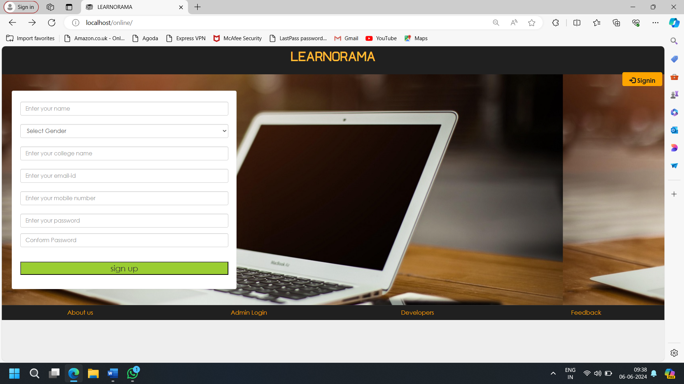
Fig-2: Home Page
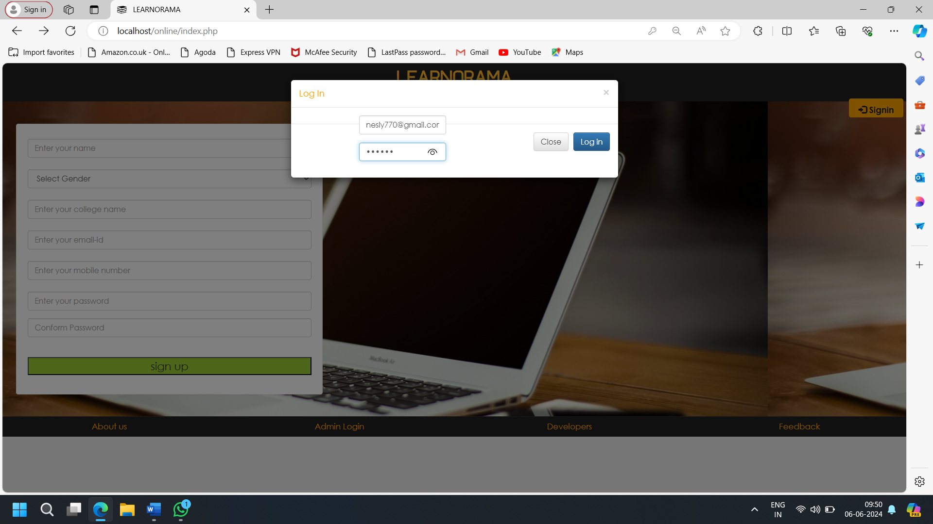

Fig -3: Login page

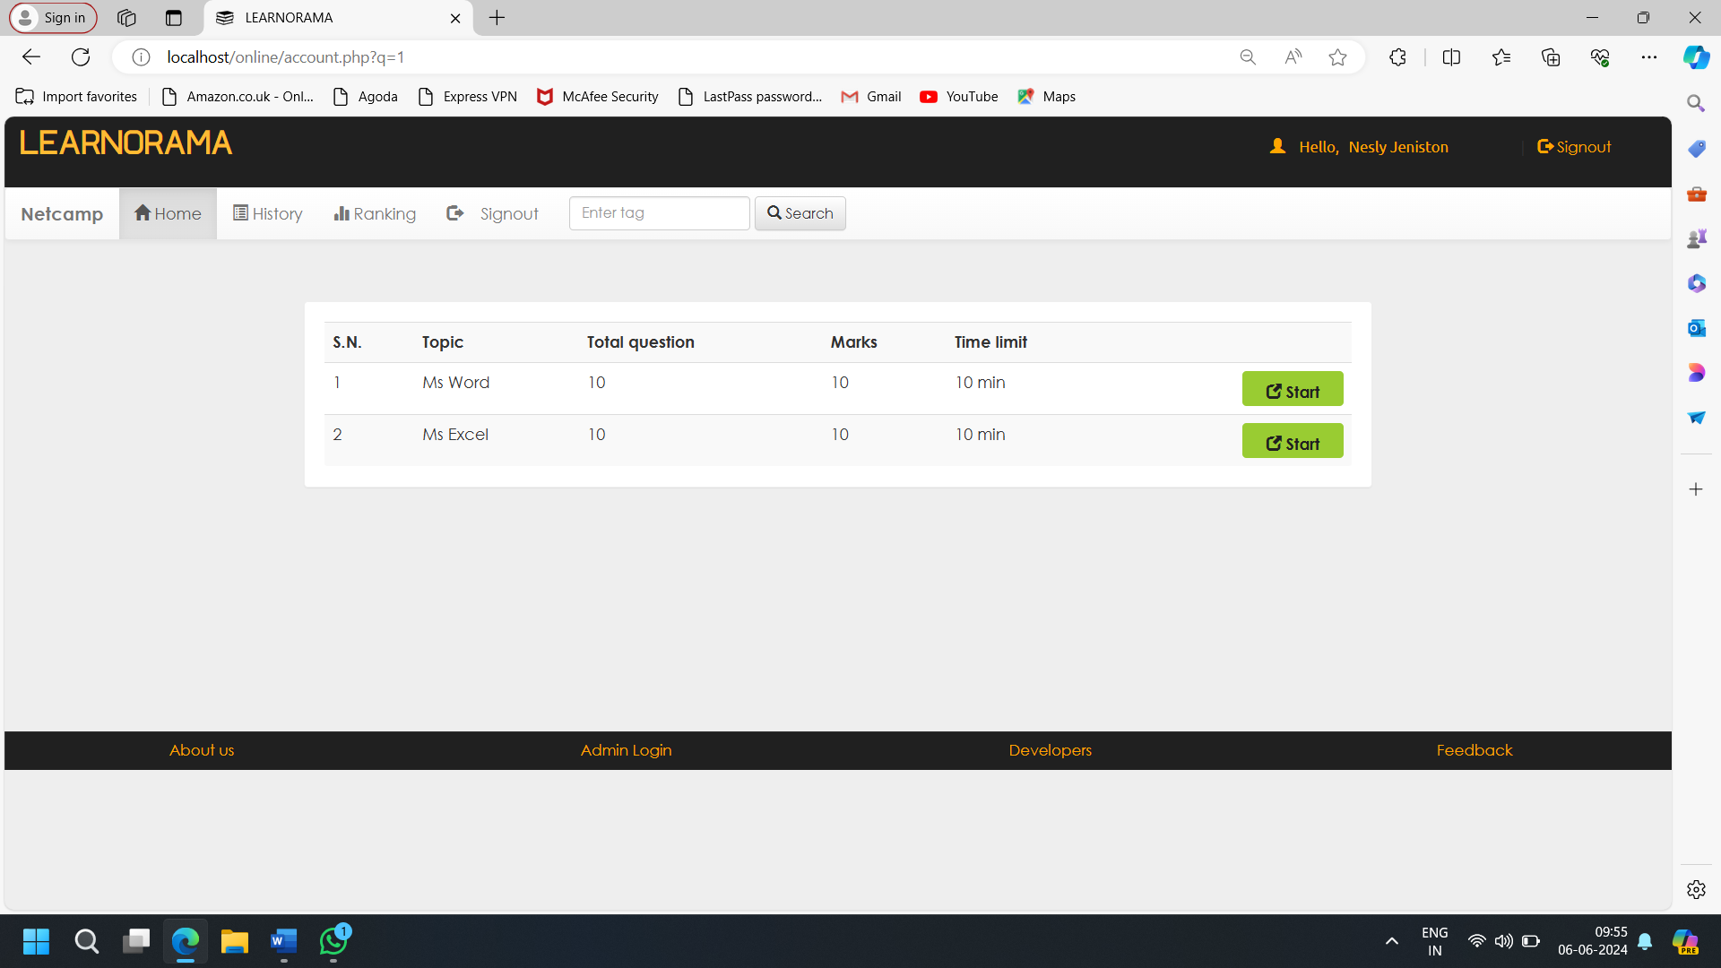

Fig-3:Dashboard page

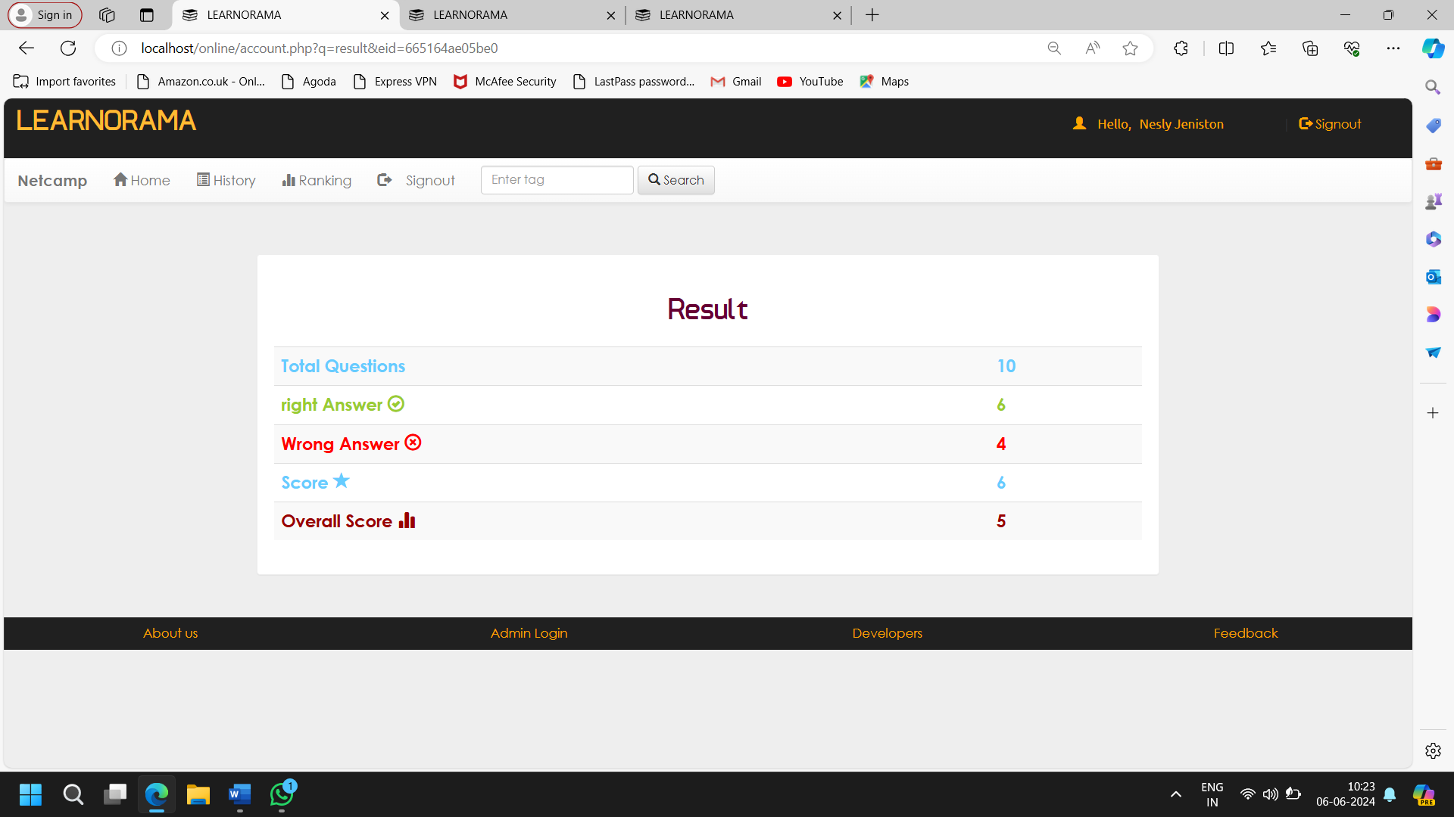

Fig-4:Result Page

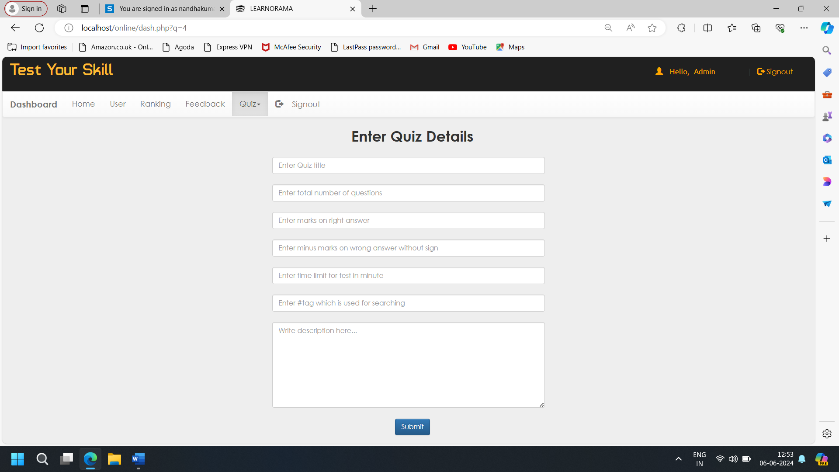

Fig-5:Admin Page

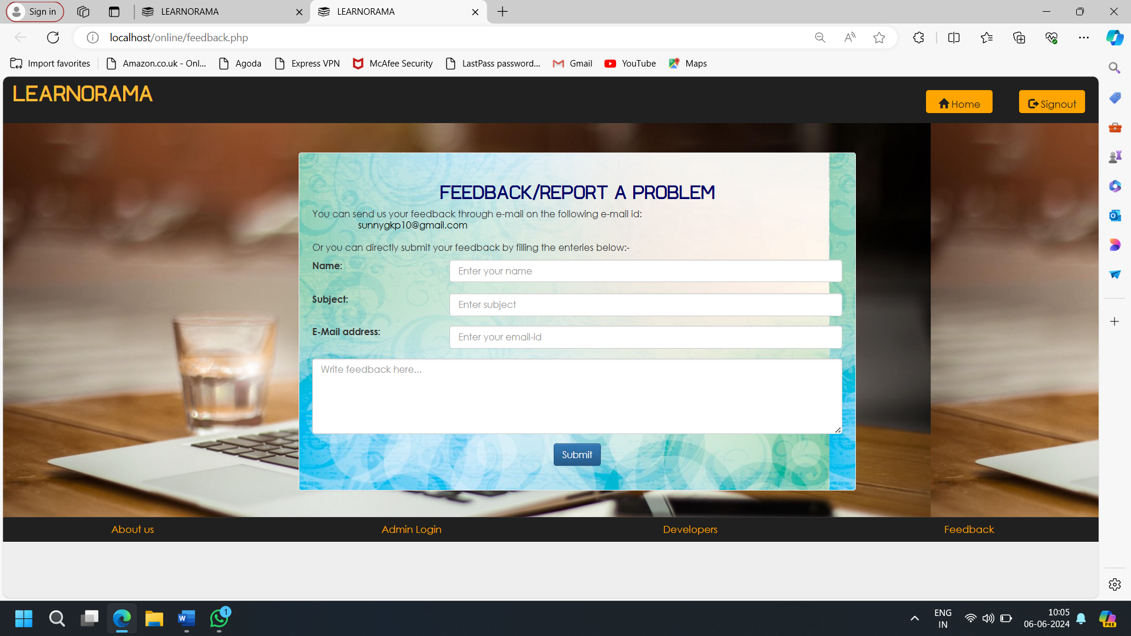
Fig-6:Feedback Page

3. CONCLUSIONS

Quiz applications are a fantastic way to engage and entertain users on websites. Whether you want to test knowledge, provide educational content, or simply offer a fun activity.Our commitment to excellence, innovation, and community engagement ensures that learners of all ages and backgrounds can thrive in their pursuit of knowledge. our documentation provides a detailed overview of our quiz website's development process, features, and functionality. We've focused on creating a user-friendly, secure, and engaging platform, adhering to industry standards and best practices. Moving forward, we're committed to improving the user experience, adding new features, and ensuring the ongoing success of our website.
ACKNOWLEDGEMENT

We extend our heartfelt gratitude to our honourable Chairman, Dr. S. Thangavelu for providing a wonderful platform to educate our minds, inculcate ideas and implement the technological changes in the real-world environment.

Deepest thanks to our dynamic Joint Secretary, Mr. T. Sheelan for monitoring the infrastructure and for providing the work atmosphere to implement the project and providing an excellent and maintaining the decorum and discipline of the students.
We are tremendously thankful to our beloved Principal, Dr.D. Elangovan,M.E.,Ph.D. for his incredible support to make us follow ethics and morality in our life and also for allocating sufficient time and resources.

A big salute to our vibrant Head of the Department, Dr. S. Prakash for imbibing scope of the project and systematic procedure in execution. We express our genuine thanks for encouraging us throughout the project period to complete it successfully.

Our great thanks to the Project mentor, Mrs.K.Sugashini for her ever lasting contribution in making the project a smooth journey and also for her valuable guidance and for making us realize our potential and be successful.

Our great thanks to the Project Co-Ordinator, Dr. M. Deepa for her ever lasting contribution in making the final year project phase a smooth journey and also for her valuable guidance and for making us realize our potential and be successful. We also thanks for her kind help and Cooperation throughout the research period to make us a grant successful completion of project.
REFERENCES
- Faulkner, Ash. (2022). Financial literacy resources in US public libraries: website analysis. Reference Services Review. 50. 10.1108/RSR-02-2022-0008.
- Pšenák, Peter & Ildikó, Pšenáková & Szabo, Tibor & Kovac, Urban. (2019). The Interactive Web Applications in Financial Literacy Teaching. 661-666. 10.1109/ICETA48886.2019.9040011.
- D. L. Remund, “Financial Literacy Explicated: The Case for a Clearer Definition in an Increasingly Complex Economy,”
- Journal of Consumer Affairs, vol. 44, no. 2, pp. 276–295, 2010.
L. Klapper, A. Lusardi, and P. van Oudheusden, “Financial
Literacy Around the World:” p. 28.
- K. Rentková, Ľ. Mitková, and V. Mariak, “Financial (i)literacy: does the financial advisor help?” in Leadership & management: integrated politics of research and innovations : LIMEN 2018, Belgrade: Association of Economists and Managers of the Balkans, 2018, pp. 166–172.

