CHAPTER 1
INTRODUCTION
A chatbot is an AI-driven software designed to simulate human conversation, allowing users to interact with digital systems through text or voice. Utilizing natural language processing (NLP) and machine learning algorithms, chatbots can understand and respond to queries in real-time. They are employed in various domains such as customer service, virtual assistants, and information retrieval. Chatbots can operate on websites, messaging apps, and smart devices, offering users a convenient and efficient means to obtain information, perform tasks, or solve problems. Their ability to handle repetitive queries allows businesses to enhance user experience and streamline operations.Chatbots boost operational efficiency and bring cost savings to businesses while offering convenience and added services to internal employees and external customers. They allow companies to easily resolve many types of customer queries and issues while reducing the need for human interaction.
With chatbots, a business can scale, personalize, and be proactive all at the same time—which is an important differentiator. For example, when relying solely on human power, a business can serve a limited number of people at one time. To be cost-effective, human-powered businesses are forced to focus on standardized models and are limited in their proactive and personalized outreach capabilities.
By contrast, chatbots allow businesses to engage with an unlimited number of customers in a personal way and can be scaled up or down according to demand and business needs. By using chatbots, a business can provide humanlike, personalized, proactive service to millions of people at the same time.
Consumer research is showing that messaging apps are increasingly becoming the preferred method for connecting with businesses for certain types of transactions. Delivered through messaging platforms, chatbots enable a level of service and convenience that in many cases exceeds what humans can provide. For example, banking chatbots save an average of four minutes per inquiry compared to traditional call centers. The same capabilities that help businesses achieve greater efficiency and cost reductions also deliver benefits to customers in the form of an improved customer experience.
E-commerce is the use of electronic communications and digital information processing technology in business transactions to create, transform, and redefine relationships for value creation between or among organizations, and between organizations and individuals. In simpler terms, e-commerce is the extension of traditional business operations to electronic space Regarded as the most promising application of information technology, it has enabled the businesses to augment their internal efficiency and to expand their operations globally, thus, surpassing geographical barriers.
E-commerce empowers businesses to reach a global audience, offering a vast selection of products accessible from the comfort of your couch. Customers benefit from unparalleled convenience, with 24/7 shopping capabilities and the ability to compare prices across numerous online retailers. E-commerce thrives on innovation, constantly evolving to integrate new technologies. Chatbots provide real-time customer support, while personalized recommendations guide users towards their ideal purchases. Social media platforms have become powerful marketing tools, allowing brands to connect directly with consumers and build brand loyalty.
The “E-COMMERCE CHATBOT" has been developed to override the problems prevailing in the websites with a large amount of content and poorly structured navigation can make it difficult for user to find the information easily and quickly. In this scenario a Chabot to make it easier for the user to find information. The user has an option to chat with the bot and ask it normal questions to get responses. The evolution of ecommerce has transformed how businesses interact with their customers, necessitating innovative solutions to meet the growing demand for efficient and responsive customer service. An ecommerce chatbot, designed using HTML, CSS, JavaScript, JSON, and Flask, offers a modern approach to enhancing user engagement and support on online retail platforms. The chatbot integrates the Flask framework as the backend to manage the server-side logic and handle user requests. The front-end of the chatbot is built using HTML for structuring the user interface, CSS for styling, and JavaScript for enabling interactive functionalities. The chatbot's intelligence is driven by a set of predefined rules stored in a JSON file, ensuring that it can provide accurate and relevant responses to user inquiries.
An e-commerce chatbot serves as a dynamic and interactive tool designed to enhance the online shopping experience by providing instant, personalized assistance to customers. Integrating seamlessly into e-commerce platforms, these AI-driven chatbots help shoppers navigate the site, answer product queries, offer recommendations, and facilitate transactions. By understanding and responding to customer inquiries in real-time, e-commerce chatbots improve customer engagement, reduce response times, and streamline the shopping process, ultimately driving higher satisfaction and sales. This innovative technology transforms how businesses interact with their customers, offering a more efficient, convenient, and user-friendly shopping environment.

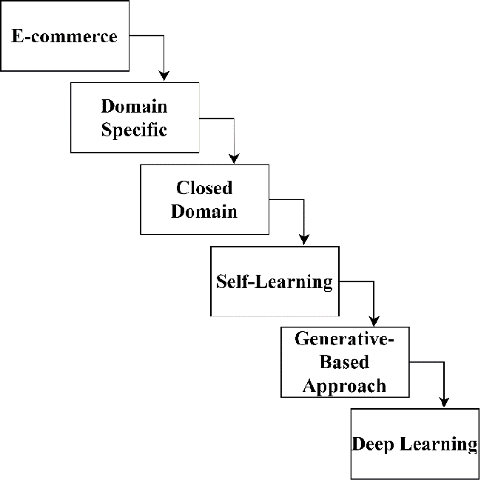
Figure 1:E-commerce chatbot struture
The diagram illustrates the evolution of approaches within the context of e-commerce, moving through increasingly sophisticated stages. It starts with E-commerce, focusing on leveraging online platforms for commercial transactions. From there, it progresses to Domain Specific applications, which involve tailoring solutions to specific industries or business needs within e-commerce. This is followed by the Closed Domain stage, where systems are designed to operate within a well-defined and restricted area, enhancing their efficiency and accuracy within that scope.
Next, the Self-Learning phase introduces systems that can adapt and improve their performance over time without human intervention, utilizing data to refine their operations continuously. The Generative-Based Approach marks a significant advancement, employing models that can generate content or predictions based on learned patterns, offering more dynamic and creative solutions. Finally, Deep Learning represents the pinnacle of this progression, utilizing complex neural networks to process vast amounts of data, enabling highly accurate and nuanced decision-making capabilities in e-commerce applications. Each step builds upon the previous one, reflecting a trajectory of increasing complexity and capability in leveraging data and artificial intelligence within the e-commerce domain.

  - DOMAIN INTRODUCTION
In the ever-competitive world of e-commerce, customer experience reigns supreme. Enter the e-commerce chatbot, a game-changer that personalizes the shopping journey like never before. Imagine a helpful assistant, always available, answering your product questions, offering tailored recommendations, and even guiding you through checkout. That's the magic of these AI-powered chatbots.
Integrated seamlessly into websites, mobile apps, or messaging platforms, they provide instant, 24/7 support. No more waiting on hold or navigating confusing menus. Customers benefit from immediate answers, personalized suggestions, and a smooth buying process, leading to increased satisfaction and brand loyalty.
They also gather valuable customer data, allowing for targeted marketing and product recommendations. By automating repetitive tasks, chatbots boost efficiency and empower businesses to focus on what matters most – creating a thriving online store. As e-commerce chatbots evolve, expect even more sophisticated features to personalize and streamline the online shopping experience for everyone.
The e-commerce industry has experienced exponential growth, reshaping the way consumers shop and interact with brands. As online retail platforms expand, the demand for efficient, personalized, and round-the-clock customer service has become more critical than ever. Enter the e-commerce chatbot: a sophisticated, automated solution designed to enhance customer engagement and streamline service operations.
  - PROJECT INTRODUCTION
E-Commerce chatbot involves several key steps to ensure that the chatbot is effective, user-friendly, and meets the business goals.Every e-commerce has their own ways of communicating with their customers. Some have their own chatbots and others personally respond to their customers concerns.
The primary goal of our project is to develop thechatbot that assists users in finding the productthey are searching for, and it will use its advanced search capabilities to scour the web.The chatbot doesn't limit you to a single e-commerceplatform. It searches across various reputable e-commerce platforms, finding the best deals and widest selection for your needs.
Once chatbot identifies relevant options, it presents you with clear and concise information, and most importantly - links to the product. With just a click, you'll be whisked away to the product page for a seamless buying experience.This e-commerce chatbot analyzes user queries and redirects them to relevant items on various external e-commerce platforms by providing direct links.
These virtual assistants are more than just automated pop-ups; they're personalized shopping buddies that transform the online experience. Imagine having a helpful guide by your side 24/7, ready to answer your product inquiries, suggest deals across various platforms, and even navigate you to the perfect purchase. That's the magic of e-commerce chatbots.Powered by AI, these chatbots can understand your questions and preferences through natural language processing. Gone are the days of tedious browsing; simply describe what you're looking for, and the chatbot scours the web to find the best options from trusted e-commerce platforms.

CHAPTER 2
LITERATURE SURVEY
A literature survey for an e-commerce chatbot involves examining various research papers, articles, and reports that cover the development, deployment, and effectiveness of chatbots in the e-commerce domain.Here is an outline of relevant topics and key points that are typically addressed in such surveys:
2.1 Web Development using Flask and Python
Web is the most widely and quickly utilized networking tool, meeting the needs of all types of users and providing solutions to anyproblem. We must select the appropriate technology in order to create and develop such well-defined and well-structured systems. As a result, flaskand python can be used to create a dynamic web application or portal. A well-designed web page or application can readily attract users, resulting in the project's success.It's like having a personal shopper at your fingertips, always ready to decode your visual inspirations and turn them into tangible shopping possibilities. Using "python" and "flask," you can meet the technological requirements of a web development project. Flask has the technical advantages like Integrated support for unit testing, secure cookies, extensive documentation. It is also feasible to connect new modules to python in order to extend the language's fundamental features. Because of Python'srobustness, many great websites are migrating to it. This paper concludes that, in contrast to other languages used for web development, Python is faster, more versatile, and more powerful than java, perl, and tcl.
2.2 E-commerce websites development
In the present developing world, the growing number of people use e-commerce websites for making their everyday purchases. This intuitive approach not only simplifies product discovery but also opens doors to trend-based searches and serendipitous finds you might have missed with text aloneThearticleoutlines numerous ways to build e-commerce websites as well as best practices and solutions to development problems. Theentiredevelopment process of e-commerce is divided into two parts. Development forms include front-end development and back-enddevelopment. There are several tabs visible on the front-end, including the home page, administration page, contact page, and cart pageetc… which comes under the UI designing. The Back-end part comprises of the coding parts of front-end pages and the database connectionand its interaction with the front-end. This paper shows the developing of the e-commerce with standard languages such as: HTML, CSS, JavaScript, BootStrap for the front-end part and PHP for the back-end part and MySql for its database connection.
2.3 The E-commerce platform
People now a days are completely dependent on internet. Web based will always give a upper hand where client base is increased, as we can see individuals who are interstate or abroad. Online shopping can be used to send and receive large quantities of data, items, and instalments between customer’s, website owners, and providers. Online platforms will offer item depiction, pictures, cost, and product reviews. Atypical application will be split into two parts: front-end development and back-end development. During front-end development, the site's login page, home page, contact page, admin page, shopping cart page, and payment page are developed visually. Another crucial feature of eCommerce chatbots is their ability to offer personalized product recommendations. Leveraging data analytics and machine learning, chatbots analyse customers' past behaviors, preferences, and purchase history to suggest products that are likely to be of interest.
This level of personalization not only improves the shopping experience for customers by making it more relevant and tailored to their needs but also boosts sales and conversion rates for businesses.In addition to assisting with product recommendations. For example, a customer can inquire about a product, receive a recommendation, and then proceed to checkout, all within a single, cohesive conversation.By default, the back end will manage the database and all interactions with the front end. For front end developing we use JavaScript. It is a client-side programming language designed specifically for web development. It was simply a matter of combining JavaScript code with HTML5 code. A client-side scripting language typically used in web browsers; JavaScript allows the user to interact with client-side scripts.
2.4Chatbots with Dialogue Management
Building a chatbot with advanced dialogue management is a multifaceted process that involves integrating various components to create a seamless, intelligent conversational agent. At its core, dialogue management refers to the system's ability to handle multi-turn conversations, maintain context, manage state, and produce coherent and contextually appropriate responses. The architecture typically comprises several layers, including natural language understanding (NLU), dialogue state tracking, policy learning, and natural language generation (NLG).Chat bot is like a question answer pair between user and the computer system. The disclosure tree acts as an interface. For example, if user gives a dialogue to a system, the responses should be aligned on the left and other responses on the right which are system responses. We have developed a chatbot for complex queries are best suitable for user interactive. The conversation between user and system should not be just like a conversation, it should be like clarification request and perfect, suitable clarification response. Chatbots used earlier are responsive to user. So, we use DT for building the chatbot effectively. The chatbot examples are Siri in iPhone.
2.5 Chatbots with Response Generation
Developing a chatbot with an advanced response generator is a sophisticated process that integrates various technological elements to produce coherent, contextually appropriate, and engaging responses. The response generator, often referred to as the natural language generation (NLG) module, is pivotal in translating the structured data or intent derived from user inputs into natural, human-like language. This task is not merely about stringing words together; it involves a deep understanding of syntax, semantics, context, and pragmatics to ensure the generated response is meaningful and useful.Chatbot is based on question-and-answer interaction between human being and a robot. In this paper, we first find a generatedresponsefrom generation-based polisher and then GR is passed into polished response filter. According to the evaluate relevance score, the robot ingoing to gives the output. The output generated is based on score. If the score is high then the output is achieved to that node. Retrieval polished response generation for chatbot is an advanced technology which gives efficient, fluent answers. The first model used is retrieval based which is written by humans. The main disadvantage is irrelevant context. Retrieval based is similar to computational contextual. The second model is generation based which is language rules learned learning during the training process. The main disadvantageissaferesponses and grammatical errors. The combined two models give efficient question and answer pair fluent and no grammatical errors.
2.6 Web based E-commerce system integrated with Chatbot
The literature survey on a "Web-based E-commerce System Integrated with Chatbot" explores the existing body of research concerning the integration of chatbot technology into online retail platforms. Scholars have extensively investigated the implications and advantages of incorporating chatbots within web-based e-commerce systems. Studies often emphasize the potential for chatbots to enhance user engagement, improve customer service, and provide real-time assistance in the online shopping process.Developing a web-based e-commerce system integrated with a chatbot represents a cutting-edge approach to enhancing customer experience, streamlining operations, and driving sales. This integration leverages the capabilities of conversational AI to provide real-time, personalized assistance to users, creating a more interactive and user-friendly shopping environment. The chatbot serves as a virtual assistant, guiding customers through their shopping journey, answering queries, offering product recommendations, and facilitating transactions, all within the e-commerce platform. Additionally, research has delved into the technical aspects of integrating chatbots with e-commerce websites, addressing issues related to natural language processing, user experience design, and system architecture.

2.7 Shop BuddyEnhanced Automated Chatbot
Shop Buddy Enhanced Automated Chatbot is a sophisticated conversational agent designed to revolutionize the online shopping experience by providing personalized, efficient, and engaging customer interactions. This chatbot leverages the latest advancements in artificial intelligence, natural language processing (NLP), and machine learning to understand and respond to user queries in a human-like manner, transforming the way customers interact with e-commerce platforms.This explores the landscape of automated chatbots and data analytics in the context of e-commerce platforms. Previous research has extensively investigated the integration of chatbots to enhance user interactions and support functions in online retail. Scholars have highlighted the significance of personalized customer engagement and how chatbots, equipped with natural language processing capabilities, contribute to improved user experiences The integration of data analytics functionalities within an automated chatbot, as proposed in "Shop Buddy," is a novel approach that aligns with the contemporary trends in leveraging data for enhancing customer satisfaction and optimizing business operations.
2.8 An E-commerce Chatbot for a University Shopping Mall
An e-commerce chatbot for a university shopping mall is designed to enhance the shopping experience for students, faculty, and staff by providing real-time assistance, personalized recommendations, and efficient customer service. This chatbot, tailored specifically for the needs of a university community, integrates seamlessly with the university's e-commerce platform, offering a range of features that cater to the unique requirements of a campus shopping environment.It refers to the implementation of a chatbot within the online shopping infrastructure specifically tailored for a university setting. This innovative feature combines artificial intelligence and e-commerce capabilities to create a virtual assistant designed to cater to the unique needs of the university community.
The chatbot can assist students, faculty, and staff in navigating the virtual shopping mall, helping them find and purchase items related to their academic and personal needs. This could include textbooks, university merchandise, and other essentials.Additionally, the chatbot may offer personalized recommendations based on the user's academic program or past purchase history, contributing to a more tailored and efficient shopping experience. By integrating machine learning, the chatbot continually refines its responses and recommendations, adapting to the evolving preferences and requirements of the university community.

2.9 Artificial intelligence in e-commercecase Amazon
The literature survey on "Artificial Intelligence in E-commerce: Case Amazon" provides an in-depth exploration of the role and impact of artificial intelligence (AI) within the context of e-commerce, with a specific focus on the practices and strategies employed by the industry giant, Amazon. Numerous scholarly works have delved into the transformative effects of AI technologies on various aspects of the e-commerce ecosystem. These studies often emphasize how AI enhances personalized recommendations, streamlines logistics and supply chain management, and optimizes customer service. Amazon, being a pioneer in incorporating AI, serves as a prominent case study.
2.10 Customer Focused E-commerce Site with AI Bot
It suggests the integration of artificial intelligence (AI) technology to enhance the user experience and overall customer satisfaction in an online retail environment. The term "AI Boat" may imply a streamlined and efficient system that navigates through vast amounts of data and customer interactions to personalize the shopping journey. In this context, AI could be employed to analyze customer preferences, predict buying patterns, and provide tailored recommendations. It may also involve features like chatbots or virtual assistants powered by AI to assist customers in real-time, addressing queries and offering product information. The emphasis on being customer-focused implies a commitment to understanding and meeting the unique needs and preferences of individual users.
.

CHAPTER 3
EXISTING SYSTEM AND PROPOSED SYSTEM
In this chapter, we will be discussing the Existing System and Proposed System for the project we are developing.
3.1 EXISTING SYSTEM
Existing e-commerce chatbots are typically rule-based, meaning that they can only respond to a limited set of pre-defined queries. The rule-based systems govern specific actions and responses, ensuring accuracy and consistency in handling common ecommerce tasks such as product information retrieval. However, newer chatbots are being developed using machine learning and natural language processing, which allows them to have more natural and engaging conversations with users.
E-Commerce Website that has a catalogue of products that can be browsed. The website itself is designed so it can be integrated seamlessly with the chatbot. The website has traditional navigation options for the user if he or she desires to browse the website, in a conventional manner. It will also feature conventional search/filter options. This website will have an unobtrusive chatbot that can be accessed from any page. The user can interact with the bot using Natural Language. The bot can make suggestions, give information or ask further questions to elicit further information depending on the user interaction. The bot has a small response time.
3.2 PROPOSED SYSTEM
The proposed system is developed keeping ecommerce platform (apps) in mind so that people can use ecommerce easily and resolve their problem at a moment with the help of a chatbot. Design a conversional chatbot that respond like human and hence visually impaired people can also use it easily. We will be using stochastic gradient descent algorithm. SGD is a fundamental optimization algorithm widely used in training machine learning models, including chatbot models.
The primary goal of gradient descent is to identify the model parameters that provide the maximum accuracy on both training and test datasets. In gradient descent, the gradient is a vector pointing in the general direction of the function’s steepest rise at a particular point. The algorithm might gradually drop towards lower values of the function by moving in the opposite direction of the gradient, until reaching the minimum of the function.

Stochastic Gradient Descent Algorithm
- Initialization: Randomly initialize the parameters of the model.
- Set Parameters: Determine the number of iterations and the learning rate (alpha) for updating the parameters.
- Stochastic Gradient Descent Loop: Repeat the following steps until the model converges or reaches the maximum number of iterations:
- Shuffle the training dataset to introduce randomness.
- Iterate over each training example (or a small batch) in the shuffled order.
- Compute the gradient of the cost function with respect to the model parameters using the current training example (or batch).
- Update the model parameters by taking a step in the direction of the negative gradient, scaled by the learning rate.
- Evaluate the convergence criteria, such as the difference in the cost function between iterations of the gradient.
- Return Optimized Parameters: Once the convergence criteria are met or the maximum number of iterations is reached, return the optimized model parameters.
In SGD, since only one sample from the dataset is chosen at random for each iteration, the path taken by the algorithm to reach the minima is usually noisier than your typical Gradient Descent algorithm. But that doesn’t matter all that much because the path taken by the algorithm does not matter, as long as we reach the minimum and with a significantly shorter training time.
Stochastic Gradient Descent is a powerful optimization algorithm that has become a staple in the field of machine learning. Its ability to handle large datasets efficiently and adapt to new data makes it particularly useful for training complex models. While it has its challenges, the various enhancements available ensure that SGD remains a versatile and effective tool for machine learning practitioners.
The proposed system for a rule-based eCommerce chatbot using HTML, CSS, JavaScript, JSON, and Flask involves creating a multi-component web application where users can interact with a chatbot to get answers to their queries. The system's structure includes a Flask backend (app.py) that serves the web application and handles chat requests. The chatbot's behavior is defined in a rules.json file, which contains predefined input-response pairs. When a user sends a message, the front-end JavaScript captures this input and sends it to the Flask server via a POST request. The server processes the message by checking it against the rules in the JSON file and returns an appropriate response. This response is then displayed to the user in the chat interface, which is built using HTML for structure, CSS for styling, and JavaScript for functionality. This architecture ensures a simple yet effective interaction model where users receive instant responses based on predefined rules, making the e-commerce experience more interactive and user-friendly.
In the e-commerce chatbot built with Flask, the backend functionality is encapsulated within the `app.py` script. This script starts by importing the necessary modules: `Flask` for creating the web application, `render_template` for rendering HTML templates, `request` for handling incoming requests, and `json` for working with JSON data. The Flask app is initialized with `app = Flask(__name__)`, and the chatbot's predefined rules are loaded from a `rules.json` file using the `json.load` function.
The main routeserves the homepage by rendering the `index.html` template when a user accesses the root URL. The core functionality of handling user messages is implemented in the `/get_response` route, which is accessed via a POST request.. This function iterates over the rules and matches the user's message with the predefined inputs. If a match is found, the corresponding response is returned; otherwise, a default message is provided. Finally, the response is sent back to the client in JSON.This Flask function provides a straightforward and efficient way to handle user interactions in the eCommerce chatbot, ensuring quick and relevant responses based on predefined rules.
The system incorporates an advanced dialogue management module that handles the flow of conversation. This module maintains the context of the dialogue, tracking previous interactions and user preferences to provide coherent and contextually appropriate responses. For instance, if a user previously mentioned a preference for a particular brand, the dialogue manager will remember this detail and prioritize products from that brand in future recommendations. This context-awareness is crucial for creating a seamless and personalized user experience.the chatbot supports conversational commerce, allowing users to complete transactions directly within the chat interface. From browsing products and adding items to the cart to processing payments and tracking orders, the chatbot guides users through each step of the purchase journey, providing a seamless and frictionless shopping experience. This functionality is particularly valuable for mobile users and those seeking quick and convenient shopping options.
Continuous improvement and optimization are integral aspects of the proposed system, with mechanisms in place to gather user feedback, analyze performance metrics, and iterate on the chatbot's capabilities over time. Machine learning algorithms and data-driven insights are leveraged to enhance the chatbot's understanding, responsiveness, and effectiveness, enabling it to evolve and adapt to changing user needs and market dynamics.
In conclusion the proposed system for an ecommerce chatbot represents a sophisticated and intelligent solution that aims to enhance the online shopping experience for users. By combining advanced AI technologies, seamless integration, personalization, and security features, the chatbot empowers users to discover, browse, and purchase products with ease and confidence, driving customer engagement, satisfaction, and loyalty in the competitive ecommerce landscape.

CHAPTER 4
PROBLEM DEFINATION, OBJECTIVES AND PROPOSED METHODOLOGIES
4.1 PROBLEM DEFINATION
An e-commerce chatbot is designed to streamline the online shopping experience by providing real-time assistance to customers, improving overall engagement, and increasing sales conversions. The problem it addresses is multifaceted, involving the need for instant customer support, personalized shopping experiences, and efficient handling of a wide range of customer queries. In traditional e-commerce settings, customers often face delays in getting responses to their questions about products, shipping, returns, and more, which can lead to frustration and abandoned shopping carts.
Secondly, it must integrate seamlessly with existing e-commerce platforms and databases to provide real-time information on product availability, order status, and personalized recommendations. Thirdly, ensuring the chatbot's responses are contextually relevant and valuable to the customer requires sophisticated AI and machine learning algorithms that learn from interactions and improve over time. Maintaining the security and privacy of customer data is paramount, necessitating robust encryption and data protection measures.
Additionally, the challenge of providing personalized recommendations in a scalable manner is significant to address these challenges, we aim to develop an E-commerce Chatbot that can serve as a virtual shopping assistant, answering customer inquiries, helping them navigate the online store, and offering product recommendations.

4.2 OBJECTIVES
The objectives for implementing of E-commerce Chabot typically include enhancing customer experience, providing instant support, improving engagement, guiding product selection, facilitating transactions, and ultimately boosting sales.
- Enhance User Experience:
Ecommerce chatbots significantly enhance user experience by providing instant, personalized assistance around the clock. They streamline the shopping process by answering queries, offering product recommendations, and facilitating transactions, thus reducing wait times and improving satisfaction. Chatbots can handle multiple customers simultaneously, ensuring that no user feels neglected. Additionally, they collect and analyze user data to personalize interactions and anticipate needs, creating a more engaging and tailored shopping experience.
- 24/7 Customer Support:
E-commerce chatbots provide 24/7 customer support by using advanced AI to handle queries and issues at any time of day, ensuring constant availability for customers. They can assist with common questions, process orders, and troubleshoot problems, enhancing the shopping experience by offering immediate responses and personalized interactions. This continuous support helps reduce wait times, improve customer satisfaction, and increase sales by guiding users through the buying process efficiently. Additionally, chatbots can collect data on customer preferences, enabling more targeted marketing and better service customization.
- Optimize Chatbot Interactions:
Use analytics to understand which queries your chatbot handles well and which ones require human intervention. Continuously refining the chatbot’s responses and capabilities based on this data can improve its effectiveness, reduce miscommunication, and minimize the need for customers to escalate issues to human agents.They use natural language processing to understand and respond to customer inquiries swiftly and accurately, improving satisfaction. By analyzing past interactions and purchase history, chatbots offer tailored product recommendations, boosting sales.
- Product Recommendations:
Utilize AI algorithms to analyze user preferences and behavior, providing personalized product recommendations, thereby increasing sales and customer engagement. They engage with customers in real-time, asking questions to refine recommendations, providing product information, and assisting with purchase decisions. By integrating with the e-commerce platform's database, chatbots ensure that the recommendations are current and relevant. This personalized interaction not only increases customer satisfaction but also boosts sales by guiding users to products they are more likely to buy, thus improving the overall efficiency of the online shopping experience.
- Automate Common Inquiries:
Focus the chatbot on handling frequently asked questions and routine tasks. By automating these common inquiries, you can reduce the workload on human customer service agents, allowing them to focus on more complex and high-value interactions. They analyze queries, access relevant data, and provide accurate, timely information, enhancing customer satisfaction and reducing the need for human intervention.This can decrease the number of agents needed, directly reducing labour costs.
- Integration Efficiency:
Efficient integration reduces redundancy and speeds up response times, which enhances customer satisfaction and reduces bounce rates due to poor user experience.Chatbots streamline customer service by providing instant responses to common inquiries, reducing the need for human intervention. This leads to faster resolution times and improved customer satisfaction.They also assist in personalized marketing by analyzing user data and offering tailored recommendations, driving higher sales. By automating routine tasks, chatbots free up human resources for more complex issues, further boosting the efficiency of e-commerce operations.
- Security and Privacy:
Chatbots handle vast amounts of sensitive information, including personal details and payment data. If not properly secured, this information can be intercepted by cybercriminals. Additionally, chatbots are susceptible to various attacks such as phishing, where malicious actors can manipulate the chatbot to deceive users into revealing confidential information. Privacy issues also arise from the collection and storage of user data. Without stringent data protection measures, there is a risk of unauthorized access and misuse of personal information.Ensure the chatbot follows robust security measures to protect sensitive user information and complies with privacy regulations, building trust with customers.
- Scalability:
As scalability worsens, a chatbot might struggle to manage a higher volume of customer inquiries, leading to slower response times, increased errors, and potentially a decrease in customer satisfaction. This can happen due to limitations in the chatbot's underlying infrastructure, such as server capacity, processing power, or the complexity of its algorithms.Design the chatbot to handle increasing user interactions, adapting to the growing demands of the e-commerce business without compromising performance.

- Cost Efficiency:
E-commerce chatbots enhance cost efficiency in several ways. By automating customer interactions, they significantly reduce the need for human customer service representatives, leading to lower labor costs. These chatbots can handle multiple inquiries simultaneously, improving response times and customer satisfaction without increasing expenses. Streamline customer support processes and reduce operational costs by automating routine tasks, allowing human agents to focus on more complex issues and improving overall efficiency.

4.3 PROPOSED METHODOLOGIES
By following methodologies, you can develop a rule-based chatbot that is effective within a well-defined domain and provides a good user experience.
Data Collection and Preparation:
Gather relevant data from your e-commerce platform.Data collection and preparation are crucial for developing effective e-commerce chatbots. This process begins with gathering diverse datasets from customer interactions, including chat logs, purchase histories, and browsing patterns. The data is then cleaned to remove inaccuracies and inconsistencies, ensuring high-quality input for training the chatbot. Natural language processing (NLP) algorithms are employed to understand and categorize customer intents and responses accurately. Additionally, anonymizing sensitive data is essential to maintain customer privacy. Preparing this data involves structuring it into training sets to teach the chatbot various conversational scenarios, enabling it to handle real-time queries efficiently and enhance the overall customer experience. This includes product details, user queries, and historical interactions. Organize and structure this data using JSON for easy retrieval and manipulation.
Natural Language Processing (NLP):
It is a pivotal subfield of artificial intelligence (AI) that revolves around the interaction between computers and human language. It entails the development of algorithms and models designed to empower computers with the ability to comprehend, interpret, and generate human language in a manner that captures meaning and context. Key tasks within NLP include tokenization, part-of-speech tagging, named entity recognition, syntax analysis, semantic understanding, sentiment analysis, machine translation, speech recognition, text generation, and question answering NLP's continual evolution, fueled by advancements in machine learning and deep learning, propels the ongoing enhancement of computers' ability to understand and engage with human language, thereby enriching user experiences in numerous domains.
Processing the user data:
Processing user data in a chatbot involves a multifaceted approach to understanding and utilizing the information users provide during interactions. Initially, the user's input is parsed using natural language processing techniques to extract keywords, entities, and intent. Intent recognition is then employed to decipher the user's underlying purpose or request.

Model Training:
Feed the training data into the selected model, allowing it to learn the patterns and relationships within the data. During training, the model adjusts its internal parameters to minimize the difference between its predictions and the actual target values.Machine learning (ML) model training is a pivotal phase in the development of predictive models aimed at making informed decisions or generating insights from data. This process begins with the collection of a representative dataset, comprising input features and corresponding target values. Following data preprocessing to address issues like missing values or outliers, feature engineering enhances the model's ability to discern patterns. The selection of an appropriate ML algorithm or model architecture aligns with the specific problem, such as classification or regression. The core of model training involves feeding the dataset into the chosen model, allowing it to adjust internal parameters iteratively to minimize the discrepancy between predictions and actual outcomes, guided by a defined loss function. Optimization algorithms, like gradient descent, facilitate this parameter adjustment. Model performance is then validated on a separate dataset, checking for generalizability to new data and mitigating overfitting.
Analysis:
The analysis of data gathered from the interview begins with the categorization of data according to specific themes as part of the coding process. An affinity diagram will be devised from the outcome of previous coding. The gathered data will then be constructed into a flowchart, which would eventually enable the developer to use the flowchart as a foundation for program design on Chatbot.
Research Methods:
Research methods are deployed for the development of the chatbot; interviews and questionnaires. A one-to-one interview, of a semi-structured nature will be the primary method for information gathering. Senior member(s) of the administrative team will be interviewed using several key questionsto foster insight on all processes under the APU Administrative arm, the individuals in charge and its underlying dependencies. Upon analysis of data gathered from the interview, the developer can proceed to identify and explore patterns that can be utilized to create the conversational narrative of the chatbot. Subsequently, a mixed questionnaire was applied to elicit feedback from APU students as part of the Requirements Analysis phase to identify and explore areas that can be further enhanced to meet end user.



Figure 1: Workflow of Chatbot
It shows the steps involved in building a system that recommends products to users on an e-commerce platform. Data is collected about users and products.This data can be used to understand the current system, identify requirements for the new system, and develop the system design. The collected data is then validated to ensure its accuracy and completeness.The workflow of a chatbot encompasses a series of stages designed to create an efficient, responsive, and intelligent conversational agent capable of interacting seamlessly with users. This workflow begins with user input and extends through several critical phases, including natural language understanding (NLU), dialogue management, and natural language generation (NLG), culminating in the delivery of an appropriate and coherent response.
Any errors or inconsistencies are corrected or removed during this stage. This data is cleaned and formatted for use in the system. Algorithms are chosen to analyse the data.When a user initiates interaction by typing a query or command, the first step in the workflow is the input processing stage. Here, the chatbot receives and preprocesses the input to prepare it for further analysis. This preprocessing might involve text normalization techniques such as converting the text to lowercase, removing punctuation, and correcting spelling errors to ensure the input is clean and standardized.A model is built to recommend products based on user behaviour.These algorithms are chosen based on the system requirements and the type of data being processed.This model is deployed using a web framework like Flask, and a web application is created for users to interact with the system.
Anaconda Prompt is a powerful command-line interface that comes bundled with the Anaconda distribution, a popular package manager and environment management system for Python . Anaconda Prompt provides users with a streamlined and efficient way to manage packages, create and maintain isolated environments, and execute scripts in a controlled setting, making it an invaluable tool for data scientists, researchers, and developers who work extensively with data-driven projects.
At its core, Anaconda Prompt is a customized version of the standard command prompt (cmd) on Windows or terminal on macOS and Linux. It is pre-configured to recognize commands specific to the Anaconda ecosystem, which simplifies the process of managing complex dependencies and environments. When you launch Anaconda Prompt, it automatically sets up the necessary environment variables and paths to ensure that Anaconda and its suite of tools are readily accessible.Anaconda Prompt supports installing packages from the Python Package Index (PyPI) using the pip command. This flexibility allows you to leverage the extensive range of packages available in the broader Python ecosystem while still benefiting from Anaconda’s robust environment management.

CHAPTER 5
5.1 SYSTEM DESIGN
The block diagram of an advanced chatbot system involves crucial components seamlessly working together. At the forefront is the Chatbot Interface, where users interact with the system through a user-friendly interface, typically a messaging platform.
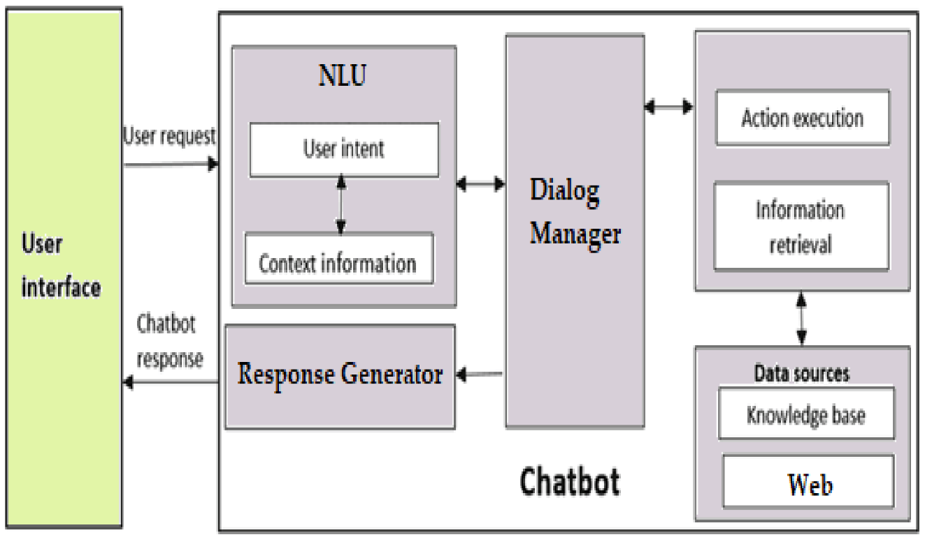

Figure 2: Block diagram of project
Imagine a conversation between a user and a chatbot. The user initiates by sending a message through a chat window that is user interface. This is the starting point for your interaction, typically a chat window on a website or app where you type your questions or requests.This message goes to a part called the NLU (Natural Language Understanding) unit.This component acts like a translator, analyzing the user's message and extracting its meaning. It uses complex language processing techniques to decipher the intent behind your words and identify key information.
Here, fancy language processing techniques try to understand what the user is trying to achieve (their intent).The NLU unit then identifies the user's intent and relays it to the dialog manager. This manager acts like a conversation guide, using the intent and the history of the conversation (if available) to determine the appropriate next step.Imagine this as the conversation director. Based on the NLU's analysis and the context of the chat, the dialog manager determines what the chatbot needs to do next to effectively respond to your query.
Depending on the intent, the dialog manager might instruct different parts of the system to take action. It could ask the information retrieval unit to find relevant information from the knowledge base (a storage of chatbot's knowledge), or it might tell the action execution unit to perform a specific task (like booking a flight).If the chatbot needs additional information to answer your question, this component retrieves it from relevant sources. These sources could be a company knowledge base packed with product details or external data pulled from the web.
The knowledge base it's a vast repository of information that the chatbot can leverage to answer your questions. It might include product descriptions, FAQs, or company policies.Once the chatbot has determined the most suitable response, this component takes action. This action might involve generating text for you, retrieving information from external sources, or even controlling smart home devices (depending on the system's capabilities).
This response generator component takes all the information gathered from various parts of the system and crafts a natural language response tailored to your query. The goal is to provide a clear, informative, and helpful answer that mimics human conversation. Whereas the data source this could encompass the knowledge base, external web data, or other sources that provide the chatbot with information to answer your questions comprehensively.
Finally the chatbot response this is the final output you see after interacting with the chatbot system. It can be text, images, or even a combination of both, depending on the nature of your request and the chatbot's capabilities.In essence, this block diagram highlights the intricate interplay between these components, working together seamlessly to provide a user-friendly and informative experience during your interaction with a chatbot system.

5.2 MODULE DESCRIPTION
The chatbot interface is developed using HTML, CSS, JAVASCRIPT a front-end framework for building single-page web applications. Also, Flask a python library helps in managing the functionality of the e-commerce chatbot. The user can ask the bot questions concerning current products available, the current prices of the products sold in the shopping mall, and closing and opening times of CUSM and pay for the items the user desires to purchase via website's payment platform.
Natural Language Toolkit (NLTK):Itis a powerful Python library for working with human language data. It provides tools for tasks such as tokenization, stemming, tagging, parsing, and more. NLTK is widely used in natural language processing (NLP) and offers a comprehensive set of resources, including corpora, lexical resources, and various algorithms, making it a valuable resource for researchers, developers, and students in the field of computational linguistics.
FLASK:Flask is a popular Python framework for crafting web applications. Unlike some bulkier frameworks, Flask offers a minimalist approach, focusing on core functionalities like handling web requests and routing. This streamlined design gives you flexibility to choose additional tools for more intricate features. At its heart, Flask acts as a web server, receiving requests from users and delivering responses. You define specific paths (URLs) within your application to handle different functionalities. Flask's decorators, like @app.route('/'), connect these paths to Python functions that handle user interactions. These functions can process data, interact with databases if needed, and generate dynamic responses. Flask integrates well with HTML templates, allowing you to create user-friendly interfaces with placeholders for dynamic content. Data exchange often happens in JSON format, and Flask provides tools to simplify working with this format. Finally, Flask's modularity lets you extend its capabilities through various extensions for security, databases, or form handling. Overall, Flask offers a powerful yet approachable foundation for building web applications in Python, making it a great choice for beginners and experienced developers alike.
CORS (Cross-Origin Resource Sharing):It is a security mechanism implemented by web browsers that restricts web pages from making requests to a different domain than the one that served the initial page.It is like getting permission for these stores to chat. Websites use CORS to control if chatbots or scripts from one domain can access resources from another. Special messages (headers) allow authorized access, ensuring information stays secure while enabling features like chatbots fetching product data from different servers. This helps prevent malicious scripts from stealing data or performing unauthorized actions on other websites.
Neural Net:A neural network is a computer program inspired by the human brain. Imagine a web of interconnected neurons, like tiny brains cells. Neural networks mimic this structure using artificial neurons that process information. These networks learn by adjusting connections between the artificial neurons, based on data they're fed. Over time, they can recognize patterns and make predictions. They consist of interconnected layers that process information and learn by adjusting connections based on data.
PyTorch:PyTorch is a popular deep learning library in Python specifically designed to build, train, and deploy these neural networks.ItIs a toolbox for artificial intelligence. It lets you create these complex networks of interconnected processors that mimic the human brain. PyTorch is known for its ease of use and flexibility. It allows you to define models quickly and experiment with different approaches. This makes it popular for research and development in areas like image recognition, natural language processing, and robotics.

CHAPTER 6
6.1 SYSTEM REQUIREMENTS
Hardware Requirements
Hardware requirements refer to the specifications needed for a computer system or device to function properly. Meeting the hardware requirements ensures that software and applications can run smoothly and efficiently on the device.
Processor: 2.4 gigahertz (GHz)
RAM: 6 gigabyte (GB) (64-bit)
Hard disk space: 16 GB (64 GB)
Hard Disk: 500 GB
Network card:10-100 MBPS of Network
Software Requirements
Software requirements define what a program should do, how it should behave, and the conditions it must meet. They guide the entire development process, from design to testing. We will be discussing the programming language which we used to implement the machine learning approaches.
Operating system: Windows 10
Software Technique: Python
Python version: Python v3.11.0
Visual Studio Code
Anaconda Prompt to run Python scripts
Web Browser: Google Chrome, Internet Explorer

6.2SYSTEM IMPLIMENTATION
This code sets up a basic Flask web application that serves an HTML page and provides an API endpoint for generating responses based on user input.
fromflaskimportFlask, render_template, request, jsonify
fromflask_corsimportCORS
fromchatimportget_response

app = Flask(__name__)
CORS(app)
@app.get("/")
defindex_get():
returnrender_template("base.html")

@app.post("/predict")

defpredict():
text= request.get_json().get("message")
response = get_response(text)
message = {"answer":response}
returnjsonify(message)

if__name__ == "__main__":
app.run(debug=True)
Figure 3: Program code snippet
It begins by importing necessary modules: Flask for creating the web application, render_template for rendering HTML templates, request for handling incoming requests, jsonify for returning JSON responses, CORS for enabling Cross-Origin Resource Sharing, and get_response from a separate module named chat for generating responses based on input text. The application is instantiated with Flask(__name__) and CORS is enabled to allow cross-origin requests.
The application defines two routes: a GET route at the root URL ("/") and a POST route at "/predict". The GET route is handled by the index_get function, which renders and returns the "base.html" template when the root URL is accessed. The POST route is handled by the predict function, which expects a JSON payload with a "message" field. It extracts this field from the request, uses the get_response function to generate a response, and then returns this response as a JSON object with the key "answer".Moreover, the code includes a conditional statement if name == "main": that ensures the application runs in debug mode when executed directly. This debug mode is particularly advantageous for development as it provides detailed error messages and automatically reloads the server when code changes are detected, facilitating a smoother and more efficient development process. This setup, with its clear separation of concerns and robust handling of web requests, creates a user-friendly interface where users can interact with the server by sending messages and receiving generated responses. The inclusion of CORS support ensures that the application can be integrated with other web applications or front-end frameworks without facing cross-domain issues, making it versatile and suitable for various interactive applications beyond chatbots.
The below JSON snippet represents a set of intents and responses for a simple chatbot. Each intent defines a specific category of user input, along with a set of patterns that represent possible variations of that input, and a corresponding set of responses from the chatbot.
{
"intents": [
{
"tag": "greeting",
"patterns": [
"Hi",
"Hey",
"Is anyone there?",
"Hello",
"Good day"
],
"responses": [
"Hey :-) My name is Sam!",
"Hello, thanks for visiting. My name is Sam!",
"Hi there, My name is Sam!. What can I do for you?",
"Hi there, My name is Sam! How can I help?"
]
},
{
"tag": "personal",
"patterns": [
"How are you?",
"How are you doing?",
"How is your day?"
],
"responses": [
"I'm good, all's good, thanks. How about you?"
]
},….
Figure 4: Data set to train chatbot

This JSON snippet represents a set of intents and responses for a simple chatbot. Each intent defines a specific category of user input, along with a set of patterns that represent possible variations of that input, and a corresponding set of responses from the chatbot.For instance, the "greeting" intent captures different ways users might greet the chatbot, such as "Hi," "Hey," or "Hello." When the user sends one of these messages, the chatbot responds with one of the predefined responses, creating a conversational interaction.
This JSON structure forms the backbone of the chatbot's understanding of user input and enables it to generate appropriate responses based on the detected intents. It provides a foundation for building more complex conversational flows and enhancing the chatbot's ability to engage with users in a meaningful way.
Finally, the application runs in debug mode when executed directly, allowing for easier development and debugging. This setup provides a basic interactive interface where users can send a message to the server and receive a generated response, potentially for a chatbot or similar application.
Anaconda is a free and open-source software distribution that includes the Python programming language and a collection of popular scientific computing libraries. The Anaconda Prompt allows you to run Python scripts and commands, as well as manage Anaconda packages and environments.
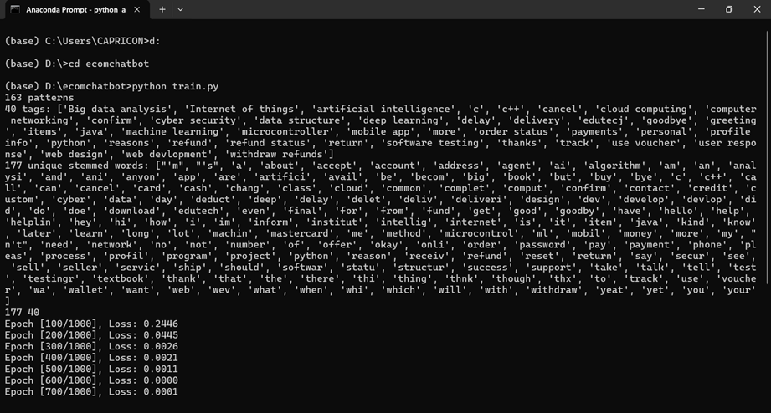

Figure 4: Commands to be executed in Anaconda prompt
In the image, the user is running a Python script named train.py. The script is apparently training a machine learning model, as indicated by the output, which shows the epoch and loss values. The epoch is a unit of iteration in machine learning, and the loss is a measure of how well the model is performing. The output shows that the loss is decreasing over time, which suggests that the model is learning.
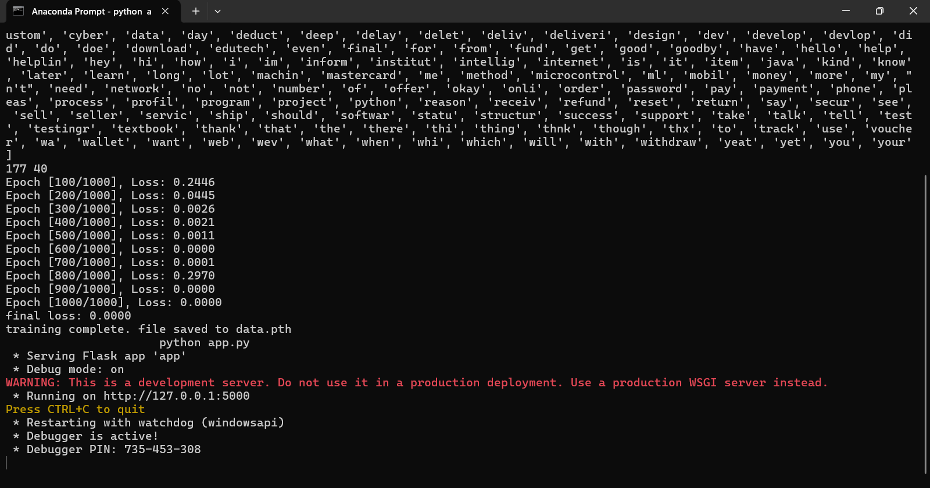
Figure 5: Anaconda Prompt
The output shows the epoch and loss values, which are typical outputs during model training. Epoch refers to the number of times the training data is passed through the model, and loss indicates how well the model is performing on a specific task. In this case, the loss is decreasing over time which suggests the model is learning.

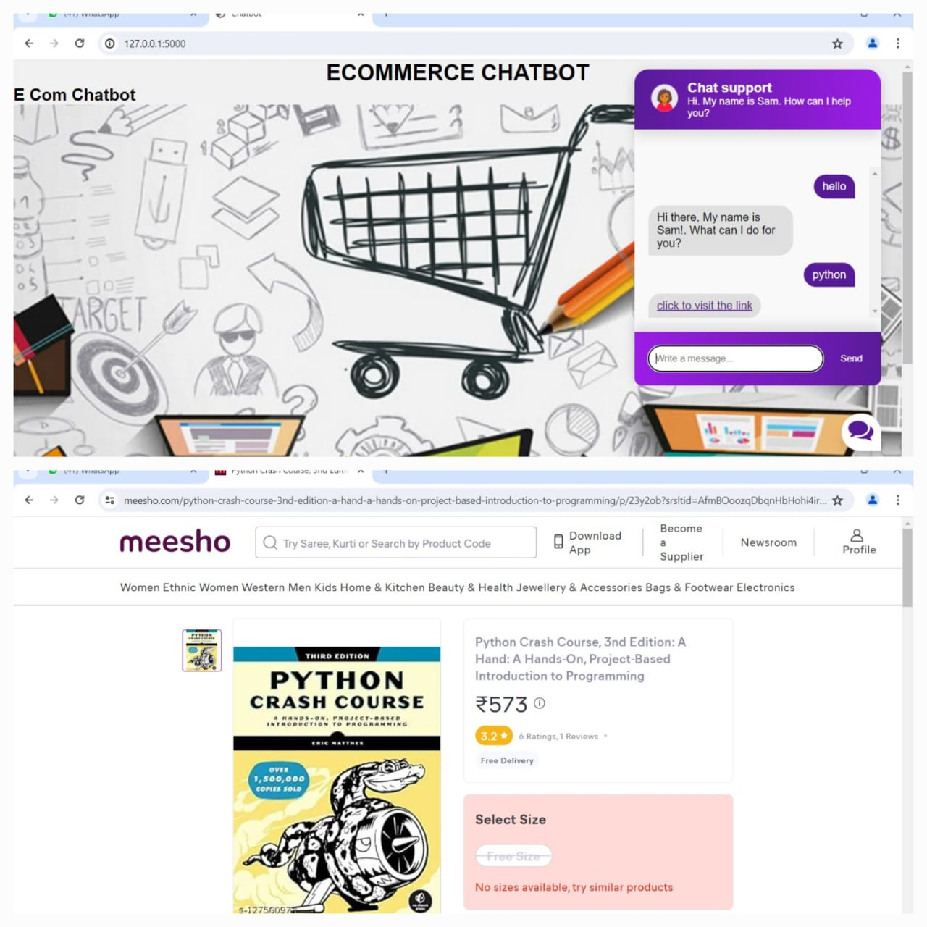

Figure 6: Outcome of the Project

CHAPTER 7
CONCLUSION AND FUTUREWORK
7.1 CONCLUSION
This website based chatbot that attempts to improve User Interaction with the E-Commerce website. The chatbot has a stored set of responses, but also takes dynamic user input into account and it tends to provide relevant responses and product suggestions, 24/7 support, answering product inquiries in real-time.As technologies continue to evolve, chatbots will become increasingly intelligent and capable of handling more complex tasksMoreover, the integration of machine learning and data analytics enables chatbots to continuously learn and adapt to user preferences, further enhancing their effectiveness over time Since the product database is independent of the stored responses, newer products under the respective category can be easily added and removed and require no modification of the stored chatbot responses.

7.2 FUTURE WORK
In the future, e-commerce chatbots will continue to play a crucial role in enhancing customer interactions and driving sales for businesses. These chatbots will become more sophisticated and personalized, utilizing advanced AI algorithms to provide tailored product recommendations, answer customer queries, and assist with the shopping process. They will also be integrated with various social media platforms and messaging apps to reach customers where they are most active. Additionally, e-commerce chatbots will be equipped with voice recognition technology to enable hands-free shopping experiences and offer seamless customer support. Overall, the future of e-commerce chatbots looks promising, as they will continue to revolutionize the way businesses engage with customers and drive revenue growth.E-commerce chatbots will leverage data analytics and machine learning to provide highly personalized shopping experiences. They will understand individual preferences, purchase history, and browsing behavior to offer tailored product recommendations.

REFERENCES
- J. Sanchez, “Facebook messenger chatbots. How businesses can benefit from this opportunity,” School of Industrial and Information Engineering, Politecnico Milano, Milan, Italy, 2019, M.Sc. Thesis
- S. Reshmi and K. Balakrishnan, “Enhancing inquisitiveness of chatbots through NER integration,” in Proceedings of the 2018 International Conference on Data Science and Engineering (ICDSE), pp. 1–5, IEEE, Kochi, India, August 2018.
- J. P. McIntire, L. K. McIntire, and P. R. Havig, “Methods for chatbot detection in distributed text-based communications,” in Proceedings of the 2010 International Symposium on Collaborative Technologies and Systems, pp. 463–472, IEEE, Chicago, IL, USA, May 2010.
- R. Asadi and R. Hemadi, “Design and implementation of a chatbot for e-commerce,” Information Communication Technology and Doing Business, pp. 1–10, 2018
- S. Ghose and J. J. Barua, “Toward the implementation of atopic speciﬁc dialogue based natural language chatbot as anundergraduate advisor,” in Proceedings of the 2013 Interna-tional Conference on Informatics, Electronics and Vision(ICIEV), pp. 1–5, IEEE, Dhaka, Bangladesh, May 2013
- J. P. McIntire, L. K. McIntire, and P. R. Havig, “Methods forchatbot detection in distributed text-based communications,”in Proceedings of the 2010 International Symposium on Col-laborative Technologies and Systems, pp. 463–472, IEEE,Chicago, IL, USA, May 2010.
- P. A. Angga, W. E. Fachri, A. Elevanita, Suryadi, andR. D. Agushinta, “Design of chatbot with 3D avatar, voiceinterface, and facial expression,” in Proceedings of the 2015International Conference on Science in Information Technology(ICSITech), pp. 326–330, Yogyakarta, Indonesia, October2015.
- T. Kowatsch, M. Nißen, C.-H. Iris Shih et al., “Text-basedhealthcare chatbots supporting patient and health profes-sional teams: preliminary results of a randomized controlledtrial on childhood obesity,” in Proceedings of the 17th In-ternational Conference on Intelligent Virtual Agents (IVA2017), Stockholm, Sweden, August 2017
- Bhawiyuga, M. A. Fauzi, E. S. Pramukantoro, andW. Yahya, “Design of e-commerce chat robot for automati-cally answering customer question,” in Proceedings of the 2017International Conference on Sustainable Information Engi-neering and Technology (SIET), pp. 159–162, Malang, Indo-nesia, November 2017.
- S. Gupta, D. Borkar, C. De Mello, and S. Patil, “An e-com-merce website based chatbot,” International Journal ofComputer Science and Information Technologies. 2015

- F. Steinbauer, R. Kern, and M. Kr¨oll, “Chatbots assistingGerman business management applications,” in Proceedingsof International Conference on Industrial, Engineering andOther Applications of Applied Intelligent Systems, pp. 717–729,Springer, Graz, Austria, July 2019.
- D. Kraus, V. Reibenspiess, and A. Eckhardt, “How voice canchange customer satisfaction: a comparative analysis betweene-commerce and voice commerce,” in Proceedings of the 14Internationale Tagung Wirtschaftsinformatik (WI 2019), Sie-gen, Germany, February 2019
- V. Subramanian, N. Ramachandra, and N. Dubash, “Tutor-Bot: contextual learning guide for software engineers,” inProceedings of the 2019 IEEE/ACM 1st International Work-shop on Bots in Software Engineering (BotSE), pp. 16-17,Montreal, Canada, May 201.
- V. Oguntosin, A. Akindele, and A. Uyi, “A convolutionalneural network for soft robot images classiﬁcation,” in Pro-ceedings of the 7th International Conference on Soft Computing& Machine Intelligence (ISCMI), pp. 110–114, Stockholm,Sweden, November 2018.

