Face Detection and Tracking:
Techniques, Challenges, and Applications
Kanishka Punjabi(B-87), Nikhil Prasad(B-75), Tanushree(B-92)
kanishkapunjabi23@outlook.com , knikhil656@gmail.com , mahajantanushree03@gmail.com
Guided by: Prof. Ashwini Kale
B. Tech, Department of Computer Engineering,
SOET D Y Patil University, Ambi

Abstract
This paper offers an extensive review of face detection and tracking technologies, addressing essential techniques, present challenges, and numerous applications. It carefully analyses both conventional and contemporary approaches, with a strong focus on the significant advancements brought about by deep learning. By tracing the historical development and the most recent innovations, the paper illustrates how deep learning has greatly improved the accuracy and efficiency of face detection and tracking systems. Additionally, it explores various practical implementations, demonstrating the application of these technologies in diverse fields such as security, healthcare, and entertainment. The paper also points out ongoing challenges, including managing occlusions, lighting variations, and the demands of real-time processing. Finally, it suggests future research directions, offering innovative solutions and highlighting new areas for further investigation. This thorough analysis aims to provide meaningful insights for both researchers and industry professionals.

Introduction
Face detection and tracking technologies have become essential components of contemporary computer vision systems, profoundly influencing various fields such as security, human-computer interaction, and entertainment. Initially emerging from early computer vision research, these technologies have evolved significantly, transitioning from basic methods to advanced systems that offer real-time processing and high accuracy. The rapid progress in artificial intelligence, particularly deep learning, has been instrumental in this evolution, fostering the development of robust algorithms capable of detecting and tracking faces in diverse and complex scenarios. These advancements have resulted in systems adept at handling variations in lighting, facial expressions, and occlusions, thereby enhancing the reliability and applicability of face detection and tracking.

The accurate detection and tracking of faces are critical for numerous applications. In security and surveillance, these technologies improve monitoring capabilities, enabling real-time identification and tracking of individuals, which is crucial for ensuring safety in both public and private spaces. In human-computer interaction, face detection and tracking contribute to more natural and intuitive interfaces, enhancing user experiences in applications such as virtual reality, gaming, and mobile device user authentication. Moreover, in the healthcare sector, these technologies are used for patient monitoring, diagnostic purposes, and therapeutic settings, promoting more efficient and non-invasive medical procedures.

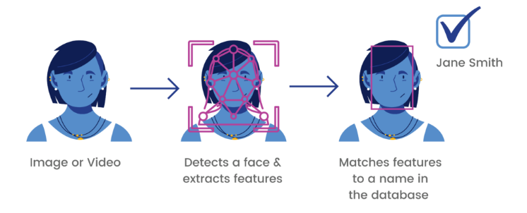

This paper aims to provide a thorough overview of the current state of face detection and tracking technologies. By examining the historical context, current methodologies, and future directions, this paper seeks to highlight the key challenges and opportunities within the field. Furthermore, it will discuss various real-world implementations to demonstrate the practical significance of these technologies. Through this comprehensive analysis, the paper intends to offer valuable insights for researchers, practitioners, and policymakers interested in advancing face detection and tracking systems.

Literature Review
Face detection, a fundamental aspect of computer vision, involves the identification and localization of human faces within images or video content. Its application spans diverse fields including security, entertainment, healthcare, and human-computer interaction, where accurate face detection is essential for tasks like automated tagging in photo collections, surveillance monitoring, and facial recognition systems.

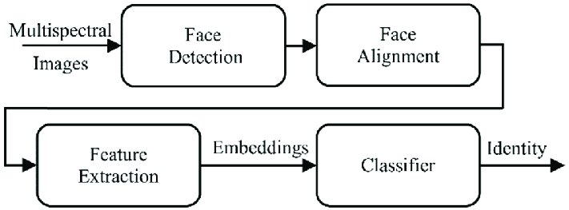

The historical evolution of face detection traces back to the early stages of computer vision research. Traditional methodologies, exemplified by Viola-Jones' algorithm employing Haar-like features and cascaded classifiers, established the groundwork for modern approaches. While these techniques offered some effectiveness, they grappled with challenges such as scale variations, occlusions, and fluctuations in lighting conditions.

The emergence of deep learning marked a significant turning point in face detection. Convolutional Neural Networks (CNNs), including architectures such as AlexNet, VGGNet, and more recent iterations like ResNet and EfficientNet, have notably enhanced detection accuracy. Deep learning models possess the capability to discern intricate features directly from raw pixel data, facilitating robust face detection across diverse scenarios.

Nevertheless, despite considerable advancements, face detection encounters persistent challenges. Variations in facial pose, expression, and occlusion present substantial obstacles, particularly in real-world settings. Furthermore, the imperative for real-time processing in certain applications necessitates algorithms that are not only precise but also computationally efficient.

To summarize, the trajectory of face detection has transitioned from conventional methodologies to deep learning-driven paradigms, significantly elevating accuracy and resilience. Nonetheless, hurdles such as coping with occlusions and achieving real-time performance endure. Addressing these challenges mandates ongoing research and innovation, heralding the development of more sophisticated face detection techniques in the future.

Facial tracking, an essential aspect of computer vision, entails the dynamic identification and monitoring of human faces within images or videos. Its applications span from surveillance and human-computer interaction to augmented reality functionalities. Challenges within facial tracking encompass the need for resilience against obstructions and diverse lighting scenarios, the precision in tracking across various poses and facial expressions, and the requirement for real-time processing to ensure smooth operation. Existing literature emphasizes the transition from conventional techniques such as optical flow to contemporary methodologies integrating deep learning. Recent progressions concentrate on refining tracking precision via intricate algorithms and exploiting contextual cues to enhance overall performance.

Methods of Face Detection
The field of face detection has undergone significant advancements, presenting a spectrum of techniques including traditional methods, machine learning approaches, and deep learning algorithms. This section offers an overview of these methodologies along with a comparative examination to elucidate their respective merits and limitations.
1. Traditional Approaches
In the realm of face detection, traditional methods rely on predefined features and algorithms. Among these, Haar Cascades stands out as one of the pioneering techniques, employing a series of Haar-like features and cascaded classifiers to identify facial regions within images. Template Matching, another conventional method, involves comparing a template image against sub-images within a larger context to pinpoint regions resembling the template. Eigenfaces utilize Principal Component Analysis (PCA) to represent facial features and identify faces based on their similarity to these eigenfaces.
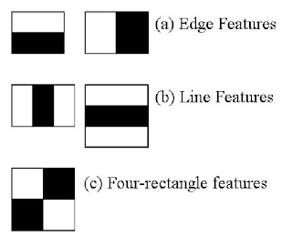

2. Machine Learning Strategies
Machine learning techniques play a pivotal role in advancing face detection capabilities by enabling algorithms to learn from data. Support Vector Machines (SVMs), for instance, categorize faces based on discerned patterns within the dataset. AdaBoost, on the other hand, amalgamates weak classifiers to construct a robust model, enhancing detection accuracy through collective decision-making.

3. Deep Learning Innovations
The advent of deep learning has revolutionized face detection by empowering models to autonomously extract features from raw data. Convolutional Neural Networks (CNNs) are widely employed for their prowess in capturing intricate spatial hierarchies of features. Region-based CNNs (R-CNN) propose region proposals and subsequently classify them individually. Real-time object detection algorithms such as You Only Look Once (YOLO) and Single Shot MultiBox Detector (SSD) efficiently detect faces in a single pass through the network, facilitating real-time applications.

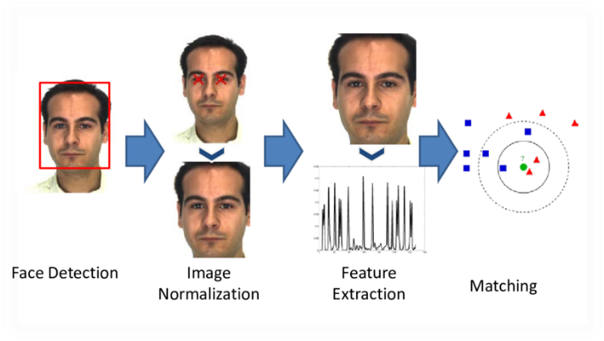

4. Comparative Assessment of Techniques
A comparative evaluation of these techniques’ sheds light on their respective strengths and weaknesses concerning accuracy, computational efficiency, and adaptability to varying scenarios. Traditional methods, while foundational, may encounter challenges with intricate scenarios, whereas deep learning techniques boast superior performance at the cost of computational resources. Machine learning strategies serve as a middle ground, offering a balance between accuracy and computational efficiency.

Methods of Face Tracking
In the domain of face tracking, a plethora of methods have emerged to address the diverse challenges posed by this task. Foundational techniques like optical flow, Kalman filtering, and mean-shift/ CAMShift algorithms have historically played crucial roles, relying on mathematical models to predict object motion and monitor faces across successive frames. Evolving beyond traditional methods, machine learning strategies have risen to prominence, offering improved adaptability and precision. Correlation filters employ pattern recognition to efficiently track faces, while multiple instance learning enhances tracking robustness by learning from various face instances. However, the most notable advancements have come with the introduction of deep learning methodologies. Long Short-Term Memory (LSTM) networks and Recurrent Neural Networks (RNNs) excel in capturing temporal dependencies, allowing for more nuanced and context-sensitive tracking. Furthermore, deep reinforcement learning frameworks have transformed tracking by integrating decision-making processes, thereby improving adaptability in dynamic settings. Conducting a comparative evaluation of these techniques is essential to grasp their unique strengths and limitations, thus guiding future enhancements in face tracking technology. Such an assessment will facilitate the development of more sophisticated, precise, and versatile face tracking systems applicable across a wide array of domains.

Integration of Detection and Tracking
The fusion of face detection and tracking is pivotal for achieving robust performance in practical settings, where the seamless integration of these frameworks is imperative. This segment explores the integration process, encompassing combined strategies, real-time processing nuances, and the assessment of accuracy and performance metrics.

1. Synthesizing Frameworks
The integration of face detection and tracking within a unified structure is fundamental for ensuring consistent and precise face tracking in dynamic scenarios. One method involves cascading detection and tracking algorithms: face detection initially pinpoints faces within an image or video frame, succeeded by tracking algorithms that preserve face identities and trajectories over time.

2. Real-Time Processing Considerations
Real-time processing stands as a critical requirement across many face detection and tracking applications, particularly in fields like surveillance and human-computer interaction. Furthermore, lightweight models and feature extraction techniques can curtail computational complexity without compromising accuracy, ensuring the operability of face detection and tracking systems in real-time, even on devices with limited resources.

3. Precision and Performance Metrics
Appraising the accuracy and efficacy of integrated face detection and tracking systems entails employing suitable metrics and benchmarks. Common performance gauges include detection and tracking accuracy, gauging the proportion of accurately detected faces and the system's adeptness in tracking face positions and identities over time. Standardized evaluation frameworks and benchmark datasets, such as the WIDER FACE and MOT datasets, furnish ground truth annotations and established protocols for scrutinizing the performance of face detection and tracking algorithms across diverse datasets and scenarios.

Applications of Face Detection and Tracking
The utilization of face detection and tracking extends across diverse sectors, each harnessing these technologies to meet specific requirements and address distinct challenges.

1. Security and Surveillance
Within security and surveillance frameworks, face detection and tracking serve as vital components, enabling the identification and monitoring of individuals within public spaces, airports, and other high-security environments. Integration of these technologies into surveillance systems empowers law enforcement agencies and security personnel to bolster public safety measures and swiftly respond to potential security risks.

2. Human-Computer Interaction
In the domain of human-computer interaction, face detection and tracking pave the way for natural and intuitive interfaces. By discerning and tracing facial expressions, gestures, and movements, these technologies facilitate hands-free interactions with devices like smartphones, tablets, and computers.

3. Augmented and Virtual Reality
Face detection and tracking serve as foundational elements in augmented reality (AR) and virtual reality (VR) experiences. In AR applications, they enrich the realism and interactivity of virtual overlays, while in VR simulations, they contribute to immersive experiences by faithfully capturing and reproducing facial expressions and motions.

4. Automotive Industry
Face detection systems monitor drivers for signs of drowsiness, distraction, or impairment, thereby enhancing road safety. Moreover, facial recognition technology identifies authorized drivers, adjusts seat positions, climate controls, and entertainment settings, thereby personalizing the driving experience for occupants.

5. Healthcare
Within healthcare settings, face detection and tracking find diverse applications, encompassing patient monitoring, biometric identification, and telemedicine services. These technologies enable remote patient monitoring systems to track vital signs, detect changes in facial expressions indicative of pain or discomfort, and facilitate teleconsultations between patients and healthcare providers. Additionally, facial recognition enhances patient identification accuracy, streamlines administrative processes, and fortifies the security of electronic health records.

Challenges and Future Directions

1. Handling Occlusions and Variability
Handling occlusions and variability remains a major obstacle in face detection and tracking. Faces can be partly hidden by objects, accessories, or other individuals, complicating detection. Furthermore, differences in facial expressions, poses, and lighting conditions introduce additional complexity. Although deep learning techniques have enhanced robustness against these challenges by utilizing extensive datasets and sophisticated algorithms, achieving high accuracy in varied real-world scenarios is still challenging.

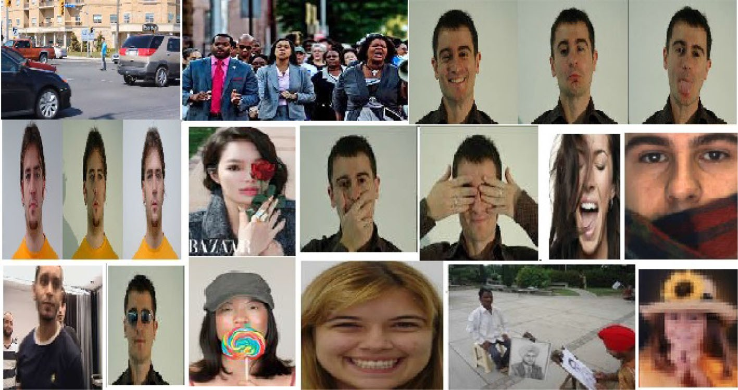

2. Real-Time Processing and Scalability
Real-time processing and scalability are crucial for the practical use of face detection and tracking technologies. Applications such as surveillance and interactive systems demand immediate processing to be effective. Ensuring that algorithms function in real-time while preserving accuracy is a significant technical challenge. Moreover, scalability is vital for large-scale deployments, requiring efficient computational methods and optimization strategies to manage large data volumes without compromising performance.

3. Ethical and Privacy Considerations
The deployment of face detection and tracking technologies raises serious ethical and privacy concerns. Continuous monitoring and identification capabilities can lead to potential misuse and privacy breaches. Ensuring these technologies are used responsibly and with proper consent is essential. Researchers must adhere to ethical guidelines and legal frameworks to safeguard privacy, including implementing strong data protection measures and maintaining transparency in the use of these technologies.

4. Future Research Directions
Future research should aim to enhance robustness, efficiency, and ethical use. Developing algorithms that better manage extreme variability and occlusions is crucial. Optimizing systems for real-time performance and scalability will enable wider applications. Addressing ethical and privacy concerns through privacy-preserving techniques and compliance with regulations is essential. Exploring new modalities, such as 3D face tracking and integration with other biometric systems, could further advance the field.

Conclusion
To summarize, this paper has thoroughly examined face detection and tracking technologies, covering both basic and advanced methods. We have emphasized the pivotal role of deep learning in significantly enhancing the accuracy and efficiency of these technologies. Traditional techniques such as Haar cascades and template matching have been supplemented and often outperformed by contemporary methods like Convolutional Neural Networks (CNNs) and Region-based CNNs (R-CNN). Additionally, the review has highlighted real-world applications across various fields, including security, healthcare, and entertainment, underscoring the broad relevance and usefulness of these technologies.

The implications for the field are profound. The adoption of deep learning techniques has not only boosted the performance of face detection and tracking systems but also expanded their potential applications. In security and surveillance, the capability to detect and track faces accurately in real-time enhances monitoring and threat detection significantly. In healthcare, these technologies can facilitate patient monitoring and diagnosis, providing a non-invasive and efficient tool for medical practitioners. Furthermore, in the entertainment sector, face detection and tracking can improve user experiences in gaming and augmented reality applications.

In conclusion, despite the considerable advancements made, challenges persist, particularly regarding occlusions, lighting variations, and real-time processing. Future research should aim to address these issues, as well as explore new applications and ethical considerations concerning privacy and security. This paper aspires to contribute to the continuous development and comprehension of face detection and tracking technologies, offering valuable insights for both researchers and professionals in the field.

Acknowledgement
We express our sense of gratitude towards our project guide Prof. Ashwini Kale for the valuable guidance at step of study of this project and also for the necessary guidelines and timely co-operation during the completion of project. We are thankful to our Project Coordinator Dr. Moresh Mukhedkar, Head of the Department Prof. Malayaj Kumar and all the staff members who extended their support for the project. We are very much thankful to respected Dean Prof. Dr. Pranav Charkha for their support and providing all facilities to complete the Project. Last but not the least we want to express thanks to our family for giving us support and confidence at each and every stage of completion of Project.

References
[1] Viola, P., & Jones, M. (2001). Rapid object detection using a boosted cascade of simple features. Proceedings of the 2001 IEEE Computer Society Conference on Computer Vision and Pattern Recognition (CVPR), 1, I-511-I-518.
https://ieeexplore.ieee.org/document/990517

[2] Dalal, N., & Triggs, B. (2005). Histograms of oriented gradients for human detection. 2005 IEEE Computer Society Conference on Computer Vision and Pattern Recognition (CVPR), 1, 886-893. https://doi.org/10.1109/CVPR.2005.177

[3] Zhu, X., & Ramanan, D. (2012). Face detection, pose estimation, and landmark localization in the wild. 2012 IEEE Conference on Computer Vision and Pattern Recognition (CVPR), 2879-2886. https://doi.org/10.1109/CVPR.2012.6248014

[4] Cao, Z., Simon, T., Wei, S. E., & Sheikh, Y. (2017). Realtime multi-person 2D pose estimation using part affinity fields. 2017 IEEE Conference on Computer Vision and Pattern Recognition (CVPR), 1302-1310. https://doi.org/10.1109/CVPR.2017.143

[5] Everingham, M., Gool, L. V., Williams, C. K. I., Winn, J., & Zisserman, A. (2010). The Pascal Visual Object Classes (VOC) Challenge. International Journal of Computer Vision, 88, 303-338. https://doi.org/10.1007/s11263-009-0275-4

[6] Taigman, Y., Yang, M., Ranzato, M., & Wolf, L. (2014). DeepFace: Closing the gap to human-level performance in face verification. 2014 IEEE Conference on Computer Vision and Pattern Recognition (CVPR), 1701-1708. https://doi.org/10.1109/CVPR.2014.220

[7] Ren, S., He, K., Girshick, R., & Sun, J. (2015). Faster R-CNN: Towards real-time object detection with region proposal networks. Advances in Neural Information Processing Systems, 28, 91-99.

[8] Redmon, J., Divvala, S., Girshick, R., & Farhadi, A. (2016). You only look once: Unified, real-time object detection. 2016 IEEE Conference on Computer Vision and Pattern Recognition (CVPR), https://doi.org/10.1109/CVPR.2016.91

