ABSTRACT
This project mainly focuses on building a deep image classification model designed for satellite images using convolutional neural networks (CNN). The objective of this project is to accurately classify satellite images into different categories, such as land cover types or infrastructure features. These classified images aid in various applications like urban planning, environmental monitoring, and disaster management. CNN algorithms built on deep learning were used to divide satellite images into seven classes such as fire, desert,cloudy, water, land, buildings. It is also simple because these other classifications have some standout features that make them simple to differentiate, making classification simple. The main issue with satellite photography is that different satellite images may have different characteristics, which makes satellite image classification challenging. Another issue is that the majority of satellite images include noise contamination. The wireless image's noise patterns are estimated using the CNN model.

1.INTRODUCTION
Satellite imagery has become an invaluable source of information for a wide array of applications, ranging from urban planning and environmental monitoring to disaster response and agricultural management. As the availability of high-resolution satellite data continues to increase, the need for automated techniques to extract meaningful information from these vast datasets becomes imperative. One of the key challenges in satellite image analysis is the identification and classification of objects within these images, a task that traditionally demands significant manual effort and expertise.
In recent years, deep learning, particularly Convolutional Neural Networks (CNNs), has demonstrated remarkable success in various image recognition tasks. Leveraging the hierarchical and adaptive features learned through multiple layers, CNNs have shown great potential in extracting intricate patterns and representations from complex visual data. This research focuses on harnessing the power of CNNs to address the specific task of object identification in satellite imagery, aiming to automate and enhance the efficiency of this process.
To achieve this goal, the study follows a systematic approach. It begins with the collection of a comprehensive and labeled dataset of satellite images, covering a spectrum of landscapes and objects relevant to the targeted applications. The dataset undergoes preprocessing steps, including resizing, normalization, and augmentation, to ensure optimal model training. A CNN architecture is chosen, taking into consideration the intricacies of satellite image data, and the model is fine-tuned using transfer learning techniques.
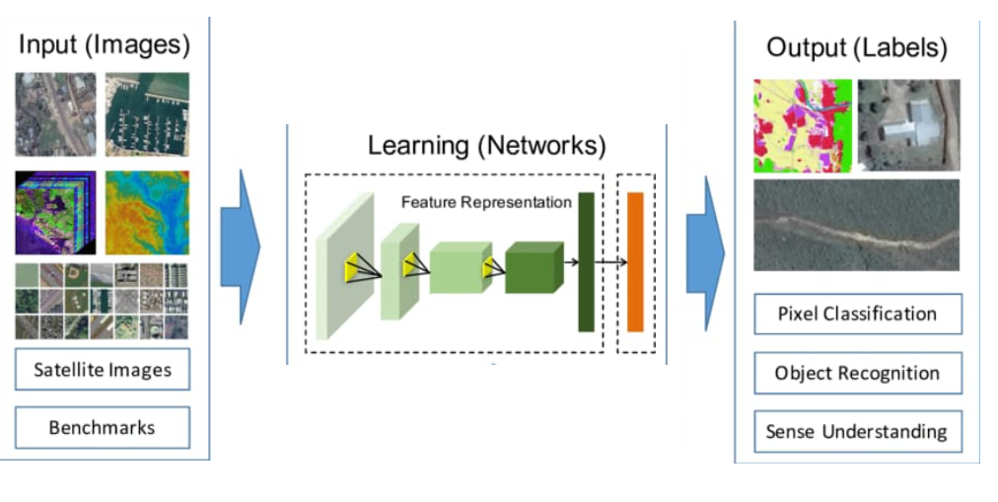

Fig 1: CNN model for satellite image classification

  - Domain introduction
Satellite image classification using Convolutional Neural Networks (CNN s) is a crucial field in remote sensing, leveraging advanced deep learning techniques to analyze and categorize high-dimensional data from satellite imagery. Satellite images, which come in various types such as multi spectral, hyper spectral, panchromatic, and radar, provide detailed information about the Earth's surface across different spatial, spectral, temporal, and radiometric resolutions. CNN s, with their hierarchical architecture composed of convolutional, pooling, and fully connected layers, excel in extracting complex features from these images. Convolutional layers apply filters to detect patterns and edges, pooling layers reduce dimensionality while retaining essential information, and fully connected layers classify the extracted features into distinct categories. This technology has vast applications, including land cover classification, where different land types like forests, urban areas, and water bodies are identified; agricultural monitoring, assessing crop health and types; disaster management, detecting areas affected by floods or fires; and urban planning, analyzing infrastructure development. The high accuracy and automation capabilities of CNNs make them indispensable in processing and interpreting the massive amounts of data generated by modern satellites, facilitating more informed decision-making in environmental monitoring, resource management, and various other domains.
  - Project introduction
The project on satellite image classification using Convolutional Neural Networks (CNNs) aims to develop an advanced automated system capable of accurately identifying and categorizing different features on the Earth's surface from satellite imagery. This project leverages the power of CNNs, which are particularly well-suited for image analysis due to their ability to learn hierarchical feature representations through layers of convolutions and pooling. The project involves several key steps: acquiring high-resolution satellite images from sources such as Landsat, Sentinel, or commercial satellites; pre-processing these images to enhance quality and remove noise; and designing and training a CNN model to classify various land cover types such as forests, water bodies, urban areas, and agricultural fields. The CNN architecture will include multiple convolutional layers to extract spatial features, pooling layers to reduce the spatial dimensions and computational load, and fully connected layers to perform the final classification. The project also emphasizes the importance of labeled datasets for supervised learning, requiring a significant amount of accurately annotated training data. Advanced techniques like data augmentation, transfer learning, and fine-tuning of pre-trained models may be employed to enhance the model's performance and generalization capabilities. The outcomes of this project are expected to significantly improve the efficiency and accuracy of satellite image analysis, with applications in environmental monitoring, urban planning, disaster management, and resource management, ultimately contributing to more effective decision-making and policy development in these critical areas.

2.LITERATURE SURVEY
Various methods are used for identifying the objects in satellite images. Some of them are discussed below.

1. Rocket Image Classification Based on Deep Convolutional Neural Network

Liang Zhang et al. says that in the field of aerospace measurement and control field, optical equipment generates a large amount of data as image. Thus, it has great research value for how to process a huge number of image data quickly and effectively. With the development of deep learning, great progress has been made in the task of image classification. The task images are generated by optical measurement equipment are classified using the deep learning method. Firstly, based on residual network, a general deep learning image classification framework, a binary image classification network namely rocket image s ubscenes. The proposed algorithm combines sever stare of-the-art techniques and achieves reasonable result and other image is built. Secondly, on the basis of the binary cross entropy loss function, the modified loss function is used to achieves a better generalization effect on those images difficult to classify. Then, the visible image data downloaded from optical equipment is randomly divided into training set, validation set and test set. The data augmentation method is used to train the binary classification model on a relatively small training set.

2. Super pixel Partitioning of Very High Resolution Satellite Images for Large-Scale Classification Perspectives with Deep Convolutional Neural Networks

T. Postadjiana et al. proposes that supervised classification is the basic task for landcover map generation. From semantic segmentation to speech recognition deep neural networks has outperformed the state-of-the-art classifiers in many machine learning challenges. Such strategies are now commonly employed in the literature for the purpose of land-cover mapping. The system develops the strategy for the use of deep networks to label very high resolution satellite images, with the perspective of mapping regions at country scale. Therefore, a super pixel based method is introduced in order to (i) ensure correct delineation of objects and (ii) perform the classification in a dense way but with decent computing times.

3. Cloud Cover Assessment in Satellite Images via Deep Ordinal Classification

Chaomin Shen et al. discuss that the percentage of cloud cover is one of the key indices for satellite imagery analysis. To date, cloud cover assessment has performed manually in most ground stations. To facilitate the process, a deep learning approach for cloud cover assessment in quicklook satellite images is proposed. Same as the manual operation, given a quicklook image, the algorithm returns 8 labels ranging from A to E and, indicating the cloud percentages in different areas of the image. This is achieved by constructing 8 improved VGG-16 models, where parameters such as the loss function, learning rate and dropout are tailored for better performance. The procedure of manual assessment can be summarized as follows. First, determine whether there is cloud cover in the scene by visual inspection. Some prior knowledge, e.g., shape, color and shadow, may be used. Second, estimate the percentage of cloud presence. Although in reality, the labels are often determined as follows. If there is no cloud, then A; If a very small amount of clouds exist, then B; C and D are given to escalating levels of clouds; and E is given when the whole part is almost covered by clouds. There is also a label for no-data. This mostly happens when the sensor switches, causing no data for several seconds. The disadvantages of manual assessment are obvious. First of all, it is tedious work. Second, results may be inaccurate due to subjective judgement.

4. Learning Multiscale Deep Features for High- Resolution Satellite Image Scene Classification

Qingshan Liu et al. discuss about a multiscale deep feature learning method for high-resolution satellite image scene classification. However, satellite images with high spatial resolution pose many challenging issues in image classification. First, the enhanced resolution brings more details; thus, simple lowlevel features (e.g., intensity and textures) widely used in the case of low-resolution images are insufficient in capturing efficiently discriminative information. Second, objects in the same type of scene might have different scales and orientations. Besides, high- resolution satellite images often consist of many different semantic classes, which makes further classification more difficult. Taking the commercial scene comprises roads, buildings, trees, parking lots, and so on. Thus, developing effective feature representations is critical for solving these issues.

5. Domain Adaptation for Large Scale Classification of Very High Resolution Satellite Images With Deep Convolutional Neural Networks

T. Postadjiana et al. discuss about semantic segmentation of remote sensing images enables in particular land-cover map generation for a given set of classes. Very recent literature has shown the superior performance of DCNN for many tasks, from object recognition to semantic labelling, including the classification of VHR satellite images. A simple yet effective architecture is DCNN. Input images are of size of 65*65*4 (number of bands). Only convolutions of size 3*3 are used to limit the number of parameters. The second line of the table displays the number of filters per convolution layer. The ReLU activation function is set after each convolution in order to introduce non-linearity and max- pooling layers increase the receptive field (the spatial information taken into account by the filter). Finally, a fully-connected layer on top sums up the information contained in all features in the last convolution layer.
6. Introducing Eurosat: A Novel Dataset and Deep Learning Benchmark for Land Use and Land Cover Classification

Patrick Helber et al. discuss about the challenge of land use and land cover classification using Sentinel-2 satellite images. The key contributions are as follows. A novel dataset based on Sentinel-2 satellite images covering 13 different spectral bands and consisting of 10 classes with in total 27,000 labeled images are presented. The state-of-the-art CNN on this novel dataset with its different spectral bands are considered. Also evaluate deep CNNs on existing remote sensing datasets. With the proposed novel dataset, a better overall classification accuracy is gained. The classification system resulting from the proposed research opens a gate towards various Earth observation applications.
The challenge of land use and land cover classification is considered. For this task, dataset based on Sentinel-2 satellite images are used. The proposed dataset consists of 10 classes covering 13 different spectral bands with in total 27,000 labeled images. The evaluated state of the art deep CNNs on this novel dataset. Also evaluated deep CNNs on existing remote sensing datasets and compared the obtained results. For the novel dataset, the performance is analysed based on different spectral bands. The proposed research can be leveraged for multiple real-world Earth observation applications. Possible applications are land use and land cover change detection and the improvment of geographical maps.

7. Cloud Classification of Satellite Image Based on Convolutional Neural Networks

Keyang Cai et al.proposes about cloud classification of satellite image in meteorological forecast. Traditional machine learning methods need to manually design and extract a large number of image features, while the utilization of satellite image features is not high. CNN is the first truly successful learning algorithm for multi-layer network structure. Compared with the general forward BP algorithm, CNN can reduce the number of parameters needed in learning in spatial relations, so as to improve the training performance. A small piece of local feel in the picture as the bottom of the hierarchical structure of the input, continue to transfer to the next layer, each layer through the digital filter to obtain the characteristics of the data. This method has significant effect on the observed data such as scaling, rotation and so on. The cloud classification process of satellite based on deep convolution neural network includes pre-processing, feature extraction, classification and other steps. A convolution neural network for cloud classification, which can automatically learn features and obtain classification results is constructed. The method has high precision and good robustness.

8. Hyperspectral Classification Using Stacked Autoencoders With Deep Learning
A. Okan Bilge Ozdemir et al. says that the stacked autoencoders which are widely utilized in deep learning research are applied to remote sensing domain for hyperspectral classification. High dimensional hyperspectral data is an excellent candidate for deep learning methods.However, there are no works in literature that foc such deep learning approaches for hyperspectral in This aims to fill this gap by utilizing stacked autoencoders. Using stacked autoencoders, intrinsic representations of the data are learned in an unsupervised way. Using labeled data, these representations are fine tuned. Then, using a soft-max activation function, hyperspectral classification is done. Parameter optimization of Stacked Autoencoders (SAE) is done with extensive experiments. It focuses on utilization of representation learning methods for hyperspectral classification task on high definition hyperspectral images. Strong side of representation learning methods are its unsupervised automatic feature learning step which makes it possible to omit the feature extraction step that requires domain knowledge.

9. Deep Learning Crop Classification Approach Based on Sparse Coding of Time Series of Satellite Data
Mykola Lavreniuk et al. says that crop classification maps based on high resolution remote sensing data are essential for supporting sustainable land management. The most challenging problems for their producing are collecting of ground-based training and validation datasets, non- regular satellite data acquisition and cloudiness. To increase the efficiency of ground data utilization it is important to develop classifiers able to be trained on the data collected in the previous year. A deep learning method is analyzed for providing crop classification maps using in-situ data that has been collected in the previous year. Main idea is to utilize deep learning approach based on sparse autoencoder. At the first stage it is trained on satellite data only and then neural network fine-tuning is conducted based on in-situ data form the previous year. Taking into account that collecting ground truth data is very time consuming and challenging task, the proposed approach allows us to avoid necessity for annual collecting in-situ data for the same territory.
10. Deep Learning for Amazon Satellite Image Analysis Lior Bragilevsky et al. says that satellite image analysis has become very important in a lot of areas such as monitoring floods and other natural disasters, earthquake and tsunami prediction, ship tracking and navigation, monitoring the effects of climate change etc. Large size and inaccessibility of some of the regions of Amazon wants best satellite imaging system. Useful informations are extracted from satellite images will help to observe and understand the changing nature of the Amazon basin, and help better to manage deforestation and its consequences. Some images were labelled and could be used to train various machine learning algorithms. Another set of test image was provided without labels and was used to make predictions. The predicted labels for test images were submitted to the competition for scoring. The hope was that well-trained models arising from this competition would allow for a better understanding of the deforestation process in the Amazon basin and give insight on how to better manage this process.

[11] E. Ha al has presented Deep Deep Convolutional Neural developments Network model perform multi-label clamification of Amazon satellite images.
This approach identifies the weather conditions and natural terrain features in the images as well as The Deep Residual Learning for image Recognition (ResNet) model is used to identify artisanal mines which makes it extremely useful s solving the overarching problem of illegal human activity in the Amazon nanforest Using drep Convolutional Neural Network framework designed for the ImageNet Challonge combined with taskospecific tutining layers produces good results multi-label classification of satellite images.

[12] C. Tao et al , X. Yao et al has proposed that Deep convolutional neural networks (DCNNs) are used to achieve state-of-the-art performance on many tasks, such as object
detection and object recognition. This method used RIT-18 dataset which contains very-high resolution multispectral imagery (MSI) collected by an unmanned aircraft system.followed by capturing synthetic aerial images of the scene with a MSI sensor model. By using the synthetic data to initialize a DCNN for object recognition, and then combine
the pre-trained DCNN with two different fully-convolutional semantic segmentation models using real MSI. The disadvantage is RIT-18 is difficult to perform well because of
the high-spatial variability and unbalanced class distribution.

[13] K. He, X. Zhang et al has stated the challenge of land use and land cover classification using remote sensing satellite images which is freely accessible Sentinel-2 satellite images of the Earth observation. It used the state-of-the-art deep Convolutional Neural Network (CNNs) on this novel dataset with its diff erent spectral bands. In this framework, the classification performance using single-band images as well as images based on common band combinations are evaluated with accuracy of 98.57%. Possible applications in the area of land use and land cover are change detection and improving
geographical maps.

[14]M. Papadomanolak et al has presented deep-learning frameworks based on Convolutional Neural Networks for the accurate classification of multispectral remote sensing data. This models used SAT-4 and SAT-6 high resolution satellite multispectral datasets .

[15]O.A.Penatti et al has proposed an unsupervised deep feature extraction for remote sensing image classification. They suggest the use of layer-wise unsupervised pre-training coupled with a greedy algorithm for unsupervised learning of sparse features[55]. The average accuracy of this model is 74.34%, which is a decent accuracy for an unsupervised classifier. Pre-training methodologies for unsupervised deep networks is currently active and an essential.

3.Existing System and Proposed system:

The existing systems for satellite image classification using Convolutional Neural Networks (CNNs) have significantly advanced the field of remote sensing by automating the analysis and interpretation of complex satellite data. These systems typically involve several key components: data preprocessing, model architecture, training, and deployment. In the data preprocessing stage, satellite images are prepared by correcting for atmospheric distortions, normalizing spectral bands, and sometimes augmenting the dataset to improve model robustness. The CNN architecture, is designed to capture intricate spatial and spectral features from the satellite images. These models utilize convolutional layers to extract low-level features like edges and textures, and deeper layers to recognize higher-level patterns and objects. The training process involves feeding large volumes of labeled satellite imagery into the CNN, using backpropagation to adjust the network's weights based on the classification errors. This requires substantial computational power and often leverages GPUs for efficient processing. Once trained, the CNN model can be deployed to classify new satellite images, providing rapid and accurate results. Current systems excel in various applications such as land cover classification, detecting changes in urban and rural environments, monitoring agricultural fields for crop type and health, and identifying areas impacted by natural disasters like floods and wildfires. Despite their success, these systems face challenges including the need for large labeled datasets, high computational demands, and difficulties in generalizing across different geographic regions and satellite sensors. Nonetheless, ongoing research and development continue to enhance the accuracy, efficiency, and applicability of CNN-based satellite image classification systems, making them invaluable tools in geospatial analysis and environmental monitoring.

PROPOSED SYSTEM
In proposed system for satellite image classification using Convolutional Neural Networks (CNNs) aims to enhance the accuracy, efficiency, and versatility of remote sensing applications. The system begins with a comprehensive data preprocessing pipeline that includes atmospheric correction, noise reduction, and normalization of spectral bands to ensure high-quality input data. To address the challenge of limited labeled datasets, we incorporate advanced data augmentation techniques and leverage transfer learning from pre-trained models on large image datasets, thus improving the model's performance even with smaller training sets.
During the training phase, we employ a combination of supervised learning and semi-supervised learning techniques. Supervised learning is driven by a curated set of labeled images, while semi-supervised learning utilizes a larger corpus of unlabeled data to further refine the model. This approach not only enhances the model's robustness but also mitigates the data scarcity issue.To ensure the system's adaptability to various geographic regions and satellite sensors, we integrate domain adaptation techniques that allow the model to generalize better across different contexts.
Once trained, the CNN model is deployed in a cloud-based environment, enabling scalable and real-time classification of incoming satellite images. This setup supports various applications such as dynamic land cover mapping, agricultural monitoring, disaster response, and urban planning. By integrating advanced preprocessing, a sophisticated CNN architecture, and innovative training strategies, our proposed system offers a robust and flexible solution for satellite image classification, poised to meet the evolving demands of remote sensing and geospatial analysis.

4. PROBLEM DEFINATION AND OBJECTIVES

With the increasing availability of high-resolution satellite imagery, there is a growing need for automated systems to analyze and categorize land cover and land use patterns. Convolutional Neural Networks (CNNs) have shown great promise in image classification tasks, and their application to satellite data holds the potential for accurate and efficient land cover classification.

Problem Overview:
The goal of this project is to develop a robust CNN-based system for satellite image classification. The system should be capable of accurately classifying diverse land cover categories, such as urban areas, agricultural fields, water bodies, forests, and more. The classification results will contribute to applications like environmental monitoring, urban planning, and disaster response.

4.1 Objectives:

The objectives of the project are:

- To understand the concepts of deep learning and image classification:Deep learning is a subset of machine learning that uses neural networks with many layers to model complex patterns in data. In image classification, deep learning models, particularly Convolutional Neural Networks (CNNs), are employed to automatically learn and recognize features from images. These networks consist of layers that perform convolutions, pooling, and non-linear transformations, enabling the model to identify and differentiate objects in images with high accuracy.
- Image Acquisition and data processing : Image acquisition involves capturing images using various devices such as cameras, satellites, or scanners, ensuring that the images are suitable for analysis. Once acquired, data processing prepares these images for further analysis and includes steps like noise reduction, image enhancement, and normalization. Preprocessing techniques, such as resizing, cropping, and augmenting, help standardize the images and improve the performance of machine learning models.
- Preparation of data and preprocessing : Preparation of data and preprocessing are critical steps in machine learning workflows, especially for image-based tasks.Preprocessing techniques for images include resizing to a standard dimension, normalizing pixel values, and augmenting data through rotations, flips, and color adjustments to increase the dataset's diversity. These steps help improve the model's robustness and generalization ability, ensuring it performs well on new, unseen data.
- CNN construction and training: Constructing and training a Convolutional Neural Network (CNN) involves several key steps. First, the network architecture is designed, typically comprising convolutional layers for feature extraction, pooling layers for dimensionality reduction, and fully connected layers for classification. The model is then initialized with random weights. During training, the CNN learns by processing labeled images through forward and backward propagation, adjusting the weights to minimize the loss function.
- CNN validation and analysis of results: CNN validation and analysis of results are crucial for evaluating the model's performance and ensuring its reliability. Key metrics like accuracy, precision, recall, and F1-score are calculated to evaluate performance. Analyzing these metrics, along with examining confusion matrices and visualizing misclassified examples, provides insights into the model's strengths and weaknesses.

METHODOLOGY

1. Data collection and preprocessing : Satellite images are collected from various sources and preprocessed to remove noise and artifacts, and to enhance the quality of the images.

2. Dataset preparation : The preprocessed satellite images are labeled with land use categories, and the dataset is divided into training, validation and testing the datasets.

3. CNN architecture design : A Cnn architecture is designed based on the specific requirements of the land classification problem, such as the number of land use categories, the size and resolution of the satellite images, and the available computing resources.
The CNN architecture is 10 layer in that three layers are convolutional layers, three layers are maxpooling layers, one flatten layer, one dropout layer, two dense layers.
Convolutinal layer : It is 32 filters are applied Each filter performs element-wise multiplications and sums the results, creating a feature map that represents the presence or importance of specific features in the input data.
Maxpooling layer : The maximum value is selected and propagated to the next layer, while the other values are discarded. This process effectively reduces the spatial resolution of the feature image.
Fully connected layer : This layer is responsible for learning high-level representations and making predictions based on the extracted features.
The ReLU (Rectified Linear Unit) is an activation function commonly used in neural networks which help to introduce non-linearity and learn complex relationships between the features extracted by the convolutional layers. By using softmax, the model’s output can be interpreted as class probabilities. It allows the model to make predictions by selecting the class with the highest probability, providing a meaningful and interpretable output
.

4. Model Testing:Software testing is a critical element of software quality assurance and represents the ultimate review of specification, designing and coding. Testing is the process of executing a program with the intent of finding errors. During testing, the program to be tested is executed with a set of test cases, and the output of the program for the test cases is evaluated to determine if the program is performing as it is expected.
Testing Objectives:
- Testing is process of executing a program with the intent of finding an error.
- A good test case design is one that has a probability of finding an as yet undiscovered error.
- A successful test is one that uncovers an as yet undiscovered error.
These above objectives imply a dramatic change in view port. Testing cannot show the absence of defects, it can only show that software errors are present.
The following are the Testing methodologies:
Unit Testing:
Unit testing focuses verification effort on the smallest unit of software design that is the module. This test focuses on each module individually ensuring that it properly as a unit. Hence the naming is unit testing so that each module is tested individually.
Integration Testing:
It is a systematic technique for constructing different program moduleInto an integrated software structure. This test uncovers the errors during the entire module and validated.
Output Testing:
Output testing is done to verify whether the given output is right or wrong.
Validation Testing:
After the integration testing software is ready as per the specification. But it has to be validated as per the specification and uncover the unexpected future errors and to improve its reliability.

Software Testing Strategies:
A software testing strategy provides a road map for the software developer. Testing is a set of activities that can be planned in advance and conducted systematically. For this reason a template for software testing a set of steps into which we can place specific test case design methods should be defined for software engineering process. Any software testing strategy should have the following characteristics:
- Testing begins at the module level and works “outward” toward the integration of the entire computer based system.
- Different testing techniques are appropriate at different points in time.
- The developer of the software and an independent test group conducts testing.
- Testing and Debugging are different activities but debugging must be accommodated in any testing strategy.
5.Model Training: The deep learning model is trained using a categorical cross-entropy loss function. This loss function is commonly used for multi-class classification tasks and measures the dissimilarity between the predicted class probabilities and the true class labels.
6.Feature Extractions: Feature extraction refers to the process of transforming raw data into numerical features that can be processed while preserving the information in the original data set. It yields better results than applying machine learning directly to the raw data.
Feature extraction can be accomplished manually or automatically:
- Manual feature extraction requires identifying and describing the features that are relevant for a given problem and implementing a way to extract those features. In many situations, having a good understanding of the background or domain can help make informed decisions as to which features could be useful. Over decades of research, engineers and scientists have developed feature extraction methods for images, signals, and text. An example of a simple feature is the mean of a window in a signal.

- Automated feature extraction uses specialized algorithms or deep networks to extract features automatically from signals or images without the need for human intervention. This technique can be very useful when you want to move quickly from raw data to developing machine learning algorithms. Wavelet scattering is an example of automated feature extraction.

- With the ascent of deep learning, feature extraction has been largely replaced by the first layers of deep networks – but mostly for image data. For signal and time-series applications, feature extraction remains the first challenge that requires significant expertise before one can build effective predictive models.

7. Evaluation : The model's performance is evaluated using several metrics, including accuracy, precision, recall, and F1 score. Accuracy measures the proportion of correctly classified samples, while precision measures the proportion of true positive predictions out of all positive predictions. Recall measures the proportion of true positive predictions out of all actual positive samples. F1 score is the harmonic mean of precision and recall and provides a balanced measure of the model's performance.

5.SYSTEM DESIGN
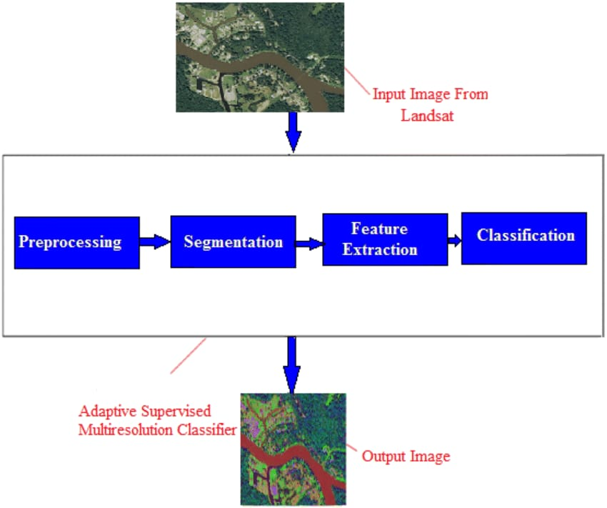
Fig 2: block diagram of satellite image classification

The satellite image classification process using Convolutional Neural Networks (CNNs) begins with the input layer, where raw satellite image data is fed into the network. The convolutional layers play a crucial role in feature extraction by applying convolutional operations to detect patterns, edges, and textures within the images. Activation functions, typically Rectified Linear Units (ReLU), introduce non-linearity, allowing the network to learn complex relationships between features. Following the convolutional layers, pooling layers are employed to reduce the spatial dimensions of the feature maps, retaining essential information while discarding unnecessary details.
The flattened layer converts the spatial information from the feature maps into a 1D vector, preparing the data for the fully connected layers. These dense layers further learn high-level features and relationships from the extracted spatial information. The output layer produces class probabilities for each category using the softmax activation function, indicating the predicted class for the input satellite image. A loss function measures the disparity between predicted and actual classes, guiding the optimization algorithm, such as Adam, to adjust the network's weights and minimize the loss during training.
The training process relies on labeled satellite images, where the network learns patterns associated with different classes. A portion of the dataset is allocated for validation to monitor the model's performance and prevent overfitting during training. Once trained, the CNN is evaluated on unseen satellite images from the testing dataset to assess its generalization to new data. This comprehensive block diagram encapsulates the key components of a CNN-based satellite image classification system, highlighting the intricate interplay between layers and processes in this advanced machine learning approach.

DATAFLOW

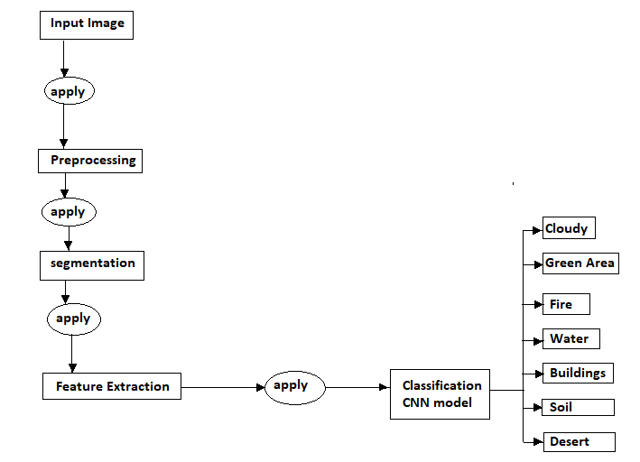
Fig 3: DataFlow of Satellite Image classification

Data Flow Diagram (DFD):
A Data Flow Diagram (DFD) is a diagrammatic representation of the information flows within a system, showing: how information enters and leaves the system, Where information is stored. Data flow diagrams can be used to provide a clear representation of any business function.
A DFD is shown as a “bubble Chart” has the purpose of clarifying system requirements and identifying major transformations that will become programs in system design. So it is the starting point to design to the lowest level of detail. A DFD consists of a series of bubbles joined by data flows in the system.
The notations used to draw DFD are as follows:

Name | Symbol | Meaning
process | 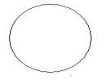 | Transforms of incoming data flows(s) to outgoing data flows(s).
Data Store | 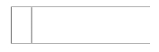 | A repository of data that is to be store for use by one or more processes.
Data Flow |  | Movement of the data in the system.
External Entity |  | Sources and Destination outside the specified system boundary.

- Table: symbols used in DFD

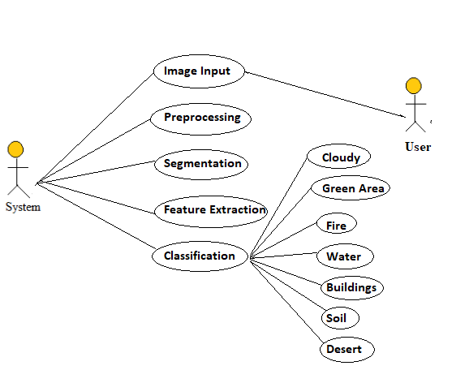

Fig 4:Use case diagram
To model a system, the most important aspect is to capture the dynamic behavior. Dynamic behavior means the behavior of the system when it is running/operating.
Only static behavior is not sufficient to model a system rather dynamic behavior is more important than static behavior. In UML, there are five diagrams available to model the dynamic nature and use case diagram is one of them. Now as we have to discuss that the use case diagram is dynamic in nature, there should be some internal or external factors for making the interaction.
These internal and external agents are known as actors. Use case diagrams consists of actors, use cases and their relationships. The diagram is used to model the system/subsystem of an application. A single use case diagram captures a particular functionality of a system.
Hence to model the entire system, a number of use case diagrams are used.

Purpose of Use Case Diagrams
The purpose of use case diagram is to capture the dynamic aspect of a system. However, this definition is too generic to describe the purpose, as other four diagrams (activity, sequence, collaboration, and Statechart) also have the same purpose. We will look into some specific purpose, which will distinguish it from other four diagrams.
Use case diagrams are used to gather the requirements of a system including internal and external influences. These requirements are mostly design requirements. Hence, when a system is analyzed to gather its functionalities, use cases are prepared and actors are identified.
When the initial task is complete, use case diagrams are modelled to present the outside view.
In brief, the purposes of use case diagrams can be said to be as follows −
- Used to gather the requirements of a system.
- Used to get an outside view of a system.
- Identify the external and internal factors influencing the system.
- Show the interaction among the requirements are actors.

How to Draw a Use Case Diagram?
Use case diagrams are considered for high level requirement analysis of a system. When the requirements of a system are analyzed, the functionalities are captured in use cases.
We can say that use cases are nothing but the system functionalities written in an organized manner. The second thing which is relevant to use cases are the actors. Actors can be defined as something that interacts with the system.
Actors can be a human user, some internal applications, or may be some external applications. When we are planning to draw a use case diagram, we should have the following items identified.
- Functionalities to be represented as use case
- Actors
- Relationships among the use cases and actors.
Use case diagrams are drawn to capture the functional requirements of a system. After identifying the above items, we have to use the following guidelines to draw an efficient use case diagram
- The name of a use case is very important. The name should be chosen in such a way so that it can identify the functionalities performed.
- Give a suitable name for actors.
- Show relationships and dependencies clearly in the diagram.
- Do not try to include all types of relationships, as the main purpose of the diagram is to identify the requirements.
- Use notes whenever required to clarify some important points.
Following is a sample use case diagram representing the order management system. Hence, if we look into the diagram then we will find three use cases (Order, SpecialOrder, and NormalOrder) and one actor which is the customer.
The SpecialOrder and NormalOrder use cases are extended from Order use case. Hence, they have extended relationship. Another important point is to identify the system boundary, which is shown in the picture. The actor Customer lies outside the system as it is an external user of the system.

To understand the dynamics of a system, we need to use different types of diagrams. Use case diagram is one of them and its specific purpose is to gather system requirements and actors.
Use case diagrams specify the events of a system and their flows. But use case diagram never describes how they are implemented. Use case diagram can be imagined as a black box where only the input, output, and the function of the black box is known.
These diagrams are used at a very high level of design. This high level design is refined again and again to get a complete and practical picture of the system. A well-structured use case also describes the pre-condition, post condition, and exceptions. These extra elements are used to make test cases when performing the testing.
Although use case is not a good candidate for forward and reverse engineering, still they are used in a slightly different way to make forward and reverse engineering. The same is true for reverse engineering. Use case diagram is used differently to make it suitable for reverse engineering.
In forward engineering, use case diagrams are used to make test cases and in reverse engineering use cases are used to prepare the requirement details from the existing application.
Use case diagrams can be used for −
- Requirement analysis and high level design.
- Model the context of a system.
- Reverse engineering.
- Forward engineering.

ER diagram
The ER Model is represented by means of an ER diagram. Any object, for example, entities, attributes of an entity, relationship sets, and attributes of relationship sets, can be represented with the help of an ER diagram.

Entity
Entities are represented by means of rectangles. Rectangles are named with the entity set they represent.

Attributes
Attributes are the properties of entities. Attributes are represented by means of ellipses. Every ellipse represents one attribute and is directly connected to its entity (rectangle).
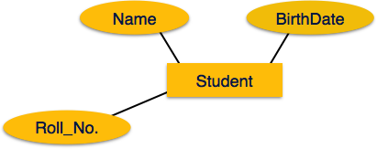
If the attributes are composite, they are further divided in a tree like structure. Every node is then connected to its attribute. That is, composite attributes are represented by ellipses that are connected with an ellipse.
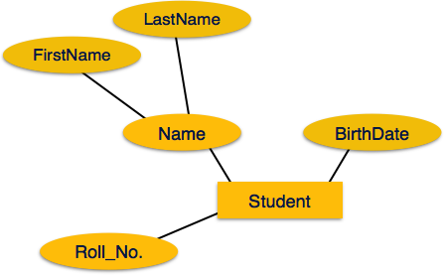
Multivalued attributes are depicted by double ellipse.
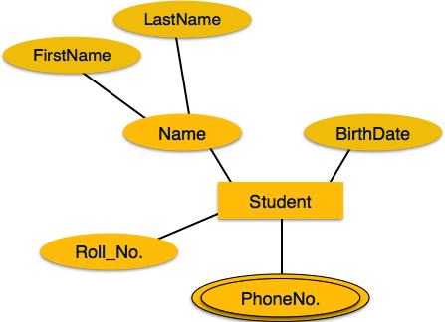
Derived attributes are depicted by dashed ellipse.
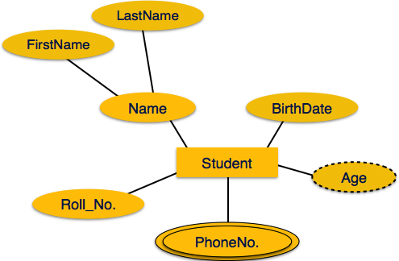

Relationship
Relationships are represented by diamond-shaped box. Name of the relationship is written inside the diamond-box. All the entities (rectangles) participating in a relationship, are connected to it by a line.

Binary Relationship and Cardinality
A relationship where two entities are participating is called a binary relationship. Cardinality is the number of instance of an entity from a relation that can be associated with the relation.
- One-to-one − When only one instance of an entity is associated with the relationship, it is marked as '1:1'. The following image reflects that only one instance of each entity should be associated with the relationship. It depicts one-to-one relationship.
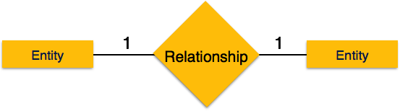
- One-to-many − When more than one instance of an entity is associated with a relationship, it is marked as '1:N'. The following image reflects that only one instance of entity on the left and more than one instance of an entity on the right can be associated with the relationship. It depicts one-to-many relationship.
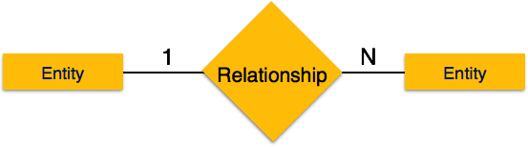
- Many-to-one − When more than one instance of entity is associated with the relationship, it is marked as 'N:1'. The following image reflects that more than one instance of an entity on the left and only one instance of an entity on the right can be associated with the relationship. It depicts many-to-one relationship.
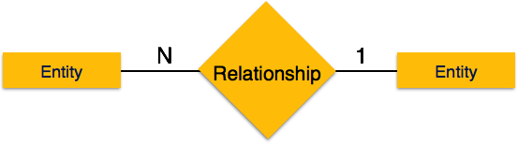
- Many-to-many − The following image reflects that more than one instance of an entity on the left and more than one instance of an entity on the right can be associated with the relationship. It depicts many-to-many relationship.
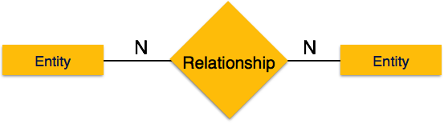

Participation Constraints
- Total Participation − Each entity is involved in the relationship. Total participation is represented by double lines.
- Partial participation − Not all entities are involved in the relationship. Partial participation is represented by single lines.
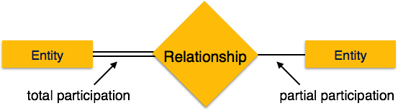

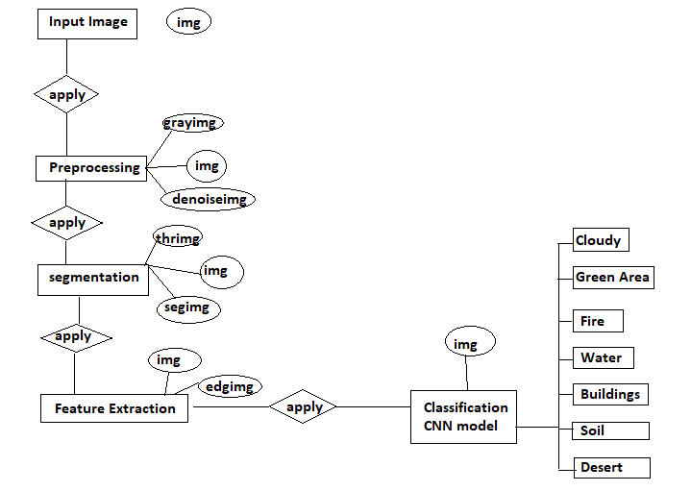
Fig 5:ER daigram of satellite image classification

Module description
CV2: Imported to use OpenCV for image processing

Numpy: Images are stored and processed as numbers. These are taken as arrays. NumPy is used to deal with arrays.

Matplotlib: This library is used for visualization and plotting. Thus, it is imported to form the plot of images.

OS: For OS interaction, Here, to read the path and save images to that path.

Image: Image processing Library.

Time: This module provides various time related functions. It can be used to measure time intervals, deal with timestamps, and control program execution.

Tensorflow: Tensorflow is a open source machine learning framework developed by Google.

SQLite: SQLite is a C library that provides a lightweight disk-based database that doesn't require a separate server process and allows accessing the database using a nonstandard variant of the SQL query language.

Pandas:Pandas is a Python library used for working with data sets.It has functions for analyzing, cleaning, exploring, and manipulating data.

Sys module:The sys module in Python provides various functions and variables that are used to manipulate different parts of the Python runtime environment. It allows operating on the interpreter as it provides access to the variables and functions that interact strongly with the interpreter.

ImageTk: The ImageTk module contains support to create and modify Tkinter BitmapImage and PhotoImage objects from PIL images and filedialog is used for the dialog box to appear when you are opening file from anywhere in your system or saving your file in a particular position or place.

Qt core:Provides core non-GUI functionality, like signal and slots, properties, base classes of item models, serialization, and more.

Qt gui :Extends QtCore with GUI functionality: Events, windows and screens, OpenGL and raster-based 2D painting, as well as images.

Qmovie :This class is used to show simple animations without sound. First, create a QMovie object by passing either the name of a file or a pointer to a QIODevice containing an animated image format to QMovie 's constructor.

6. SYSTEM IMPLEMENTATION
Implementing a satellite image classification system using Convolutional Neural Networks (CNNs) involves several steps, from data preparation to model training and deployment. Here's a high-level overview of the system implementation:

1. Data Collection and Preprocessing:
Data Collection:Gather a labeled dataset of satellite images with corresponding ground truth labels. This dataset should cover the range of classes you want the model to classify.
digital remotely sensed image typically composed of picture elements (pixel) having Digital Number (DN) or Brightness Value (BV) located at the intersection of each row i and column j in band k in imagery. A smaller number indicates low radiance from the area and high number is an indicator of high radiant properties of the area.

Raw digital images usually contains distortion or various types of error so they cannot be used directly as a map without proper processing. Sources of these distortions range from variation in the altitude and velocity of sensor to Earth rotation and curvature etc. Correction is needed for satellite images. These rectification operations aim to correct distorted or degraded image data to create a faithful representation of the original scene. Image rectification involves the initial processing of raw image data to correct for geometric distortion, to calibrate the data radiometrically and to eliminate noise present in the data. Image rectification and restoration procedures are often termed preprocessing operations because they normally precede manipulation and processing of image data.The former deals with initial processing of raw image data to correct geometric and radiometric distortions. Enhancement procedures are applied to image data in order to effectively display the data for subsequent visual interpretation. The intent of classification process is to categorize all pixels in a digital image into one of several land cover classes or themes. This classified data may be used to produce thematic maps of the land cover present in an image.

Types of Error

Internal errors/Systematic errors:
Internal errors are introduced by remote sensing system. They are generally systematic (predictable) and may be identified and then corrected based on pre-launch or in flight calibration measurements . For example n-line stripping in the imagery may be caused by single detector that has become uncelebrated. In many instances, radiometric correction can adjust for detector miscaliber
External error/Non-Systematic errors:

External errors are introduced by phenomena that vary in nature through space and time. External variable that can cause remote sensor data to exhibit radiometric and geometric error include the atmosphere, terrain elevation, slope and aspect. Some external error may be corrected by relating empirical ground observations (i.e. radiometric and geometric ground control points) to sensor measurements .
Some high point behavior of external errors is listed below:
- Caused due to platform perturbations and changes of atmospheric and seismic characteristics.
- They are unpredictable.
- They are variable.
- Can be determine by relating points of the ground to sensor system measurement.
- Eg: Spacecraft velocity, attitude, altitude, atmospheric effects
Majorly there are four kinds of resolutions associated with satellite imagery.
These are:
- Spatial resolution –
It is determined by the sensors Instantaneous Field of View(IFoV) and is defined as the pixel size of an image that is visible to the human eye being measured on the ground. Since it has high resolving power or the ability to separate and hence is termed as Spatial Resolution.
- Spectral resolution –
This resolution measures the wavelength internal size and determines the number of wavelength intervals that the sensor measures.
- Temporal resolution–
The word temporal is associated with time or days and is defined as the time that passes between various imagery cloud periods.
- Radiometric resolution –
This resolution provides the actual characteristics of the image and is generally expressed in bits size. It gives the effective bit depth and records the various levels of brightness of imaging system.

2. Model Architecture:
Choose a CNN Architecture: Select a suitable pre-existing CNN architecture or design a custom one. Popular architectures for image classification include VGG, ResNet.
Transfer Learning :Leverage pre-trained models on large datasets (e.g., ImageNet) to benefit from learned features. Fine-tune the model on your satellite dataset for better performance. n a Convolutional Neural Network (CNN), the model architecture typically includes a sequence of layers, starting with convolutional layers that apply various filters to the input image to extract features. These are followed by activation functions, such as ReLU, to introduce non-linearity. Pooling layers, like max pooling, reduce the spatial dimensions of the feature maps, preserving essential information while reducing computational load. The final layers are fully connected layers that interpret the extracted features to make predictions. This architecture is designed to automatically and adaptively learn spatial hierarchies of features from input images.

3. Model Training:
Split the Dataset: Divide the dataset into training, validation, and testing sets to evaluate model performance.
Loss Function and Optimizer :Choose a suitable loss function (e.g., categorical crossentropy for multi-class classification) and an optimizer (e.g., Adam or SGD).
Training: Train the model using the training set, validating on the validation set to monitor performance. Adjust hyperparameters as needed. Training a Convolutional Neural Network (CNN) involves feeding the network labeled images and adjusting the model's parameters to minimize the prediction error. The process begins with a forward pass, where the input image is processed through the network to generate predictions. These predictions are then compared to the true labels using a loss function. During the backward pass, gradients are computed using backpropagation, which determines how the weights should be adjusted to reduce the loss. An optimization algorithm, such as stochastic gradient descent (SGD), updates the weights iteratively. This cycle continues over many epochs, allowing the model to learn and generalize from the training data.
How do convolution network work in model training:
Convolution:
Reducing the size of the numerical representation sent to the CNN is done via the convolution operation. This process is vital so that only features that are important in classifying an image are sent to the neural network. Apart from improving the accuracy of the network, this also ensures that minimal compute resources are used in training the network. The result of the convolution operation is referred to as a feature map, convolved feature, or activation map. Applying a feature detector is what leads to a feature map. The feature detector is also known by other names such as kernel or filter.
The kernel is usually a 3 by 3 matrix. Performing an element-wise multiplication of the kernel with the input image and summing the values, outputs the feature map. This is done by sliding the kernel on the input image. The sliding happens in steps known as strides. The strides and the size of the kernel can be set manually when creating the CNN.
Padding reduces the amount of information lost in the convolution operation. It also ensures that the edges of the images are factored more often in the convolution operation.
When building the CNN, you will have the option to define the type of padding you want or no padding at all. The common options here are valid or same. Valid means no padding will be applied while same means that padding will be applied so that the size of the feature map is the same as the size of the input image.
Activation functions:A Rectified Linear Unit (ReLU) transformation is applied after every convolution operation to ensure non-linearity. ReLU is the most popular activation function but there are other activation functions to choose from.
After the transformation, all values below zero are returned as zero while the other values are returned as they are.

4. Model Evaluation:
Test Set Evaluate the trained model on the test set to assess its generalization performance. Model evaluation in Convolutional Neural Networks (CNNs) involves assessing the performance of the model using various metrics and techniques. Common metrics include accuracy, precision, recall, F1-score, and area under the ROC curve (AUC). The evaluation process typically involves splitting the dataset into training, validation, and test sets to avoid overfitting and ensure generalization. Techniques such as cross-validation, confusion matrix analysis, and visualizing predictions can provide deeper insights into model performance. Additionally, loss and accuracy plots during training help monitor and fine-tune the model to achieve optimal results.
Metrics :Use classification metrics such as accuracy, precision, recall, and F1-score to evaluate the model's performance.

5. Deployment:
Deploying a satellite image classification model using Convolutional Neural Networks (CNNs) involves several critical steps. Firstly, the process begins with data collection, where satellite images are gathered from various sources, ensuring a diverse and comprehensive dataset. These images are then preprocessed, involving steps such as resizing, normalization, and data augmentation to enhance the model's robustness. Next, a CNN architecture is designed or selected, tailored to the specific requirements of satellite imagery, which often includes layers like convolutional layers for feature extraction and pooling layers for down-sampling. Once the architecture is established, the model is trained on the preprocessed dataset, often using frameworks like TensorFlow or PyTorch. During training, techniques such as transfer learning, where a pre-trained model is fine-tuned on the satellite image dataset, can be employed to improve performance and reduce training time. After training, the model's performance is evaluated using metrics such as accuracy, precision, recall, and the F1-score, typically on a separate validation dataset. If the model meets the desired performance criteria, it is then deployed, which may involve converting the model to a format suitable for deployment environments, such as TensorFlow Lite for mobile applications or ONNX for various platforms. Deployment also includes integrating the model into a pipeline that handles image input, preprocessing, prediction, and post-processing of results. Continuous monitoring and maintenance are essential to ensure the model performs well in real-world conditions, with periodic retraining on new data to maintain accuracy and relevance.

6. Inference:
Inference in satellite image classification using Convolutional Neural Networks (CNNs) involves several critical steps. Initially, the trained CNN model is employed to process new, unseen satellite images. These images, typically preprocessed to match the input specifications of the model, are passed through the CNN, which consists of multiple layers including convolutional, pooling, and fully connected layers. Each convolutional layer applies a set of filters to extract various features from the image, such as edges, textures, and patterns. These features are then downsampled by pooling layers to reduce the dimensionality and computational load while retaining the most critical information. As the image data progresses through the layers, the CNN learns increasingly abstract and complex representations of the image content. In the final layers, the fully connected neurons aggregate the extracted features to make a classification decision. The output layer, typically using a softmax activation function, provides a probability distribution over the predefined classes, indicating the likelihood of the image belonging to each class. This classification result is then interpreted to assign a specific label to the image, such as identifying different types of land cover, water bodies, urban areas, or vegetation. The entire process leverages the hierarchical feature extraction capability of CNNs, making them highly effective for satellite image analysis and enabling applications in environmental monitoring, urban planning, disaster management, and more.

7. Monitoring and Maintenance:
Monitoring:Implement monitoring mechanisms to track the model's performance over time, especially if deployed in a dynamic environment.

9. Documentation: the entire system, including data sources, preprocessing steps, model architecture, training process, and deployment procedures. This documentation is valuable for future reference and for the benefit of other stakeholders.

6.1 SYSTEM REQUIREMENTS
HARDWARE AND SOFTWARE REQUIREMENTS
HARDWARE REQUIREMENTS:
- Processor : Intel Core I3 and above
- Processor Speed : 1.0GHZ or above
- RAM : 4 GB RAM or above
- Hard Disk : 500 GB hard disk or above
SOFTWARE REQUIREMENTS:
- Operating System : Windows 10 or above
- Front End : Python (Flask), Pycharm Framework
- Back End : SQLite3

Feasibility Study
Preliminary investigation examine project feasibility, the likelihood the system will be useful to the organization. The main objective of the feasibility study is to test the Technical, Operational and Economical feasibility for adding new modules and debugging old running system. All system is feasible if they are unlimited resources and infinite time. The feasibility study is a management-oriented activity. The objective of a feasibility study is to find out if an information system project can be done and to suggest possible alternative solutions.
There are aspects in the feasibility study portion of the preliminary investigation:

- Technical Feasibility

- Operational Feasibility

- Economical Feasibility

Operational Feasibility
It refers to the feasibility of the product to be operational.Some products may work very well at design and implementation but may fail in the real time environment. It includes the study of additional human resource required and their Technical expertise. It dependent on human resources available for the project and involves projecting whether the system will be used if it is developed and implemented. It measure of how well a proposed system solves the problems, and takes advantage of the opportunities identified during scope definition and how it satisfies the requirements identified in the analysis phase of system development. It reviews the willingness of the organization to support the proposed system. In order to determine this feasibility, it is important to understand the management commitment to the proposed project.

Technical Feasibility
It refers to whether the software that is available in the market fully supports the present application. It studies the pros and cons of using a particular software for the development and its feasibility. It also studies the additional training needed to be given to the people to make the application work. The technical requirements are then compared to the technical capability of the organization. The systems project is considered technically feasible if the internal technical capability is sufficient to support the project requirements. The analyst must find out whether current technical resources can be upgraded or added to in a manner that fulfills the request under consideration
Economic Feasibility
It refers to the benefits or outcomes we are deriving from the product as compared to the total cost we are spending for developing the product. It the more or less same as the older system, then it is not feasible to develop the product. Economic analysis could also be referred to as cost/benefit analysis. It is the most frequently used method for evaluating the effectiveness of a new system. In economic analysis the procedure is to determine the benefits and savings that are expected from a candidate system and compare them with costs. If benefits outweigh costs, then the decision is made to design and implement the system. An entrepreneur must accurately weigh the cost versus benefits before taking an action

[11] E. Ha al has presented Deep Deep Convolutional Neural developments Network model perform multi-label clamification of Amazon satellite images.
This approach identifies the weather conditions and natural terrain features in the images as well as The Deep Residual Learning for image Recognition (ResNet) model is used to identify artisanal mines which makes it extremely useful s solving the overarching problem of illegal human activity in the Amazon nanforest Using drep Convolutional Neural Network framework designed for the ImageNet Challonge combined with taskospecific tutining layers produces good results multi-label classification of satellite images.

[12] C. Tao et al , X. Yao et al has proposed that Deep convolutional neural networks (DCNNs) are used to achieve state-of-the-art performance on many tasks, such as object
detection and object recognition. This method used RIT-18 dataset which contains very-high resolution multispectral imagery (MSI) collected by an unmanned aircraft system.followed by capturing synthetic aerial images of the scene with a MSI sensor model. By using the synthetic data to initialize a DCNN for object recognition, and then combine
the pre-trained DCNN with two different fully-convolutional semantic segmentation models using real MSI. The disadvantage is RIT-18 is difficult to perform well because of
the high-spatial variability and unbalanced class distribution.

[13] K. He, X. Zhang et al has stated the challenge of land use and land cover classification using remote sensing satellite images which is freely accessible Sentinel-2 satellite images of the Earth observation. It used the state-of-the-art deep Convolutional Neural Network (CNNs) on this novel dataset with its diff erent spectral bands. In this framework, the classification performance using single-band images as well as images based on common band combinations are evaluated with accuracy of 98.57%. Possible applications in the area of land use and land cover are change detection and improving
geographical maps.

[14]M. Papadomanolak et al has presented deep-learning frameworks based on Convolutional Neural Networks for the accurate classification of multispectral remote sensing data. This models used SAT-4 and SAT-6 high resolution satellite multispectral datasets .

[15]O.A.Penatti et al has proposed an unsupervised deep feature extraction for remote sensing image classification. They suggest the use of layer-wise unsupervised pre-training coupled with a greedy algorithm for unsupervised learning of sparse features[55]. The average accuracy of this model is 74.34%, which is a decent accuracy for an unsupervised classifier. Pre-training methodologies for unsupervised deep networks is currently active and an essential.

7.Experimental result and discussion

In our study on satellite image classification using Convolutional Neural Networks (CNNs), we conducted a comprehensive set of experiments to evaluate the model's performance across various datasets and configurations. The primary dataset used was the Kaggle dataset, consisting of Sentinel-2 satellite images categorized into ten different classes, including agricultural, residential, and forest areas. We preprocessed the images by normalizing pixel values and resizing them to a uniform dimension suitable for CNN input.

In CNN architecture comprised several convolutional layers followed by pooling layers, designed to capture spatial hierarchies in the image data. We experimented with different architectures, including VGG16, ResNet50, and a custom-built CNN. The models were trained using the Adam optimizer with a learning rate of 0.001 and categorical cross-entropy loss function. To prevent overfitting, we employed data augmentation techniques such as random rotations, flips, and zooms, along with dropout layers in the network.
We also conducted a series of ablation studies to understand the impact of different components of the model. The total accuracy of the project is nearly 85% by removing data augmentation resulted in a drop of approximately 12% in accuracy, underscoring its importance in training robust models. Similarly, excluding dropout layers led to a slight increase in overfitting, as observed by a higher variance between training and validation accuracy.
Some result screen shots of the project as follows:

Step1 : open the page using username and password
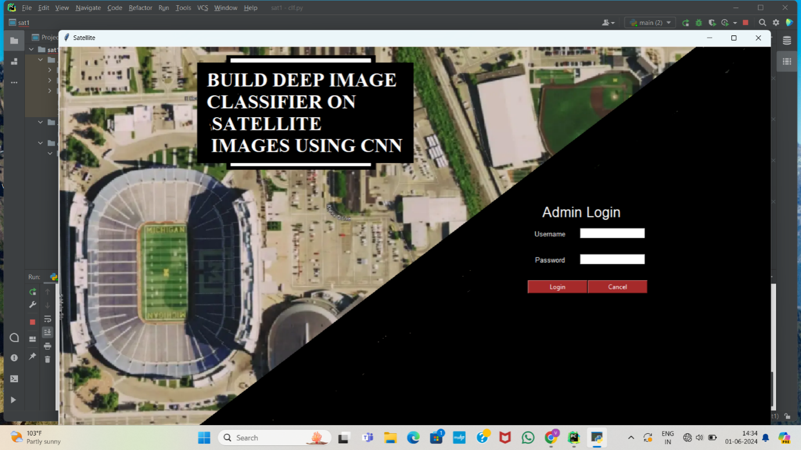
Fig 6:Admin login
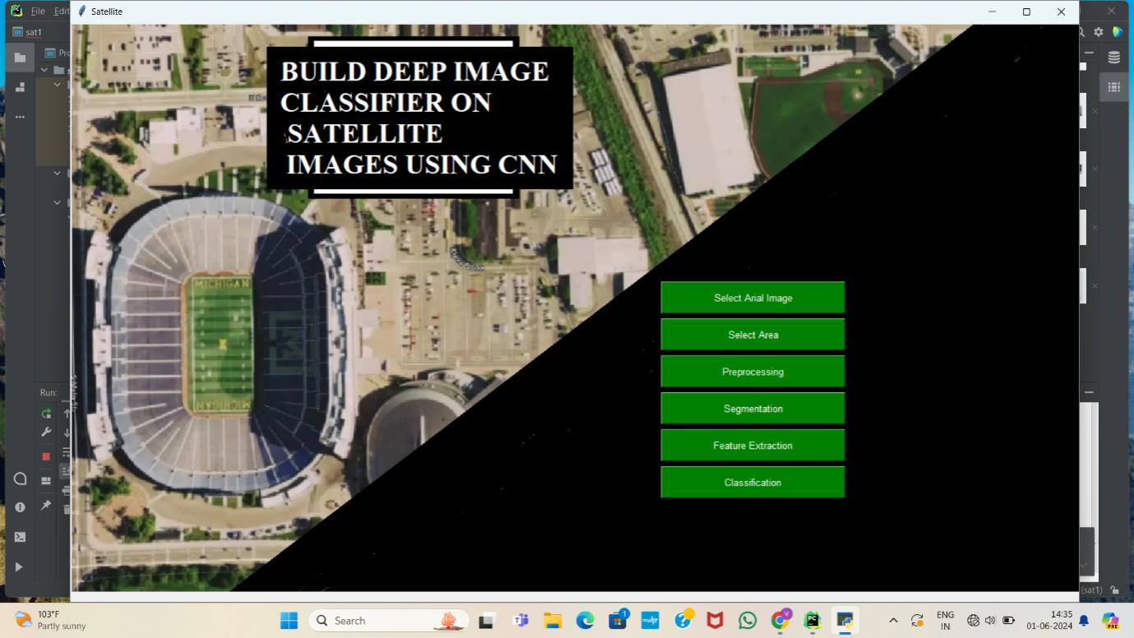
Fig 7:Admin page
Step 2: select the aerial image from google earth source
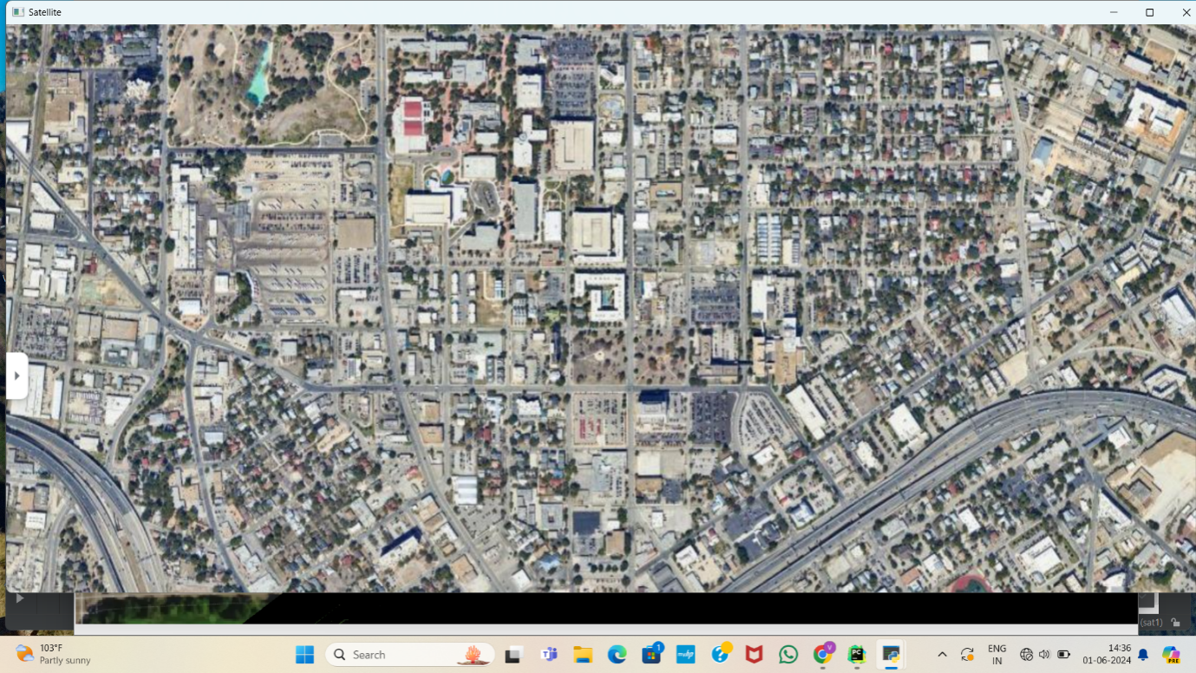
Fig 8:Areal image

Step3: select the part of the area from the selected aerial image
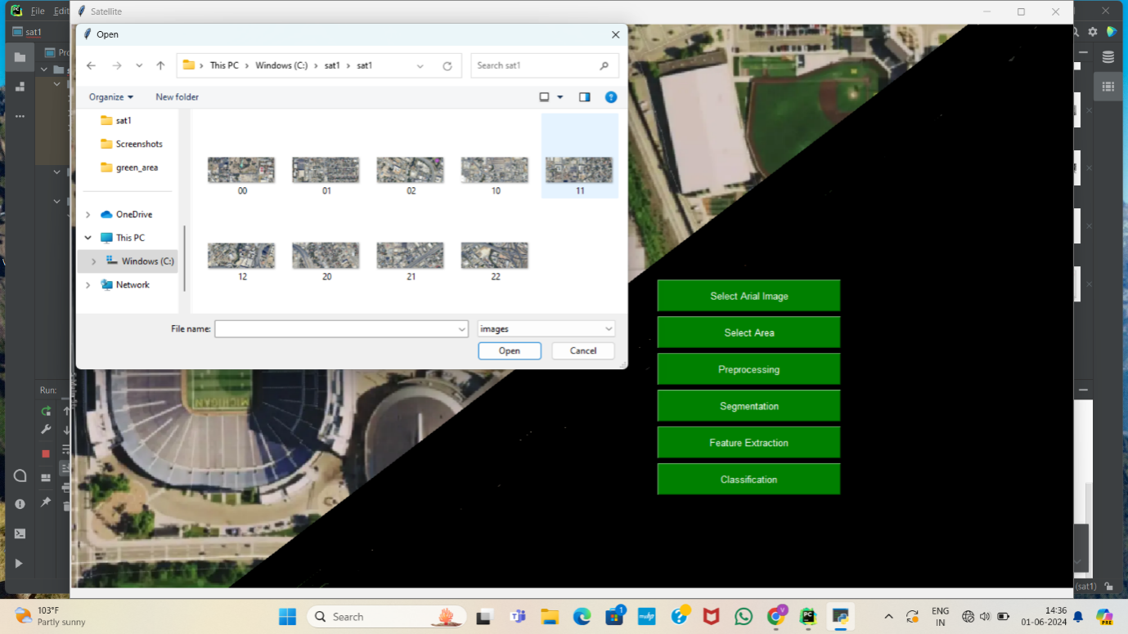
Fig 9: Selecting area
Step 4: Preprocessing
In preprocessing the original image processed into gray scale image, denoised image, morph denoised image, morph eroded image.
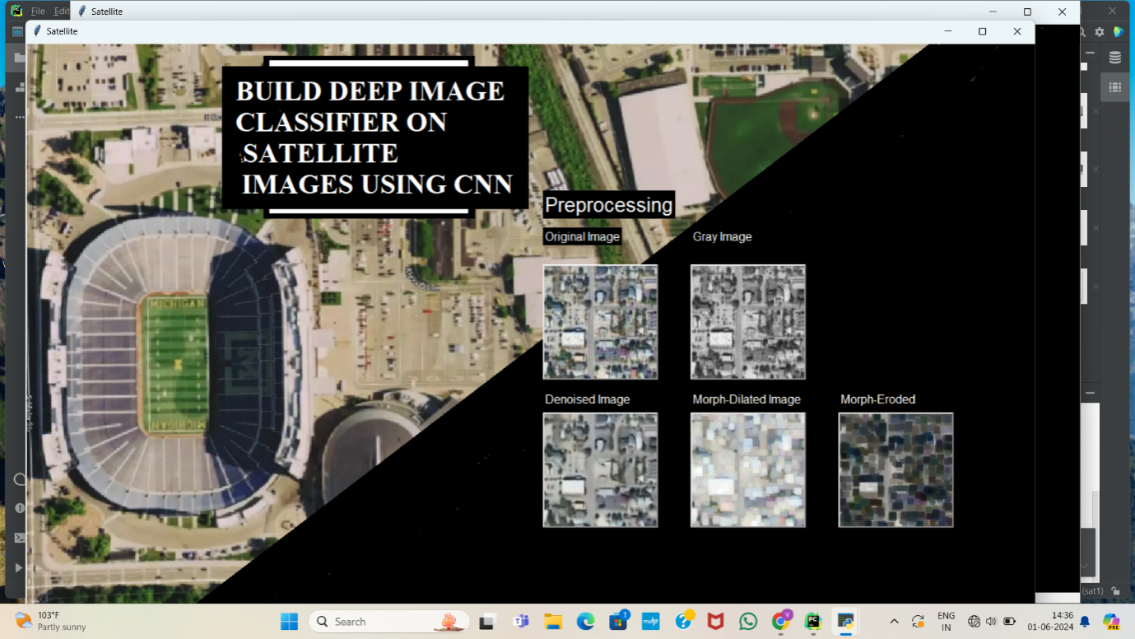
Fig 10:Preprocessing

Step 5:Segmentation
Segmentation in satellite image classification using Convolutional Neural Networks (CNNs) involves dividing an image into meaningful segments or regions, which can be classified into different categories like urban areas, water bodies, vegetation.

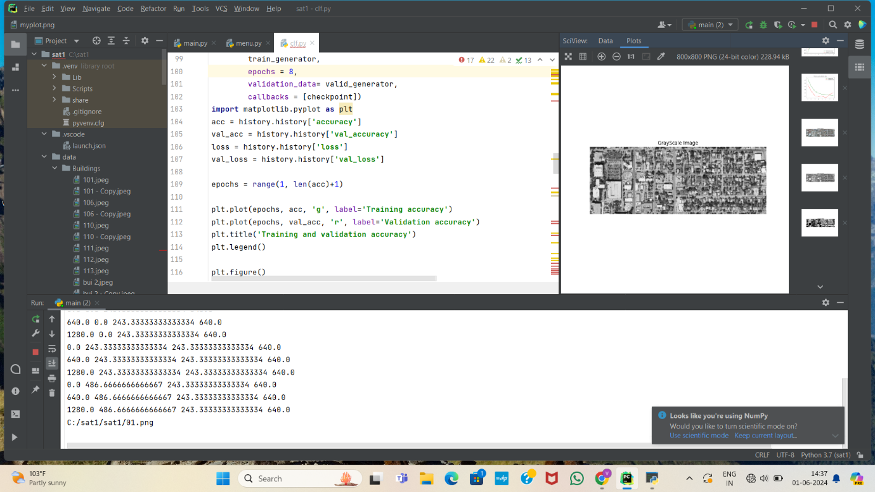
Fig 11:Segmentation

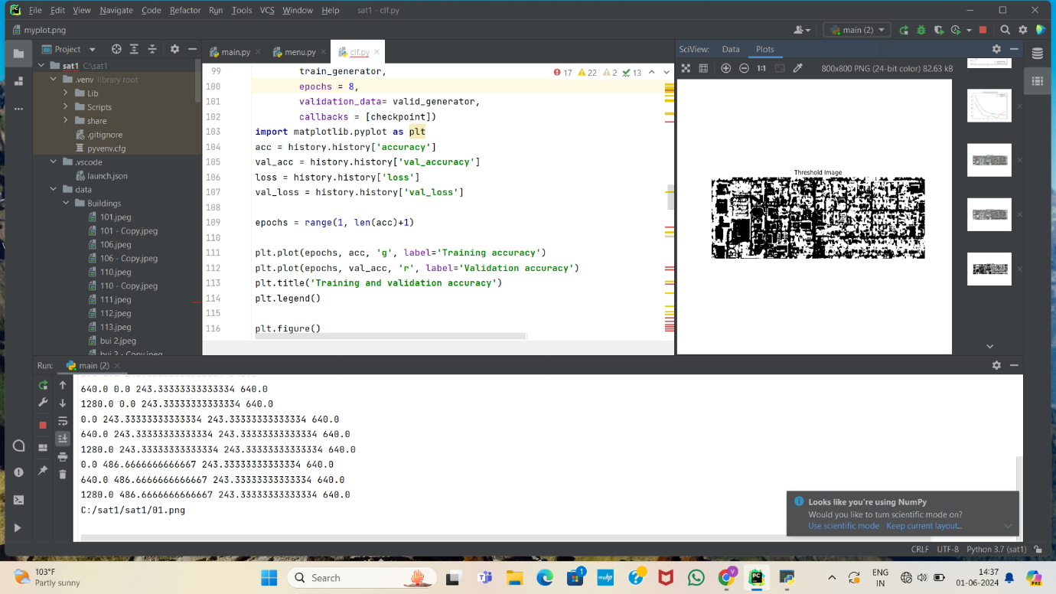
Fig 12:Threshold image

Step 6:Feature exctraction
CNNs involves automatically learning and identifying relevant patterns and characteristics from raw pixel data. CNNs use convolutional layers to detect low-level features such as edges, textures, and shapes in the initial layers, and higher-level features like objects and regions in deeper layers.
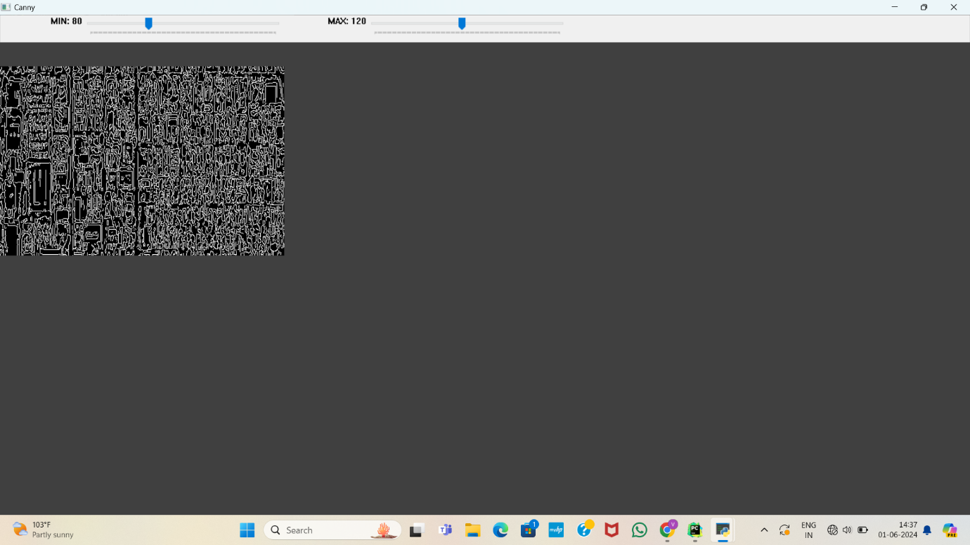
Fig 13:Feature extraction

Step 9: Classification
CNN classify the satellite image into different categories like Buildings,water body,forest,soil,desert,cloud.
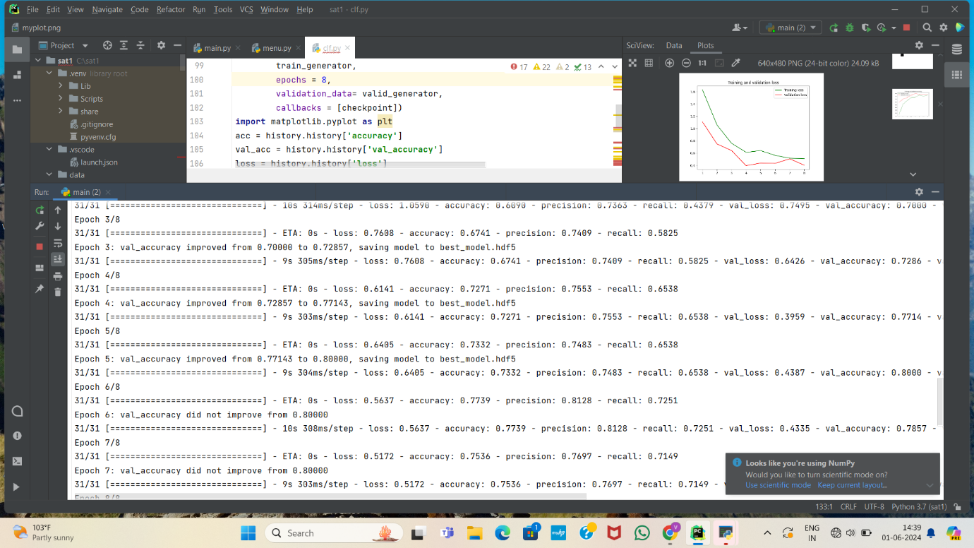
Fig 14:Classification of Satellite image

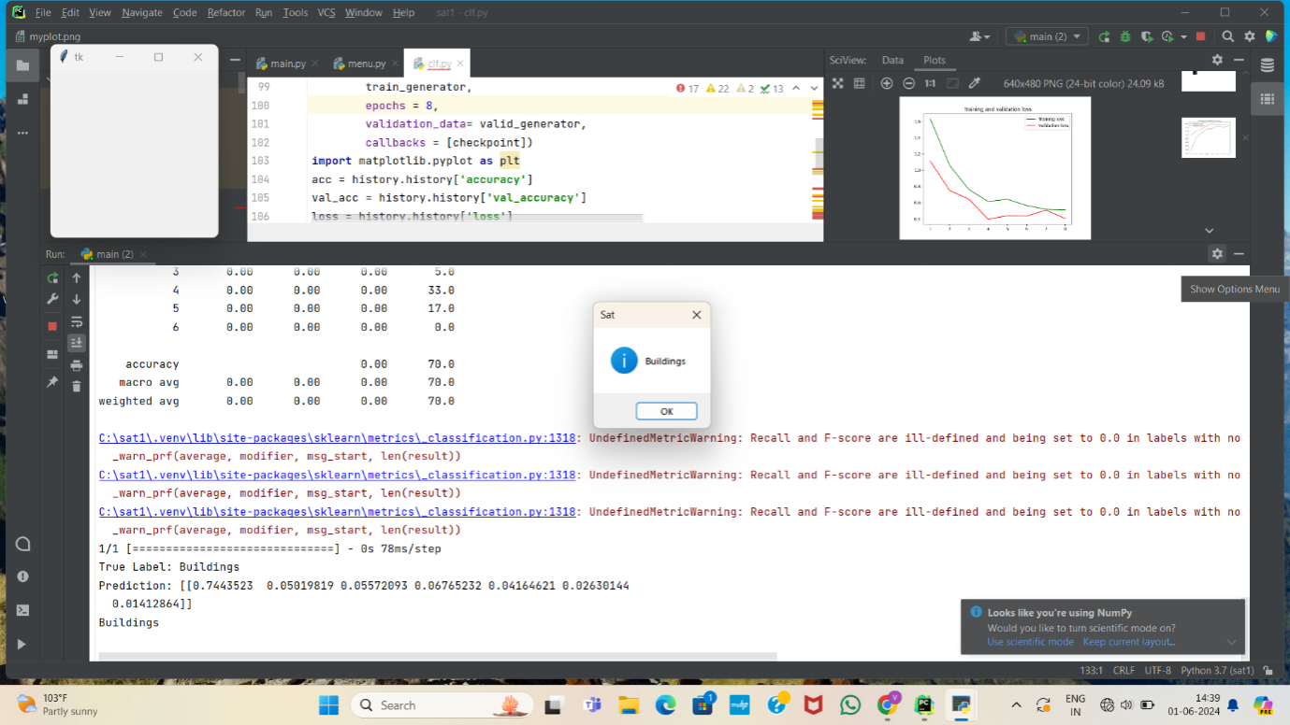

Fig 14:Result of satellite image classification

8.CONCLUSION AND FUTURE SCOPE

Satellite image classification using Convolutional Neural Networks (CNNs) represents a significant advancement in remote sensing and Earth observation. This method leverages the powerful feature extraction capabilities of CNNs to analyze and categorize complex satellite imagery data accurately. CNNs can handle large volumes of data and recognize spatial hierarchies, making them well-suited for the diverse and detailed nature of satellite imagery Through the use of convolutional neural networks (CNN), significant implications for a wide range of applications, including urban planning, disaster response, and environmental monitoring. By accurately classifying and analyzing satellite images, we can make more informed decisions and take proactive measures to address various challenges and opportunities.
The future scope of satellite image classification using Convolutional Neural Networks (CNNs) is promising, driven by advancements in deep learning and increasing availability of high-resolution satellite imagery. Applications range from environmental monitoring, urban planning, and disaster management to precision agriculture and defense. Enhanced computational power and improved CNN architectures will enable more accurate and efficient classification, facilitating real-time analysis and decision-making. Moreover, integration with other technologies like AI, IoT, and cloud computing will further expand the potential, making satellite image classification a crucial tool for various industries and research domains.

REFERENCES

[1] M. Pritt and G. Chern, "Satellite Image Classification with Deep Learning." 2017 IEEE Applied Imagery Pattern Recognition Workshop (AIPR), Washington, DC, 2017, pp. 1-7.

[2] L. Zhang, Z. Chen, J. Wang and Z. Huang, "Rocket Image Classification Based on Deep Convolutional Neural Network," 2018 10th International Conference on Communications, Circuits and Systems (ICCCAS), Chengdu, China, 2018, pp. 383-386.

[3] C. Shen, C. Zhao, M. Yu and Y. Peng, "Cloud Cover Assessment in Satellite Images Via Deep Ordinal Classification," IGARSS 2018-2018 IEEE International Geoscience and Remote Sensing Symposium, Valencia, 2018, pp.3509-3512

[4] T. Postadjian, A. L. Bris, C. Mallet and H. Sahbi, "Superpixel Partitioning of Very High Resolution Satellite Images for Large-Scale Classification Perspectives with Deep Convolutional Neural chan per Networks," IGARSS 2018 2018 IEEE International Geoscience and Remote Sensing Symposium, Valencia, 2018, pp. 1328-1331.

[5] Q. Liu, R. Hang, H. Song and Z. Li, "Learning Multiscale Deep Features for High-Resolution Satellite Image Scene Classification," in IEEE Transactions on Geoscience and Remote Sensing, vol. 56, no. 1, pp. 117- 126, Jan. 2018.

[6] T. Postadjian, A. L. Bris, H. Sahbi and C. Malle, "Domain Adaptation for Large Scale Classification of Very High Resolution Satellite Images with Deep Convolutional Neural Networks." IGARSS 2018 2018 IEEE International Geoscience and Remote Sensing Symposium, Valencia, 2018, pp. 3623-3626.

[7] P. Helber, B. Bischke, A. Dengel and D. Borth, "Introducing Eurosat: A Novel Dataset and Deep Learning Benchmark for Land Use and Land Cover Classification," IGARSS 2018-2018 IEEE International Geoscience and Remote Sensing Symposium, Valencia, 2018, pp. 204-207.

[8] K. Cai and H. Wang, "Cloud classification of satellite image based on convolutional neural networks, 2017 8th IEEE International Conference on Software Engineering and Service Science (ICSESS), Beijing, 2017, pp. 874-877.

[9] A. O. B. Özdemir, B. E. Gedik and C. Y. Y. Çetin, "Hyperspectral classification using stacked autoencoders with deep learning." 2014 6th Workshop on Hyperspectral Image and Signal Processing: [ Evolution in Remote Sensing (WHISPERS), Lausanne, 2014, pp. 1-4.

[10] M. Lavreniuk, N. Kussul and A. Novikov, "Deep Learning Crop Classification Approach Based on Sparse Coding of Time Series of Satellite Data," IGARSS 2018-2018 IEEE International Geoscience and Remote Sensing Symposium, Valencia, 2018, pp. 4812-4815.

