ABSTRACT
This project mainly focuses on building a deep image classification model designed for satellite images using convolutional neural networks (CNN). The objective of this project is to accurately classify satellite images into different categories, such as land cover types or infrastructure features. These classified images aid in various applications like urban planning, environmental monitoring, and disaster management. CNN algorithms built on deep learning were used to divide satellite images into seven classes such as fire, desert,cloudy, water, land, buildings. It is also simple because these other classifications have some standout features that make them simple to differentiate, making classification simple. The main issue with satellite photography is that different satellite images may have different characteristics, which makes satellite image classification challenging. Another issue is that the majority of satellite images include noise contamination. The wireless image's noise patterns are estimated using the CNN model.

1.INTRODUCTION
Satellite imagery has become an invaluable source of information for a wide array of applications, ranging from urban planning and environmental monitoring to disaster response and agricultural management. As the availability of high-resolution satellite data continues to increase, the need for automated techniques to extract meaningful information from these vast datasets becomes imperative. One of the key challenges in satellite image analysis is the identification and classification of objects within these images, a task that traditionally demands significant manual effort and expertise.
In recent years, deep learning, particularly Convolutional Neural Networks (CNNs), has demonstrated remarkable success in various image recognition tasks. Leveraging the hierarchical and adaptive features learned through multiple layers, CNNs have shown great potential in extracting intricate patterns and representations from complex visual data. This research focuses on harnessing the power of CNNs to address the specific task of object identification in satellite imagery, aiming to automate and enhance the efficiency of this process.
To achieve this goal, the study follows a systematic approach. It begins with the collection of a comprehensive and labeled dataset of satellite images, covering a spectrum of landscapes and objects relevant to the targeted applications. The dataset undergoes preprocessing steps, including resizing, normalization, and augmentation, to ensure optimal model training. A CNN architecture is chosen, taking into consideration the intricacies of satellite image data, and the model is fine-tuned using transfer learning techniques.
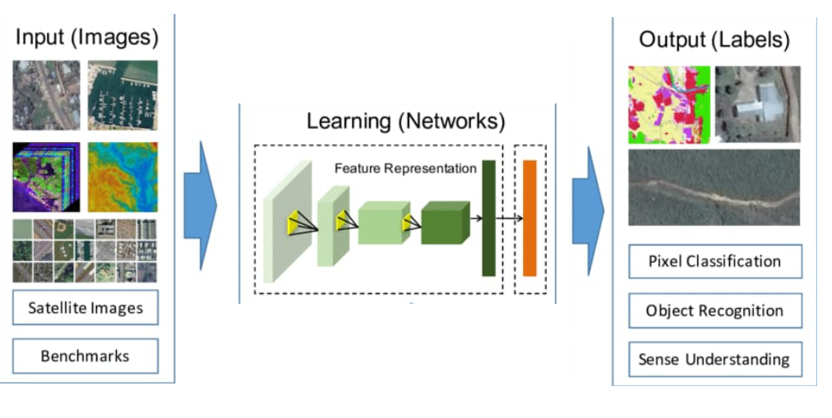

Fig 1: CNN model for satellite image classification

  - Domain introduction
Satellite image classification using Convolutional Neural Networks (CNN s) is a crucial field in remote sensing, leveraging advanced deep learning techniques to analyze and categorize high-dimensional data from satellite imagery. Satellite images, which come in various types such as multi spectral, hyper spectral, panchromatic, and radar, provide detailed information about the Earth's surface across different spatial, spectral, temporal, and radiometric resolutions. CNN s, with their hierarchical architecture composed of convolutional, pooling, and fully connected layers, excel in extracting complex features from these images. Convolutional layers apply filters to detect patterns and edges, pooling layers reduce dimensionality while retaining essential information, and fully connected layers classify the extracted features into distinct categories. This technology has vast applications, including land cover classification, where different land types like forests, urban areas, and water bodies are identified; agricultural monitoring, assessing crop health and types; disaster management, detecting areas affected by floods or fires; and urban planning, analyzing infrastructure development. The high accuracy and automation capabilities of CNNs make them indispensable in processing and interpreting the massive amounts of data generated by modern satellites, facilitating more informed decision-making in environmental monitoring, resource management, and various other domains.
  - Project introduction
The project on satellite image classification using Convolutional Neural Networks (CNNs) aims to develop an advanced automated system capable of accurately identifying and categorizing different features on the Earth's surface from satellite imagery. This project leverages the power of CNNs, which are particularly well-suited for image analysis due to their ability to learn hierarchical feature representations through layers of convolutions and pooling. The project involves several key steps: acquiring high-resolution satellite images from sources such as Landsat, Sentinel, or commercial satellites; pre-processing these images to enhance quality and remove noise; and designing and training a CNN model to classify various land cover types such as forests, water bodies, urban areas, and agricultural fields. The CNN architecture will include multiple convolutional layers to extract spatial features, pooling layers to reduce the spatial dimensions and computational load, and fully connected layers to perform the final classification. The project also emphasizes the importance of labeled datasets for supervised learning, requiring a significant amount of accurately annotated training data. Advanced techniques like data augmentation, transfer learning, and fine-tuning of pre-trained models may be employed to enhance the model's performance and generalization capabilities. The outcomes of this project are expected to significantly improve the efficiency and accuracy of satellite image analysis, with applications in environmental monitoring, urban planning, disaster management, and resource management, ultimately contributing to more effective decision-making and policy development in these critical areas.

2.LITERATURE SURVEY
Various methods are used for identifying the objects in satellite images. Some of them are discussed below.

1. Rocket Image Classification Based on Deep Convolutional Neural Network

Liang Zhang et al. says that in the field of aerospace measurement and control field, optical equipment generates a large amount of data as image. Thus, it has great research value for how to process a huge number of image data quickly and effectively. With the development of deep learning, great progress has been made in the task of image classification. The task images are generated by optical measurement equipment are classified using the deep learning method. Firstly, based on residual network, a general deep learning image classification framework, a binary image classification network namely rocket image s ubscenes. The proposed algorithm combines sever stare of-the-art techniques and achieves reasonable result and other image is built. Secondly, on the basis of the binary cross entropy loss function, the modified loss function is used to achieves a better generalization effect on those images difficult to classify. Then, the visible image data downloaded from optical equipment is randomly divided into training set, validation set and test set. The data augmentation method is used to train the binary classification model on a relatively small training set.

2. Super pixel Partitioning of Very High Resolution Satellite Images for Large-Scale Classification Perspectives with Deep Convolutional Neural Networks

T. Postadjiana et al. proposes that supervised classification is the basic task for landcover map generation. From semantic segmentation to speech recognition deep neural networks has outperformed the state-of-the-art classifiers in many machine learning challenges. Such strategies are now commonly employed in the literature for the purpose of land-cover mapping. The system develops the strategy for the use of deep networks to label very high resolution satellite images, with the perspective of mapping regions at country scale. Therefore, a super pixel based method is introduced in order to (i) ensure correct delineation of objects and (ii) perform the classification in a dense way but with decent computing times.

3. Cloud Cover Assessment in Satellite Images via Deep Ordinal Classification

Chaomin Shen et al. discuss that the percentage of cloud cover is one of the key indices for satellite imagery analysis. To date, cloud cover assessment has performed manually in most ground stations. To facilitate the process, a deep learning approach for cloud cover assessment in quicklook satellite images is proposed. Same as the manual operation, given a quicklook image, the algorithm returns 8 labels ranging from A to E and, indicating the cloud percentages in different areas of the image. This is achieved by constructing 8 improved VGG-16 models, where parameters such as the loss function, learning rate and dropout are tailored for better performance. The procedure of manual assessment can be summarized as follows. First, determine whether there is cloud cover in the scene by visual inspection. Some prior knowledge, e.g., shape, color and shadow, may be used. Second, estimate the percentage of cloud presence. Although in reality, the labels are often determined as follows. If there is no cloud, then A; If a very small amount of clouds exist, then B; C and D are given to escalating levels of clouds; and E is given when the whole part is almost covered by clouds. There is also a label for no-data. This mostly happens when the sensor switches, causing no data for several seconds. The disadvantages of manual assessment are obvious. First of all, it is tedious work. Second, results may be inaccurate due to subjective judgement.

4. Learning Multiscale Deep Features for High- Resolution Satellite Image Scene Classification

Qingshan Liu et al. discuss about a multiscale deep feature learning method for high-resolution satellite image scene classification. However, satellite images with high spatial resolution pose many challenging issues in image classification. First, the enhanced resolution brings more details; thus, simple lowlevel features (e.g., intensity and textures) widely used in the case of low-resolution images are insufficient in capturing efficiently discriminative information. Second, objects in the same type of scene might have different scales and orientations. Besides, high- resolution satellite images often consist of many different semantic classes, which makes further classification more difficult. Taking the commercial scene comprises roads, buildings, trees, parking lots, and so on. Thus, developing effective feature representations is critical for solving these issues.

5. Domain Adaptation for Large Scale Classification of Very High Resolution Satellite Images With Deep Convolutional Neural Networks

T. Postadjiana et al. discuss about semantic segmentation of remote sensing images enables in particular land-cover map generation for a given set of classes. Very recent literature has shown the superior performance of DCNN for many tasks, from object recognition to semantic labelling, including the classification of VHR satellite images. A simple yet effective architecture is DCNN. Input images are of size of 65*65*4 (number of bands). Only convolutions of size 3*3 are used to limit the number of parameters. The second line of the table displays the number of filters per convolution layer. The ReLU activation function is set after each convolution in order to introduce non-linearity and max- pooling layers increase the receptive field (the spatial information taken into account by the filter). Finally, a fully-connected layer on top sums up the information contained in all features in the last convolution layer.
6. Introducing Eurosat: A Novel Dataset and Deep Learning Benchmark for Land Use and Land Cover Classification

Patrick Helber et al. discuss about the challenge of land use and land cover classification using Sentinel-2 satellite images. The key contributions are as follows. A novel dataset based on Sentinel-2 satellite images covering 13 different spectral bands and consisting of 10 classes with in total 27,000 labeled images are presented. The state-of-the-art CNN on this novel dataset with its different spectral bands are considered. Also evaluate deep CNNs on existing remote sensing datasets. With the proposed novel dataset, a better overall classification accuracy is gained. The classification system resulting from the proposed research opens a gate towards various Earth observation applications.
The challenge of land use and land cover classification is considered. For this task, dataset based on Sentinel-2 satellite images are used. The proposed dataset consists of 10 classes covering 13 different spectral bands with in total 27,000 labeled images. The evaluated state of the art deep CNNs on this novel dataset. Also evaluated deep CNNs on existing remote sensing datasets and compared the obtained results. For the novel dataset, the performance is analysed based on different spectral bands. The proposed research can be leveraged for multiple real-world Earth observation applications. Possible applications are land use and land cover change detection and the improvment of geographical maps.

7. Cloud Classification of Satellite Image Based on Convolutional Neural Networks

Keyang Cai et al.proposes about cloud classification of satellite image in meteorological forecast. Traditional machine learning methods need to manually design and extract a large number of image features, while the utilization of satellite image features is not high. CNN is the first truly successful learning algorithm for multi-layer network structure. Compared with the general forward BP algorithm, CNN can reduce the number of parameters needed in learning in spatial relations, so as to improve the training performance. A small piece of local feel in the picture as the bottom of the hierarchical structure of the input, continue to transfer to the next layer, each layer through the digital filter to obtain the characteristics of the data. This method has significant effect on the observed data such as scaling, rotation and so on. The cloud classification process of satellite based on deep convolution neural network includes pre-processing, feature extraction, classification and other steps. A convolution neural network for cloud classification, which can automatically learn features and obtain classification results is constructed. The method has high precision and good robustness.

8. Hyperspectral Classification Using Stacked Autoencoders With Deep Learning
A. Okan Bilge Ozdemir et al. says that the stacked autoencoders which are widely utilized in deep learning research are applied to remote sensing domain for hyperspectral classification. High dimensional hyperspectral data is an excellent candidate for deep learning methods.However, there are no works in literature that foc such deep learning approaches for hyperspectral in This aims to fill this gap by utilizing stacked autoencoders. Using stacked autoencoders, intrinsic representations of the data are learned in an unsupervised way. Using labeled data, these representations are fine tuned. Then, using a soft-max activation function, hyperspectral classification is done. Parameter optimization of Stacked Autoencoders (SAE) is done with extensive experiments. It focuses on utilization of representation learning methods for hyperspectral classification task on high definition hyperspectral images. Strong side of representation learning methods are its unsupervised automatic feature learning step which makes it possible to omit the feature extraction step that requires domain knowledge.

9. Deep Learning Crop Classification Approach Based on Sparse Coding of Time Series of Satellite Data
Mykola Lavreniuk et al. says that crop classification maps based on high resolution remote sensing data are essential for supporting sustainable land management. The most challenging problems for their producing are collecting of ground-based training and validation datasets, non- regular satellite data acquisition and cloudiness. To increase the efficiency of ground data utilization it is important to develop classifiers able to be trained on the data collected in the previous year. A deep learning method is analyzed for providing crop classification maps using in-situ data that has been collected in the previous year. Main idea is to utilize deep learning approach based on sparse autoencoder. At the first stage it is trained on satellite data only and then neural network fine-tuning is conducted based on in-situ data form the previous year. Taking into account that collecting ground truth data is very time consuming and challenging task, the proposed approach allows us to avoid necessity for annual collecting in-situ data for the same territory.
10. Deep Learning for Amazon Satellite Image Analysis Lior Bragilevsky et al. says that satellite image analysis has become very important in a lot of areas such as monitoring floods and other natural disasters, earthquake and tsunami prediction, ship tracking and navigation, monitoring the effects of climate change etc. Large size and inaccessibility of some of the regions of Amazon wants best satellite imaging system. Useful informations are extracted from satellite images will help to observe and understand the changing nature of the Amazon basin, and help better to manage deforestation and its consequences. Some images were labelled and could be used to train various machine learning algorithms. Another set of test image was provided without labels and was used to make predictions. The predicted labels for test images were submitted to the competition for scoring. The hope was that well-trained models arising from this competition would allow for a better understanding of the deforestation process in the Amazon basin and give insight on how to better manage this process.

3.Existing System and Proposed system:

The existing systems for satellite image classification using Convolutional Neural Networks (CNNs) have significantly advanced the field of remote sensing by automating the analysis and interpretation of complex satellite data. These systems typically involve several key components: data preprocessing, model architecture, training, and deployment. In the data preprocessing stage, satellite images are prepared by correcting for atmospheric distortions, normalizing spectral bands, and sometimes augmenting the dataset to improve model robustness. The CNN architecture, is designed to capture intricate spatial and spectral features from the satellite images. These models utilize convolutional layers to extract low-level features like edges and textures, and deeper layers to recognize higher-level patterns and objects. The training process involves feeding large volumes of labeled satellite imagery into the CNN, using backpropagation to adjust the network's weights based on the classification errors. This requires substantial computational power and often leverages GPUs for efficient processing. Once trained, the CNN model can be deployed to classify new satellite images, providing rapid and accurate results. Current systems excel in various applications such as land cover classification, detecting changes in urban and rural environments, monitoring agricultural fields for crop type and health, and identifying areas impacted by natural disasters like floods and wildfires. Despite their success, these systems face challenges including the need for large labeled datasets, high computational demands, and difficulties in generalizing across different geographic regions and satellite sensors. Nonetheless, ongoing research and development continue to enhance the accuracy, efficiency, and applicability of CNN-based satellite image classification systems, making them invaluable tools in geospatial analysis and environmental monitoring.

PROPOSED SYSTEM
In proposed system for satellite image classification using Convolutional Neural Networks (CNNs) aims to enhance the accuracy, efficiency, and versatility of remote sensing applications. The system begins with a comprehensive data preprocessing pipeline that includes atmospheric correction, noise reduction, and normalization of spectral bands to ensure high-quality input data. To address the challenge of limited labeled datasets, we incorporate advanced data augmentation techniques and leverage transfer learning from pre-trained models on large image datasets, thus improving the model's performance even with smaller training sets.
During the training phase, we employ a combination of supervised learning and semi-supervised learning techniques. Supervised learning is driven by a curated set of labeled images, while semi-supervised learning utilizes a larger corpus of unlabeled data to further refine the model. This approach not only enhances the model's robustness but also mitigates the data scarcity issue.To ensure the system's adaptability to various geographic regions and satellite sensors, we integrate domain adaptation techniques that allow the model to generalize better across different contexts.
Once trained, the CNN model is deployed in a cloud-based environment, enabling scalable and real-time classification of incoming satellite images. This setup supports various applications such as dynamic land cover mapping, agricultural monitoring, disaster response, and urban planning. By integrating advanced preprocessing, a sophisticated CNN architecture, and innovative training strategies, our proposed system offers a robust and flexible solution for satellite image classification, poised to meet the evolving demands of remote sensing and geospatial analysis.

4. PROBLEM DEFINATION AND OBJECTIVES

With the increasing availability of high-resolution satellite imagery, there is a growing need for automated systems to analyze and categorize land cover and land use patterns. Convolutional Neural Networks (CNNs) have shown great promise in image classification tasks, and their application to satellite data holds the potential for accurate and efficient land cover classification.

Problem Overview:
The goal of this project is to develop a robust CNN-based system for satellite image classification. The system should be capable of accurately classifying diverse land cover categories, such as urban areas, agricultural fields, water bodies, forests, and more. The classification results will contribute to applications like environmental monitoring, urban planning, and disaster response.

4.1 Objectives:

The objectives of the project are:

- To understand the concepts of deep learning and image classification:Deep learning is a subset of machine learning that uses neural networks with many layers to model complex patterns in data. In image classification, deep learning models, particularly Convolutional Neural Networks (CNNs), are employed to automatically learn and recognize features from images. These networks consist of layers that perform convolutions, pooling, and non-linear transformations, enabling the model to identify and differentiate objects in images with high accuracy.
- Image Acquisition and data processing : Image acquisition involves capturing images using various devices such as cameras, satellites, or scanners, ensuring that the images are suitable for analysis. Once acquired, data processing prepares these images for further analysis and includes steps like noise reduction, image enhancement, and normalization. Preprocessing techniques, such as resizing, cropping, and augmenting, help standardize the images and improve the performance of machine learning models.
- Preparation of data and preprocessing : Preparation of data and preprocessing are critical steps in machine learning workflows, especially for image-based tasks.Preprocessing techniques for images include resizing to a standard dimension, normalizing pixel values, and augmenting data through rotations, flips, and color adjustments to increase the dataset's diversity. These steps help improve the model's robustness and generalization ability, ensuring it performs well on new, unseen data.
- CNN construction and training: Constructing and training a Convolutional Neural Network (CNN) involves several key steps. First, the network architecture is designed, typically comprising convolutional layers for feature extraction, pooling layers for dimensionality reduction, and fully connected layers for classification. The model is then initialized with random weights. During training, the CNN learns by processing labeled images through forward and backward propagation, adjusting the weights to minimize the loss function.
- CNN validation and analysis of results: CNN validation and analysis of results are crucial for evaluating the model's performance and ensuring its reliability. Key metrics like accuracy, precision, recall, and F1-score are calculated to evaluate performance. Analyzing these metrics, along with examining confusion matrices and visualizing misclassified examples, provides insights into the model's strengths and weaknesses.

METHODOLOGY

1. Data collection and preprocessing : Satellite images are collected from various sources and preprocessed to remove noise and artifacts, and to enhance the quality of the images.

2. Dataset preparation : The preprocessed satellite images are labeled with land use categories, and the dataset is divided into training, validation and testing the datasets.

3. CNN architecture design : A Cnn architecture is designed based on the specific requirements of the land classification problem, such as the number of land use categories, the size and resolution of the satellite images, and the available computing resources.
The CNN architecture is 10 layer in that three layers are convolutional layers, three layers are maxpooling layers, one flatten layer, one dropout layer, two dense layers.
Convolutinal layer : It is 32 filters are applied Each filter performs element-wise multiplications and sums the results, creating a feature map that represents the presence or importance of specific features in the input data.
Maxpooling layer : The maximum value is selected and propagated to the next layer, while the other values are discarded. This process effectively reduces the spatial resolution of the feature image.
Fully connected layer : This layer is responsible for learning high-level representations and making predictions based on the extracted features.
The ReLU (Rectified Linear Unit) is an activation function commonly used in neural networks which help to introduce non-linearity and learn complex relationships between the features extracted by the convolutional layers. By using softmax, the model’s output can be interpreted as class probabilities. It allows the model to make predictions by selecting the class with the highest probability, providing a meaningful and interpretable output
.

4. Model Testing:Software testing is a critical element of software quality assurance and represents the ultimate review of specification, designing and coding. Testing is the process of executing a program with the intent of finding errors. During testing, the program to be tested is executed with a set of test cases, and the output of the program for the test cases is evaluated to determine if the program is performing as it is expected.
Testing Objectives:
- Testing is process of executing a program with the intent of finding an error.
- A good test case design is one that has a probability of finding an as yet undiscovered error.
- A successful test is one that uncovers an as yet undiscovered error.
These above objectives imply a dramatic change in view port. Testing cannot show the absence of defects, it can only show that software errors are present.
The following are the Testing methodologies:
Unit Testing:
Unit testing focuses verification effort on the smallest unit of software design that is the module. This test focuses on each module individually ensuring that it properly as a unit. Hence the naming is unit testing so that each module is tested individually.
Integration Testing:
It is a systematic technique for constructing different program moduleInto an integrated software structure. This test uncovers the errors during the entire module and validated.
Output Testing:
Output testing is done to verify whether the given output is right or wrong.
Validation Testing:
After the integration testing software is ready as per the specification. But it has to be validated as per the specification and uncover the unexpected future errors and to improve its reliability.

Software Testing Strategies:
A software testing strategy provides a road map for the software developer. Testing is a set of activities that can be planned in advance and conducted systematically. For this reason a template for software testing a set of steps into which we can place specific test case design methods should be defined for software engineering process. Any software testing strategy should have the following characteristics:
- Testing begins at the module level and works “outward” toward the integration of the entire computer based system.
- Different testing techniques are appropriate at different points in time.
- The developer of the software and an independent test group conducts testing.
- Testing and Debugging are different activities but debugging must be accommodated in any testing strategy.
5.Model Training: The deep learning model is trained using a categorical cross-entropy loss function. This loss function is commonly used for multi-class classification tasks and measures the dissimilarity between the predicted class probabilities and the true class labels.

6. Evaluation : The model's performance is evaluated using several metrics, including accuracy, precision, recall, and F1 score. Accuracy measures the proportion of correctly classified samples, while precision measures the proportion of true positive predictions out of all positive predictions. Recall measures the proportion of true positive predictions out of all actual positive samples. F1 score is the harmonic mean of precision and recall and provides a balanced measure of the model's performance.

5.SYSTEM DESIGN
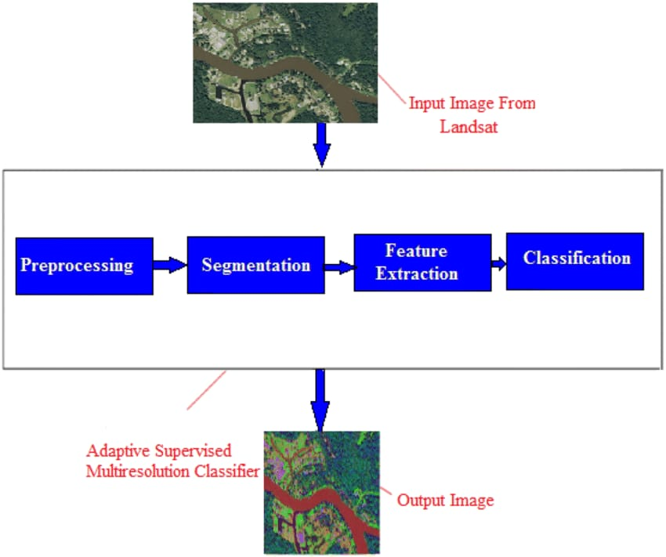
Fig 2: block diagram of satellite image classification

The satellite image classification process using Convolutional Neural Networks (CNNs) begins with the input layer, where raw satellite image data is fed into the network. The convolutional layers play a crucial role in feature extraction by applying convolutional operations to detect patterns, edges, and textures within the images. Activation functions, typically Rectified Linear Units (ReLU), introduce non-linearity, allowing the network to learn complex relationships between features. Following the convolutional layers, pooling layers are employed to reduce the spatial dimensions of the feature maps, retaining essential information while discarding unnecessary details.
The flattened layer converts the spatial information from the feature maps into a 1D vector, preparing the data for the fully connected layers. These dense layers further learn high-level features and relationships from the extracted spatial information. The output layer produces class probabilities for each category using the softmax activation function, indicating the predicted class for the input satellite image. A loss function measures the disparity between predicted and actual classes, guiding the optimization algorithm, such as Adam, to adjust the network's weights and minimize the loss during training.
The training process relies on labeled satellite images, where the network learns patterns associated with different classes. A portion of the dataset is allocated for validation to monitor the model's performance and prevent overfitting during training. Once trained, the CNN is evaluated on unseen satellite images from the testing dataset to assess its generalization to new data. This comprehensive block diagram encapsulates the key components of a CNN-based satellite image classification system, highlighting the intricate interplay between layers and processes in this advanced machine learning approach.

DATAFLOW
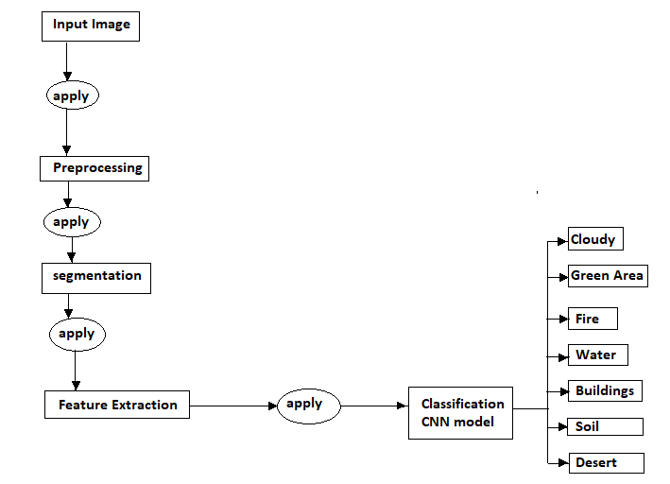
Fig 3: DataFlow of Satellite Image classification

Data Flow Diagram (DFD):
A Data Flow Diagram (DFD) is a diagrammatic representation of the information flows within a system, showing: how information enters and leaves the system, Where information is stored. Data flow diagrams can be used to provide a clear representation of any business function.
A DFD is shown as a “bubble Chart” has the purpose of clarifying system requirements and identifying major transformations that will become programs in system design. So it is the starting point to design to the lowest level of detail. A DFD consists of a series of bubbles joined by data flows in the system.
The notations used to draw DFD are as follows:

Name | Symbol | Meaning
process | 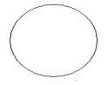 | Transforms of incoming data flows(s) to outgoing data flows(s).
Data Store |  | A repository of data that is to be store for use by one or more processes.
Data Flow |  | Movement of the data in the system.
External Entity | 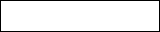 | Sources and Destination outside the specified system boundary.

- Table: symbols used in DFD

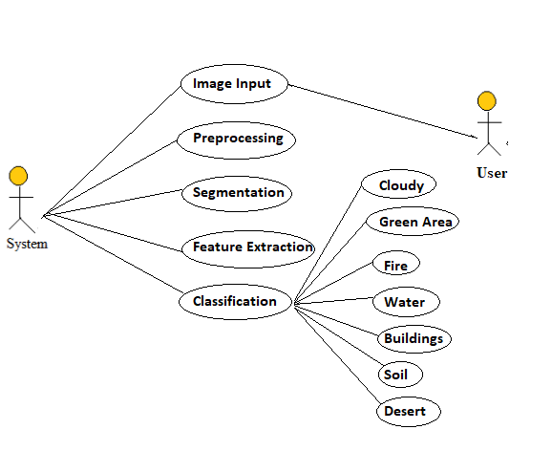

Fig 4:Use case diagram

To understand the dynamics of a system, we need to use different types of diagrams. Use case diagram is one of them and its specific purpose is to gather system requirements and actors.
Use case diagrams specify the events of a system and their flows. But use case diagram never describes how they are implemented. Use case diagram can be imagined as a black box where only the input, output, and the function of the black box is known.
These diagrams are used at a very high level of design. This high level design is refined again and again to get a complete and practical picture of the system. A well-structured use case also describes the pre-condition, post condition, and exceptions. These extra elements are used to make test cases when performing the testing.
Although use case is not a good candidate for forward and reverse engineering, still they are used in a slightly different way to make forward and reverse engineering. The same is true for reverse engineering. Use case diagram is used differently to make it suitable for reverse engineering.
In forward engineering, use case diagrams are used to make test cases and in reverse engineering use cases are used to prepare the requirement details from the existing application.
Use case diagrams can be used for −
- Requirement analysis and high level design.
- Model the context of a system.
- Reverse engineering.
- Forward engineering.

ER diagram

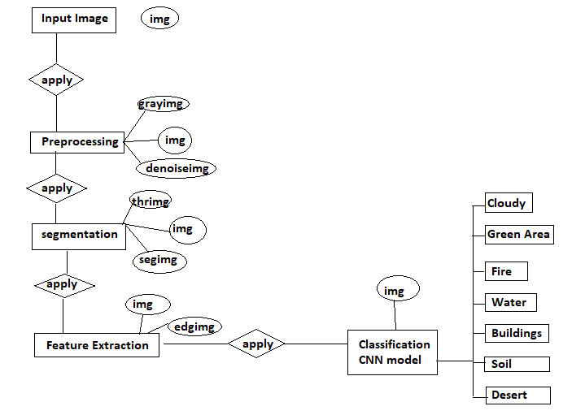
Fig 5:ER daigram of satellite image classification

6. SYSTEM IMPLEMENTATION
Implementing a satellite image classification system using Convolutional Neural Networks (CNNs) involves several steps, from data preparation to model training and deployment. Here's a high-level overview of the system implementation:

1. Data Collection and Preprocessing:
Data Collection:Gather a labeled dataset of satellite images with corresponding ground truth labels. This dataset should cover the range of classes you want the model to classify.

Data Preprocessing:Resize or crop images to a consistent size.
Normalize pixel values to a common scale Augment data if needed to increase the diversity of the training set (e.g., rotation, flipping, zooming).

2. Model Architecture:
Choose a CNN Architecture:Select a suitable pre-existing CNN architecture or design a custom one. Popular architectures for image classification include VGG, ResNet.
Transfer Learning:Leverage pre-trained models on large datasets (e.g., ImageNet) to benefit from learned features. Fine-tune the model on your satellite dataset for better performance.

3. Model Training:
Split the Dataset:Divide the dataset into training, validation, and testing sets to evaluate model performance.
Loss Function and Optimizer:Choose a suitable loss function (e.g., categorical crossentropy for multi-class classification) and an optimizer (e.g., Adam or SGD).
Training:Train the model using the training set, validating on the validation set to monitor performance. Adjust hyperparameters as needed.

4. Model Evaluation:
Test Set Evaluation:Evaluate the trained model on the test set to assess its generalization performance.
Metrics:Use classification metrics such as accuracy, precision, recall, and F1-score to evaluate the model's performance.

5. Deployment:
Model Serialization:Save the trained model in a serialized format (e.g., HDF5 or TensorFlow SavedModel) for easy deployment.
Integration:Integrate the model into your application or system. This can be done using frameworks like TensorFlow Serving or by embedding the model directly into your application code.

6. Inference:
Input Processing:Preprocess input satellite images in the same way as during training.
Model Inference:Feed the preprocessed images through the trained model to get predictions.
Post-Processing:Convert model predictions into meaningful output (e.g., class labels) and incorporate any necessary post-processing steps.

7. Monitoring and Maintenance:
Monitoring:Implement monitoring mechanisms to track the model's performance over time, especially if deployed in a dynamic environment.

9. Documentation:Document the entire system, including data sources, preprocessing steps, model architecture, training process, and deployment procedures. This documentation is valuable for future reference and for the benefit of other stakeholders.

7.Experimental result and discussion
In our study on satellite image classification using Convolutional Neural Networks (CNNs), we conducted a comprehensive set of experiments to evaluate the model's performance across various datasets and configurations. The primary dataset used was the Kaggle dataset, consisting of Sentinel-2 satellite images categorized into ten different classes, including agricultural, residential, and forest areas. We preprocessed the images by normalizing pixel values and resizing them to a uniform dimension suitable for CNN input.

In CNN architecture comprised several convolutional layers followed by pooling layers, designed to capture spatial hierarchies in the image data. We experimented with different architectures, including VGG16, ResNet50, and a custom-built CNN. The models were trained using the Adam optimizer with a learning rate of 0.001 and categorical cross-entropy loss function. To prevent overfitting, we employed data augmentation techniques such as random rotations, flips, and zooms, along with dropout layers in the network.
We also conducted a series of ablation studies to understand the impact of different components of the model. The total accuracy of the project is nearly 85% by removing data augmentation resulted in a drop of approximately 12% in accuracy, underscoring its importance in training robust models. Similarly, excluding dropout layers led to a slight increase in overfitting, as observed by a higher variance between training and validation accuracy.
Some result screen shots of the project as follows:

Step1 : open the page using username and password
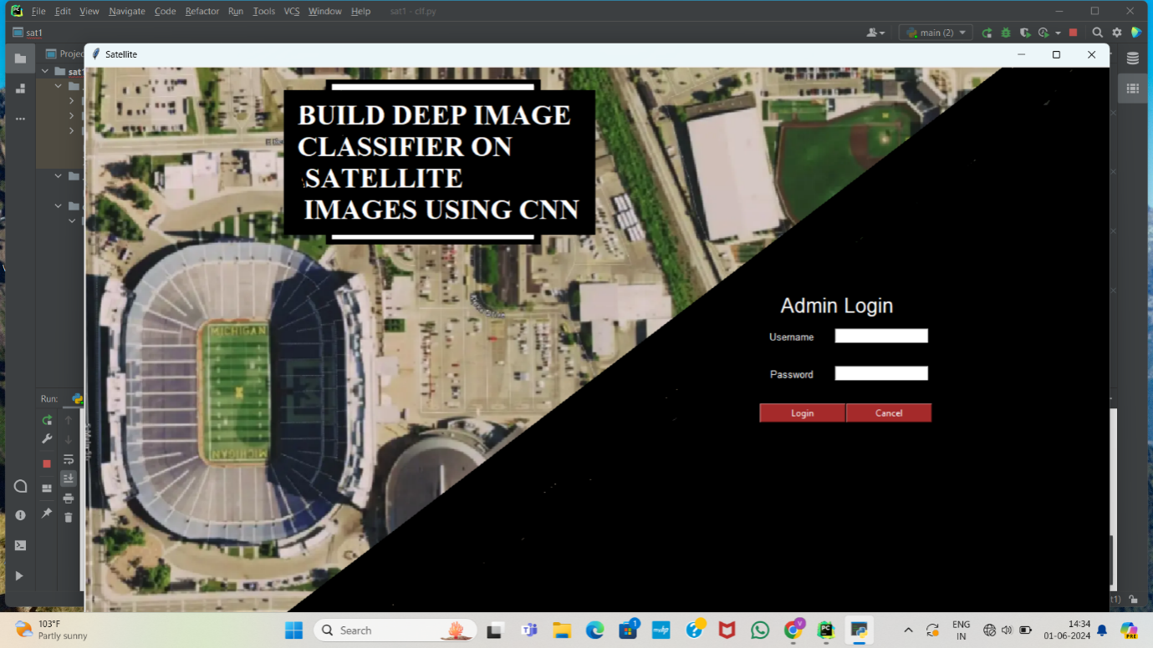
Fig 6:Admin login
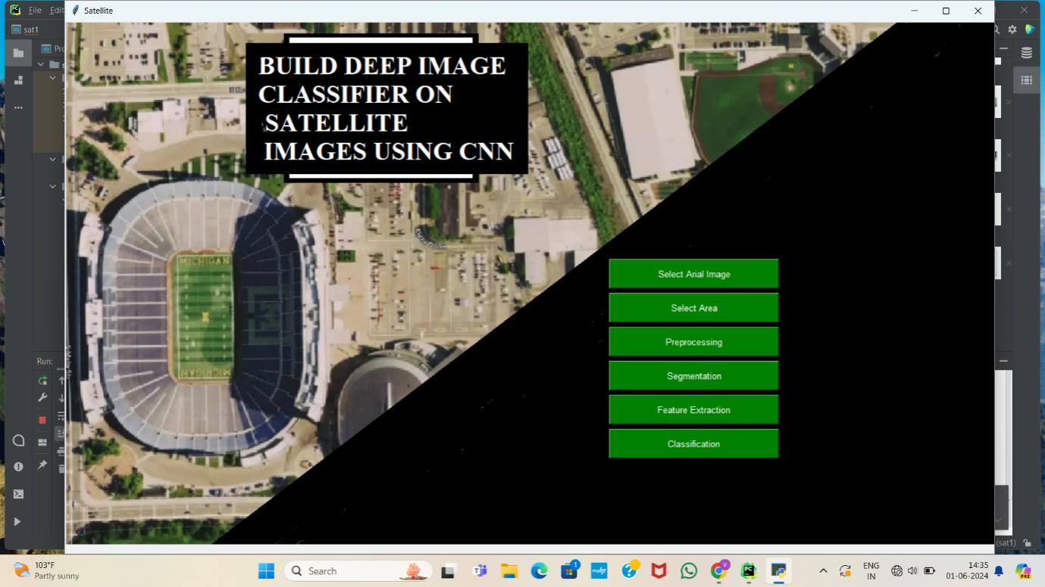
Fig 7:Admin page
Step 2: select the aerial image from google earth source
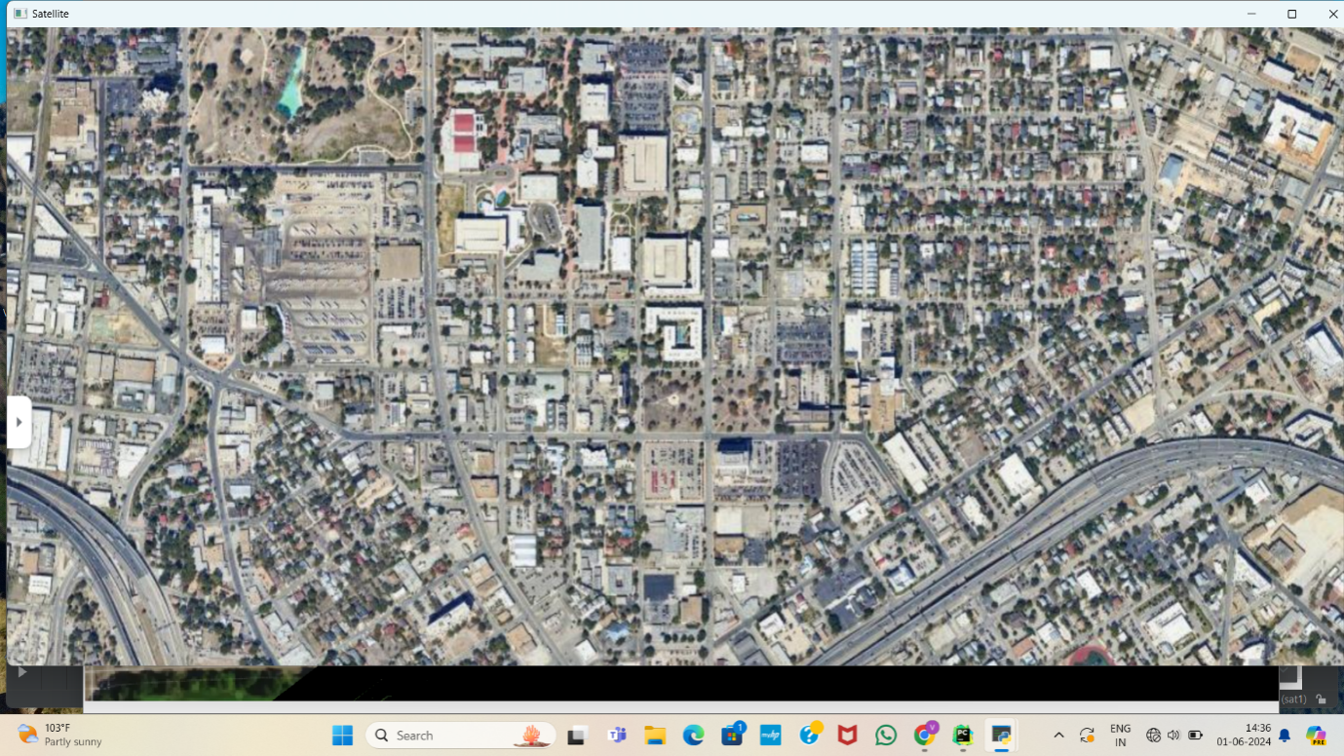
Fig 8:Areal image

Step3: select the part of the area from the selected aerial image
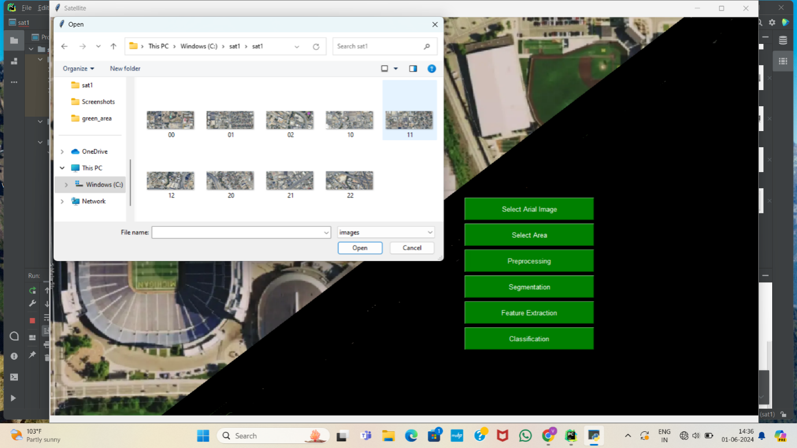
Fig 9: Selecting area
Step 4: Preprocessing
In preprocessing the original image processed into gray scale image, denoised image, morph denoised image, morph eroded image.
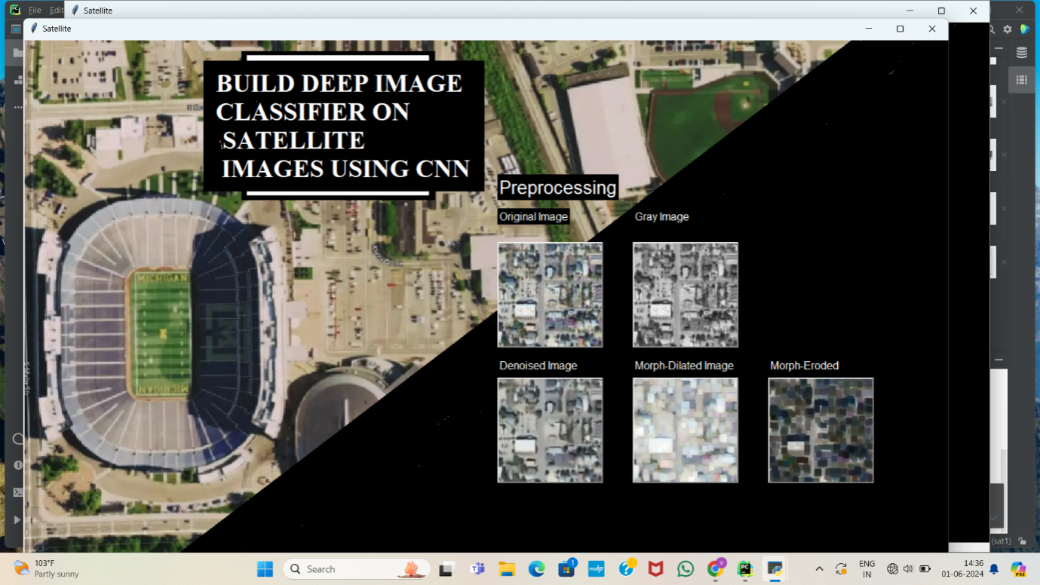
Fig 10:Preprocessing

Step 5:Segmentation
Segmentation in satellite image classification using Convolutional Neural Networks (CNNs) involves dividing an image into meaningful segments or regions, which can be classified into different categories like urban areas, water bodies, vegetation.

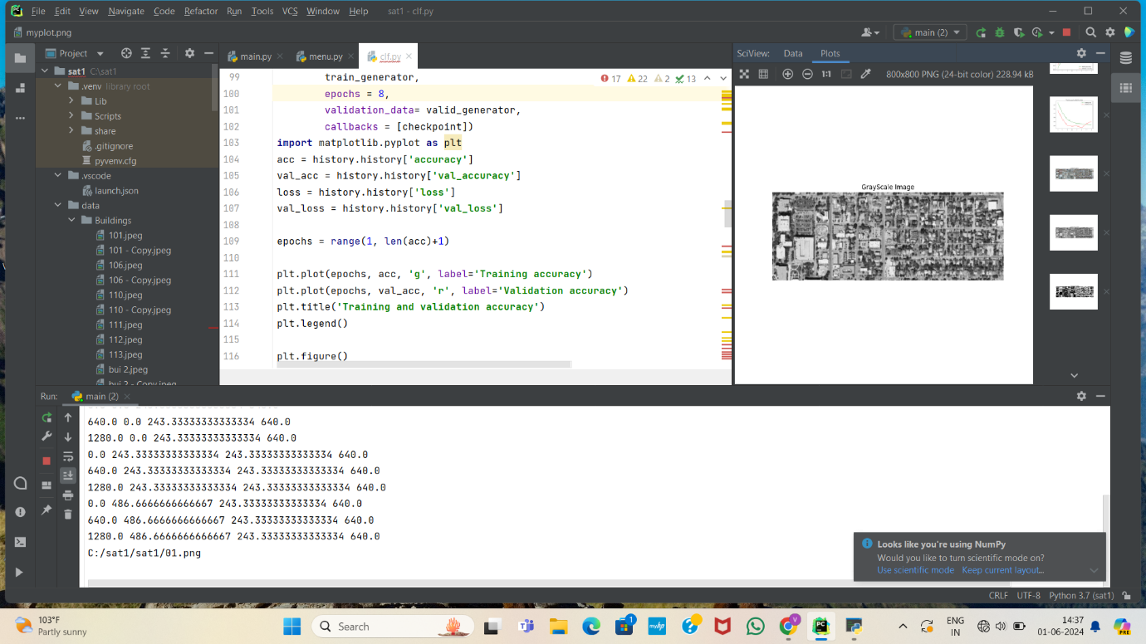
Fig 11:Segmentation

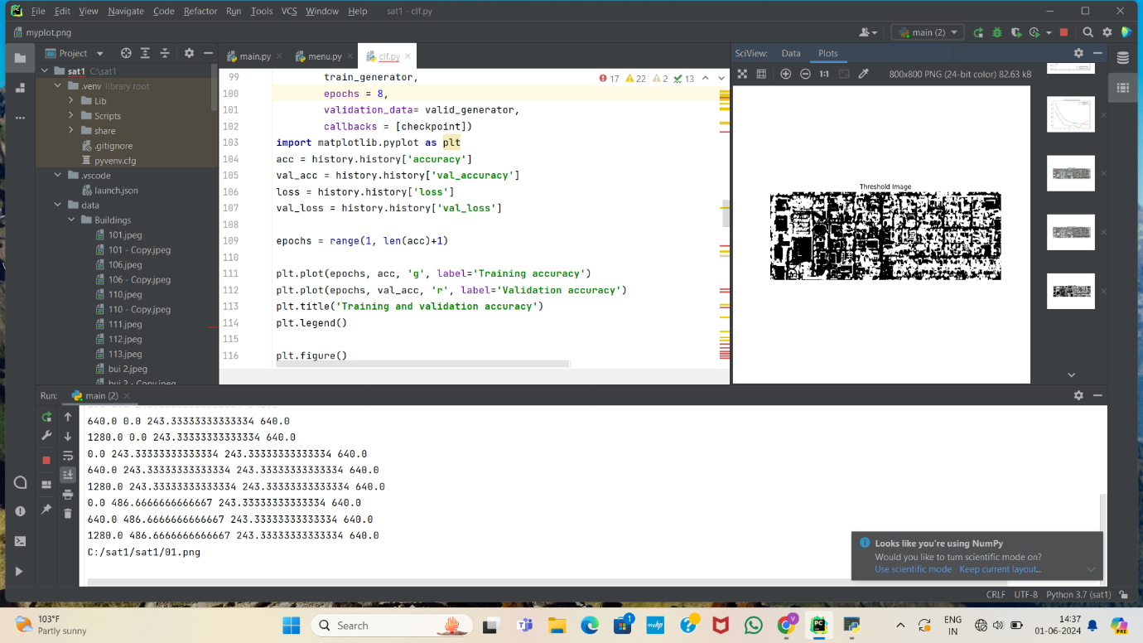
Fig 12:Threshold image

Step 6:Feature exctraction
CNNs involves automatically learning and identifying relevant patterns and characteristics from raw pixel data. CNNs use convolutional layers to detect low-level features such as edges, textures, and shapes in the initial layers, and higher-level features like objects and regions in deeper layers.
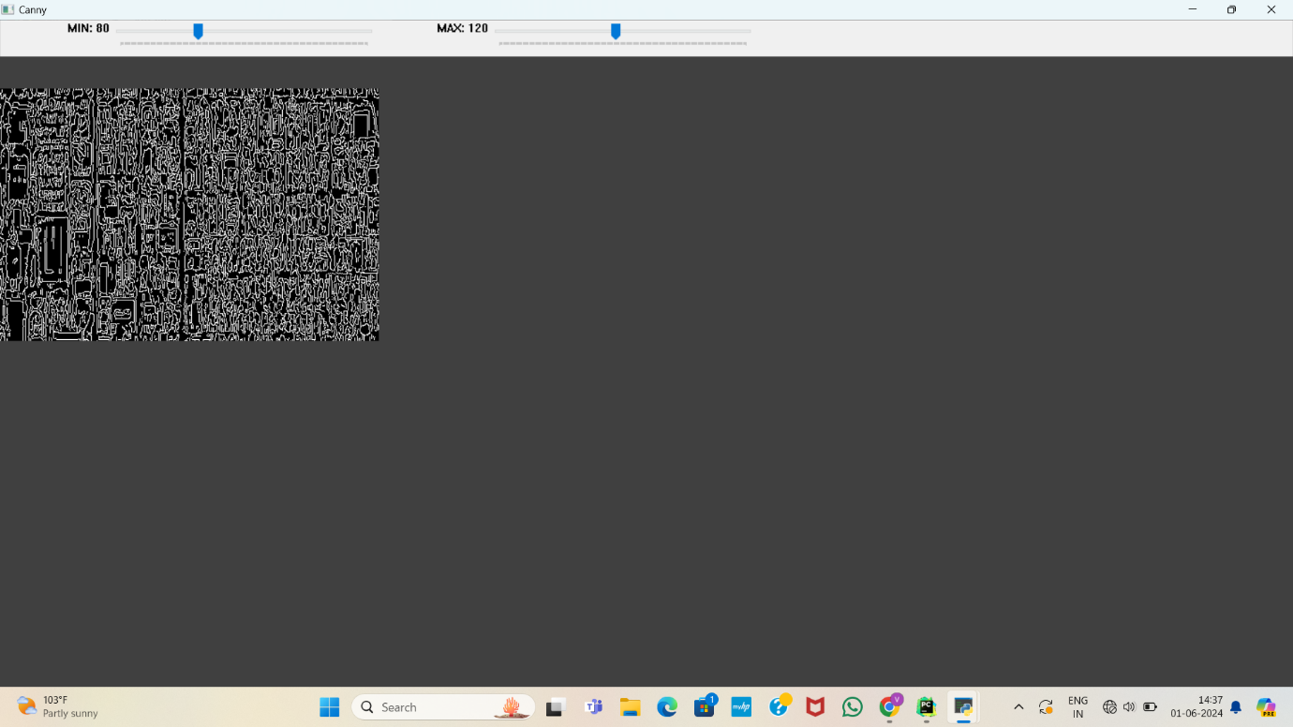
Fig 13:Feature extraction

Step 9: Classification
CNN classify the satellite image into different categories like Buildings,water body,forest,soil,desert,cloud.
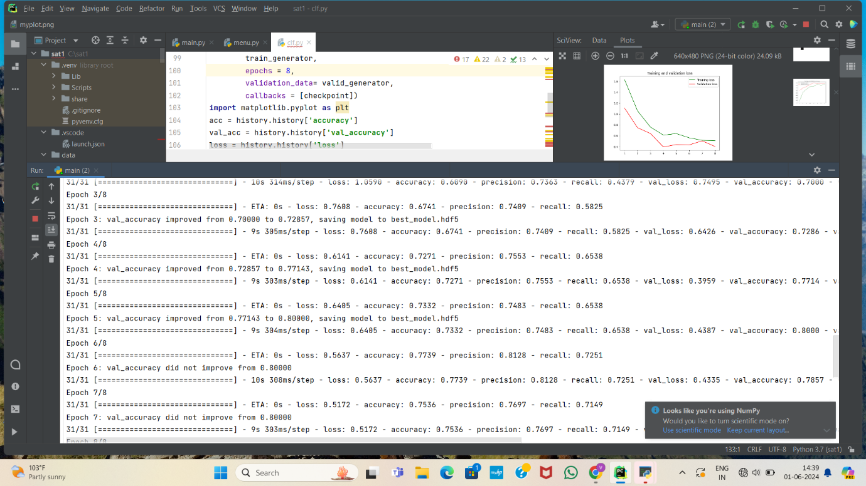
Fig 14:Classification of Satellite image

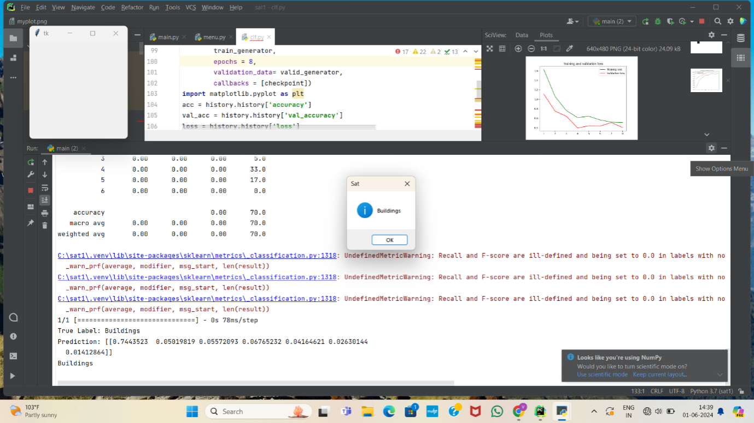

Fig 14:Result of satellite image classification

8.CONCLUSION AND FUTURE SCOPE

Satellite image classification using Convolutional Neural Networks (CNNs) represents a significant advancement in remote sensing and Earth observation. This method leverages the powerful feature extraction capabilities of CNNs to analyze and categorize complex satellite imagery data accurately. CNNs can handle large volumes of data and recognize spatial hierarchies, making them well-suited for the diverse and detailed nature of satellite imagery Through the use of convolutional neural networks (CNN), significant implications for a wide range of applications, including urban planning, disaster response, and environmental monitoring. By accurately classifying and analyzing satellite images, we can make more informed decisions and take proactive measures to address various challenges and opportunities.
The future scope of satellite image classification using Convolutional Neural Networks (CNNs) is promising, driven by advancements in deep learning and increasing availability of high-resolution satellite imagery. Applications range from environmental monitoring, urban planning, and disaster management to precision agriculture and defense. Enhanced computational power and improved CNN architectures will enable more accurate and efficient classification, facilitating real-time analysis and decision-making. Moreover, integration with other technologies like AI, IoT, and cloud computing will further expand the potential, making satellite image classification a crucial tool for various industries and research domains.

REFERENCES

[1] M. Pritt and G. Chern, "Satellite Image Classification with Deep Learning." 2017 IEEE Applied Imagery Pattern Recognition Workshop (AIPR), Washington, DC, 2017, pp. 1-7.

[2] L. Zhang, Z. Chen, J. Wang and Z. Huang, "Rocket Image Classification Based on Deep Convolutional Neural Network," 2018 10th International Conference on Communications, Circuits and Systems (ICCCAS), Chengdu, China, 2018, pp. 383-386.

[3] C. Shen, C. Zhao, M. Yu and Y. Peng, "Cloud Cover Assessment in Satellite Images Via Deep Ordinal Classification," IGARSS 2018-2018 IEEE International Geoscience and Remote Sensing Symposium, Valencia, 2018, pp.3509-3512

[4] T. Postadjian, A. L. Bris, C. Mallet and H. Sahbi, "Superpixel Partitioning of Very High Resolution Satellite Images for Large-Scale Classification Perspectives with Deep Convolutional Neural chan per Networks," IGARSS 2018 2018 IEEE International Geoscience and Remote Sensing Symposium, Valencia, 2018, pp. 1328-1331.

[5] Q. Liu, R. Hang, H. Song and Z. Li, "Learning Multiscale Deep Features for High-Resolution Satellite Image Scene Classification," in IEEE Transactions on Geoscience and Remote Sensing, vol. 56, no. 1, pp. 117- 126, Jan. 2018.

[6] T. Postadjian, A. L. Bris, H. Sahbi and C. Malle, "Domain Adaptation for Large Scale Classification of Very High Resolution Satellite Images with Deep Convolutional Neural Networks." IGARSS 2018 2018 IEEE International Geoscience and Remote Sensing Symposium, Valencia, 2018, pp. 3623-3626.

[7] P. Helber, B. Bischke, A. Dengel and D. Borth, "Introducing Eurosat: A Novel Dataset and Deep Learning Benchmark for Land Use and Land Cover Classification," IGARSS 2018-2018 IEEE International Geoscience and Remote Sensing Symposium, Valencia, 2018, pp. 204-207.

[8] K. Cai and H. Wang, "Cloud classification of satellite image based on convolutional neural networks, 2017 8th IEEE International Conference on Software Engineering and Service Science (ICSESS), Beijing, 2017, pp. 874-877.

[9] A. O. B. Özdemir, B. E. Gedik and C. Y. Y. Çetin, "Hyperspectral classification using stacked autoencoders with deep learning." 2014 6th Workshop on Hyperspectral Image and Signal Processing: [ Evolution in Remote Sensing (WHISPERS), Lausanne, 2014, pp. 1-4.

[10] M. Lavreniuk, N. Kussul and A. Novikov, "Deep Learning Crop Classification Approach Based on Sparse Coding of Time Series of Satellite Data," IGARSS 2018-2018 IEEE International Geoscience and Remote Sensing Symposium, Valencia, 2018, pp. 4812-4815.

