ONLINE REAL ESTATE (ORE.in)
T MUKESH KUMAR,S RAJAVEL,S POOVEL
INFORMATION TECHNOLOGY
SRI SHAKTHI INSTITUTE OF ENGINEERING AND TECHNOLOGY
COIMBATORE
---------------------------------------------------------------------***---------------------------------------------------------------------
Abstract – This project to create a real estate website our aim is to visible all the land and house in our website that the client offer us to sell. All the land and are visible in our land module. In this website makes the user easer to find the land and house wherever he wants.

Key Words: management , house , land .

1.INTRODUCTION :

Ore.in is a website which helps you to access and buy house and land. Here, you can directly contact the land or house holder . In today world, its really tough to find the house or land in your expecting area . The world of real estate has been transformed with the introduction of online platforms. These online real estate projects provide a convenient and efficient way for buyers, sellers, and renters to connect and conduct business. With just a few clicks, users can browse through a wide range of properties, compare prices, and even schedule virtual tours. This has opened up new opportunities for individuals and businesses alike, making the process of buying and selling properties faster, easier, and more transparent. These online real estate projects also offer various features such as advanced search options, real-time updates, and secure payment options, making them a one-stop solution for all real estate needs. Moreover, these platforms have also played a crucial role in bridging the gap between buyers and sellers from different geographical regions, making it possible to invest in properties from the comfort of one's own home. With the ever-evolving technology and increasing demand for convenience, the future of online real estate projects seems bright and promising. The real estate industry has been rapidly evolving with the advancement of technology, and the emergence of online real estate projects is proof of this. These projects provide a platform for buyers and sellers to connect and conduct business transactions in the comfort of their own homes. Online real estate projects aim to revolutionize the traditional way of buying and selling properties by offering a more efficient, transparent, and convenient process. Through these projects, users can easily search for properties, compare prices, view images and virtual tours, and even negotiate deals with sellers. Additionally, these projects also offer tools for real estate agents to manage their listings and communicate with potential buyers.

2. Working and principle:

In the Online real estate website any one can access the land and contact the land holder. In the main page the online real estate heading on the top of the page. And the login, about us, contact us link are placed on the right side of the navigation bar. On the login page you can login and access the land page. All the data of login information are stored in the data base . For login you have to register to our website using sign up page. In the sign page date of birth, name , passward , email should be added. We us XAMPP software for connecting database after login user can access the land page where all the land and house visible if user wants to buy land or house they can make a direct contact with the land or house holder this make easer to buy and reduce the communication
Error and misunderstanding. In about us page the information of admin given and in contact us page the admin contact number is given all the page are given below.

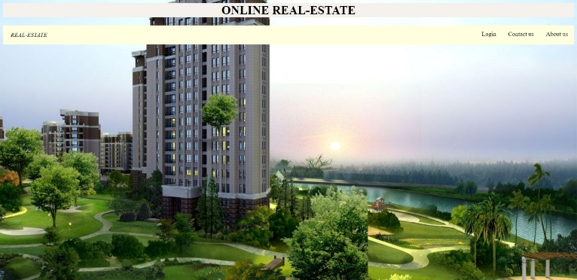
Fig-1: Home Page
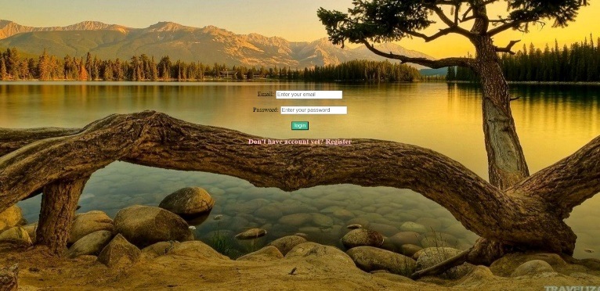

Fig -2: Login page

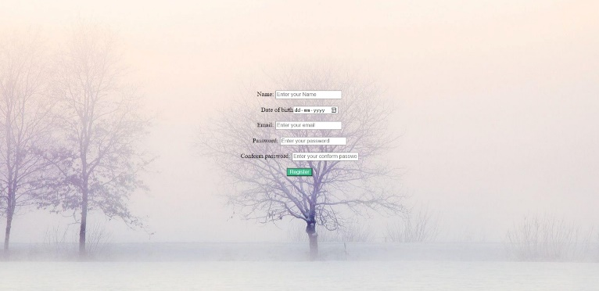

Fig-3:Sign page

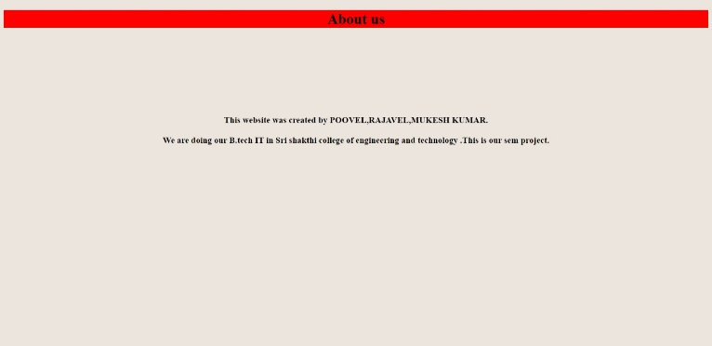

Fig-4:About Us page

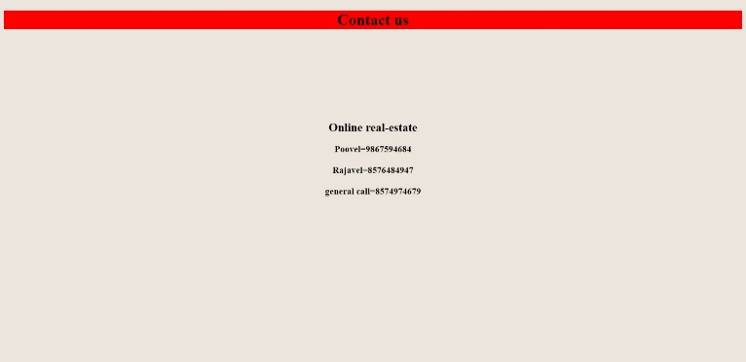
Fig-5:Contact Page

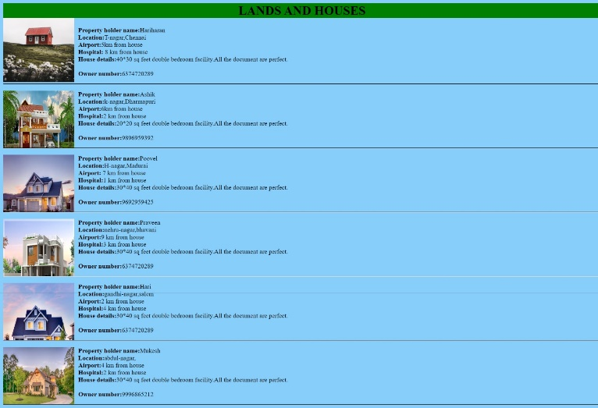

Fig-6:Land Page

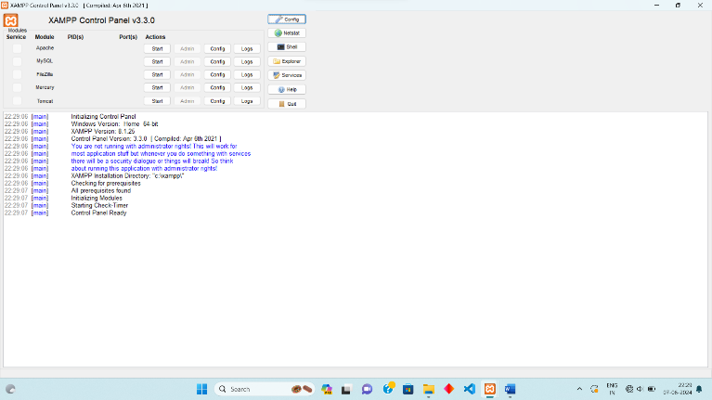

Fig-7:Xampp database Page

3. CONCLUSIONS

Online real estate (ORE.in) is a website to buy land and house and for that it used a Few Languages such as HTML,CSS,JS and for the backend connectivity this project has an inclusion of the XAMPP. With that this website has an inclusion of a Login page , register page, about us page , contact us page and there is a page to buy house and land.

ACKNOWLEDGEMENT

Our great thanks to the our institute and Project mentor, Ms.Bhuvana for her ever lasting contribution in making the project a smooth journey and also for her valuable guidance and for making us realize our potential and be successful.

REFERENCES :

- Housing.com: A leading property portal in India, offering a comprehensive list of properties for sale and rent, along with tools like EMI calculators and property valuation.

- NoBroker.in: This platform eliminates brokerage fees by connecting property owners directly with potential tenants or buyers.

- MagicBricks.com: One of India's best-known online real estate marketplaces, featuring a wide range of properties and providing detailed information to help users make informed decisions.

