Authors Photos

- Ms. Pranjal Kamble (Author 1)
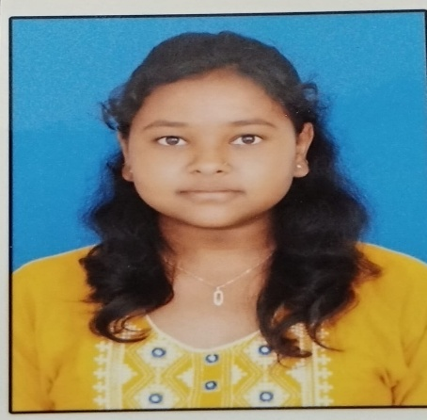

- Ms. Disha Shelar (Author 2)
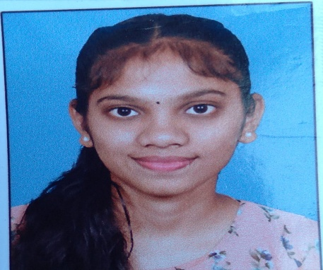

- Ms. Urmila Dukre (Author 3)
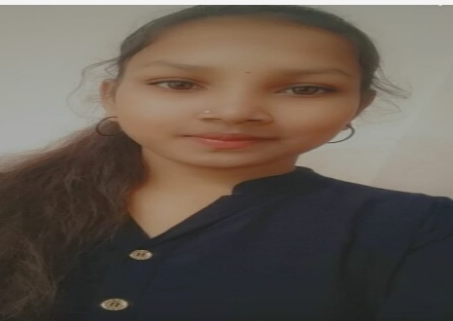

- Ms. Komal Dhawale (Author 4)
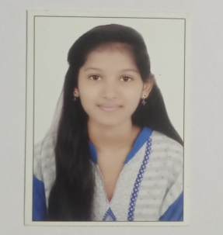

- Ms. Nandini More (Author 5)
